Women and Wool Working in the Roman Empire
By
Morgan A Lemmer-Webber
A dissertation submitted in partial fulfillment of
the requirements for the degree of
Doctor of Philosophy
(Art History)
at the
UNIVERSITY OF WISCONSIN-MADISON
2021
Date of final oral examination: xx/xx/xxxx
The dissertation is approved by the following members of the Final Oral Committee:
Nicholas D. Cahill, Professor, Art History
William Aylward, Professor, Classics
Marc Kleijwegt, Professor, History
Laura McClure, Professor, Classics
Ann Smart Martin, Professor, Art History

Released under the Creative Commons Attribution-ShareAlike 4.0 International license
by Morgan Lemmer-Webber 2021

Table of Contents
1 Introduction
1.1 Central research questions
1.2 Stages of Roman Textile Production
1.3 Methodology
1.4 State of current research
2 Karanis
2.1 History and Excavation
2.2 Archaeological Evidence of Textile Production
2.3 Textual Evidence of Textile Production
2.4 Visual Evidence of Textile Production
2.5 Conclusion
3 Trier (Augusta Treverorum)
3.1 History and Excavation
3.2 Visual Evidence of Textile Production
3.3 Textual Evidence of Textile Production
3.4 Archaeological Evidence of Textile Production
3.5 Conclusions
4 Ephesus
4.1 History and Excavation
4.2 Archaeological Evidence of Textile Production
4.2.1 Textile Tools from the Roman Terrace Houses
4.2.2 Textile Tools from Elsewhere in Ephesus
4.3 Textual Evidence of Textile Production
4.4 Visual Evidence of Textile Production
4.5 Conclusions
5 Domestic Production of Textiles
5.1 Augustan Propaganda and the Domestic Production of Textiles
5.1.1 Epitaphs to Virtuous Housewives
5.2 Social Hierarchy and the Division of Domestic Labor
5.3 Archaeological Evidence of Domestic Production of Textiles
5.4 Conclusions
6 Commercial Production of Textiles
6.1 Introduction/framing
6.2 Grounding for a cottage industry
6.3 Archaeological evidence
6.4 Epigraphic Evidence
6.5 Administrative Evidence for Commercial Production
6.5.1 Diocletian’s Price Edict
6.6 Iconographic evidence
6.7 The solution to the mystery: women
7 Performative aspects of Textile Production
7.1 Marriage
7.2 Funerary rites
7.2.1 Grave goods
7.2.2 Funerary Iconography
7.3 Religion
7.3.1 Christian Associations
7.4 Ceremonial functions of Ephesus distaffs
7.5 Conclusions
8 Weaving this all together
8.1 A gap, revisited
8.2 Patterns, evidence, and observations
8.2.1 Domestic and commercial: contrast or complement?
8.2.2 Cultural threads
8.3 Mending the gap
9 Addendum: Experiential and Experimental Textile Production
9.1 Spinning
9.2 Weaving
9.3 Artifact dispersal
10 Image List
Bibliography
Index

Acknowledgements
It is difficult to write an acknowledgments section without feeling like it will be inadequate. A project like this takes years, and I am fully aware just how many family members and friends lent their support. To everyone who gave encouraging words in times of doubt, who dropped off cookies or fruit at our doorstep in sessions of mad writing towards another deadline, I am truly grateful.
Thank you in particular to my advisor, Nicholas Cahill, for supporting the topic of this dissertation and providing much advice, including the suggestions of the particular archaeological sites which became the focus of this dissertation. Thank you also to the other members of my committee for their time and guidance: William Aylward, Marc Kleijwegt, Laura McClure, and Ann Smart Martin. Extra thanks to Ann for providing me with an opportunity which occurred in the middle of this dissertation, the William Ramsay ledger website, which helped me branch out into digital humanities directions. Thank you to my MA advisor, Sinclair Bell, for his continued support.
Thanks also to the Racket programming language community, who took interest and helped provide advice and debugging when hearing about my unusual choice to write this dissertation in Racket’s Scribble document authoring programming language.
Sebastián E. Encina and the Kelsey Museum of Archaeology granted access to the Karanis database and collections, which provided significant grounding and evidence for many of the key ideas in this dissertation. Thank you, and thank you also for permitting me to take pictures of your wonderful collection of spindle whorls.
Thanks to my parents, who dealt with the stubbornness of and even supported an unusual middle-schooler who set her heart and mind on achieving an art history PhD at such a young age. I’m glad to be able to share with you that I made it to that goal at last.
Sara Champlin has been my friend and colleague through my entire PhD program. Thank you for the many hours spent bouncing ideas off of each other. It has been much easier being able to go through this process with someone I trust and admire so much.
Thank you also to Jamie Sprovach. Your friendship, along with your stubborn and enthusiastic support for my ambitions, have never been lost on me for all these years.
Finally, thank you to my spouse Christopher, to whom this dissertation is dedicated. You always brought me tea and reminded me I needed to eat, you never lost belief that I would make it, and wouldn’t allow me to either.

Abstract
This dissertation looks at women’s roles in textile production in the Roman Empire, from the first through third centuries C.E., utilizing archaeological, epigraphic, literary, administrative, and visual evidence. The sites of Karanis, Trier, and Ephesus are used as case studies to focus analysis alongside domestic, commercial, and performative lines. Scholars have often viewed the domestic and commercial divide in textile production along gendered lines, associating domestic production with women in the context of the ideal of feminine virtue and commercial production with men working in centralized production centers. This study uses the cottage industry model to explore the role of women’s labor in the Roman textile industry, exploring the links between domestic production and commercial distribution.

Chapter 1 : Introduction

1.1 Central research questions
The moral ideal of a productive and virtuous wife is embedded in Greek and Roman mythology and widely recorded in ancient literature and visual traditions. Archaeological evidence from domestic contexts confirms that textile production was to an extent carried out in the home, at times alongside larger commercial practices. Epigraphic and literary evidence suggest that the association between women and wool working remained prevalent throughout Roman culture. In the pre-Roman through early Republican periods, textile production was a domestic activity performed by women and slaves. It is generally accepted by scholars that the textile industry shifted into an increasingly commercial endeavor in the Republican and Imperial periods and therefore women’s role in textile production became less prominent. However, the performative and idealized associations between women and textile production persisted in Roman culture.
In this study I will examine the persistence of this tradition and explore the roles women played in wool working in the Roman Empire from the first through third centuries CE. The evidence for Roman textile production in general is relatively scarce and scattered, especially when it comes to women’s involvement. There is no one source or site that can give us a comprehensive view of women’s roles in textile production. Instead, we see several emerging themes including the ancient idea of the productive matron; the trope of the dutiful woman; the labor force within the Roman household; and the labor force in a cottage industry. Written and epigraphic sources that discuss the topic either tend to be skewed toward male involvement in the larger textile economy or toward the domestic roles of women. Addressing the above themes as well as the missing evidence, I argue that women played integral roles throughout the Roman textile industry.
In order to narrow the focus of this research, I will use the sites of Karanis, Trier, and Ephesus as case studies. I chose these sites because they each provide multiple sources and types of evidence that have been published. These sites also reflect a geographic dispersal throughout the Empire. ’Roman culture’ was not a consistent construct. There is wide diversity throughout the empire due to the local cultural traditions and by assessing sites from different provinces, I hope to gain some insight into both that diversity and the consistencies. As in any study that cross-analyzes disparate sites across the empire, I will also explore what impact, if any, the long-distance trade network that operated throughout the empire had on textile production and the role of women in the provinces. Therefore, while the scope of this research focuses on evidence from the first through third centuries CE, a brief summary of pre-Roman evidence of textile production will be provided for each site.
This study will begin with three brief case-study chapters that present archaeological, epigraphic, and visual evidence or lack thereof for textile production at each case study site. These will be followed by three synthetic chapters that place the evidence from these sites into the larger narrative of Roman textile production. In chapter one I will discuss the wealth of material culture of textile production supported by epigraphic evidence in the form of apprenticeship contracts from Karanis. In chapter two I will cover evidence from Trier with a focus on visual representations of the textile industry through the Igel column as well as references to professional textile associations. In chapter three I will discuss the archaeological evidence of textile production in both domestic and funerary contexts from Ephesus, particularly the ornate distaffs that suggest a symbolic or ceremonial use. Chapter four will discuss how evidence from these sites reflects the domestic production of textiles as evidenced more broadly within the Roman empire. Chapter five will consider the commercial production of textiles while also calling into question how distinct the division of domestic and commercial production of textiles actually was in the Roman world. Chapter six will look at the performative aspects of women and textile production particularly in the contexts of marriage and funerary rites. This evidence will be analyzed with an emphasis on how changing political, economic, and social factors impacted changes in practice. This interdisciplinary approach allows for a more nuanced view of how textile manufacture related to women’s lives. The conclusion will then situate the evidence from these three sites into a discussion of women’s roles in textile production and whether evidence from the provinces reflects the cultural ideals of femininity of the Roman Empire more broadly.
Through this structuring of chapters, I hope to demonstrate how the association between women and textile production manifested itself over time and in various cultural climates. In fields where evidence is scarce and varied it is necessary to analyze where and why certain streams of evidence were preserved and how that informs our interpretations. For this reason, highlighting the lack of evidence for specific themes in different locations may provide insight otherwise ignored in the scholarly discourse of textile production.

1.2 Stages of Roman Textile Production
Overall, this study focuses on the social and cultural aspects of textile production rather than the technical processes themselves; however, a broad overview of the stages of production is in order. As in every type of production, the first obstacle is obtaining raw materials. It likely varied by location whether the sheep were raised in town, in the surrounding hinterland, or whether the wool was imported. In addition to faunal evidence of the sheep themselves, the archaeological record may include the metal sheers used to remove the excess winter fleece annually in the spring. The fleece is then cleaned and processed into long bundles of fiber called a roving.
While it is possible to spin directly from the roving, the Romans often wrapped the roving around a distaff to help manage the unspun quantity of wool. The primary element to the distaff is a shaft to wind the roving around, this might have a fork at the end to help secure the wool. The style of distaff that most commonly survives in the archaeological record from Roman contexts is a ring-distaff or finger distaff, which involves a shaft with one end terminating in a ring and the other end often topped with a decorative element. The shaft may be decorated with simple patterns, the texture of which help adhere the roving to the distaff without it slipping. When the distaff is loaded with wool, the decorative element at the top would be visible above the wool. Since most of the surviving distaffs are made of glass, bone, ivory, jet, or other precious or semi-precious stones, their dominance may represent a survival bias over simpler distaffs made of wood. The hard nature of these materials combined with the cushion of the roving also are unlikely to show the same signs of wear that a wooden distaff would. Combined with the fact that they are frequently found in funerary contexts, it is difficult to determine if these surviving examples were ever used or were purpose-made to serve as grave goods.
The basic tool required for spinning the processed wool into thread is a drop spindle. This consists of a shaft and whorl. Whorls come in multiple shapes and sizes depending on the desired size, material, and consistency of the thread. The basic description of a whorl is a round or disc-shaped object that is heavier than the shaft with a hole in the center. The weight of this whorl gives the spindle the centrifugal force to continue spinning while the spinner drafts out the thread. The shaft of the spindle may be slightly tapered in order to secure the whorl to it. Though not strictly necessary to an experienced spinner, a groove, notch, or metal hook may be included at the top of the spindle to secure the thread and ensure that it does not unravel. Spindle shafts were typically made of wood and therefore do not often survive. Spindle whorls could be made of wood, clay, glass, stone, or ivory and therefore are more common in the archaeological record. Very few metal hooks that were potentially from spindles survive, suggesting that they were not the norm. Where wooden spindle shafts survive, signs of wear include ridges or incisions near the top of the spindle from the thread wearing against the shaft, marks around where the whorl would have sat, and general nicks and scrapes. On spindle whorls, the most common signs of wear are chips around the edges of the whorl.
To make thread, the spinner holds the distaff in one hand and uses the other hand to set the spindle twirling. She then uses that free hand to draft the thread out by pulling small clusters of fiber out of the roving at a time. With her thumb and forefinger she controls the amount of twist that travels up to create the thread. Since both hands are occupied, she may use her teeth to remove impurities or inconsistencies from the thread. Once the spindle loses momentum and stops spinning, she grabs the suspended spindle, winds the thread around the spindle shaft, and repeats the process. In his description of the Parcae, the Roman equivalent of the Greek Moirai who determine each person’s fate by spinning, measuring, and cutting the thread of their life, Catullus gives a detailed description of this process:
... their hands pursued their never-ending toil, as of custom. The left hand bore the distaff enwrapped in soft wool, the right hand lightly withdrawing the threads with upturned fingers shaped them, then twisting them with the prone thumb it turned the balanced spindle with well-polished whirl. And then with a pluck of their tooth the work was always made even, and the bitten wool-shreds adhered to their dried lips, which shreds at first had stood out from the fine thread. And in front of their feet wicker baskets of osier twigs took charge of the soft white woolly fleece.
The combination of the velocity of the spin, the weight of the whorl, and the number of fibers she drafts at a time determine the thickness of the thread. Most surviving examples of Roman textiles use only single threads created by the above process. Some examples, however, use a sturdier plied thread either for the warp strands or sewing thread. To ply thread, two or more single threads are spun in the opposite direction (i.e. if they were spun clockwise for the initial single, they would be plied counter-clockwise), causing the threads to fold back on each other. Spinning is also the most time-intensive step of the textile process and therefore can become a production bottleneck. While we have no primary records indicating the actual amount of time it took Roman women to spin, various attempts have been made to gauge this. One method is using experimental archaeology to test the amount of time required. At my own rate of spinning it would take 180 hours to spin one Roman pound of wool. Based on similar experiments at the Centre for Textile Research, Mary Harlow estimates it would take roughly 900 hours to spin the 40km of thread required to make a Roman toga. Ulrike Roth estimates that at a rate of 100 metres per hour to spin wool, it would take roughly 135 hours to produce the 13,500m of thread to weave a Roman tunic. These experiments, however, are limited the the spinning capabilities of those conducting the tests and it is difficult to recreate the level of skill and ease that a Roman woman would have had. References to cultures who still produce thread using a drop spindle are perhaps more accurate. Traditional spinners from the Andes average roughly ninety-eight yards an hour to spin wool or alpaca fiber. An Incan tunic required roughly four hundred hours to spin the required thread. Calculating between cultural sources, Virginia Postrel indicates that it would take 444 hours by an Andean spinner to spin the 40km Harlow estimates for a Roman toga, 400 hours using an Indian charkha spinning wheel, and 440 hours on a medium spinning wheel.
Spinning is the stage of textile production most closely associated with women. Evidence from job titles in epitaphs indicates that the job of spinner, quasillaria, was performed exclusively by women. Though it is entirely possible that some male domestic slaves and servants performed this task as part of their duties, there are no men commemorated as spinners. Furthermore, given the altogether low number of quasillariae mentioned in inscriptions, the activity must have been more widespread, most likely performed alongside other duties by servants and members of the household.
The precise mode of weaving in the Roman world is difficult to pin down because no Roman looms survive in the archaeological record. The warp-weighted loom was the standard type used in Ancient Greece and early Rome (Figs. 1-2) This type consists of an A-frame on either side with a beam connecting them from the top. The warp threads are suspended from this beam are weighted in clusters at the bottom relying on gravity to provide tension. The warp threads alternate between two positions, half are draped over a horizontal beam along the front of the loom with the other half hanging behind. The A-frame design gives the front of the loom an angle making it so that the threads hanging behind the horizontal beam fall straight down while those in front of the horizontal beam are further forward leaving a gap between the two sets of threads. This gap, or shed, is the space through which the weft thread is passed. A horizontal bar called the heddle connects to the warp threads which hang behind the beam. By shifting the heddle from the resting position against the front beams of the loom onto the heddle jacks, support structures which protrude from the front vertical beams of the loom, the weaver can shift the shed in the opposite direction, allowing the weft thread to pass through again. Since the warp threads are only secured to the loom via the top horizontal beam, the weaver must work from the top down. Loom weights made of clay or stone are typically the only surviving archaeological evidence of this type of loom. Signs of use on loom weights typically include vertical grooves from the hole in the weight to the top where the warp threads would have been looped through. The presence of loom weights at Roman sites suggests that this loom type continued to be used to some extent into the Imperial period. However, sets of weights large enough to supply an entire loom are scarce and certainly could not supply the quantity of fabric the population required.
A Roman two-beam upright loom consists of two upright beams on the sides with horizontal beams at the top and roughly a third of the height from the bottom. The warp threads are looped around these two horizontal beams to create tension, the thickness of the beams forms the shed. The process of weaving from this point can follow the same pattern as described above with the heddle connected to the warp strands in the back. However, since the structure of this loom type is more secure with the warp threads secured at both ends of the loom, this type of loom was also more efficient for tapestry weaving. Unfortunately, this loom type does not survive in the archaeological record since it is made entirely out of perishable material and generic hardware. We know the structure of the loom from visual representations, one relief from the Forum Transitorium (Fig. 3) and a fresco in the Hypogeum of the Aurelii (Fig. 4). Seneca, paraphrasing Posidonius’s description of weaving, references both a loom with "threads stretched by means of hanging weights" and a loom where "the web is bound to frame," indicating that while the warp-weighted loom was somewhat old-fashioned it was still in use concurrently with the Roman two-beam loom. Since the warp threads are secured at both ends of the loom, the two beam upright loom can also be physically easier to weave on because it is possible to work from the bottom up, allowing the weaver to sit while weaving. In the fresco from the Hypogeum of the Aurelii, the woven portion of fabric is represented at the bottom of the loom. In the three looms represented on the Forum Transitorium reliefs, the thread and fabric are not detailed, however women sit on the ground in front of two of the looms weaving.
The amount of time required for weaving is difficult to assess because the size of the desired fabric, the style and pattern of weaving, the density of threads per inch, and the method of finishing off the ends of the fabric all impact the final time investment. Overall, however, the process of weaving on either loom type typical of the Roman Empire required somewhere between one tenth and one sixth the time investment than spinning. Karen Carr suggests that weaving a square metre of fabric on a warp weighted loom could vary from four to twelve hours per meter. Ulrike Roth estimates that it would take roughly fifteen hours to weave a Roman tunic. Mary Harlow estimates that a single Roman toga could take two weavers roughly one hundred hours to weave.
Both male, textor, and female, textrix, weavers are identified by job titles in epitaphs. Though professional weavers are more frequently men, weaving within the household is associated with women. In his description of the mythological weaving battle between Arachne and Minerva, Ovid describes the dressing of the loom and the process of weaving:
And both, at once, selected their positions, stretched their webs with finest warp, and separated warp with sley. The woof was next inserted in the web by means of the sharp shuttles, which their nimble fingers pushed along, so drawn within the warp, and so the teeth notched in the moving sley might strike them.—Both, in haste, girded their garments to their breasts and moved their skillful arms, beguiling their fatigue in eager action.
Dyeing of textiles could be done at nearly any stage of textile production, raw wool, spun fibers, or woven fabrics. Furthermore, used fabrics were often re-dyed to refresh their appearance. Dyeing shops can be identified archaeologically by deep lead cauldrons with furnace installations below to heat the chemicals.
Fulling is the final stage of Roman textile production. After the cloth is woven it is exposed to heated liquid, agitated, and combed to tease out some of the fibers. After the fulled fabric dries it shrinks down in size tightening the weave. In essence, the combination of heat and friction effectively felts a layer on top of the cloth. The final step is to finish the cloth by sheering off any excess fibers to create a smooth surface. Fulling requires specialized equipment installed into a workspace and therefore it is easily identifiable in the archaeological record. A fullery is typically divided into stalls with basins sunken into the floor separated by partial walls with waterproofed coating.
While it is unclear where the distinction between domestic and commercial production of textiles begins, or even if that distinction has any real value, some stages of production could be done anywhere while others required more specialized spaces. The processing of the wool, spinning, and weaving described above could be performed within a domestic space, and archaeological finds support this. The large cauldrons, basins, and vats required for dyeing and fulling necessitated facilities that multiple households and commercial endeavors would have shared. After the production stages, the finished products were either used within the household where they were produced or fed into the commercial textile industry where they were packaged, shipped, and sold. According to Roman practice, clothing was typically woven as a single piece on the loom, so little alteration or tailoring was necessary from weaver to consumer. Job titles for the textile manufacture and commerce which happened outside of the house including dyers, fullers, and merchants were almost exclusively associated with men.

1.3 Methodology
For this research, I will chiefly employ the methodologies of social archaeology and social history. These two approaches varry primarily in their source material; however, given the limited amount of evidence for textile production overall, I incorporate both archaeological and written sources into my evidence. It is important to examine the social and cultural factors that inform textile production and the people involved in performing it. In order to understand the extent of social and cultural relationships between these women and their craft, it is important to look at multiple aspects of identity. Because the category of ’women in the Roman empire’ is far too broad on its own, I will consider how factors such as status, class, and age effect this discussion. It is likewise important to note that these factors can change over a woman’s lifetime and in relation to the social situation.
Since this research focuses largely on the social history of women in particular, it will also be greatly informed by feminist methodologies of historical and art historical research. While the early stages of feminist -history, -art history, and -archaeology focused on the gaps in our understanding of women’s roles in history and writing women back in, this work has largely been accomplished over the last fifty years of scholarship. My research focuses on recontextualizing women’s roles in textile production from a more intersectional approach and analyzing how the biases of antiquity in regards to gender, slavery, and labor overall have been perpetuated in scholarship to categorize women’s labor as domestic while maintaining relative silence on women’s roles in commercial endeavors. As Amy Richlin highlights, locating women in the Roman world involves arguments with silence to counteract the lack of women’s voices.
I explore both domestic and commercial production of textiles and the various ways that those methods of production overlap. In order to accomplish this, I also incorporate economic history into my approach. This methodology assesses textile production within the larger commercial structure of the Roman Empire. Scholarship in ancient economic history since 1973 has hinged on the watershed publication of Moses I. Finley’s The Ancient Economy. This work upended the notion within the research of classical antiquity that economics of the ancient world could be understood as in terms of the same economics we are biased from within our current era and led to great interest in perceiving the ancient world in terms of the study of issues of historical justice. Nonetheless, other historians such as Paul Cartledge have bemoaned that this has lead to research surrounding ancient economics being split into two areas: that of the study of raw data, material culture, and archaeological findings (modernists), and that of a strand of social analysis which, while trying to avoid recognized contemporary social biases (primitivists), which – while useful for upending stale assumptions – may be injecting its own cultural biases within the vacuum that remains. Jean Andreau in particular has pointed out that the field has amended significantly from this dual-state, and that in particular much progress was made outside of English-speaking circles. My own work does not fall cleanly on one side of this supposed duality. My interpretation of the Roman textile economy acknowledges contemporary biases that lead to a lack of account for the roles that women played in that larger social structure; no doubt this sounds extremely primitivist. However, I have tried to ground the shape of my claims within data, archaeological findings, and material culture in a way that has some modernist flavor. However, the scope of this work is to account for women’s roles in textile production, not to form a concrete understanding of the Roman economy as a whole. The particular economic model that I focus on is cottage industry, a system in which goods are produced within the home with the intention of feeding into a larger market economy. This model allows for the permeability between domestic and commercial production that the Roman textile evidence suggests.
For this study, I employ an interdisciplinary approach to studying artifacts through the inter-related fields of archaeology and material culture which both use material objects as evidence of past societies. Archaeological evidence from my three case study sites of Karanis, Trier, and Ephesus as well as other sites across the Roman empire forms a central part of my arguments. As Jules David Prown highlights, "material culture is thus an object-based branch of cultural anthropology or cultural history." It therefore incorporates aspects of the above methodologies as well as incorporates issues of consumerism and the materiality of objects. Within this framework, we can also approach the use and re-use of artifacts through object biographies or life-cycles, allowing for shifting significance of an object given the context of its use.
In conjunction with this research, I have learned the basic skills of combing, spinning, and weaving wool on a warp weighted loom and a two-beam upright loom (Figs. 5-8). I constructed a small-scale loom (24 inches wide) based on ancient sources and reconstructions from textile historians such as Eva Hoffman, Elizabeth Barber, and John Peter Wild. I have also constructed a full-sized Roman 2-beam loom primarily from the visual evidence from the Forum Transitorium and the tomb of the Aurellii (Figs. 3-4) This experiential knowledge of the technologies used has helped my understanding of the material. After honing these skills, I was then able to collect quantitative data on the amount of time it took to spin a pound of wool, the length and thickness of the resulting thread, and the amount of material loss. To this extent, I have practiced experimental archaeology, the attempt to lend credence to archaeological interpretations through experimenting with ancient technologies and crafts. Experiential knowledge of crafts can lend us opportunities to revisit assumptions we may derive from purely reading primary and secondary sources. For example, Elisabeth Trinkl asserts that decorative distaffs from Ephesus were not used because they do not show signs of wear and have too small a space for wool to be wrapped around them to be functional. This is a reasonable interpretation to make. However, based on my own experience spinning, it seems unlikely that fluffy wool roving would leave signs of wear on bone. Furthermore, I have personally used a distaff with a smaller surface area.
When well done, experimental archaeology can allow scholars to cast projections on historical output. For example, Ulrike Roth gave a range of projections for the average output of a rural Villa, giving three potential levels of economic potential depending on the number of workers, looms, and productive hours in a day. There are, however, limitations to the conclusions we can make about the time and output of ancient craftsmen. There is no way for a scholar to simulate the time investment or early and constant training of a lifelong skill that ancient craftswomen would have gained. These techniques are more valuable when paired with ethnographic study of cultures that continue to use similar technologies.

1.4 State of current research
While this study covers little Greek material, a scholarly foundation of research regarding the relationship between women and wool working in the Greek world has been crucial to framing my research. Most notably, Elizabeth Barber efficiently breaks down the central role that women played in the early development of textile production in her 1994 book Women’s Work. Furthermore, studies on the dispersal of spinning and weaving tools have been frequently used to either locate or disqualify the notion of women’s spaces in the Greek house. These discussions of gendered artifacts in domestic contexts can be useful templates for Roman domestic sites as well.
Some attention must be given to cultural contact between Greeks and native Italic tribes where direct social interaction occurred due to Greek colonies in Italy and Sicily. Extensive evidence for trade between the Greeks and Italic cultures survives including many Greek vases discovered from Etruscan tombs. Margareta Gleba has written extensively on textile production in Pre-Roman Italy and edited two volumes on the topic. Marianne Kleibrink, Jan Kindberg Jacobsen and Søren Handberg discuss the merging of Enotrian and Greek religious practices resulting in a cult, likely to Athena, associated with wool production. Lin Foxhall and Alessandro Quercia have written on women’s production and women’s networks in Italic communities. Sana Lipkin analyzes evidence of textile tools in Central Tyrrhenian Italy from Pre-Roman through the Republican period. She breaks down the types of fibers used, the types of tools used, and the cultural implications about women. Her evidence is primarily archaeological backed up with literary and epigraphic sources.
Research on textile production in the Roman Empire has primarily focused on commercial production and trade. Willem Jongman and Miko Flohr have focused on the Roman textile industry largely through analysis of fulleries and dyeshops. The most prolific scholar of Roman textiles, J.P. Wild, focuses primarily on production techniques, analysis of surviving textile fragments, and trade. Lena Larsson Lovén and Suzanne Dixon have approached the issue of women’s roles in textile production in the Roman world and both focus on wool work as iconic of feminine virtue in a society whose textile production is primarily commercial. Both Larsson Lovén and Dixon use funerary epigraphic and iconographic sources but do not include direct archaeological evidence in their analyses. Daniella Cottica discusses the relationship between women and wool working in Rome including the deposition of spindles as grave goods; however, she does not have the space to fully analyze these materials in her brief articles. Penelope Allison has included weaving implements in her analysis of the material culture of Pompeiian households, yet the small quantities of these objects is not conclusive as to the extent of domestic production of textiles. Loom weights, for example, were frequently found in Pompeiian houses, yet rarely in large enough quantities to supply a loom.
Therefore, while the various aspects of this topic have been well discussed in the scholarly literature, there have been few attempts to apply a holistic approach to women and textile production in the Roman Empire. Daniella Cottica’s “The Symbolism of Spinning in Classical Art and Society” rather deftly analyzes this topic thematically utilizing both Greek and Roman evidence; however, the breadth of the topic exceeds the bounds of an article spanning only 20 pages including copious images. Lena Larsson Lovén’s work largely covers the symbolic aspect of this topic through literary, epigraphic, and iconographic sources. Since most of her evidence is funerary, she does not engage with the way this related to the lived experiences of Roman women. Sana Lipkin incorporates evidence from domestic, religious, and funerary contexts to discuss the relationship of women to textile production. Yet, she does not discuss the ways that the association between women and textile production continued through the changing social, political, and commercial environment of the Roman Empire because she uses the shift from domestic to commercial production in the Imperial period as a turning point and ends her analysis with the Republican era. All of the aforementioned research is of excellent quality and invaluable to this study; the distinction for this dissertation is of focus and scope.
My contribution to the field will be in cross-analyzing the evidence of textile production from three sites – Karanis, Trier, and Ephesus – with evidence evidence from the Roman Empire more broadly to examine how local textile production and the associations between women and textile production changed or persisted as the Roman empire expanded. In this way, is a continuation of the legacy of Elizabeth Barber and Sana Lipkin, extending both the analysis of the existing surveyed timescales and bringing the research forward into the Imperial period. This dissertation takes into account archaeological, epigraphic, iconographic, and literary sources for a holistic approach to understanding how the evidence reflects the cultural realities of Roman women or invokes wool working as iconic of feminine domestic economy. Additionally, I will look at the agency of women in textile production, particularly how women’s labor translates into economic potential for both women individually, for their households, and as an essential component of the textile economy as a whole. The model of a cottage industry illuminates how this economic potential need not be divorced from well-documented domestic production.
There is a running theme throughout this dissertation: sometimes the hole that delineates the absence of evidence is itself the shape of the evidence. Given the relative dearth of evidence for women’s agency in the Roman world overall, the lack of women’s perspectives in the written sources, and the gender biases of the past and present, my analysis will hinge on reading the empty spaces between the evidence available.

Chapter 2 : Karanis

2.1 History and Excavation
Karanis is a rural village in the Fayum region of Egypt that offers a wide variety of evidence for every stage of textile production and consumption. The site was first settled in the 3rd century BCE. It was multi-ethnic from the beginning, populated with Egyptians and Greek mercenaries following the conquests of Alexander the Great. By the first century CE, the waterworks which supported agriculture in the Fayum had begun to malfunction but repair efforts from the Roman army after Egypt was annexed into the Roman Empire revitalized the economy of the village just as it expanded to accommodate Roman settlers, further diversifying the population. The maintenance or neglect of these dikes and canals would ebb and flow with the prosperity of the town – and indeed the empire at large. Whether the decline of the town led to the neglect of the waterworks or their state of disrepair contributed to the demise of the town, by the sixth or seventh century CE the town was abandoned. Because of the disruption of the site prior to excavation, the specific dating of artifacts is difficult even within stratigraphic layers. However, production peaked in the mid third century and most artifacts cited in this study were given the broad range of first through third centuries CE.
Desertification of the area caused the city to be largely submerged in the sands and between that and the hot and arid conditions of Egypt, many artifacts survive in Karanis that do not survive in other areas of the Roman Empire such as wood, raw wool, textiles, and papyri. However, in the late 19th and early 20th centuries the site fell prey to an agricultural practice that granted local farmers permits to mine archaeological sites for soil. When ancient cities were buried, the decaying materials from the settlement produced a nitrogen-rich soil, sebbakh, that could be used for fertilizer. While this severely disrupted major portions of the site, the minor finds that the farmers sold on the antiquities market piqued the interest first of Burnard Pyne Grenfell and Arthur Surridge Hunt then Francis W. Kelsey. As director of excavations at Karanis carried out by the University of Michigan, Kelsey’s ambitious vision for Karanis included “the reconstruction of the environment of life in the Greco-Roman period ... [and the] increase of exact knowledge rather than the amassing of collections.” The analysis of artifacts at present in this study will focus primarily on the Michigan excavations because Kelsey’s meticulous documentation of small finds primarily from domestic contexts provide a wealth of textile tools. Access to this database, graciously provided to me by the Kelsey Museum of Archaeology, has been crucial in my analysis of the textile tools and artifacts from Karanis.

2.2 Archaeological Evidence of Textile Production
The tools uncovered in Karanis suggest that all stages of the textile process occurred within this city. A pair of iron wool shears with bronze handles from a domestic context would have been used to annually shear the wool from sheep (Fig. 15). The presence of this artifact in addition to faunal remains suggest that at least some sheep were kept in-town or nearby. The single set of shears on its own does not give us much information about the scale of sheering in Karanis; however, as these objects were made of bronze and were portable, it is likely that other shears were simply packed for future use by the owners when the town was abandoned.
The evidence for the processing of wool within the site is more abundant. The wool itself survived in various stages of processing. A mass of unwashed fleece was found in an undesignated area of the site (Fig. 16). This sample retains the original locks as well as particulates of vegetal matter and feces. Another mass of wool excavated from a domestic context shows a more advanced stage of processing as it was washed, combed, and ready to be spun (Fig. 17). These two finds together suggest that at least some portion of the wool supply for the town was cleaned, washed, and processed on site.
A total of 477 spindles and spindle whorls in various states of preservation were recorded in the excavations at Karanis. The variation in size, weight, and shape of the spindle whorls suggest that various weights and types of thread were produced. In most ancient contexts outside of Egypt, the only evidence for spindles that survive are spindle whorls of ceramic, stone, glass, or ivory because the perishable materials do not survive. This can give us a skewed representation of materials and distribution of the spindles used. The climate of Karanis preserved a much larger sample of textile tools of varying materials and types. Twenty-four spindles survive with a whorl or fragment of a whorl attached to a shaft or fragment of a shaft (Figs. 18-19). Spindle shafts were uniformly made of wood with the occasional addition of an iron hook (Fig. 20). Spindle whorls came in a wider variety of materials : wood, stone, clay, glass, ivory, and bone (Table 1, Figs. (Figs. 21-26). In spite of this impressive array of materials, 62% of the spindle whorls in the Karanis database which note the materials are made of wood, whereas glass, it’s closest contender, represents only 16%. Spindle whorls of wood, ivory, bone, and glass were decorated with simple geometric patterns, most frequently crossed lines intersecting the hole of the whorl and arrangements of concentric circles. The product of these tools, hanks of spun thread and yarn, survive as well (Fig. 27).
Material | Quantity
Wood | 46
Glass | 12
Bone | 6
Ivory | 4
Stone | 4
Clay | 2
Table 1: Spindle Whorls from Karanis by material}
Archaeological evidence for weaving at Karanis is simultaneously extensive yet inconclusive. There were likely multiple types of looms in use at Karanis including warp-weighted (the standard form of loom used in Ancient Greece), two-beam upright looms (the standard form of loom used in late Republican and Imperial Rome), and horizontal looms (the traditional form used in Ancient Egypt). Loom weights were found in abundance; however, many were individual weights or small groups (Figs. 28-32). Only seven sets of ten or more loom weights were found and only two groups were large enough to service a loom (29 and 56 weight respectively). As the majority of loom weights were made of unfired clay, it is probable that more of these were once serviceable sets but some had deteriorated beyond recognition. Three loom weights were preserved with string still attached (Fig. 28). Only two loom weights from Karanis had any noted decoration and in both cases it was minimal.
Material | Quantity
Clay | 219
Limestone | 2
Pebble | 1
Stone | 9
Plaster | 3
Pottery | 1
Marble | 1
Table 2: Loom Weights from Karanis by material}
At most Roman sites, the most we can expect for archaeological evidence of weaving are loom weights for the warp-weighted loom since they are made of clay or stone and the frames of the looms were wooden and therefore perishable. However, several wooden textile tools which are often absent from the archaeological record at other sites survive at Karanis. One loom shuttle, used to pass the weft thread through the warp was discovered in a domestic context (Fig. 33). This long, flat ovoid piece of wood has one complete and one partially drilled hole to hold the thread in place, and shows evidence of wear on both sides. A high quantity of weaver’s combs and fragments thereof, 298 total, were uncovered at Karanis (Figs. 34-37). This wooden implement is typically around 24cm across constructed of three or four pieces of wood held together with dowels with the center piece extended into a handle. The comb has short, evenly spaced tines cut out of the front that were used to evenly pack the weft strands when weaving heavy fabrics without disturbing the spacing of the warp strands. Wooden heddles – used to separate the warp strands and create a shed for the weft to pass through – and heddle jacks – blocks used to support the heddle – also survive in Karanis (Figs. 38-39). The variation in numbers between these types of tools is difficult to interpret. If we assume that in use each loom would require a shuttle, a weaver’s comb, a heddle, and two heddle jacks, it is unclear why only a single shuttle, six heddle fragments, and seven heddle jacks were recovered in comparison to the 298 weaver’s combs.
In spite of both archaeological and written records that indicate that weaving was done in the city there is a notable absence of looms in the archaeological record of Karanis. This is surprising given the fact that other large-scale wooden objects survive, such as a complete wooden door with a lock. Some larger wooden fragments were cataloged in the Record of Objects as ’loom fragments;’ however, upon closer inspection they appear to be independent pieces such as heddle jacks and support beams as opposed to pieces of the loom frame itself (Figs. 45-47).
It is possible that while certain tasks such as preparation of fibers and spinning were performed in the house weaving could have been done in a centralized location. If such a production center had existed, it likely would have been located in the city center, presumed to be the location of most of the public activities of the village. Unfortunately that location was too damaged by farmers digging for sebbakh to be methodically excavated. The presence of other weaving tools, such as wool combs, loom weights, and shuttles in domestic contexts, however weakens that explanation. It is unlikely that these artifacts would be stored in the home unless weaving was likewise done there. A more likely explanation is that when the village was abandoned, looms were disassembled and moved with their owners – a similar fate to much of the furniture of Karanis. As an integral part of the domestic economy of a household, a loom likely would have been a considerable investment and held continued value to the family.
The majority of these textile implements found in Karanis came from houses and were often grouped in assemblages. This indicates that textile production on some level continued to be practiced in the home in Karanis. As is often the case with small portable artifacts, isolated finds occur in streets and unknown contexts. In addition to these finds, three loom weights and a wooden heddle were found in the temple. These numbers are far too low to comprise a working set and were therefore likely votive offerings rather than evidence of religious production of textiles.
Textiles of all types and uses were found across the whole site of Karanis (Figs. 40-43). Most of the nearly 3,500 pieces of textiles from Karanis were from domestic contexts. Overwhelmingly, the textiles from Karanis show extensive signs of use-wear and are often mended or fragmentary from extended use. Textiles were a commodity and since most of the inhabitants of Karanis were unpretentious rural families, textiles would be mended when possible and re-purposed as they were woren beyond use or torn into smaller sections. Several cloth dolls survive from Karanis, offering us a glimpse of the non-utilitarian uses of textiles, though they were likely made of scraps of fabric that had exceeded their use elsewhere (Fig. 44). Most textiles that were more serviceable at the time the village was abandoned would likely have been taken with.

2.3 Textual Evidence of Textile Production
Perhaps more fascinating than the tools themselves are the texts about textile production from Karanis. Two apprentice contracts survive, the first contracting the writer’s son as an apprentice to a male weaver (P. Mich. 81), the other apprenticing a slave girl to a female weaver (P. Mich. Inv. 5191).
P. Mich. 81:
To Theon, collector of the weavers’ tax, from Pausiris, son of Ammonios, resident of the city of Oxyrhynchus, of the Cavalry Camp Quarter. I wish, from the present ninth year of Nero Claudius Caesar Augustus Germanicus Imperator, to apprentice my son, Pausiris, a minor, to the master weaver, Epinikos, son of Theon, of the Temple of Hermes Quarter, that he may learn the art of weaving and pay the tax paid by persons of his class. Therefore I ask that my son be registered in the class of apprentices, as is fitting. Farewell. The 9th year of Nero Claudius Caesar Augustus Germanicus Imperator, Phaophi 22.
(2nd hand) I, Theon, have affixed my signature. The ninth year of Nero Claudius Caesar Augustus Germanicus Imperator, Phaophi 23.
P. Mich. Inv. 5191:
Aurelius Ision, son of Nilammon, a resident of Karanis, has given over to Aurelia Libouke, a resident of the quarter of the Bithynians and other areas, a weaver, acting without guardian by right of her children, the slave child of the same Ision, to learn with Aurelia Libouke the indicated craft in the period of one year from the first of the ensuing month Mecheir, the child being fed and clothed by her ... may receive from the weaver .... And for as many days as she is idle because of sickness or any other cause, she is to remain available an equal number of days as compensation after the end of the period. When the slave child has completed the agreed time without fault, the teacher shall return her after she has learned the craft with skill equal to those of her own age.
Neither party shall have authority to alter either one or another stipulation nor to transgress any part of the written agreement, but let whosoever does transgress give to the one abiding by it, as penalty, two hundred silver drachmai. The apprentice contract is valid, and when questioned, they reciprocally agreed. Aurelia Libouke, about 58 years of age, with a scar on her left shin: the slave child is receiving at the end of the time,T to the account of Ision, sixty drachmai.
Year one of Lucius Domitius Aurelianus and Septimius Vaballathus Athenodorus, Tybi 26.
This contract gives us an unusually detailed account of the relationship between two women weavers in Karanis, the craftswoman Aurelia Libouke and her pupil, an unnamed slave girl from the household of Aurelius Ision. The document reveals quite a bit about Aurelia Libouke. In addition to her age, the location of her residence, and the location of her scar, the phrase "by right of her children" implies that she had acquired the ius trium liberorum, which allowed women who had three sons the privilege of acting in her own interests without guardianship of an adult male relative. This contract is of further interest to this study since it stipulates that the slave girl will acquire skills in weaving which she will then put to use to produce textiles in her owner’s household. Between these two women, it therefore provides evidence for women participating in weaving that blurs the commercial and domestic distinctions.
Another contract barters a woman’s domestic labor in exchange for money (P. Mich. Inv. 2819).
Aurelia Taesis, daughter of Asklepiades and Sarapous, from the city of Memphis, has acknowledged to have received from Aurelia Thaisarion, daughter of Komon, from the village of Karanis, the capital sum of one myriad eight thousand [18,000] silver drachmai, i.e. three talents, which, as Aurelia Taesis has further acknowledged, have been paid for a debt of her aforementioned father Asklepiades; and that she, the first party, will of necessity stay by Aurelia Thaisarion, performing the weaving and household tasks that she knows in place of the interests of the capital sum. If she wants to give up, [she acknowledges that] she will also of necessity repay the aforementioned three talents of silver without delay, and that the right of execution on demand shall rest with Aurelia Thaisarion against the first party, Aurelia Thaesis, or against all her property, as if in accordance with a legal decision. This document written as a single copy shall be valid anywhere it may be produced. And in response to the formal question, she has so agreed.
(2nd hand) I, Aurelia Taesis, have received the aforementioned three talents of silver and shall stay [by her] for service of my craft and other household tasks. If I give up, I shall repay the aforementioned money, as aforementioned. And in response to the formal question, I have so agreed. I, Aurelius Horion son of Soterichos, from the quarter of Phremei, have written for her because she is illiterate.
[In the ... year] of our lord Probus Augustus, Tybi 15.
Again we have two women at the center of this contract incidentally both also named Aurelia. The lender, Aurelia Thaisarion of Karanis has paid a sum of three silver talents in order to discharge the debts of Asklepiades of Memphis. In lieu of interest on the loan, his daughter, Aurelia Taesis, will work off the debt through weaving and other domestic labor. The contract does not set a length of time to completion although it is rather specific as to the immediate repayment of the loan should Aurelia Taesis leave. This implies that the contract is indefinite until the full sum may be paid. The effect of this contract is that A. Taesis is effectively a domestic slave in A. Thaisarion’s house until the loan is paid off.
The generally accepted paradigm for women’s roles in textile production in the Roman empire posits that women produced textiles within their own homes primarily to provide for the needs of their own domus then sold the surplus to aid in the domestic economy. A parallel narrative to this places predominantly male professional laborers working in larger-scale commercial textile production workshops. While the high percentage of homes containing textile tools discussed above supports the narrative of domestic production, these contracts verify that women served as weavers outside of their production for their own homes in Karanis. These women participated in the commercial production of textiles as skilled artisans, not merely wives providing home-spun cloth for their own families. They also provide evidence for women’s active roles in the economic world of Roman Egypt with a central focus on textile production. The only textile-related professional association we find in the Karanis tax rolls is a guild of sheep shearers associated with the temple. An even more abundant type of written sources for textiles at Karanis are receipts (P. Mich. Inv. 1050) or letters with descriptions of or requests for clothing items (P. Mich. Inv. 121, P. Mich. Inv. 5638, P. Mich. Inv. 5390, P. Mich. Inv. 5391, P. Mich. Inv. 5389, 5401). While these do not directly speak to the production of textiles in Karanis, they illustrate the market base and demand for textiles both purchased locally or imported from Rome or elsewhere in the empire. They demonstrate that while domestic production was certainly present, and perhaps even prevalent, in Karanis, the rural site was still ingrained into the large-scale trading networks of the empire.

2.4 Visual Evidence of Textile Production
Although there are no direct visual representations of textile production in Karanis, a sculpture of Isis-Aphrodite offers an interesting possibility (Fig. 48). The copper-alloy statue was found in a domestic context with a hoard of 2944 coins. The female figure is smaller than life size, nude, and wearing the distinctive star crown of Isis-Aphrodite. Her arms are both raised and her left hand posed with three fingers curled in as if wrapped around a cylindrical object while her index finger and thumb are somewhat extended. Her right hand is posed with her thumb and index finger pinched together and her other fingers splayed out. This pose is consistent with her holding a distaff in her left hand and drafting thread with her right. Even with one missing digit on her right hand, the poses of the hands are strikingly similar to images of women spinning on Greek vases. The positioning of her fingers is nearly identical to an Attic red-figure white-ground oinochoe from the British Museum depicting a spinning woman (Fig. 49). There is, however, a notable difference in the position of her arms. The vase from the British Museum, as well as many other such depictions, holds the distaff in her left hand significantly higher than her right drafting hand, whereas the Isis-Aphrodite from Karanis holds her right drafting hand only slightly higher than her left distaff hand. While a pose where the distaff hand positioned higher is more common in Greek depictions of women spinning, an Attic white-ground Lekythos of a woman spinning at the Yale University Art Gallery reflects a similar pose to the Isis-Aphrodite from Karanis (Fig. 49).
While this pose is fairly ubiquitous in Greek depictions of women spinning on vases, evidence for such sculptural depictions is less common. In her book Women’s Work, Elizabeth Wayland Barber notes a similarity in musculature and pose between this same iconography of spinning women and the Venus de Milo (Figs. 50-51). Barber argues that the unnatural position of her missing arms would be consistent with the pose of spinning wool. Several statues of Aphrodite of the same type – including the Venus of Capua and the Venus of Arles – display similar poses (Figs. 52-53). The Venus of Capua is a rare example that retains her arms. The left is raised above and to the left while her right hand is lower and extended in front of her. Both hands feature the thumb and index finger pinched together. The three fingers on her left hand are wrapped as if gripping a cylindrical object such as a distaff. The three fingers on her right hand are loosely curled as if she were drafting. Like the Venus de Milo, the arms of the Venus of Capua do not survive, only the right shoulder and the left arm to the drapery covering the elbow to indicate arm position. The statue was reconstructed in the reign of Louis XIV, approximating the position of the arms and adding an apple and mirror in her hands as attributes of Venus. Barber argues that in this sculpture type, the distaffs and spindles they potentially held would have been made of more perishable materials and were therefore lost to time. The symbolic association between female deities and textile production is a common theme in Greco-Roman antiquity. Barber notes that spinning is a fitting association with Aphrodite’s role as the goddess of love and procreation since it is often associated with the beginning of life and formation of new beginnings. If this is a continuing tradition, it may also be something of a bawdy joke, such as the so-called "spinning hetaira" on Greek vases, which are representations of nude or provocatively dressed women that are often interpreted as prostitutes.
Although the idea of the Isis-Aphrodite from Karanis spinning is particularly tempting for a location with such strong evidence for female textile production, it is also tenuous. The statue does not have a spindle and thread in her hands and no spindles or whorls found in the same context that could have belonged to the statue. Since the statue is made of costly metal, and was found in the same context as a hoard of coins, ii is possible that this space served as something of a domestic treasury for the owners of the house and the associated spindle was missing before it was stored.

2.5 Conclusion
In comparison to the urban centers of Trier and Ephesus discussed below, the village of Karanis played a relatively insignificant role in political and economic networks of the Roman Empire. However, the remarkable level of preservation at Karanis gives us a greater breadth of archaeological and papyrological evidence for textile production than any other Roman site. The wealth of textile tools provides us with objects that typically do not survive in the archaeological record such as weaver’s combs, heddle jacks, and spindle shafts. Even for tools that do survive elsewhere, such as spindle whorls and loom weights, the range and ratio of materials that survive at Karanis likely give us a better-rounded idea of the missing evidence from other sites. The fact that over half of the spindle whorls from Karanis were made of wood and the majority of the loom weights were made of an unfired clay, neither of which would have survived outside of the arid conditions of Egypt, suggests that similarly simple and cost-efficient tools were likely used elsewhere as well. The corresponding raw materials, textiles, and contracts for weaving apprenticeships, and receipts give us a reasonably well-rounded understanding of the local textile market.
Even with this wealth of material culture, Karanis does leave us with missing evidence, most notably the absence of any looms. Unlike the sites of Pompeii and Herculaneum, Karanis does not leave us with a snapshot of a living city. The village went through a gradual decline in prosperity and ultimately was abandoned. Therefore what survived archaeologically were the objects left behind. It is possible that the higher ratio of perishable tools may have reflected the worn, mundane objects that were left behind while higher-quality stone, glass, and ceramic equivalents were packed away when the inhabitants removed from the site. Likewise, the damage to the city center and the paucity of funerary evidence likewise limit the types of evidence we have if there was a separate purpose-made market for hihgher quality tools as grave goods.

Chapter 3 : Trier (Augusta Treverorum)

3.1 History and Excavation
Augusta Treverorum was a Roman urban center in Gallia Belgica located along the Moselle river in modern day Trier, Germany. Celtic artifacts on the site indicate pre-Roman settlement, from the eponymous tribe of the Treveri. The exact dates for the foundation of the Roman city are unknown, though it certainly occurred after Caesar’s campaigns in Gaul. The first wooden bridge across the Moselle – and therefore the first dateable evidence of the network of Roman roads in the area – was built in 17 BCE. A fourth century C.E. honorific inscription for Caius and Lucius Caesar, most likely a dedicatory inscription for a sanctuary, reflects the city’s engagement with the Imperial cult. The location of Trier, along the Moselle river and at the crossroads of two major roadways through Gaul, was prime for both travel and trade and was therefore a strategic location for the governance of the province. By the end of the first century CE, Trier was the seat of the Procurator for Gallia Belgica, Germania Superior, and Germania Inferior.} Trier’s political significance grew in the third and fourth centuries. It was the capital of the Gallic Empire from 261-274 CE and the imperial residence of the Western Roman Empire from 286-393 CE.
Since Trier has been continuously inhabited since the Roman period, complete excavation of the ancient city is impossible. Like many major European cities with classical origins, some of the larger monumental structures, such as the Porta Nigra and the basilica were preserved and re-purposed while others were dismantled to re-use the stone on later structures. More modest structures such as homes, manufacturing centers, and shops were torn down and replaced as the city continued to grow and modernize. With the foundation of the Provinzialmuseums der preußischen Rheinprovinz in 1877, now known as the Rheinisches Landesmuseum Trier, excavations in Trier became more systematized but due to the nature of urban archaeology, excavations have been conducted piecemeal and often correspond with construction.

3.2 Visual Evidence of Textile Production
The most prominent local evidence concerning textile production is found on the Igel monument, a funerary monument for the Secundini family dating from the early to mid third century CE (Figs. 54-71). While Igel is located roughly eight kilometers outside of Trier, its location along the Moselle river and along one of the primary roadways through Gaul inevitably link it to the social and economic networks of the ancient city. The monument remains in situ which, unfortunately, has led to significant deterioration of the reliefs.
The monument is a thirty meter (98 ft) tall pillar with decorative elements on the base, podium, primary panel, frieze, attic, cornice, and storey of each side. It is topped with a sculptural representation of Jupiter and Ganymede. The motifs include a combination of genre scenes of stages of the textile trade and mythological scenes.
The primary decorative panel of the south side comprises six portraits, of the deceased that the monument commemorates (Figs. 56-57). In the main portrait scene, two men flank a youth. All three wear long-sleeve tunics, the man on the left wears a mantel over his tunic, the man on the right wears a toga over his tunic. The two men each hold a scroll in their left hand and the man on the right grasps the youth’s right wrist with his right hand. Above these full-bodied portraits are three roundels. In the center is a woman with two boys in the outer roundels. An inscription below identifies the woman as Publia Pacata, one of the men as Publius Aelius Secundinius, his sons Secundinius Securus and Secundinus Aventinus, the other man is Lucius Saccus Modestus and his son Modestius Macedo. The inscription does not include job titles for any of the deceased.
D(is) M(anibus) P— Secu— voca/t — / no— fili(i)s Secundini Securi et Publiae Pa/catae coniugi Secundini Aventini et L(ucio) Sac/cio Modesto et Modestio Macedoni filio ei/ius(!) Luci Secundinius Aventinus et Secundi/nius Securus parentibus defunctis et / sibi vivi ut (h)aberent fecerunt
On the remaining three sides of the lavishly decorated monument, mythological scenes fill the same pictorial space as the portraits on the front. The eastern side splits the space into two scenes with Thetis dipping Achilles into the river Styx on top. The lower panel is partially illegible but contains a reclining woman (possibly Polyxena). The northern side is dominated by a central medallion with the apotheosis of Hercules. The western side is broken into two scenes of Perseus with the head of Medusa.
The base and attic panels are the most relevant to this study and are primarily filled with genre scenes, many of which depict various aspects of the textile trade. On the southern side both the base and attic panels depict either presentation or inspection of large pieces of finished cloth. The southern base panel (conventionally titled Tuchladen/Salesroom) depicts a room with two large tables (Figs. 58-59). At the left there is a man seated at the table with a book while two people place or count piles of coins. At the right two men unfold a large piece of cloth while a third man inspects it. At the far right another man carries a large folded or rolled piece of fabric. The background is crowded with other men. The southern attic panel (conventionally titled Tuchprobe/Quality Control) depicts four men unfolding a large piece of cloth in the center (Figs. 60-61). At the left, one man is centered in an arch carrying in another large piece of folded or rolled cloth over his shoulder and another man moves to take it. At the right, a man is centered in an arch and looks down to the right while another man behind him looks at the unfolded cloth.
The base scene on the northern side (conventionally titled Verschnürung/Baling) depicts four men binding a large package with rope. Three of them use poles to maneuver the package while a fourth man secures the ropes. A fifth man stands in the background holding a book (Figs. 62-63). The bunching of the packaging where the ropes intersect suggests a product that is large and heavy, but not solid – such as folded fabric wrapped for shipping. On the western base panel (conventionally titled Lastwagen/Goods Cart) a man drives an open cart pulled by three horses out of a city gate (Figs. 64-65). On the cart is a large bale tied similarly to that seen on the northern side and covered with another piece of cloth. The northern and western socles (conventionally titled Treidelfahrt auf der Mosel/Mosel River Barge) depict large bales of cloth being transported by water (Figs. 66-69). In both scenes one man sits in the boat with two bundles of product while two other men pull the boat with a rope from the shore. The eastern attic scene (conventionally titled Kontor/Counting house), though not directly related to textiles, is likely related to the business affairs of the Secundini (Fig. 70). It depicts four men standing around a table while a fifth man leans over it and counts two piles of coins and a sixth man sits holding a book.
Because of the prominence of large, uncut fabrics and their packaging and shipping in the genre scenes, scholars have long agreed that the Secundini family played some part in the textile industry. What their specific role was has varied from scholar to scholar: cloth merchants who dealt only with the final product; landlords who saw the production from sheep to salesroom relying primarily on raw materials and labor from their property and tenants; or clothiers who paid laborers by the piece through production then used their connections to export the cloth.
The focus of these genre scenes largely center around management and oversight. The south side of the column bookends the portraits of the Secundini with the presentation of cloth in a showroom and the inspection of the product (Fig. 55). Three of the scenes include books as an indication of record-keeping (Figs. 58, 62, 70). The Tuchprobe scene includes seven laborers intently focused on their work while the eighth man is clearly distinguished – bearded where the others are clean shaven, standing at the edge of the scene, looking down at the object in his hands – perhaps as an overseer.
A notable absence in this decorative plan is any stage of production. The eastern base panel is too damaged today for interpretation (Fig. 71). Dragendorf and Krüger suggested that it may have been a workshop scene (Fig. 72), though that interpretation is based on vague outlines of figures. With this possible exception, the product visible on the column is depicted in a completed state. The second notable absence, any women in the textile scenes, is perhaps related to the first. The roles that women would have played in Roman textile production – spinning, weaving, and some processing of the fiber – apparently did not fit into the overall themes of industry and professional oversight that the image program otherwise conveys.
This focus on industry via commerce, and sales over production is seen in other, less prominent, funerary reliefs from Trier as well. In a fragment of a funerary relief from Trier, a man holds up one end of a large piece of fabric with his right hand while gesturing toward it with his left (Fig. 73). This fits under the image-type of the Tuchprobe/Quality Control scene as seen in the southern attic panel of the Igel Monument and elsewhere in Gallo-Roman iconography. A fragment of a funerary relief from Trier shows rolls of fabric stacked on a shelf, likely as part of a Tuchladen/Salesroom scene. Only one funerary relief from Trier, unfortunately now lost, referenced any connection between women and textile production. It depicted three women, one of whom wielded a distaff.

3.3 Textual Evidence of Textile Production
The Late Antique text the Notitia Dignitatum identifies two textile related posts in Trier – the Procurator gynaecii Triberorum, Belgicae primae and the Praepositus barbaricariorum siue argentariorum Triberorum. Since the Notitia Dignitatum is just a list of dignitaries, it does not give context as to exactly what function either of these positions served in the textile industry of Trier, though it is clear that both are related to textile production.
Gynaecaeum is a Latinized form of the Greek word γυναικεῖον which refers to the women’s quarters of a household. Over time the word became short hand for the domestic labor that occurred in those women’s spaces, i.e. textile work. In this context, the position has been interpreted as the procurator of the ’weaving-house. Whether this was in fact a centralized production center where spinners and weavers worked or something closer to an administrative building where laborers exchanged goods produced at home for payment is unclear. The extent of women’s roles in the gynaecaeum is likewise unclear. Spinning and weaving were respectable means for women to make money largely because they could be done from the home; however, women working in a centralized public location would likely be of lower classes, slaves, or otherwise marginalized. However, regardless of whether there were in fact women working at these weaving houses, the term itself confirms the lingering association between textile production and women’s domestic work.
Sources sentencing criminals to time in Gynaecea suggest that such warehouses may have been closer to prison labor or workhouses. The feminine name of the warehouse in this context, suggests two further implications: For the men working there, it was emasculating and the women there were associated with sex-workers.
The barbaricariorum siue argentariorum was likely a textile manufacturer that dealt in high-end fabrics above the quality of the gynaecaeum. The barbaricarii that worked in this facility produced cloth that was either brocaded or embroidered with silver or gold threads. Surviving examples of fabric with gold-thread embroidery survive from the Sarcophagus of St. Paulinus in Trier ca. 395 CE, and another in a third or fourth century CE sarcophagus from nearby Trittenheim.
We also have epigraphic evidence in the form of job titles. A clothier from Trier made a dedicatory inscription to Mithras in Eauze near Bordeaux: Deo Invict(o) / Sex(tus) Vervic(ius)/ Eutyches / vestar(ius) civ(is) / Trev(er) pater. This brief inscription gives us a great deal of information about the dedicant’s public life. He is the highest ranking member of the cult of Mithras in Trier, (the pater. His profession is a vestiarius (a clothier or tailor). And the fact that the inscription is from Eauze but identifies Sextus Vervicius Eutyches as coming from Trier indicates that he traveled out of the city, likely as part of his business. Other tailors (vestarii), mantle merchants (sagarii), and linen merchants lintiarii) from Trier are mentioned in inscriptions, but notably all male merchants. There are no lanificii (wool-workers), quasillariae (spinners), or textrices (weavers). Essentially, there are no job titles of textile producers, and therefore none of the roles associated with women in the textile industry are represented. This essentially gives us information via omission. If textiles were produced in Trier, we know that the roles of spinning and weaving were necessary, but the emphasis of commemorative epitaphs in Trier was primarily focused on the mercantile roles of men in higher ranking positions than on the craftsmen/women who produced the textiles.

3.4 Archaeological Evidence of Textile Production
In contrast to other possible sites, Trier does not have a wealth of archaeological evidence for textile production. Since many of the textile tools recorded from the city come from rubbish layers, they can tell us little about who was using them and for what market. The lack of systematic excavations of domestic contexts in Trier likely contributes to this imbalance. The Rheinisches Landesmuseum, where the majority of finds from Trier are housed, has few textile tools from the 1st-4th centuries CE on display. A single display case of textile tools (Figs. 74-78) includes four loom-weights of unknown provenience, four sewing needles – three from Trier and one from Newel – a pair of shears from Lautenbach, and a flat comb from Hontheim. The museum did not have any spindles or spindle whorls from the 1st-3rd centuries CE on display, though they did have three earlier spindle whorls from the 4th-1st centuries BCE from a rubbish layer in Brudenbach (Fig. 79). An inscribed spindle whorl in the Rheinisches Landesmuseum playfully orders the viewer to "IMPLE ME, SIC VERSA ME" or: "load me up, give me a twist." Two triangular, three-hole weaving tablets were found in Trier, one from the Böhmerstraße and the other from the Barbarathermen.
Funerary contexts in Trier did not produce much more for textile tools. A fourth century grave in the St. Matthias cemetery in Trier contained a double-handled ornamental jet distaff. While outside of the scope of this study, a bone spindle whorl is also mingled with a rich assortment of jewelry and other luxuries from the grave of a 6th century Frankish woman (Fig. 80).

3.5 Conclusions
Trier has strong evidence for the commercial distribution of textiles, but evidence of production is thin. One has to ask two questions: where are the women, and who is performing the labor to produce the actual textile goods? The one reference to women and textile production here is in the archaic name of the gynaecaeum. Whether women worked at this facility is unknown, as is the exact nature of what precisely happened there. In fact the only reason this information is recorded is in reference to the male procurator in charge of the facility. Given the elevated status of the mercantile roles and the emphasis placed on trade and oversight, the production roles at Trier have been diminished or erased from the story. This familiar trend matches with our own contemporary stories of industry. Elon Musk and Bill Gates are household names but the general public knows little about the production techniques and laborers at Tesla factories or Microsoft. This, and the historic (yet undervalued) role that women have played in the production of textiles hints at how we should fill in the negative space silhouetting the producing worker: it stands to reason that the likely candidates (at least for spinning) are either women or slaves or both. Particularly if Trier’s commercial enterprise was supported by an undervalued cottage industry where women processed and potentially wove textiles from home that were then fed into the commercial pipeline.

Chapter 4 : Ephesus

4.1 History and Excavation
Located in modern day Turkey along the Aegean coast, the port city of Ephesus had a long history before its integration into the Roman Republic. The earliest settlement in the area, Çukuriçi Höyük, dates to the seventh millennium BCE and was followed by Bronze Age, Archaic, and Classical settlements that were slightly geographically offset from each other in the region. The location of the Hellenistic settlement persisted and was adapted and expanded in the Roman era. The port of Ephesus was one of the largest in Asia and its location on the coast of Asia Minor made it a strategic location in a bustling trade network. From 29 BCE, Ephesus was the capital of the Province of Asia in the Roman Empire.
Ephesus is an urban site that was under Greek control before it became part of the Roman province of Asia. This means that the association between women and textile production here has a shared history with the Greek tradition.

4.2 Archaeological Evidence of Textile Production
As was the case for Trier, I am relying on previously published artifacts from Ephesus. I do not have access to a comprehensive database of the archaeological finds at Ephesus in the same way that I do for Karanis. Therefore, I am unable to give exact numbers of textile tools found at the site. The highest concentration of Roman textile tools in Ephesus came from the Roman Terrace Houses and therefore most of the publications on textiles for the site focus on these contexts. As such, I will first present finds from the Terrace Houses followed by a more general summary of finds from elsewhere in the city.

4.2.1 Textile Tools from the Roman Terrace Houses
The majority of the domestic evidence from Ephesus comes from the two Roman terrace houses (Hanghaus 1 and 2). While the structures were built in the Hellenistic period, they were occupied until the mid-third century CE when they were damaged by an earthquake. The houses were still under repair from that disaster when they were consumed by a fire and the structures were abandoned. Most of the textile tools from the terrace houses can be dated to this destruction level.
Due to the nature of the site, tools made of perishable materials do not survive. This includes wooden spindle shafts and likely wooden whorls as well. The evidence for spinning from Ephesus is therefore comprised of non-perishable components. A grouping of spindle whorls were found in Hanghaus 2 WE6. Five of these examples were made of stone (Figs. 82-84) and one of clay (Fig. 85). A long tapered bone implement may possibly be a spindle shaft (Fig. 86). Three bronze hooks have been identified as spindle hooks (Figs. 87-89). These would have been attached to the end of a spindle shaft to bind off the spun yarn, keep it neatly affixed to the spindle, and make the process of spinning easier.
In Hanghaus 2 there were a total of four loom weights found. However, they do not appear to be an inter-operable set as they are of differing weights and shapes: one pyramidal (Fig. 90), one lentoid (Fig. 91), and two doughnut or ring-shaped weights (Figs. 92-93). A set of four lead pyramidal loom weights discovered in Hanghaus 1 displays signs of use with a vertical line worn into the weight above the hole (Fig. 94). Overall, the loomweights from Ephesus are unornamented, although five have marks that likely reflect ownership – four have incised crosses, and one has an epsilon rho (Fig. 95).
The only assemblage approaching what textile historians would typically consider a functional set for a full-size warp weighted loom is a group of twenty lentoid loom weights discovered in a foundation trench of the street outside of Hanghaus 2 (Fig. 96). Elisabeth Trinkl, however, argues that the set of four weights could dress a smaller loom.
Three objects discovered in Hanghaus 2 likely had some function in either textile production or clothing construction (Fig. 97). These artifacts have larger bulbous terminations at either side and slope down to a thinner central portion. Rathmayr suggests that they were used as either ornamentation or as double buttons to fasten together leather. Of the Ephesus examples, one is made of bronze and two of iron. Similar artifacts have been identified elsewhere as spools that could be used as loom weights by wrapping the warp threads around the center and securing them in such a way that they are easier to unravel as you weave; however, these artifacts are more commonly made of clay.
Just outside of Hanghaus 2, a bone object was found that has been cautiously identified as a weaving tablet (Fig. 98). Weaving tablets are typically rectangular devices with three or four holes through which different strands of warp threads are fed. Each time the tablet is rotated, a different warp thread raises, allowing more intricate patterns to be woven than a single-heddle loom on its own accommodates. Like loom weights, a functional set would require a quantity of twenty or more tablets. While the rectangular artifact has only two holes as opposed to the three or four typical of weaving tablets, its function is presumed to be linked to weaving. It is decorated with two sets of concentric circles with dots in the center and again between the two circles.
Evidence for sewing was also discovered in terrace house 2. A thimble with an open top has textured points on the side to provide traction for the needle (Fig. 99). Of the four sewing needles two were made of bone (Figs. 100-101), two are bronze (Fig. 102). All four examples vary in size, shape, and the number and size of holes suggesting that they had varied uses.
The most distinctive type of textile tool found in the terrace houses the ornate bone distaffs and distaff fragments (Figs. 103, 105-110). While nine of these distaffs were discovered in the terrace houses, they were not part of one assembly. They are all of the fingerkunkel or ring distaff type. This shape includes a ring at one end with a shaft that is typically segmented with a smooth workspace and/or segments with alternating geometric designs. The other end of the distaff typically terminates in a decorative element. The ornamentation of these distaffs will be discussed in greater detail below.

4.2.2 Textile Tools from Elsewhere in Ephesus
A set of spinning tools, including a spindle, spindle whorl, and distaff was discovered in the sarcophagus of a pregnant woman and her unborn child from the Damianosstoa (Figs. 112-113). Other lavish grave goods in this assemblage include jewelry, cosmetics bottles, and a mirror. All three components of this set were made of bone. The spindle shaft is unornamented, has a slight taper, and is slightly curved – likely due to warping rather than design. The whorl is mostly flat with a slight arch near the base and is decorated with grooves around the hole and at the outer edge.
This distaff from the Damianosstoa sarcophagus fits with the type of distaffs excavated from the terrace houses. Three distaff fragments of this type were discovered in the Staatsmarkt (Figs. 114-116), and another discovered in the sewer of the Magnesian Gate (Fig. 117). A final fragment of unknown provenance now housed at the Efes Museum in Selçuk (Fig. 118) brings the total number of ring distaffs from Ephesus to fifteen. The iconography and decoration of these objects will be discussed in greater detail below.
A small bronze spindle hook of the same type discovered in the terrace houses was discovered in front of the Celsus Library.
Although it predates the main scope of this study, it is worthwhile to note that the temple to Artemis, the Artemision, provides a wealth of textile tools such as spindle whorls, loom weights, and distaffs; however, these are primarily dated to the Archaic through Hellenistic periods. These could suggest either religious production of textiles, or votive offerings of textile tools likely offered by women to the goddess on the occasion of their marriage.

4.3 Textual Evidence of Textile Production
There is very little written evidence for the production of textiles in Ephesus. A single inscription references a professional association of wool and linen (or potentially towel or basket) weavers. This inscription was part of a group located in the Vedius Gymnasium that indicate reserved seating for various synergasia who presumably contributed financially to the upkeep of the facility. While this type of professional association could include female members, the location of the inscription within the male domain of the Gymnasium suggest a male clientele.
While not referencing Ephesus in particular, Herodotus notes that the region of Asia Minor is ideal pastureland. The region is therefore well suited for husbandry of sheep and goats producing high quantities and qualities of wool.

4.4 Visual Evidence of Textile Production
While there are no images depicting textile production from Ephesus dating from the Roman period, the ornate distaffs discovered in Hanghaus 2 and elsewhere within the city deserve further discussion of their visual and stylistic elements. All of the distaffs discussed here are of the fingerkunkel or ring-distaff type which has the basic construction of a ring at one end, an unornamented section of shaft that would serve as the work-surface of the distaff, and ornamentation at the other end. In practice, the roving of unspun wool would be wrapped around the shaft to keep it from tangling in the path of the spun thread. The spinner would hold the distaff with her ring- or pinky-finger inserted in the loop with the shaft pointing upwards. This manner of holding the distaff is illustrated in a funerary relief from Palmyra, a woman holds a ring-distaff and a spindle in her left hand (Fig. 119). While ring-distaffs with similar decoration and made of precious materials have been found elsewhere in the Roman empire, they most frequently appear as grave goods. The distaffs from Ephesus are unique because there were so many found at one site and they were found in multiple contexts. While the reason for this is unclear, it is possible that these distaffs had shifting meanings throughout their object histories and were used or displayed in the home before ultimately becoming grave goods but these particular distaffs were lost in the fire that destroyed the terrace houses.
The most ornate example from Hanghaus 2 is topped with a statuette of Venus (Fig. 103). Her torso is nude with drapery clinging at her hips and she is in the pudica stance. The statuette shows a comparatively high level of detail and nuance with an attempt at naturalistic folds to the drapery and partially engaged arms that leave space between her under arms and torso. The figure is depicted in contrapposto with one knee bent, her shoulders and hips at an angle, and a gentle curve to the spine. Given that the circumference of the statuette’s ankles is nearly equal to that of the shaft of the distaff, the inclusion of a tree stump at her feet for support is likely a holdover from the full-scale prototype that the statuette is modeled after. A series of horizontal grooved lines imitating a statue base mark the transition from the figural decoration to the smooth distaff shaft.
A second Venus distaff from Hanghaus 2 displays the same basic type but in a less-refined style (Fig. 104). Again the statuette is nude from the waist up, with drapery beginning at the hips and her arms in the pudica stance. The statuette’s head is missing. Her arms are fully engaged to the body, her stance is rigid with a straight spine, and the drapery is achieved with crude incisions in repetitive shapes. Below the statuette is a similar faux statue base transitioning to a smooth distaff shaft.
The only other figurative example from Hanghaus 2 is topped with a torso-length bust (Fig. 105). The head does not survive. The drapery is carved in repetitive patterns of parallel lines. Below the bust is a faux statue base that is supported by four columns, taking on the effect of an entablature. An orb is suspended between the columns. The columns are incised with a spiral pattern.
A distaff of unknown provenance from the Efes Müzesi depicts the same tetrastyle motif with two sets of columns stacked on top of each other (Fig. 118). The columns likewise are incised with a spiral pattern. Rather than figurative decoration, this distaff is topped by a pine cone with an incised crosshatched pattern. Two fragmentary distaffs from Hanghaus 2 have the broken bases of tetrastyle columns, one of which has incised spiral decorations (Figs. 106-107).
The distaff from the sarcophagus in the Damianosstoa is also topped by a pine cone with incised crosshatched pattern (Fig. 113). This example has nearly no unornamented space on the shaft. Instead, it features alternating bays decorated with incised lines separated by horizontal grooved lines. This mode of decoration can also be found in other examples ranging from simple and comparatively unornamented (Fig. 107), or decorated with incised cross-hatch patterns (Fig. 117).
Only one distaff from the Staatsmarkt survives with no ornamentation in the juncture between the shaft and the ring (Fig. 113). This distaff has a much simpler design overall featuring an unornamented shaft topped with an urn motif. In all other cases of ornamental distaffs from Ephesus, the intersection of the shaft with the ring is decorated either by triangular protrusions (Figs. 103, 105-110, 116-117), or other flourishes (Figs. 104, 106, 108). Furthermore, the rings could be ornamented at the tip with a palmette (Fig. 103) or bush motif (Fig. 109).
Elizabeth Trinkl, who has published most expansively on this object type from Ephesus, argues that this ornamentation around the ring and the comparatively small amount of workspace on the shaft of the distaff would render these objects unusable for actual textile production. In terms of daily functional use I would tend to agree with her. However, I disagree that these objects could only have an ornamental or symbolic function. I believe that these objects are large enough to hold enough wool to be used in a ceremonial or religious capacity which would align with their ornamental design.
Trinkl argues that the ornamentation, particularly on the Venus distaffs, would not have been covered by wool roving. In the case of the highest quality Venus distaff (Fig. 103), I agree that the high level of relief and protrusion of elements like the right arm and the tree trunk would be both inconvenient and too fragile to cover with roving. However, this particular distaff is also the largest of those found at Ephesus with an overall length of 22.8cm and an unadorned workspace on the shaft of roughly 7.8cm which would allow ample space for enough wool to occupy the user for a few hours. In contrast, the unadorned workspace on the simpler Venus distaff is only roughly 4.2cm (Fig. 104); however, all of the figural elements are engaged to the body with minimal protrusions and most of the detail created in low relief. It would be far easier to cover this figure with roving without either tangling the wool or damaging the distaff. In the case of distaffs where the ornamental elements are comprised of geometric segments or tetrastyle columns, the designs are typically formed of shallow incisions that would not hinder use. I argue that the decorative elements could easily have been covered with roving, perhaps even selectively revealing the decoration as the spinning progresses. Furthermore, the projections at the rings would be of little inconvenience if the distaff was held properly.

4.5 Conclusions
Although the textile tools outside of the terrace houses have not been as systematically published, it is clear that there was domestic production of textiles here. In the shadow of the ornate distaffs, the every-day tools referenced here have been underemphasized in the publications. In the context of domestic practice, the six spindle whorls from the terrace houses alone could be used to dress a entire loom depending on the labor-force available. The current research, primarily done by Elizabeth Trinkl, dismisses the production tools because there are few and argues that the distaffs are primarily decorative status symbols which reference a tool that used to have practical use. As I will explore further in chapter seven, my own experience through experimental archaeology does not preclude the possibility of limited use within specific ceremonial contexts. Even in a diminished form, if there’s a sense of rite, there is probably a continuation of sense of practice.

Chapter 5 : Domestic Production of Textiles
The trope of the dutiful woman employed with textile work was common throughout the ancient Mediterranean world. In many ancient societies, early Rome included, women would contribute to the domestic economy of the household with wool work. This would provide the clothing and necessary textiles for the family and, if a surplus was produced, it could be sold to contribute to the household funds. In Ancient Greek literature and iconography, textile production was used as a shorthand to distinguish women’s spaces, most notably through the common representation of women spinning wool on vases. While not as visible in Roman culture as it had been in Greek culture, this trope made a resurgence in the early empire even as the Roman textile industry shifted farther toward commercialization.
This seemingly contradictory trend fit into the spirit of Augustus’s moral reforms by referring back to traditional women’s roles. When Augustus came into power the Roman world was in upheaval. The civil wars and political intrigues had depleted the population of patrician men, social structures were changing, and Augustus himself was actively re-forming the political structure of their society. The new emperor was walking a fine line between distancing himself from the despotic kings of the past while simultaneously hearkening back to an idealized past. The moral reforms aimed to mitigate the damage of the preceding decades. Many of these reforms were particularly focused on women. In rewarding patrician women who bore multiple children, for instance, they stimulated population growth for the dwindling aristocracy. Since textile production had traditionally been the women’s domain, referencing this history even as centralized production centers overtook the traditional cottage industry, was a way to praise women within the framework of tradition.

5.1 Augustan Propaganda and the Domestic Production of Textiles
The association between women, textiles, and a ’simpler time’ is particularly evident in the story of Lucretia: the mytho-historical woman whose death catalyzed the downfall of the Etruscan kings and the foundation of the Roman Republic. The two primary sources that relate Lucretia’s story are from Ovid’s Fasti and Livy’s History of Rome, both written during the reign of Augustus. The story begins at a military encampment, where a group of men including Lucretia’s husband, Tarquinius Collatinus, and the Tarquin princes brag over the virtues of their wives. In light of their drunken discussion, they decided to make a contest of it: they would ride home unexpectedly, surprise their wives, and determine by their actions and reactions whose wife was superior. Below are the accounts by Ovid and Livy of how they discovered their wives:
Ovid:
The royal palace first they seek: no sentinel was at the door. Lo, they find the king’s daughters-in-law, their necks draped with garlands, keeping their vigils over the wine. Thence they galloped to Lucretia, before whose bed were baskets full of soft wool. By a dim light the handmaids were spinning their allotted stints of yarn. Amongst them the lady spoke on accents soft: “Haste ye now, haste, my girls! The cloak our hands have wrought must to your master be instantly dispatched.
Livy:
Lucretia was discovered very differently employed from the daughters-in-law of the king. These they had seen at a luxurious banquet, whiling away the time with their young friends; but Lucretia, though it was late at night, was busily engaged upon her wool, while her maidens toiled about her in the lamplight as she sat in the hall of her house. The prize of this contest in womanly virtues fell to Lucretia.
Lucretia’s incorruptible virtue and her devotion to her husband, Tarquinius Collatinus, even in his absence so inflamed the ardor of the prince Sextus Tarquinius that he returned alone days later and raped her. To preserve her family honor, she summoned her father and husband to come with witnesses and after she told them her story she committed suicide. One of the witnesses, Lucius Junius Brutus, swore on the knife covered in Lucretia’s chaste blood to overthrow the Tarquins and no longer suffer kings in Rome.
Lucretia’s feminine virtues are what situate her as the linchpin of this political shift and domestic textile production is one of the primary indicators of that virtue. While her husband was away at war, Lucretia was at home, properly attended by maidservants, and quietly and industriously working into the night. In Ovid’s text, she even identifies the product of that labor as a cloak for her husband to use in the field while on campaign – expressing concern for his safety and needs. Her textile work and the motivations behind it reflect the virtues of a good wife: devoted, loyal, industrious, and decorous.
While both Livy and Ovid include Lucretia’s virtue as one of the primary features that attracts Sextus Tarquinius’s unwanted attention, Ovid makes the connection explicit as the prince exclaims about his forbidden love: "’Twas thus she sat, ‘twas thus she dressed, ‘twas thus she spun the yarn, ‘twas thus her tresses lay fallen on her neck ..." including her wool work within a more extensive list of her attractions. It was exactly the same positive traits that made her a good wife that Sextus Tarquinius felt compelled to despoil. As such, Lucretia was the ideal victim to fuel public outrage at the excesses and crimes of the ruling party: a good woman, doing everything properly and still blamelessly brought to shame.
In contrast to this feminine ideal, the king’s daughters-in-law provided further fuel toward the anti-royal sentiments. They were dressed extravagantly, drinking, socializing and had no porter guarding the door (the last bastion between a virtuous wife and a corrupting lover). In this description, the authors were drawing upon common characterizations and scenarios that Latin poets used to describe encounters with their mistresses. In effect, Ovid and Livy were highlighting that, unlike Lucretia, these women were neglecting their responsibilities. Based on how they were dressed, how much they drank, who they were with they were acting more like men and putting themselves and their reputations at risk.
The noble Lucretia was portrayed in an inviting scene of domestic comfort: maidservants present to do the bulk of the work, inviting lamplight, soft wool, and a softer voice as she expresses her concerns for her heroic husband’s safety. Later in the Fasti, Ovid draws on the same trope of diligent matron working with wool in an entirely different social context:
A thrifty countrywoman had a small croft, she and her sturdy spouse. He tilled his own land, whether the work called for the plough, or the curved sickle, or the hoe. She would now sweep the cottage, supported on props; now she would set the eggs to be hatched under the plumage of the brooding hen; or she gathered green mallows or white mushrooms, or warmed the low hearth with welcome fire. And yet she diligently employed her hands at the loom, and armed herself against the threats of winter.
This scene depicts the hard-working matron in the harsher world of the laboring class. Her other chores are far more numerous and menial but nonetheless she weaves by her own hand in spite of her other work. Textile production is again highlighted as a woman’s primary contribution to the household. The other tasks are grouped together in a list, whereas weaving and the looming threat of winter that necessitate her work are given greater weight in their own sentence. Both Lucretia and the country woman are providing for their husbands. While the urgency with which Lucretia produced a cloak for her husband was caused by the war, it is unlikely that Collatinus would greatly suffer without Lucretia’s direct role in its production. For the countrywoman, there is a more pressing need to weave the necessary garments before the winter falls in addition to her other daily labor. With no servants to pick up the slack, if she does not finish her work before the winter her family will suffer the consequences.
While both Lucretia and the thrifty countrywoman are archetypes, the association between women and textile production reflected real women as well. In his Life of Augustus, Suetonius tells us that: "Except on special occasions he wore common clothes for the house, made by his sister, wife, daughter or granddaughters." This assertion likely reflected extreme traditionalism on both the part of the emperor and his family. It demonstrates that Augustus preferred simplicity in his clothing over imported luxury fabrics while for the women of his family it demonstrated that they met traditional standards of domestic labor. Like Lucretia, the women of the imperial family would have sufficient servants to carry out the production of textiles for the household as well as sufficient means to purchase on the growing market of commercial textiles available. It seems, therefore, that this assertion should be taken with a grain of salt. While it is likely that these women had the skill and ability to spin and weave, it is difficult to imagine the Imperial ladies providing all of the labor for the emperor’s wardrobe given the sheer amount of production time required to spin and weave a single tunic. However, the notion that Augustus’s female relatives embodied that nostalgic ideal of female virtue was politically potent for the first emperor, particularly in light of his moral reforms that urge other noble women to follow a similar path.
Other moralizing texts applied a more direct correlation between textile production and women’s virtue. Less than a century after these Augustan paragons of domestic diligence, Columella chastised modern wives for purchasing pre-made clothing and neglecting to even supervise servant labor with wool.
But as it is now, some women are advanced to such a pitch of shamelessness as not only, though they are women, to give vent to intemperate language and abuse among a crowd of men, but even to strike men and insult them, with hands practiced rather in works of the loom and spinning than in blows and assaults, like competitors in the pancratium or wrestlers...
Philo took it a step further and juxtaposed textile production as the benchmark of traditional women’s tasks with the decidedly masculine action of physical attack. He indicates that not only were women’s hands more suited to textile work by training and experience, but that their application in physical violence against a man called into question her femininity itself.
All of the above examples, however, refer to either the ideal or the excesses of the Roman woman. While these sources are useful in establishing cultural context of the link between women and textile crafts, they do not illustrate the realities of Roman women or Roman textile production.

5.1.1 Epitaphs to Virtuous Housewives
Much like the literary trend discussed above, a small number of funerary inscriptions from Rome and elsewhere in the empire follow a formula for female virtues which include textile production tied in with the roles of wife and mother. While this handful of examples is not statistically significant, the pattern that they represent is worth noting in this work.
In the simplest instances, wool-work is merely included in a list of other feminine virtues: "Here lies Amymone, wife of Marcus, most good and most beautiful, wool-spinner, dutiful, modest, careful, chaste, stay-at-home." In this case, Amymone is described as a lanifica or wool-spinner. Elsewhere, this term is used as a job title, but paired with the term domiseda, stay at home, ties it to the domestic tradition.
An epitaph to Murdia uses lanificia as a virtue:
...Hereby my mother, dearest to me, won the greatest praise of all, in that in modesty, decency, chastity, obedience, woolmaking, zeal, and loyalty she was like and similar to other good women.
The attributes listed here include many of the same themes common in women’s epitaphs and highlighted in the story of Lucretia: modestia, probitas, pudicitia, lanificia sequio, diligentia, fide. The epitaph then self-reflectively identifies that this is a formula by noting that these are characteristics common among good women.
We have fragments from an epitaph commonly referred to as the Laudatio Turiae from multiple locations in Rome. This detailed funerary inscription from a husband to his wife is the longest known private epitaph from Rome. The full inscription tells the compelling story of a brave woman who not only persisted through the danger of the proscriptions but saved her husband’s life as well. After praising Turia for her long and faithful marriage that ended only with her death, it continues:
Why should I mention your personal virtues - your modesty, obedience, affability, and good nature, your tireless attention to wool-working, your performance of religious duties without superstitious fear, your artless elegance and simplicity of dress? Why speak about your affection toward your relatives, your sense of duty toward your family (for you cared for my mother as you cared for you own parents)? Why recall the countless other virtues which you have in common with all Roman matrons worth[y] of that name? The virtues I claim for you are your own special virtues; few people have possessed similar ones or been known to possess them. The history of the human race tells us how rare they are.
The short excerpt cited above both draws on and subverts the formula we see in the epitaph to Murdia. This inscription in unique in that is juxtaposes the public (and therefore typically masculine) exploits of the deceased with the private (and therefore typically feminine) attributes that we see in other inscriptions of this type. Following his detailed summary of his wife’s heroic and brave deeds, he questions whether he needs to follow the standard formula for feminine praise when she has so many unique virtues that set her apart from other women. In questioning whether it is necessary, however, he nonetheless utilizes and expands the standard list. She doesn’t just work with wool but had a tireless attention to wool-working (comitatis facilitatis lanificii studii).
A frequently cited epitaph to Claudia from Rome fits into this trend. It first highlights her role as a daughter, wife, and mother of sons with an emphasis on the fact that one of her sons predeceased her:
Stranger, my message is short. Stand and read it through. Here is the unlovely tomb of a lovely woman. Her parents named her Claudia. She loved her husband with all her heart. She bore two sons; of these she leaves one above ground, but one has already been laid within the earth. She was charming in conversation and gentle in manner. She kept the house, and she spun wool. That is all there is to say. Go now.
In describing the deceased herself, this epitaph notes that she was charming and gentle, that she kept the house, and she spun wool. This inscription uses the phrase lanam fecit, she spun/worked with wool, emphasizing wool-work as an activity that reflects a virtue rather than a virtue itself. This inscription, commonly dated to the Republican period, is often considered the earliest epitaph of this type. Recent scholars, however, have convincingly questioned this dating and the authenticity of this inscription due several incongruities including word-usage that was not common in the Republican period, lack of similar inscriptions from the period, and most notably naming traditions (a legitimate daughter born to a father named Claudius would be named Claudia by default, not given the name by her parents’ choice). Due to these inconsistencies, it is most likely that this particular epigraph is a sixteenth century forgery.
Funerary epitaphs, typically provided by the father, husband, or son(s) for a deceased woman, are written by the surviving family and often reflect their priorities. They frequently name the men in the woman’s life – sometimes even omitting the name of the deceased herself in favor of her husband or father’s name. In fact, another atypical aspect of the inscription to Claudia is that while her parents, husband, and sons are all mentioned, she is the only one named.

5.2 Social Hierarchy and the Division of Domestic Labor
The image of the productive housewife was the root of the associative ideal between women and wool work; however, they likely represented only a small portion of the labor force within the home. While the women of the household may have participated in this activity, much of the labor was done by domestic slaves and servants. The majority of these were likely women, but male slaves and servants performed some tasks in textile production as well. Social class and financial means dictated whether the mistress of the household herself was engaged in spinning and weaving or in supervision of slave or servant labor. In Livy’s version of the story of Lucretia, the lady of the house is engaged in her own textile work alongside her servants. In Ovid’s version, Lucretia takes on a supervisory role with the baskets of wool before her while her servants are each busy spinning an allotted amount.
Even in just the two scenes from Ovid’s Fasti discussed above we can see four tiers of women and their relationship to textile production: The royal wives who are luxurious to a fault and spend their time frivolously are not engaged in textile work at all; Lucretia who is wealthy but modest and contributes to the textile production out of duty; the thrifty countrywoman who weaves out of harsh necessity among her other work; and the domestic servants who are also working into the night at the command of their mistress while Lucretia is assigned all of the credit for their labor.
At the bottom of this social hierarchy of domestic labor, assets are transferable. The two contracts from Karanis discussed above reflect these lower tiers of domestic labor. For example, in one contract from Karanis, Aurelia Taesis offered her own domestic labor in weaving and other household tasks as collateral for a loan to pay off her father Asklepiades’s debt. Her skill at weaving, therefore transferred from her father’s household to Aurelia Thaisarion’s until the loan was paid off. This scenario likely also reflects a shift in A. Taesis’s position in that hierarchy from a free but plebian daughter to, essentially, a slave within A. Thaisarion’s household.
The transfer of labor can also serve the purpose of education in textile crafts and therefore represent an accumulation of assets. For example, the slave owner, Aurelius Ision, requires a servant to produce textiles within his home and therefore contracts out his slave girl as an apprentice to Aurelia Libouke, a professional weaver, in order to learn the trade. Typically, education of textile production would happen within the domus, with older servants or slaves teaching the younger on the job. The contract does not specify his reasons for apprenticing her to the weaver – perhaps there were no other slaves or servants to teach her, or he specifically wanted a servant capable of producing higher quality fabrics than he had – but after her apprenticeship she would put her new skills to use within his household. She would also then be in a position to pass this knowledge on to other members of the domus. This contract from Karanis stands out within a larger study of weaver’s apprenticeship contracts from Egypt, in which the majority of apprentices are boys.

5.3 Archaeological Evidence of Domestic Production of Textiles
Textile tools in domestic contexts are common finds throughout the Roman Empire, though they are often not adequately reported or assessed. While loom weights and spindle whorls are fairly ubiquitous they are rarely decorated, their forms remain static over long periods of time, and it is rare to find relatively complete domestic assemblages so they are often only briefly mentioned in excavation reports and publications as we’ve seen with Trier. Publications that focus on textiles in particular are more likely to give specific details from decentralized locations within the empire. Detailed reports about the textile tools from any one site typically cover anomalies: a large quantity of tools – like Messene where 141 loom weights were discovered in one Roman villa – a unique assemblage of artifacts – like the distaffs from Ephesus – or a particularly high level of preservation – like Karanis.
Survival bias for looms is always problematic. The majority of the loom is made of perishable materials and do not survive. In most cases we rely on clay or stone loom weights from warp-weighted looms as evidence of the loom as a whole because they can survive. Even so, complete sets of loom weights are rare. Twenty weights or more are typically required to furnish a full-size loom, yet these artifacts are often found in smaller groupings or even on their own. In Pompeii, sets of loom weights discovered in situ suggest that smaller looms may have been operational with as few as four weights. This makes interpretation of loom weights difficult. If one house contains two loom weights found in different rooms, do these reflect two separate looms, or part of a larger set?
Relying on loom weights is particularly problematic for the Roman Imperial period when the the two-beam upright loom gained popularity. Unlike the warp-weighted loom, the two-beam upright loom did not require weights at all and therefore left no archaeological footprint. Given these factors, it is often impossible to determine if a loom was present in any given context. Other weaving equipment, such as shuttles, heddles, heddle jacks, and weaver’s combs, would likewise be made of wood and therefore not survive. The presence of spindle whorls, then, becomes the most archaeologically reliable evidence of domestic textile production. However, spinning could be done nearly anywhere as spindles are extremely portable. The presence of spindle whorls, therefore, does not necessarily indicate the presence of a loom.
Within Roman houses, textile tools are most frequently uncovered in the atrium, small rooms off of the atrium, or in the courtyard. In line with this trend, five of the ornate distaffs from Ephesus were discovered either in the courtyard or the vicinity of the peristyle of the terrace houses. These locations were open, public portions of the Roman household. While spindles were portable and could have easily been moved from room to room depending on the time of day, it is difficult to move a loom once it is dressed and in use. Therefore, if it was set up in the atrium, it would have been visible to both members of the domus and guests alike. In her analysis of the Ephesus distaffs, Elizabeth Trink even argues that their concentration around the courtyard and peristyle was because they were intentionally displayed as status symbols of domestic authority and matronly virtue.

5.4 Conclusions
According to the laws and literature of the time, the early empire was a period where women gained new roles and rights, but through the virtue of maintaining old roles and duties. Mytho-historical accounts reflect old myths re-told by new authors in the imperial period with a political agenda. The moral of the stories remained, but their applications changed over time. The outcome of Lucretia’s story highlighted the negative impact of kings on the Roman people, and in the political rebirth of the empire it was re-branded to continue to disavow kings while easing the path for emperors. It is impossible to tell the extent to which this framing was real as opposed to Augustan propaganda. However, while Augustan authors were re-framing the myths to support women’s increasing rights while emphasizing their domestic duties, the archaeological record demonstrates continued production of textiles within the domestic sphere.

Chapter 6 : Commercial Production of Textiles

6.1 Introduction/framing
In spite of the domestic associations between women and textiles outlined above, commercial production of textiles in the Roman empire is typically framed in scholarly sources as a predominantly male endeavor. And yet there’s a dichotomy between some sections of textile commercialization being well documented and some sections being almost entirely overlooked in both the archaeological evidence and in the scholarly discourse.
Scholars often focus on dyeing and fulling as indicators of commercial production of textiles at a given site. In part this is due to the dearth of evidence for commercial spinning and weaving workshops. The evidence that does exist for commercial production is inherently biased against women based on three main factors: archaeological survival bias, the tools and materials required for various stages of textile production, and the way that the Romans viewed the work of women and slaves.
The problem of survival bias manifests in the very nature of the materials used in the early stages of textile production. This erases the kind of clear evidence that exists for other stages within the archaeological record, such as dyeing and fulling.
The patriarchal nature of Roman society passes on its biases to contemporary scholarship, leading to the under-representation of women’s roles in textile production. The Roman ideal of women was restricted to locally domestic tasks as opposed to tasks that were visible within the public sphere. Due to this, activities that probably constituted real economic activity by women within the household is diverted into the moral realm of "traditional wife", leading scholars to underestimate its importance. Looking at Roman commercial textile production from the hindsight of a post-industrial society, we as scholars are tempted to think of commercial activity as something that happens in organized industrial centers. The more likely economic model for the early stages of textile production (preparation of the wool, spinning, and weaving) is closer to that of a cottage industry than a modern warehouse. If we take away the assumption that commercial production happens outside the home, then the path for women’s involvement is revealed.

6.2 Grounding for a cottage industry
I have already used the term cottage industry several times in this dissertation; perhaps this term could use some stronger definition and grounding. Cottage industry is a common enough term in the literature, and refers to work done on small scale, particularly domestic, production levels, which then fed back into a larger system. This already acknowledges not just subsistence production but a wider economy, of which domestic production is integrated. Cottage industry is often used interchangeably with the "Putting-out system," both of which involve labor being performed within the household and a third-party (whether this be a manufacturer, merchant, wholesaler, or lanarius) paying for that labor then selling the final product into a broader market. However, the "putting-out" system prioritizes the manufacturer who has access to raw materials and tools which they put-out to laborers, who are then paid by the piece. This system lowers their overall cost by removing operating costs of a central production center and maintenance of their workers. Cottage industry more frequently refers to the system from the point of view of the laborers, who either have access to raw materials or purchase raw materials, use their own tools to produce the product, then sell the product by piece to the manufacturer. Both of these are in contrast to the handicraft model where the laborer would sell the final product to the consumer directly in a local market.
While all of these terms initially indicated production past subsistence, confluence and vocabulary drift has somewhat muddied their distinction. In use, authors have used the term cottage industry to indicate household production for small scale, local economies despite the initial intention of the term including the possibility for either local trade or within a larger trade network. In reference to eighteenth century production, the term ’proto-industry’ was favored to indicate production within homes of goods intended for larger-scale markets. While this terminology is applicable on the verge of the industrial revolution, it seems less relevant to the ancient economy. I find no reason to believe that this is a binary choice between industry production and domestic production or production for a local economy or a global trade network. A realistic economic model might combine all of these factors (particularly in early stages of textile production involving cleaning, spinning, etc).
Since physical evidence of textile production is scarce in the general case (survival bias is a regular theme in this dissertation), perhaps we can at least lean on whether or not we have evidence of other cottage industries in the Roman world. In Olive Production and the Roman Economy: The Case for Intensive Growth in the Roman Empire, Robert Bruce Hitchner provides an example within the world of olive oil. First, Hitchner lays out that we see evidence in many rural areas of localized presses for large-scale olive oil production:
[...] between the late 1st and 4th centuries there was substantial growth in the number of of rural agricultural settlements devoted to olive production, and that this growth was not restricted to areas under olive cultivation but extended to areas previously underdeveloped agriculturally. In an area of 1500km in the djebel [mountain or hill] to the west of Lepcis Magna, for example, Matttingly estimates that there were more than 750 presses established in the Roman period, approximately 1 press for every 2 km. Over 350 presses are known in an area of 1,500 km, in the Sbeitla-Kasserine-Thepte region of central Tunisia. In the Guadalquivir valley in Spain as many as 161 of the 1,500 recorded Roman period rural sites show evidence of pressing facilities, and the actual number of presses in the valley "could have been well in excess of 1000".
In Africa and Tripolitania, where environment and post-Antique histoircal developments have contributed to a high level of site preservation, a significant number of sites show evidence of having had multiple presses (17 in one example, more often 3-5). [...] the unpretentious character of most of the associated structures is an unequivocal indication of the intensely industrial character of oil production at these sites, suggestive of an intent to produce large volumes of surplus oil on a regular basis. Indeed, from the standpoint of economic attitudes and responses, the construction of these oilery sites reflects considerable capital investment in the future potential of the mass oil market noted above. By any standard, this must be considered a marked exception to the supposed heavy rent-seeking mentality of Roman elites.
This demonstrates that rural areas were pulled into a wider industrial production system, and also might make a reasonable case that rather than a purely parasitic approach by Roman elites, substantial investment to shape the area may have been made which benefited both local rural residents and the rent-seeking-or-not elites both. But a purely primitivist approach could still make a case at this point that this may still be interpreted as agricultural locals who could have otherwise survived off of purely subsistence being exploited by those privileged enough to participate in the market economy. And a large portion of that analysis, particularly in terms of power imbalances, rings true. However, what follows indicates that stopping here would miss a significant part of the story:
Almost certainly related to this phenomenon is the proliferation of small farms with one or two presses often in close proximity to oileries, and frequently on agricultural marginal lands (piedmont and mountain zones). That is, the decision to construct a large stone, lever press, particularly when much more modest means for extracting oil for subsistence needs were available, implies that surplus oil production was the ultimate objective of the small farm occupants. Although the capital for these presses is likely, in many instances, to have come from the owners of the nearly oileries interested in the oleocultural development of marginal lands in or around their estates, we may also see in these arrangements an effort by the farms’ occupants, whether independent small-holders, free tenants or even slaves, to better their lot.
What we read from this is that small farms, while undoubtedly exploited by the elites of Roman society, when given the chance, would willingly take steps to feed into and benefit from the market structure itself. There is no denial that the larger presses of industry within town existed, and yet still we see sophisticated presses serving needs beyond subsistence within smaller domestic farms. This is what we mean by cottage industry: industrial production and domestic production can exist side by side. While unequal in power distribution, there is nonetheless economic integration.
This is not a dissertation about olive oil, so why the long digression on this topic? The point here is to point out a generalization. A common theme of primitivist approaches is that rural communities are merely exploited by a market structure but otherwise not participants in it. A common focus of modernist research is on the higher level and elite side of the industrial economy. Yet if smaller farms willingly installed advance presses to "better their lot" within wider economic participation, then we have reason to believe that smaller domestic centers participated and benefited in selling back to the wider economy and exports.
If a cottage industry existed in the Roman empire for olive oil, it would be difficult to believe this would be necessarily exclusive to olive oil. One could even argue that the barrier for entry to small farms participating in the export economy of olive oil was higher than the barrier for entry for individual households to participate in the larger commercial textile economy since the cost of spindles was reasonably low. Of course this is not proof enough on its own that the same applies to textiles, so we now turn our eye towards that endeavor: examining evidence for commercial and domestic production both, as well as the potential role of women in each. I will first outline the existing evidence for commercial production of textiles as it is frequently discussed in economic history, with a focus on centralized production centers, then cycle back to re-examine the archaeological evidence from domestic contexts within the context of the cottage industry.

6.3 Archaeological evidence
It is difficult to reliably identify centralized textile production centers archaeologically. Fulleries (fullonicae and dyehouses both require specialized equipment make them easier to identify, though even in these cases the archaeological evidence can be ambiguous. Most houses were not equipped to accommodate these stages of textile production, so these facilities were used by multiple households. However, in the evidence from Pompeii, many fulleries or dyeshops are connected to houses with separate street access for the shop, much like bakeries. This indicates that these commercial endeavors were potentially still linked to household textile production.
Fulling is the final stage of Roman textile production. The cloth is exposed to cleansing agents (the options could vary but include the ammonia from human urine, soapwort, and fullers’ earth), agitated by being tread under food, rinsed, and combed to tease out some of the fibers. After the fulled fabric dries it shrinks down in size tightening the weave. In essence, the combination of heat and friction effectively felts a layer on top of the cloth. The final step is to finish the cloth by sheering off any excess fibers to create a smooth surface. Fulling workshops are identifiable by tubs embedded into the floor with low waterproofed walls separating each tub into stalls. Some fullonicae from Pompeii are equipped with basins that are linked to the town’s water supply for rinsing the fabric. While this is the final stage in the production process, fulling also served a role in the refurbishing of used fabrics either for use by the existing owner or for preparation for the resale market. Miko Flohr has identified twenty-two fullonicae from Pompeii, Ostia, Rome, Herculaneum, and Florence. In Timgad, Andrew Wilson has identified twenty-two workshops that were likely fulleries, however could also have been used for cold-water dyeing.
The dyeing of textiles could be done at nearly any stage of textile production, raw wool, spun thread, woven fabrics, or completed fabrics. Furthermore, used fabrics were often re-dyed to refresh their appearance. Dyeing shops can be identified archaeologically by deep lead cauldrons with furnace installations below to heat the chemicals. In some of these shops, the cauldrons are arranged in a hierarchy of sizes to accommodate different stages in the dyeing process. Other shops have a less regimented arrangement of cauldrons.
In Pompeii, two other variations of workshop space are often considered in relation to textile production. Like dyeing and fulling workshops, these two types both involve workbenches with built in furnaces and drainage. In the first type, often identified as lanifricariae, the table top is coated with waterproof plaster and includes a shallow lead basin that spans the width of the surface. These shops have been often been interpreted as spaces for cleaning wool. The second type has a travertine work surface and incorporates small lead cauldrons over the furnaces. These could have been a variation on the lanifricariae, or used for felt making. The debate over the identifications between dye shops, fulleries, and these ambiguous variations of buildings with vats and furnaces at Pompeii indicates that while these work-spaces leave far more of an archaeological footprint than spinning or weaving spaces, they are by no means easily recognizable. Outside of Pompeii and Ostia, these structures are fairly rare and much harder to systematically analyze.
Many scholars lament the absence of textile tools that can be identified for commercial production. Unlike fulleries and dye-shops, there are no unique features or equipment that would distinguish a building as a weaving warehouse or a space for spinning. While textile tools such as spindles and loom weights have been found in a myriad of locations, there have been few locations that contain high enough concentration of these tools to suggest a warehouse. In a rare example of a centralized production center, roughly 200 loom weights were discovered in a building at the ancient site near modern Viale Tiziano near ponte Milvio. In contrast, only three sets of loom weights large enough to constitute a functional set were found in potentially commercial contexts at Pompeii and even these only represent a single loom per structure. This apparent dearth of evidence has translated into a relative silence on the early stages of textile production in a commercial context.
Many of the tools used for the early stages of textile production were made out of perishable materials and therefore do not survive. At a typical Roman site, the evidence that we can expect for spinning and weaving consist of spindle whorls or loom weights made out of stone, clay, or other non-perishable materials. However, a review of the tools from Karanis, where the arid weather conditions were more conducive to preservation, show a large number of spindle whorls made out of wood. Even without direct evidence, the abundance of wood available in Italy and Northern Europe in comparison to Egypt suggests that there were likely more spindles in use at other sites than the non-perishable specimens that survive. In fact, it may even be more likely that a commercial workshop for spinners would use wooden spindles as they are more cost-efficient than the glass, bone, ivory, or stone whorls and more durable than ceramic whorls that are often found in domestic contexts. As of yet, we have no definitive archaeological evidence of the Roman two-beam loom since it was an entirely wooden construction; however the representations of the loom type from the temple of Minerva in the Forum Transitorium (Fig. 3) and the Hypogeum of the Aurelii (Fig. 4) as well as the low quantities of loom weights suggest that the two-beam loom was the dominant type in use during the Roman Empire.
In addition to the perishable nature of these tools, spinning and weaving have fewer restrictions on where they can be performed. Since drop spindles are portable, spinning can be done anywhere. Once a loom is dressed (prepared for weaving and strung with warp threads) it must stay in place until the project is completed and therefore requires a controlled space with sufficient light where it can remain for the duration of use. However, the wooden frame of a loom is easy to dismantle and move when not in use, therefore making it semi-portable. As stated above, the furnaces and workstations for fulling and dyeing require a more permanent location making the use of centralized production centers inevitable. This is particularly pertinent in urban environments where space within residential homes was limited thus having fulleries and dye shops that served multiple households or commercial endeavors was far more efficient.

6.4 Epigraphic Evidence
While the funerary inscriptions honoring domestic textile skills discussed above appeared exclusively on women’s graves, epitaphs listing professional textile-related titles include both men and women. Unlike the formulaic epigraphs lauding domestic production of textiles, those with job titles tend to be shorter and include the deceased’s name, their job title, and potentially their freed/slave status and their employer or owner’s name. Because of this, there is less to parse in the inscriptions themselves and I will present the job titles themselves and include a list of relevant inscription numbers from the Corpus Inscriptionum Latinarum for each in the footnotes. It is important to note that these professional titles span both domestic and commercial production. The majority of the funerary inscriptions that list job titles were for slaves or freedmen/women, many of whom served within a domus while others worked in centralized production centers.
The only job title that was exclusively associated with women was that of quasillaria, or spinner. While this task accounted for a large portion of the labor hours invested textile production, it could be done from almost anywhere and was likely often done from within the home even if the product of spun-wool was then sold to more commercial manufactures. The extent of textile production that occurred within each domus varied greatly and would have been dependent on size, status, and number of servants. The monument of the Statilii, a columbarium in Rome, reflects a broad range of textile jobs within the slaves and freedmen of the Statillii family including: eight quasillariae, two textores and one textrix (weavers), a lanipendius (textile supervisor), a sarcinator and three sarcinatrices (tailors). This level of differentiation suggests either a large self-sufficient household providing for itself, a household that produced textiles for the market from the domus, an advanced cottage industry, or a centralized production center operated by the Statilii family. The spinners attested by title in epigraphs realistically represent only a small portion of slaves and servants who would have spun wool as part of their domestic service. It is probable that most households had fewer servants doing a broader array of task instead of a large enough labor force to have dedicated servants for each specialized task.
The job of weaver, textor/textrix, could be undertaken by a woman or a man either within the home or in centralized weaving houses. Two of the four weavers whose ashes were incorporated in the columbarium of the Statilli were women. The lanipendius/lanipenda was the supervisor of textile production within a domus who measured out the daily amount of wool to spin. Within many households, this was the only textile-related job title commemorated in the epigraphic evidence. Whether this role was that of a man or woman was apparently dependent on the social class of the household. Imperial residences and those of the wealthiest aristocrats employed male lanipendii as a status symbol. Female lanipendae were employed by families that were prosperous but less ostentatious. The lanipendius/a worked under the supervision of the matrona, and in more modest households, this role would have been filled by the lady of the house herself.
The epigraphic evidence suggests that other roles in the Roman textile market were almost entirely occupied by men. The task of dyeing was carried out by the tinctor, infector, or offector respectively depending on whether they were dyeing fleece, new material, or re-purposed cloth. These titles only appear in epigraphs for men. We have only a loose idea of the duties of the lanarius and his counterparts the linarius and purpurarius who were involved in some managerial role in the production or sale of wool, linen, and purple fabrics respectively. These managerial roles are almost exclusively associated with men, the only exceptions being two female purpurariae, one female lintearia, and one female linaria who is commemorated alongside a linarius.
After the cloth has been produced, dyed, and distributed, the final stage is clothing production. Tailors can be divided into two groups. Vestiarii/vestiariae were tailors working commercially out of shops. In this profession, the majority of epigraphs are for male vestarii with a few outlying cases of female vestariae. Vestifices/vestifci/vestificae were part of a domestic staff that produced clothing for the household. This role could be filled by either female or male servants. The related role of sarcinator/sarcinatrice/sarcinatrix, who mended existing clothes within a household, could be filled by men or women but was more frequently performed by women. Many of these same textile-related professions that we’ve seen in funerary inscriptions appear in Plautus’ Aulularia (lanarius, lintones, fullones, sarcinatores, textores, infectores) as part of a long list of the excessive ways that wives spend money. Since this is a literary text and refering to hypothetical merchants who could be of either gender, all of the job titles are in the masculine form.
From this epigraphic evidence, it is evident that certain jobs within textile production were separated by gender. With the exception of some outliers, this split falls roughly along the division between public and private spheres. Jobs that could be performed in the house could be taken by women or men, those that required the worker to work in specialized production centers or required contact with larger trade or commercial networks were performed by men. Within the domus, female servants predominated though male servants could be indicators of social status. It is perhaps also worthwhile to note that not all servants or slaves were commemorated and a large portion of the textile workforce within the household likely had multiple roles to fill rather than a designated position.
The disproportionate number of men and women commemorated with job titles is likely also tied to the way that commercial efforts within a household were viewed. For example, the funerary inscription of Gaius Cafurnius Antiochus and his wife Veturia Deutera, both freed slaves, provides something of a puzzle. Gaius is identified as a lanarius but no title is provided for his wife. This absence of evidence, however, does not necessarily mean that she did not work. She clearly would have worked as a slave, but that labor was less likely to be highlighted in her commemoration. As the wife of a lanarius is entirely probable that she played some role in his textile business. As freedmen they emulated higher social circles in which women were not employed, therefore they might list his job title alone, leaving her own contribution implied.
Political graffiti often reference textile-related professional associations or job titles. This source has been most thoroughly explored in Pompeii, where the proximity of these graffiti to suitable structures has been applied in identifying the functions of several workshops. In the cases of the fulleries and dye workshops discussed above, this method has helped identify different types of workshops. Epigraphic evidence from Pompeii suggests some level of specialization between shops that specialized in dyeing raw material, infectores, and those that focused on secondary dyeing of used textiles, offectores. This identification is based on an electoral slogan for infectores, IX 7, 2 associated with a workshop with varying sizes of cauldrons for presumably separate stages of dyeing; and another for offectores with no such distinctions between the sizes of their cauldrons.
This method, however, can be rather imprecise. The building of Eumachia in Pompeii poses an interesting case-study. An inscription at the entrance identifies that Eumachia, a public priestess, funded the building and dedicated it to Concordia Augusat and Pietas, two personifications of the Empress Livia associated with the Imperial cult. While the location, off of the Forum of Pompeii, and its size, roughly sixty-seven by fourty meters, suggest that the building had a public function, the structure itself does not indicate the building’s function. Some connection to the textile industry is suggested by a portrait statue of Eumachia herself dedicated by the fullers. This inscription, and the presence of cisterns, vats, and basins which were recorded in early descriptions of the building which are no longer present, led to the identification of the building as a fullery. Due to the buildings incongruity with other fulleries, Mau discounted these vats and basins as belonging to the repairmen restoring the building after the 62 C.E. earthquake and instead proposed that the colonnade of the building served as a textile market. Given the lack of archaeological evidence, it could also have served as a weaving warehouse. Moeller suggests instead that the building served as a meeting place for members of the wool trade to conduct business, including but not limited to the fullers.
Other graffiti can be informative without giving us a clear indication of the purpose of the building. A list of ten women’s names appear in a graffito from the house of Eudoxus in Pompeii, accompanied by an account of the quantities of wool to be spun for warp threads, stamen, and two types of weft threads, trama and subtemen. In the same portico are the names of seven male weavers. Such examples blur the lines between what would be considered commercial production vs. domestic. It is possible, as della Corte suggests, that this structure was formally adapted into a textile workshop. It is likewise possible that the names inscribed on the portico were those of slaves and servants who worked within the structure the domus but had a focus on textile production. With seventeen textile craftsmen attested in the same space, does the distinction between the two even remain relevant?
Other inscriptions referencing textile workers are entirely separated from the context of a production center. In the instance of the linen-weavers guild from Ephesus, for example, the inscription marks a preferential seating area for members of the professional association. It informs us that such a guild existed in Ephesus and that membership in the guild had a certain social status associated with it, but it tells us little about the production methods or locations. Another epigraph from Ephesus links fullers to the goddess Diana.

6.5 Administrative Evidence for Commercial Production
Since the commercial textiles market had an impact on the public sphere, we end up with a lot more administrative evidence for this category of textile work than we’ve seen in domestic or ceremonial contexts. This loosely defined category of evidence includes the bureaucratic records of the empire including imperial decrees,
The Notitia Dignitatum is an administrative document which lists civic appointments that oversee specific functions in the provinces. Though the date of the manuscript itself is unknown, the information documents various administrative roles dating from the Tetrarchy through ca. 430 CE. The text identifies two textile-related administrative positions for Trier, the Procurator gynaecii Triberorum, Belgicae primae and the Praepositus barbaricariorum siue argentariorum Triberorum. As discussed above, the precise job description for both of these titles is unknown. The gynaecaeum was likely a weaving house of some sort. The barbaricarii were textile workers that specialized in luxury textiles for ceremonial purposes that incorporated silver and gold into their production.
The climate of Egypt preserves evidence in the form of informal letters or formal contracts which can give us more detailed information about the bureaucratic end of the textile industry. An apprenticeship contracts from Karanis reflects the education of a domestic servant of Aurelius Ision by a professional weaver. The terms of this contract indicate that the slave girl and all of her maintenance costs – such as food and clothing – are transferred from her master to her teacher for the period of the contract, after which she will presumably return and apply her new skills either within her master’s home or toward her master’s commercial interests. As such, this serves as an example of both commercial and domestic production. In a similar contract from Oxyrhynchus a father, Pausiris, son of Ammionios, apprentices his son, also named Pausiris, to a master weaver, Epinikos, son of Theon. This contract reflects a young man’s education for his future career. Papyrilogical evidence also documents labor contracts. In one such contract from Karanis, the laborer, Aurelia Taesis, daughter of Asklepiades and Sarapous, indentures herself to Aurelia Thaisarion, daughter of Komon to work off her father’s debt of eighteen thousand silver drachmai.
Wax-tablets from the House of Caecilius Iucundus in Pompeii archive the transactions of an active fullery owned by the city. In regards to dyeing, Strabo discusses how the hot springs in Hierapolis were ideal for dyeing wool, affording textiles dyed with roots a similar quality to those died with higher end materials such as crocus.

6.5.1 Diocletian’s Price Edict
Diocletian’s Price Edict of 301 CE established the maximum prices for consumer goods, raw materials, labor and shipping costs for a broad range of industries in response to inflation.} Since the Edict is a list of products and prices, each line item includes a brief explanation of the product or labor in question, the unit of measurement it is evaluated by, and the price in denarii communes. Due to this format, it is limited in what it can tell us but is useful in establishing the values and roles of textiles and textile manufacturing more broadly in the commercial economy.
In framing this information, it is important to remember that this is by no means an exhaustive list of products and services and due to its function in capping prices, many of the items included are extreme luxuries. Out of the over 1,200 entries in the price edict a single pound of "purple dyed silk" ties with a male lion for the highest priced item at 150,000 denarii . The high cost of this luxury textile is caused by the high cost of purple dye and the fact that silk was imported from China. Textiles manage to range from some of the lowest price points listed to the highest, partially because they range the whole gamut from the low-grade wool (XXV.1 5 at Den 25) and fabrics used for the clothing of slaves up to the sumptuous purple silks for the imperial court (XXIV.1 1 at Den 150,000).
Table 7.1: Textile tools from Diocletian’s Price Edict
Tool | Material | Price range in denarius | Chapter
Shuttle | Boxwood | 14 | XXIII.1 1
Shuttle | Wood | 30 | XXIII.1 2
Weavers comb | Boxwood | 12 | XXIII.1 3
Weavers comb | Wood | 14 | XXIII.1 4
Spindle | Boxwood | 12 | XXIII.1 5
Spindle | Wood | 15 | XXIII.1 6
Sewing needle, very fine | Ivory | 4 | XVI.1
Sewing Needle, second quality | Ivory | 2 | XVI.1
The tools in the edict lists are categorized by material (Table 7.1). The wooden tools give a lower-end price for tools made of boxwood, and a higher-end price for other wood tools. The wooden textile implements include a weaving shuttle (XXIII.1 1-2 at Den 14 for boxwood, 30 for wood), a weavers comb (XXIII.1 3-4 at Den 12 for boxwood, 14 for wood), and a spindle with a wooden whorl (XXIII.1 5-6 at Den 12 for boxwood, 15 for wood). In the ivory section of the edict there are two sewing needles, one of very fine quality, the other of second quality (XVI.1 Den 4-2). It is important again to note that this is a list of maximum prices, for example we know that lower-cost needles exist such as the bronze and bone needles from Trier and Ephesus (Figs. 76, 100, 102).
Table 7.2: Wages for textile workers from Diocletian’s Price Edict
Descriptor | Unit | Price in denarius | Chapter
Silk worker | Per day | 25-40 | XX.1 9-11
Woman Weaver of tunicas | Per day | 12-16 | XX.1 12-13
Wool Weaver | Per 1lb | 15-40 | XXI.1 1-4
Linen Weaver | Per day | 20-40 | XXI.1 5-6
Fuller | Per Garment | 20-600 | XXI.1 1-26
The cost of labor for textile production varies depending on the material, quality of work, and demographic (Table 7.2). Wool weavers are compensated based on the quality of material between coarse or third quality wool (XXI.1 4 Den 15), second quality wool (XXI.1 3), and those working with wool from Tarentum, Laodiceia, or Altinum (XXI.1 2 Den 30). Weavers working with ’sea wool’, or thread spun from byssus, earned higher for the delicate material (XXI.1 1 Den 40). Compensation for linen was based on the quality of the work rather than the materials with second quality work (XXI.1 6 Den 20) and first quality work (XXI.1 5 Den 40). Compensation for silk weaving was based on purity and complexity with the categories of part silk (XX.1 9 Den 25), pure silk (XX.1 10 Den 25), and pure silk checkered (XX.1 11). Weaving in wool and byssus was compensated per pound whereas weaving in linen and silk is measured per day of work.
The most relevant wage distinction for the purposes of this study is the difference in cost between the woman weaver of tunicas of soft cloth (XX.1 12-13 Den 12-16) from the other weavers. While not explicitly stated as silk in the description, these titles listed in the chapter for silk workers. That means that a female weaver working with silk or soft cloth would make roughly the same amount as a male weaver working in the lowest quality of coarse wool. Since the edict sets maximum costs by quality, this is the best indicator for wage inequality between male and female textile workers. The edict does not include a price for spinning in general, but does give a price for those spinning purple silk (XXXIV.1 14-16 Den 60-116/unica) and purple wool (XXXIV.1 17 Den 24/unica). Since the edict is giving maximum costs and the wages for labor increase with the cost of the materials in other instances, it is fair to infer that the cost of labor for spinning the various qualities of wool would have been significantly less.
Table 7.4: Raw fibers and materials from Diocletian’s Price Edict
Fiber | Unit | Price in denarius | Chapter
White unprocessed silk | Per 1lb | 12,000 | XXIII.1 1-2
Unprocessed silk, dyed purple | Per 1lb | 150,000 | XXIV.1
Wool dyed purple | Per 1lb | 300-50,000 | XXIV.1 2-12
For Spinning purple silk | Per unica | 60-116 | XXIV.1 14-15
For Spinning purple wool | Per unica | 24 | XXIV.1 16
Wool | Per 1lb | 25-175 | XXV.1 1-5
Sea wool/byssus | Per 1lb | 150 | XXV.1 6
Rabbit's hair, unsorted | Per 1lb | 100 | XXV.1 7
Combed, unspun flax | Per 1lb | 16-24 | XXVI.1 1-3
Spun linen yarn | Per 1lb | 72-1,200 | XXVI.1 4-12
Linen unit of fabric | Per 1 web | 200-11,000 | XXVI-XXVIII
Unit of purple fabric | Per 1 web | 2,500-36,000 | XXIX 30-48
Spun gold | Per 1lb | 72,000 | XXX.1 2
As far as textiles themselves go, the Price Edict reflects every stage from raw materials through woven fabric as well as completed garments (Table 7.4). Unspun fibers are listed for silk (XXIII.1 1-2 Den 12,000/lb), wool (XXV.1 1-5 Den 25-175/lb), byssus (XXV.1 6 Den 150/lb), rabbit’s hair (XXV.1 7 Den 100/lb), and flax (XXVI.1 1-3 Den 16-24/lb). The only spun yarns listed are linen (XXVI.1 4-12 Den 72-1,200/lb) and gold (XXX.1 2 Den 72,000/lb). These raw and spun fibers are sold in one pound units. No dyes themselves were listed in the price edict, but book XXIV.1 contains purple products including the aforementioned purple silk (XXIV.1 1 Den 150,000/lb), wool dyed in various shades and origins of purple (XXIV.1 2-12 Den 300-50,000/lb)
Independently, each of these lists only gives us a constrained set of information, but combined they can offer greater insights into the Roman textile economy. If we cross-reference between the cost of tools, cost of labor, cost of materials, and cost of final products it is clear that materials make up the primary portion of the real cost. Though spinning gets the least representation of the textile jobs represented in the edict, it is perhaps the best example for a full review because a single spindle is the only tool necessary to complete the task. The initial investment in tools for spinning is reasonably low at 12 denarii for a boxwood spindle and 15 for a higher quality wood. The cost of a pound of unprocessed white silk is 12,000 denarii. A pound of that same silk dyed purple is 150,000 denarii (XXIII.1, XXIV.1 1). The wage for spinning pure purple silk is 116 denarii per unica, which converts to 1/12 lb. The wage for a silk weaver using pure silk is 25 denarii per day. Sadly, all of the woven fabric prices that survive on the edict are for linen products, so that is as far as we can take the analysis on a single object.
The breakdown of this analysis is that the barrier of entry for the tools and skillset to carry out this work would be relatively negligible, a solid spindle would cost roughly 13% of the wages from spinning a single unica of purple silk. However, it would take over 10 years for a single laborer to earn enough to purchase a single pound of silk. This suggests that while labor was inexpensive, the control of the textile market, at least at the higher qualities of materials, was in the hands of the wealthy who could supply materials to the laborers.
I chose silk for this breakdown because it is the only material that has the cost for the material dyed and undyed, and has the variable wages for spinning. However, this is also a good example for why the items listed in Diocletian’s Price Edict are misleading as well. As a list of maximum prices, it sets a cap for the highest prices for already luxury items. The silk itself would have been imported from China, raising the cost of materials because it was imported and also the scarcity of the material would lead to fewer spinners with the knowledge of how to spin it properly. There is no way to get to the initial investment cost for standard, locally-sourced materials or the cost of labor for ordinary laborers from a list of maxima. Furthermore, only one category of weaver is gendered as a woman, and it reflects the lowest wage of all of the weavers. This suggests that even if the other maximum wages are infered as male by default, there was likewise a lower standard wage for women in similar positions.

6.6 Iconographic evidence
A will be discussed further in the performative associations with textile production chapter, textile-related imagery on women’s graves tended to be more domestic and took the form of wool baskets, spindles, or distaffs presented as an attribute of femininity. Textile related imagery on men’s graves was more professional. This distinction was also sometimes difficult to make or subjective to the interpretation of scholars. A pair of wool shears depicted on a man’s grave is interpreted as a symbol of his professional career, whereas a spindle depicted on a woman’s grave is interpreted as an attribute of femininity. Both examples represent the tool on its own and not in use in the margins of the stele, with a portrait of the deceased at the center. Both of these tools could be used either within a domestic setting or a commercial setting.
The funerary plaque of Gaius Cafurnius Antiochus and his wife Veturia Deutera discussed above has a representation of a sheep with a pair of conjoined hands above it (Fig. 134). The sheep is a representation of his job as a lanarius while the joined hands, the dextrarum iunctio is a common symbol used on the graves of freedmen and women to represent their marital status. In this case, the combination of the job title in the epitaph and the image of the sheep indicates a link directly with the larger textile market rather than an agricultural association.
A relief from Rome represents two men displaying a length of cloth at the right of the panel to four men at the left (Fig. 136). Unlike Gaius Cafurnius Antiochus, this relief is not preserved in association with an inscription, so we do not have epigraphic evidence to identify the profession of the deceased, though it likely represents a vestiarius or tailor. The scene is rather similar to the Tuchladen/Salesroom scene from the Igel column (Figs. 58-59).
The Igel monument from Trier, of course, has the most complete representation of the commercial stages of the textile industry ranging from baling the cloth, to quality control, through shipping the product down the river and concluding with the salesroom (Figs. 54-71). Like the archaeological evidence, this monument is glaring in its omission of the production stages of the textile industry. The monument’s focus is primarily on the managerial aspects of the industry and oversight than the production. In that same spirit, the omission of women on the monument is likewise telling.

6.7 The solution to the mystery: women
Sometimes the hole that delineates the absence of evidence is itself the shape of the evidence. Economic historians may decry the absence of evidence for spinning and weaving for textile production. However, this is not truly the case: archaeological evidence for these early stages of textile production exist in abundance in domestic contexts, just not in the centralized production centers that would fit within the narrative of commercial production. The most logical conclusion is that women still played an active role in textile production from within their homes. Jongman briefly proposes this possibility in relation to the lack of evidence for spinning and weaving in commercial contexts. Flohr likewise admits the possibility of individual weavers working from home for a commercial market. Wild directly states that spinning, at least, was a cottage industry that monetized chores of the housewife. Roth makes a solid argument for the economic potential of textile production by female slaves as part of a larger rural villa economy.
With the notable exception of Roth, who makes the claim that women’s labor in a Roman villa deserves the same economic consideration as men’s labor, these interpretations suggest that women’s domestic labor had minimal impact on either the household income or the textile market. In part, this is related to the difficulty in assessing the output of a loom and a spindle within a household. We cannot assume that all households which contained a loom participated in the textile market with any more assurance than we can assume that all households with a single loom only wove to produce clothing and linens for household consumption. Even within households that did produce textiles with the intent to sell them, the output could vary seasonally or based on other domestic duties such as childcare. The economic structure of a cottage industry (or ’putting out’ system) would allow for women and domestic servants to continue to spin and weave within their households then sell their work by weight, length, piece, or other unit of measurement. This structure allows for a greater flexibility in production modes and leaves room for variable levels of output. As discussed above, these systems have taken on various types, forms, and scales throughout history and it is likely that several types occurred concurrently in the Roman Empire.
It is highly likely that wool was sheered, processed, spun, and woven, as part of the overall agricultural model of some rural Roman sites, such as the villa of San Rocco, which has archaeological evidence for both spinning and weaving. However, many of the domestic sites that contained textile tools across the Roman Empire, particularly in urban environments such as Ephesus, Trier, or Pompeii, clearly did not have the space to raise their own sheep. These households potentially purchased unspun fiber which was imported from the hinterland. Both of these options reflect a cottage industry model where the laborers, or at least the household to which they belonged, independently produced the thread or fabric then sold a finished product either directly at a local market or to a lanarius who would introduce it into a larger trade network.
In an alternate model, closer to a putting-out system, a lanarius could control the production from distributing raw materials to spinners, purchasing back the spun thread, and redistributing it to weavers, who then sell back a finished product. It is possible that the counting of coins in the tuchladen and kontor scenes from the Igel Monument represent the lanarius or his overseers paying for and inspecting textiles that were produced within the laborer’s home (Figs. 58-59, 70). In this scenario, the lanarius could be both manufacturer and merchant. If he has control of the process from raw materials to distribution it also allows for the potential of occasional centralized production centers where multiple stages of production occur.
Various forms of cottage industries or ’putting out’ systems played a large role in European textile markets right up until the industrial revolution. With such a convenient answer at hand, how has it been largely relegated to footnotes or stray conjecture in scholarship on the Roman textile market?
If we consider the existing evidence within the patriarchal structure of society in Rome, we can see the other side of this ’missing evidence.’ Women’s roles in public life were limited and the stages of textile production that are considered as evidence of ’commercial’ activity, such as fulling and dyeing, were largely carried out in public production centers. Political graffiti referencing textile workers and dignitary positions in the Notitia Dignitatum are obviously skewed toward male roles because men were eligible to serve in office whereas women were not. Literary references to the textile market focused on either luxury items or large-scale trade, which was carried out by men. Even funerary inscriptions are skewed toward men in cases where a husband and wife are commemorated together and only the husband’s profession is mentioned.
Finally, we need to consider how extremely gendered the Roman conception of spinning was. As discussed at length in the chapters on domestic production of textiles and will be expanded in the chapter on performative aspects of textile production, spinning had a long history as the quintessential woman’s work, the epicenter of the woman’s contribution to domestic economy. This idea was carried to the extent that the mere notion of a man spinning was a matter of ridicule. In depictions of Hercules dressed as Omphale, spindles and distaffs were used as gender-markers for the hero dressed as a woman while Omphale bears his standard attributes of the lion’s skin and club (Fig. 120). In one late Republican terra sigillata cup, for example, Antonius is lampooned as Hercules dressed as Omphale followed by a procession of maids carrying a distaff and wool basket among other feminine objects. Cassius Dio informs us that the emperor Elagabalus enjoyed spinning wool as evidence of his failure to conform to standard Roman gender roles. Therefore, any men that did serve this role would not be likely to commemorate that work. It is, however, impossible to identify the extent to which these extreme examples were grounded in reality or if they were just normative.
The roles that women played in the textile industry, spinning and weaving, were the foundation of the entire industry, but were also the least remarkable work. One rarely looks at a piece of cloth and comments on the quality of the individual threads or looks at an article of clothing and discusses the fabric without noting the cut or design. Furthermore, one of the key benefits of cottage industries throughout history was that it utilized the labor of people who could not be working outside of the home including women, children, and the elderly. If women were working from inside the home the labor could easily be classed as domestic labor even if it was then sold into the larger economic structure. Therefore, we have the persistence of the dichotomy between women’s work (domestic) and men’s work (commercial) even if one supported the other.

Chapter 7 : Performative aspects of Textile Production
The roles that textile production played in ritual and ceremony are intrinsically tied to the fundamental importance of women in the practical production of textiles for either domestic or commercial purposes discussed above. As an attribute of feminine virtue, textile production took a performative role in several Roman rituals and ceremonies, most directly associated with three aspects of a woman’s life: marriage, childbirth, and death. These are, unsurprisingly, the three notable events in a woman’s life that are likely to be noted in literary, historical, or epigraphic sources. As rites of passage, these events are also deeply steeped in tradition and ceremony.

7.1 Marriage
Textile production played a prominent role in no less than three aspects of the preparation for and execution of the marriage ceremony for a Roman bride. There is no one primary source that outlines the Roman marriage ceremony. Most fragmentary accounts come from the antiquarians; however given difficulties accessing the primary sources, I had to rely on secondary sources, particularly the work of Susan Treggiari. The bridal attire itself served as an advertisement for the bride’s suitability as a wife, as she wove the traditional tunica recta and yellow hair net that she would wear in the ceremony herself. She was thus able to demonstrate to her groom her ability to contribute to his household through her craftsmanship.
After the bride and groom’s hands had been joined, the bride would be led by three boys in a ceremonial procession, the deductio in domum mariti, from her father’s home to the groom’s home. As part of this procession, either the bride or her attendants would carry a spindle or distaff. Once the bridal procession arrived at the groom’s house, the bride attached woolen fillets to the doorpost and anointed it with oils or fats.
Other aspects of the ceremony reflected the bride’s chastity, and fertility. The inclusion of textile production, textile tools, and woolen fillets in the wedding ceremony highlighted her productivity and contributions to the household. In a functional sense, these traditions called on the woman’s ability to contribute to the household, even if her role in textile production in the day-to-day running of the household would have been primarily supervisory. Symbolically, spinning and weaving in this context represented the formation of a new family with the bride as the agent. This metaphor is expanded on a larger scale as the fabric of society.

7.2 Funerary rites
The interpretation of evidence related to textiles depends very much on its context: a spindle whorl in a domestic context with signs of use was likely a practical tool used in production; a similar spindle whorl with signs of use discovered in a funerary context may maintain the practical past but its presence as a grave good has imbued it with some ceremonial significance; an image of a seated woman spinning on a gravestone could reflect the role she served in life or it could represent the further abstraction of the object into a symbol of feminine virtue. Given that funerary practices are inherently ceremonial and imbued with cultural significance outside of practical use, textile references from graves are the most concrete evidence of the symbolic nature of textile production. In this role, textile tools as grave goods, depictions of textile tools, and epigraphs are ideologically linked to gender.

7.2.1 Grave goods
Spindle whorls, distaffs, loom weights, needles, and other textile tools are common grave goods throughout the ancient world. To the extent that any artifact can be associated with a specific gender, spindle whorls have long been associated with women. In a somewhat circular argument, this association persists to the extent that they are often used in conjunction with objects such as jewelry and cosmetic bottles to indicate women’s presence. This practice can be seen at sites throughout the Roman empire. Grave goods from Rome, for example, include spindle whorls, spools, loom weights, and a distaff.
The funerary assemblage of spindle, whorl, and distaff from a sarcophagus of a woman and her unborn child in Ephesus (Fig. 112) fits stylistically within the larger set of distaffs found in the Roman terrace houses and other contexts across the city. In its use as a grave good, the distaff maintained the same connotations as those found in domestic contexts while continuing its object-life with a new layer of meaning.
In Roman Pannonia, distaffs made of precious materials and often decorated were frequent grave-goods for adult women. One finger distaff from Pannonia depicts a nude female figure shaded under the branches of a tree, holding an infant (Fig. 121). This image can easily be compared to the figural distaffs from Ephesus (Figs. 103-105). The figural distaff from Pannonia as an object is more directly associated with motherhood. In addition to the baby in her arms, this figure lacks the drapery around her waist therefore displaying a prominent pubic triangle and a line along her abdomen has been interpreted as a scar from a cesarean section. Spindle whorls from Pannonia show little distinction between those found in funerary contexts and those found elsewhere. The distaffs that were used as grave goods, however, are distinctly made of precious materials that were not common in other contexts (bone, glass, amber, and bronze).
Of the total of fifty bone distaffs discovered at Viminacium, fourty-six of them were either in graves or in the cemetery (Figs. 122-123). Typologically, the distaffs from this site vary between ring-distaffs and hand-distaffs (Fig. 124). In addition to bone, distaffs of amber and glass were represented as well. Since they were found associated with both cremation and inhumation burials, many of the specimens are distorted or scorched from exposure to the heat of the funeral pyre (Fig. 125). In contrast to the high quantity of distaffs, only six spindles were discovered at Viminacium; these spindles comprised of bone shafts and whorls of bone, stone, or glass. A grave assemblage of an inhumation burial of a woman consists of an amber distaff, a bone spindle with a glass whorl, a bone sewing needle, and the bronze fittings of a jewelry casket (Figs. 126-127). The amber distaff is a hand distaff comprised of a bronze core connecting 27 amber beads and terminating in a small female bust carved out of amber. The distaff was conspicuously placed on the left side of the deceased’s chest (Fig. 128).

7.2.2 Funerary Iconography
While depictions of women spinning and participating in other stages of wool-work were ubiquitous in Greek art in a variety of contexts, they are rare in Roman art. The most abundant source for textile iconography in Roman art is found in funerary contexts. In contrast to the familiar scenes from Greek vases of women actively engaged in textile crafts, Roman examples tend to be stationary and present the objects more as attributes than tools in use.
The motif of the wool basket (kalathos), represented as a wicker basket with a narrow base that tapers upward, was a standard part of wool-working scenes, and could also appear in other domestic scenes as an attribute demarcating a women’s space. While far less common of a motif in Roman art, when the wool basket does appear, it is typically associated with women’s funerary monuments and incorporated into the scene as a passive attribute. In the grave relief of Ulpia Epigone, the deceased is depicted reclining on a kline with a wool basket at her feet (Fig. 129). In this scene, the wool basket is depicted as the sole textile related object and its meaning could easily be overlooked without comparanda. On the gravestone of Marcus Valerius Celerinus and his wife Marcia Procula from Cologne, we see a domestic scene including a man reclining on a kline and a woman seated at the far left in a chair (Fig. 130). On the floor beside the woman’s chair is a wool basket with two loaded distaffs and a full spindle sticking out of the top. A sarcophagus from Bithynia represents a husband and wife both reclining on a kline with the wool basket on the floor beneath the couch. A loaded distaff hovers horizontally above the wool basket with a piece of roving leading off of it tapering down to thread connecting it to a spindle depicted parallel and above it (Fig. 131). The presence of the spindle and distaff, displayed in such a conspicuous manner, connect the basket below to the textile tradition.
In another funerary trend that fits within the productive housewife theme, the deceased woman is shown in a frontal portrait holding textile tools in her hands. In the funerary relief of Ba’altega from Palmyra, the deceased holds a ring-distaff in her left hand (Fig. 119). On the Gravestone of Regina from Arbeia, the deceased holds a loaded spindle and distaff idly in her left hand (Fig. 132). While the straight-sided basket at her feet doesn’t conform to the typical kalathos style wool basket discribed above, the balls wool and thread perched atop it indicate that it serves the same function. In the funerary portrait of Veriuga from Dunaújváros, she holds a distaff in her left hand and a spindle in her right (Fig. 133). While the women in each of these portraits hold textile tools in their hand, none of them are actively spinning, these idle tools equate to a symbolic formula denoting domesticity and virtue.
There are distinguishable types of representation between idealized domestic production – typically associated with women’s graves – and commercial production – more frequently associated with men’s graves or graves shared by married couples. The women, as described above, are generally an inert idealized type, whereas imagery on men’s graves could either be an innert tool representing the profession or the deceased depicted actively participating in their work with more individualized portraiture. The most common tool represented are wool shears (forfeces), which appear both as an inert tool or held by a male figure.. In three of these representations where both a man and a woman are represented, only the man is holding a the forfeces as a representation of his profession. The funerary relief of Gaius Cafurnius Antiochus and his wife Veturia Deutera depicts a sheep under a pair of joined hands (Fig. 134). The inscription that accompanies the relief identifies Gaius Cafurnius Antiochus as a lanarius but does not indicate a job for his wife. Likewise, the relief reflects the husband’s job via the sheep – source of the lana or wool – while conjoined hands represent the dextrarum iunctio, a divice used to represent marriage. A marble sarcophagus of unknown provenance at the J. Paul Getty Museum represents the deceased, Titua Aelius Evangelus, reclining on a kline while his wife, Gaudenia Nicene, stands at the foot raising a cup of wine toward him (Fig. 135). Neither the deceased or his wife are engaged in textile work themselves, but at the far left a bearded man is seated in front of a frame holding a wool comb, processing wool into roving. At the far right, another man winding wool roving from a basket at his feet, perhaps allotting daily portions of wool for the spinners. The peripheral presence of the workshop scenes suggests the deceased’s role as a lanarius, though the deceased and his wife are conspicuously at leisure while others do the labor.
The Igel column, as discussed in chapters 4 and 7, has genre scenes depicting various actions and transactions in textile trade (Figs. 54-71). While this is the most ambitious funerary monument of the type, several of the scenes appear on simpler funerary reliefs including baling or baled packages, presentation of textiles for inspection, and salesroom scenes.
While the majority of these depictions are within the context of funerary portraits, a fresco in the Hypogeum of the Aurelii contains one of the only representations of a Roman two-beam loom in the midst of other mythological scenes (Fig. 4). While thes scene has been interpreted as either the myth of Penelope or Arachne, there is nothing to definitively tie it to either myth. In fact, the woman standing beside the loom is facing away and clearly not weaving. It does serve as a divider between two scenes in the fresco.
Images of the parcae (Roman goddesses who presided over childbirth and spoke the fate of the child, often conflated with the Greek fates), Fata (a personification of Fate) and the Greek Moirai (the fates), were exceptions to the general lack of images depicting women actively spinning in Roman art. The three fates each play their own role in determining the length of a life: Clotho spins the thread of life, Lachesis measures it, and Atropos cuts it. As the role of the fates is to determine and measure the lives of mortals, they are often represented on sarcophagi either as a reflection of a life cut short, or as part of a larger pantheon in mythological scenes. In these representations, Fata/Nona/Clotho is typically shown holding a distaff in one hand and drafting with the other. In sculputral form, it is difficult to represent a single thread, therefore artists were forced to be somewhat creative with how active spinning was portrayed. In a hihg-relief representation of the myth of Prometheus from Puteoli, the thread of life itself was once disengaged but has since broken away. The fragments of the thread of life that are still visible and engaged to Nona’s hands indicate that the thread was thicker than her fingers and the top of the spindle is engaged to the bottom of her left hand (Fig. 138). In another relief of the myth of Prometheus in the Louvre, the bulky thread remains and is nearly as thick as the tines on Neptune’s trident beside her (Fig. 137).

7.3 Religion
Since there is little direct evidence between religion and textile production from Karanis, Trier, or Ephesus, I will not belabour this section. However, I felt it deserved some acknowledgment as part of my interpretation of the distaffs from Ephesus. In the Roman empire overall, religious associations of textile production manifested in three forms: the association between mythical figures such as Arachne, Penelope, and the Parcae with textile production; the production of textiles for religious purposes or in religious spaces; and the use of textile tools as votive offerings at sanctuaries.
Although textile tools appear in smaller numbers at temples across the spectrum of the pantheon, they are found with most frequency in temples of female deities, particularly Diana. From the archaeological evidence, it is often difficult to discern whether the objects served as votive offerings or evidence of sacred production. The three loom weights found in the temple at Karanis, for example, can be discounted as evidence of sacred production because a much larger set of weights was required for a functioning loom; however, sets of loom weights or spindles could be evidence of either.
"Gaia Caecilia consort of one of Tarquin‘s sons, a fair and virtuous woman, whose statue in bronze stands in the temple of Sanctus. And both her sandals and her spindle were, in ancient days, dedicated there as tokens of her love of home and of her industry respectively."
Literary sources reference both of these religious connotations for textiles and textile tools. As in the case of Plutarch’s account of Gaia Caecilia above, he connects the practice of leaving textile tools as votive offerings as an ancient tradition. Literary sources also indicate that women made votive offerings of home-made textiles at many of the same temples. This does not directly correspond to religious production of textiles, as the work does not occur within the sanctuary, it implies that women crafted some textiles with intent as votive offerings.
A frieze in the Forum Transitorium in Rome depicts women spinning and weaving on three upright looms (Fig. 3). Given the proximity to the temple of Minerva and the theme of weaving, this scene is often interpreted as a representation of the weaving contest between Minerva and Arachne. The presence of three looms rather than two, as well as the inclusion of spinning do not equate to a direct representation of the myth. Instead, Eve D’Ambra suggests that these scenes represent Minerva teaching women how to spin and weave as exempla of good behavior for a Roman woman in contrast to the reckless behavior of Arachne.

7.3.1 Christian Associations
Biblical references to textile production shared the same ancient roots, continued concurrently with the Roman tradition, and continue into the late antique and medieval periods. In describing the virtuous woman, Proverb 31 makes four distinct references to textile production including processing wool and flax, spinning, and weaving as well as several additional oblique references to the products of her labor. Perhaps the most pertinent line to this study states: "She maketh fine linen, and selleth it; and delivereth girdles unto the merchant." While most of the textile references in this proverb fall in line with the concept of the dutiful housewife outlined in chapter 5 of this study and could refer to providing directly for her family alone, this line specifies that the virtuous woman intersects directly with the merchant to sell her wares, tying her to the larger economy.
The most prominent biblical example of spinning as an attribute for feminine virtue comes from the version of the annunciation recorded in the second century apocryphal Protevangelium of James. In this version, Mary, along with other maidens, was tasked with spinning thread for a veil for the temple. After she was innitially approached by Gabriel at the fountain, she returned to her house and was engaged in spinning when the angel completed his announcement. This story not only lays a foundation for Christian iconography of Mary spinning, it also describes the religious production of textiles.
This conception of Mary as a virtuous woman represented with her woolwork was a direct reflection on the Roman tradition of the virtuous housewife that was prevalent in the second century CE when the story was written, even though the iconography of Mary spinning that emerged from this text from late antiquity are outside the scope of this study. It was more prevalent with private devotionals among women than large-scale religious movements (i.e. representations on personal items such as textiles produced within the home or rings) because it drew a direct parallel between the lives of the devout and the divine.

7.4 Ceremonial functions of Ephesus distaffs
The distaffs discovered in the Roman terrace houses and other contexts in Ephesus were not likely created for daily use. Given their precious material and ornate decoration, they likely served some ceremonial purpose but since they were predominantly found in homes, their context does not concretely identify that purpose. Of the fifteen finger distaffs discussed above (Figs. 103-118), only the distaff discovered in the Damianosstoa has a concrete funerary association as a grave good.
Given their domestic context and the strong association between women and textiles outlined above, Elizabeth Trinkl concludes that they were intended as opulent status symbols to display the domestic power of the matrona. In her opinion the precious materials, the level of decoration, and the placement of embellishments at the intersection of the shaft and the ring rule out the possibility of use.
Since we have examples of the same object type from both domestic and funerary contexts, I approach these distaffs in terms of changing meanings throughout the object’s life. The same principal can be applied to the distaffs from Ephesus.
Given the importance of textile-tools to marriage, child-birth, and death discussed above, I argue that these distaffs could have accompanied women through these various milestones in their lives. Their decoration and material, while certainly discounting them for regular use, would not have prohibited them from use for ceremonial purposes. It is possible that they were, as Trinkl suggests, gifted to a bride on her wedding as a symbol of her new status as a matrona. The distaffs could be employed for certain ceremonial uses across the life-cycle of the object: to create parts of her wedding attire, carry in her wedding procession, as a symbol of fertility, and perhaps for religious production of textiles. The symbolic function of the artifact could shift as the circumstances of the woman’s life changed and ultimately accompany her to the grave.

7.5 Conclusions
Examining "performative aspects" of textile production leads to an odd question: do the ritual associations between women and textiles stem from their domestic and commercial roles and developments or vice versa? In one scenario, women performed the labor of textile production and therefore it became a shorthand for women’s virtue as a reflection of her contributions to the household. In the other, textile production was done by whoever was available to do it until it was ascribed a gendered meaning and thence became ’women’s work.’ This is a classic chicken-and-egg scenario, but of course we know from evolutionary biology today that the evolution of eggs precedes the emergence of chickens by a great deal. But this in turn also misses the point, for reproductively mature pre-chicken egg-laying ancestors co-evolved with the process of laying eggs. One plays into the design of the other.
From that lens, textile production clearly existed before it developed performative symbolic meaning, but this symbolic meaning in turn developed from and evolves alongside social expectations of gendered domestic and commercial roles. What is and is not "women’s work" is not a concept which exists in the physical rules and properties of the universe, it emerges from and reinforces alongside social development in general. The use of textiles and textile imagery in major lifetime milestones such as marriage and death develop from existing social expectations, but also serves to codify them. But this is of great benefit to us, because knowing these rituals evolved from women’s expected practical roles helps inform us to what they likely have been.

Chapter 8 : Weaving this all together

8.1 A gap, revisited
Given the relative scarcity of evidence for Roman textile production in general and women’s roles therein more particularly, this study has aimed to present a framework patched together from scraps of evidence. As it is, we know that women from every level of society participated in wool work to some extent. At the base of the labor pyramid were the slaves and servants working either from within or without the domus that are commemorated with their job titles. A rung above them were the free and freed- women doing textile production in their own homes to provide clothing for their families, to sell into the market, or both. In higher class households the matrona would supervise the textile efforts of her slaves and servants. And at the very top of the social hierarchy were the ladies of the imperial family toiling to provide the emperor Augustus’s wardrobe. These glimpses, however, do not give a cohesive explanation of women’s roles within the process. Because of the scattered nature of this evidence, much inference is required in order to get a clear picture of what women’s roles in textile production may have been. Seen as a whole, this evidence leaves gaps that in themselves serve as evidence for the missing pieces.
In choosing the case study sites for this dissertation, I looked for those which had multiple types of evidence for textile production. However, in analyzing the available evidence, each site fulfilled a different role by mapping to one of the larger synthesis chapters. This is likely largely a matter of survival bias. In Karanis, we don’t have commercial evidence because the public areas of the city were not preserved. Since Ephesus and Trier have both been continuously inhabited, the nature of the excavations cannot be as consistent as an archaeologist might prefer. This, of course, is the negative space of evidence, but the positive is the contrast: Karanis had a wealth of domestic evidence, Trier provided mostly commercial records, and Ephesus gave grounding for a performative analysis. What has survived from each site lays a foundation from which our analysis may proceed.

8.2 Patterns, evidence, and observations

8.2.1 Domestic and commercial: contrast or complement?
The division of production between ’domestic’ and ’commercial’ contexts – a practice I’ve clearly perpetuated in this study – is probably more arbitrary than it would have been in the ancient world. Just because tools were discovered in domestic contexts does not preclude the possibility that home production could play a part in the wider commercial framework. The reasons for this division in modern scholarship are largely based on three factors: the general association between women, textile production and domesticity; the association of women with the private sphere and men with the public sphere; and modern conceptions of industry.
The association between women, textiles, and domesticity in the ancient world is attested to in literature, mythology, and epitaphs lauding women’s productivity and virtue. This construction of wool work distilled into an attribute of the hardworking housewife is seemingly substantiated archaeologically by the sizable quantities of textile tools found in domestic contexts at sites across the Roman empire including Karanis and Ephesus. In contrast, centralized production centers remain much more difficult to locate archaeologically. While there are notable exceptions, such as fulleries and dye shops which require purpose-made installations and are therefore archaeologically identifiable, even these are often connected to domestic structures. In spite of written sources referring to textile based professional associations and the Gynaecaeum or weaving-house as we find for the city of Trier, few corresponding archaeological sites have been located with large enough quantities of spindle whorls or loom weights to be considered weaving or spinning warehouses.
If we consider our knowledge of what types of materials survive in which settings, this is not surprising. With the exception of arid regions such as Karanis, wood and other perishable materials tend to rot over the passage of time. This absence of evidence leads to two significant possibilities. First, that there were more centralized production centers but, due to survival bias, they might not be easily located. Second, that spinning and weaving was done within the home and sold piecemeal into a larger commercial network. There is no need to believe that these two paths are mutually exclusive; mixed commercial and cottage industries were common in the western world up until the industrial revolution.
In general, research in this field has skewed towards the missing commercial production center thesis, and also that this work was done by men. This is linked to a dichotomy which assumes that domestic contexts are associated with women and commercial contexts are associated with men. However, we do have specific evidence for female job titles related to textile production. The spinner (quasillaria), is the only title exclusively applied to women. It is also the largest production bottleneck in the process considering that it takes far more time to spin a pound of wool than it does to weave the same quantity. Spinning, therefore, would have comprised of the largest portion of the labor force. It is disingenuous to assume that the textile economy relied on otherwise unattested male spinners when the shape of the missing evidence suggests female spinners providing this labor for commercial as well as domestic textile production.
Other positions within textile production were filled by both men and women including: weaver (textor/textrix), supervisor of textile production (lanipendius/lanipenda), and tailor (vestiarius/vestiaria). The gender and identity of the people filling these roles would be dependent on a great number of factors. People who were commemorated with job titles likely fell into one of two categories (or a blend of the two): either they were professionals working for the public; or they were working in a household with enough slaves or servants that they have specialized duties. It is likely that there were far more slaves that did spinning than we have evidence for because most households likely had fewer slaves that performed a greater variety of duties. These people likely spun and wove but wouldn’t be commemorated as spinners or weavers. At this level, there was likely less distinction between gender division and whichever slaves were available for performed the tasks that needed to be done. However, the gender of the servants also would have depended on the affluence of the household as male slaves were more expensive than female slaves and the wages for free/freed- men would be higher than for free/freed- women. Therefore in most households domestic tasks such as spinning, weaving, and even the supervision of textile work would most likely have been done by female labor because it was more cost efficient. The division between domestic and comercial production is also blurred with the question of division of labor within a household. The monument of the Statilii, for example, commemorates eight spinners and four weavers within a single household. With so many individuals performing textile-related, it is unlikely that they are merely producing for household consumption.
This permeability between domestic and commercial space is visible in another job which has also historically always been available to women: prostitution. Prostitution can be done anywhere (hopefully with some level of privacy, but not necessarily), it involves a commercial transaction, and while this is a job that could (and has) been performed by any gender, it is primarily performed by and associated with women.
Like spinning, prostitution can be done anywhere. We have evidence of purpose-built brothels (see Pompeii), but not many. But the number of brothels we have would not have fulfilled the needs of the market, so what accounts for the overflow? Prostitution can occur in private and domestic residences (of the clients or of the service-providers), or in cemeteries or in back alleys. No matter the location, the act of prostitution remains a commercial transaction: a service rendered in exchange for compensation.
However, the perception of grace and dignity assigned to the women who perform these jobs is not equal throughout society. We have a wide range of social statuses. On the higher end for prostitution, we have the meritrix, The Roman equivalent of the courtesan or hetaira. Successful courtesans might have their own (sometimes even luxurious) private residences, where they both lived and worked and saw clients. The parallel for textile work would be the matrona and her family members dutifully spinning and weaving for the family. At this level of social status, a woman might be received with grace and dignity, and may even achieve a degree of financial independence. The middle ground for prostitution is likely the brothel, and weaving/spinnning, the warehouse: a centralized location for working professionals. We have strong evidence for the existence of brothels or lupanaria; the existence of textile warehouse production centers is mostly speculative. In the lower classes of prostitution there are slaves within the household (who very well may also be those doing the spinning and performing sexual labor with the master of the house) but also those working on the street. The Latin term lupae encompasses these lower tiers of prostitutes and evokes a level of contempt. One thing that remains common across all of these are that spinning and prostitution remain available work for women to produce income for themselves and their families. (However spinning does have one advantage that it is not physically demanding or reliant on youth therefore one ages out of less quickly.)
While these two professions can be looked at in parallel, there are likely places where they actually intersected as well. Neither spinning nor prostitution must be a full time job and can even "fill in the gaps" within the disrupted timestructures of domestic work. Gerhard Rodenwaldt introduced the idea of the idea of the "Spinning Hetairai" as an interpretation of representations on Greek vases of women spinning in sexually provocative poses or even nude, often with a male audience who is often offering her a purse or gift. The purse or gift serves as a visual representation of the commercial transaction. This interpretation posits that in the downtime between customers, Hetairai spun or wove as a supplemental form of income. These representations reflect the pattern of a fetishization of women’s labor which is pervasive through history. We saw this trend above in the story of Lucretia, who incited Sextus Tarquinius’s lust by dutifully spinning into the evening, and is prevalent in sixteenth and seventeenth century print culture.
Prostitution is a job that monetizes attraction, youth, and beauty. Therefore, the earning potential for prostitutes diminishes over time... but textile work, and spinning especially, remain available as sources of income that can be performed. There is evidence that women have frequently spun in parallel to prostitution throughout history, and have increasingly transitioned to that role as they age. If we can acknowledge that women played a large role in the economy of prostitution in the Roman empire, why has women’s labor in the textile economy been minimized within the ancient Roman empire?
The parallels between prostitution and textile production only run so far, however. As occupations, both sexual labor and textile labor both have a wide hierarchy of positions. Nonetheless, the sum of prostitution’s social recognition is of negativity and cultural disdain. The sum of textile work’s social recognition is positive, deeply rooted in cultural ideas of feminine virtue.

8.2.2 Cultural threads
Moving from production to cultural meaning is a move from practical concerns to social narratives. We have glimpses of the varied ceremonies, rituals, rites, and traditions where textile production was performatively used as an allusion to feminine virtue.
From birth to death, the threads of textile production flow across the cultural narratives of women’s lives throughout history. Most of these associations with feminine virtue hinge on the idea of the productive housewife embodied in the story of Lucretia and echoed in epitaphs lauding the deceased textile skills alongside her other duties as a wife. The incorporation of handmade textiles into the bridal attire and the use of the spindle and distaff in the marriage procession demonstrates her ability to contribute to the household via her skills right from the start of her journey as a wife. The regular use of textile implements as grave goods as well as textile implements depicted on gravestones follow the matrona through to the end of that journey. The discovery of ornamental bone distaffs of a type typically associated with burials in the domestic context of the terrace houses at Ephesus implies that there may have been a physical connection between these two performative events. Perhaps these objects held social significance and were used for ritual textile production throughout a woman’s life and ultimately were buried with her.

8.3 Mending the gap
Associations between women and textile production as emergent cultural phenomena predated the Greek and Roman worlds, were likewise prevalent in cultures that were not in contact with European society, and continued through most of history. Even now, when textile manufacturing has hit a level of industrialization that the workforce isn’t terribly gendered, the hobby tradition of textile crafts continues to be skewed toward women. The modern equivalent of the ’spinster’ (a woman who spins thread as a means of income, colloquially used as a pajorative in American and British culture to refer to older, unmarried ladies) can be seen in places like Etsy or Ravelry where a higher proportion of women than men bring in supplemental income or even make their living by selling textile crafts, tools, and patterns. And yet even now, the notion of women’s role within textiles once we move to consideration of fields as esteemed as commerce and economics is generally overlooked and dismissed.
The central question of this dissertation has been: what roles did women play in textile production within the Roman Empire? Throughout this work I’ve spun a narrative navigating across the literary construction of the domestic housewife, the spinner providing thread for the textile industry, and the performative use of spinning and weaving as an attribute of femininity in the face of consistent, yet consistently minimal amounts of evidence. Therefore, I return to the motif that has appeared throughout this dissertation: sometimes the hole that delineates the absence of evidence is itself the shape of the evidence. Let us be explicit then: for the majority of the space where we lack definitive proof, this hole is women-shaped. Therefore we pick out the likely missing piece: women provided a significant commercial and domestic contribution to the economy of textile production. This is not a binary choice, as made clear through the model of the cottage industry. This is carried forward then into the performative roles of women in ceremonial contexts and social narratives.
The tendency of scholars has historically been to perpetuate the gender biases of the past, cutting women from the very thread that they have spun. At the fraying edges of this social fabric, the ghosts of these women speak to us. Yet we are not doomed to repeating past mistakes; we may mend the rips and gaps of history going forward. And indeed, progress is happening. The last fifty years of scholarly research has made great strides towards writing women back into history; I hope that through this dissertation I, in some small way, have done my part to stitch this story back together.

Chapter 9 : Addendum: Experiential and Experimental Textile Production

9.1 Spinning
As I began preliminary research for this dissertation topic, I found myself intrigued by the technologies I was studying. In order to facilitate my practical understanding, I decided to learn the processes to the extent I was able. I started this experiential learning exercise with spinning. I purchased a kit from a vendor at my local Renaissance faire containing a wooden bottom whorl spindle with a metal hook and a pound of wool roving. My initial attempts to learn from diagrams and written descriptions in secondary proved difficult. With the assistance of dozens of how-to videos on YouTube, I was able to produce yarn. The Society for Creative Anacronisms (SCA), a community focusing on Medieval reenactment and crafts, has a fiber arts guild with experienced spinners who were able to give me hands-on instruction.
With this instruction I was able to successfully and evenly spin wool at a thread-weight. I spin using my right hand to hold the roving while using my left hand to spin clockwise and draw out the fibers. This results in an s-spun thread. Given the toxic nature of many natural dyes and my lack of a workshop outside of my home, I have not learned ancient dyeing practices, electing instead to purchase wool that has already been cleaned, combed, dyed, and formed into roving. Since the construction of a spindle requires only a shaft and a whorl, I have expanded from my initial purchased spindle to make a variety of spindle-types of different sizes, weights, and whorl locations (Fig. 5). For the spindle shafts I’ve used either 3/16" thick dowel rods or repurposed knitting needles. In ancient sources and iconography, spinning was always done with a distaff; however due to the scarcity of commercial distaffs on available on the current market, most of the time I spin without a distaff. Unless I am spinning on the move, in a windy environment, or will need to make frequent stops, I find that the increased control I have over the roving is not worth the added arm strain that the distaff adds.
From August 2015 to September 2020, my spinning practice was purely experiential. It was a craft that I could do while relaxing, watching TV, socializing, or even giving presentations. While I did try out variables in this time frame, such as different sizes, weights, and configurations of spindles, none of this was done with anything approaching scientific rigor. The major reason for this is that testing or timing my own spinning before I have an easy facility with the craft would not give me useful data. In September 2020 I did a series of timed sessions spinning with controlled variables. I used a bottom-whorl spindle with a 12" long x 3/16" diameter shaft, a cyllyndrical wooden whorl with a 2.5" diameter x 3/4" height, and a 3/8" nickel hook. The total weight of the spindle was 1.4oz. Over a series of ten sessions equaling 12.25 hours, I spun .8oz of marino top wool totaling 127 yards of thread.
While my five years of experience spinning in my free time cannot compare to the level of experience of a Roman quasillaria who spun professionally for most of her life, it gave me a minimum level of expectations for the massive time-investment it would take to dress a Roman loom.

9.2 Weaving
In July 2017 I built a small warp-weighted loom so I could better understand the mechanics of the technology (Fig. 7). When this project was built I was living in an apartment and did not have access to any saws, so the loom was built on a small scale out of materials I had on hand. The frame was made of spare stretcher bars, the top beam and heddle were made of 1/2" dowel rods, the heddle jacks were supports made for curtain rods, and the loomweights were fishing weights. While this loom obviously was not made of period-appropriate materials, or to the scale used in the ancient world, it functioned mechanically like an ancient loom would. I made two small pieces of fabric on this loom, both out of a 70:30 wool : silk blend that I spun myself. The first piece was a simple 1:1 tabby or plain weave, which means that I alternated 1 strand in the front row of warp threads to 1 strand in the back row. I secured the back row of warp threads to the heddle by the simple expedient of tieing them on. In my initial attempts, I had trouble regulating the spacing of the warp threads, so I crocheted a line across the threads at near the top beam and again above the weights. In order to switch from the negative shed between the two sets of warp threads in their original position, I pulled the heddle forward to rest on the heddle jack, creating the positive shed (Fig. 8). On the second piece, I incorporated a tablet woven border followed by the tabby or plain weave, this both added a decorative embellishment and established better spacing of the warp threads at the top (Fig. 6). In both of these samples, I used a single-ply thread for the warp. Whether it was due to the quality of thread I’d spun, the weight-ratio of the weights used to the size of thread in the warp, or because it was single-ply, several warp threads broke in both samples.
In June 2020, I built a full-size Roman 2 beam upright loom based primarily on the images of looms in the Forum Transitorium frieze and the fresco from the Hypogeum of the Aurellii (Figs. 3-4, 7). For this loom I used 6’ tall 4x4 posts for the vertical beams, 4’ long 2x4s for the horizontal beams, and 10"x39" pieces of pressure-treated, finished plywood for the bases. Working under the assumption that whatever looms were in use in Karanis were packed and moved when the town was abandoned, I made this loom easy to disassemble. It is held together by 8" carriage bolts which, if removed, allow the loom to be broken down into the above listed components. The heddle jacks were cut from 2" diameter dowel rod and are each 3.5" long, with a .5" divot cut into them (Fig. 10). This configuration was based off of surviving heddle jacks from Karanis (Fig. 39). Given my experience with broken warp threads in my warp-weighted weaving samples, my limited amount of free time, and the massive time investment of spinning on a drop spindle, I elected to dress this loom with a 2-ply tensel wool warping thread which I purchased. In this style of loom, the width of the horizontal beams provides the negative shed, in this case 1.5". I used a 1" dowel rod for a heddle and placed another 1" dowel rod between the two sets of warp threads when binding on to the heddle to maintain consistent spacing. When connecting the warp threads to the heddle, I used a continuous strand of crochet thread and secured each loop with a knot. Unfortunately, when I finished binding the warp onto the heddle and pulled the heddle back, I discovered that I only had roughly a half inch of positive shed, too small a space to pass a shuttle and weft thread through. In order to create a workable shed, I made extensions for the heddle jacks using a 2.25" hole-saw bit on a 1" thick board (Fig. 11). With a workable positive shed (Figs. 12-13), I was able to weave using the same 1:1 tabby or plain weave using a single ply homespun wool weft thread. Since the warp thread was two ply, the single ply weft was disproportionately small and left noticeable gaps in the weave. Without any homespun plied wool at hand, I used a commercially produced acrylic yarn, which produced a more consistent weave (Fig. 14). The continuous tension on the warp threads caused the negative shed to stick somewhat, so I used an 18" metal ruler as a weaving sword, inserting it horizontally through the shed then turning it vertical in order to allow the space to pass the shuttle through. For lack of a weaving comb, I have been using a hair pick to beat down the weft threads into a tight weave.
Since this work was done as I was researching and writing my dissertation, I did not have the time to gain much proficiency in weaving. In the future I would like to experiment with different types of weaving. I would also like to try a few attempts at adjustable tension for the two-beam loom. In the fresco from the Hypogeum of the Aurellii, a third, thinner, horizontal line is visible toward the top of the loom which I suspect provided some form of tension. Based off of the model of two-beam looms still in use in Palestine and Syria, I would like to test a third ’warp’ beam that attaches either to external supports or to the wall behind the loom. Given the small scale of my warp-weighted loom, I was easily able to weave by myself. The full-size two beam loom was built during the self-isolation of the COVID-19 pandemic, and therefore I was unable to invite anyone to help me weave on it, therefore I only warped a smaller width which would be manageable on my own. In the future I would like to try a full-size project with the assistance of a second weaver. Time and access to tools and materials prevented me from doing so, but I would also like to make replicas of some of the bone distaffs from Ephesus to test whether they would be usable even for short, ritual use.

9.3 Artifact dispersal
In archaeology, we rely on artifact assemblages and artifact dispersal to give us information about past societies, as I have done in this dissertation. So as an archaeologist who has lived with these historical craft practices as a hobby for the last five years, I took note about what my own home would indicate archaeologically. In my home I have fifteen spindles, all have wooden shafts, the whorls are of various materials (2 stone, 1 ceramic, 11 wood, 1 wood and stone), twelve have metal spindle hooks, two have ridges, one has a notch. six are bottom whorl, eight are top whorl, and one is a Turkish spindle. I have two wooden distaffs, one a ring-distaff, one a forked distaff. There is one wooden warp-weighted loom (miniature) and one wooden two-beam upright loom (full size). If the perishable portions of the looms were lost, there would be a set of 50 metal weights lined up parallel to a wall (these weights are actually fishing weights that have been repurposed as loom weights, but the context would still suggest a loom). There are also miscellaneous sewing needles, pins, and other sewing tools, an incle loom, an eighteenth century Lithuanian spinning wheel, and a rigid heddle loom circa the 1960. Two spindles are located in the living room, one in a bag in the entryway, and the rest of the textile tools are located in an upstairs office. The office is located directly above the living room, therefore those two assemblages may be co-mingled if the floor of the building collapsed.
If the perishable materials survived, my house could easily be interpreted as a centralized production center or a household involved in a cottage industry given the concentration of textile tools. If the perishable materials did not survive, we would still have three identifiable spindle whorls, with a fourth stone object that is slightly too small and the hole in the center slightly larger than expected, and a full set of loomweights, enough to confirm domestic production of textiles and perhaps engagement in a cottage industry. Of course, if a copy of this written record was recovered within the house, the future archaeologist would know that the primary reason for these assemblages would be academic. Ten of the wooden spindles are made of identical materials, half with the hook positioned as a top-whorl and half with the hook positioned as a bottom whorl. My purpose for this is educational – these are spindles I made myself out of cheep, durable materials to use for teaching others how to spin – though such a clearly utilitarian set of spindles in contrast to those with decorations or made out of semi-precious stones may suggest a separate set of tools for the lady of the house compared to servants or workers. The future archaeologist may question the purpose of the miniature warp-weighted loom. Was it a model? A toy for a child? A loom intended for smaller items?
This future archaeologist would be further confused by the presence of tools which were conventionally dated by type thousands of years earlier than other technology in the same space – such as a computer monitor and electrical lighting fixtures. Is this a collection of antiquities for display? Could these incongruous technologies be objects handed down within a family? This would not be entirely inaccurate as two of the spindles, a distaff, and the spinning wheel were gifts from my mother, a fiber artist herself, and the ceramic spindle whorl was a gift from my confused mother-in-law who had no idea what it was other than something off of my wish list. Are these assemblages merely indicative of a consumer culture where the user might as well have six when one would do?
This whimsical thought exercise illustrates some missing evidence that we infer in our interpretations. I would have no qualms, as an archaeologist, asserting that a house with fifteen, or even four, spindle whorls and evidence of at least one loom produced textiles at a higher output that necessary for the needs of the household, and yet, I have only produced a few misshapen woven textiles roughly the size of washcloths or dish-towels, a few knit sweater vests, some scarves, and several skeins of yarn with all of the equipment in this house.

Chapter 10 : Image List
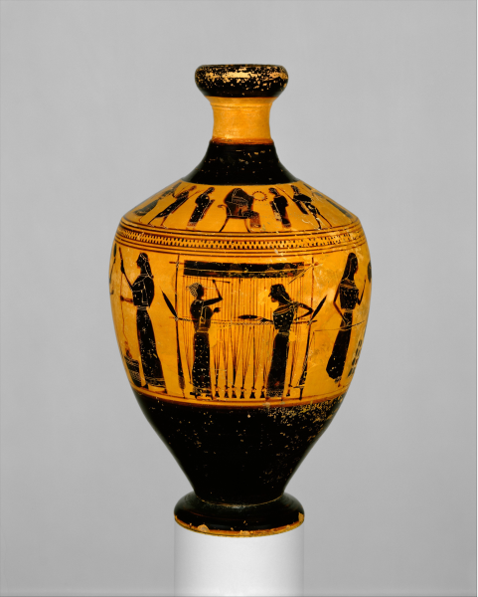
Figure 1: Attic red-figure lekythos with women weaving, spinning, and folding cloth from unknown provenance, Clay, 550-530 BCE, Metropolitan Museum of Art, 33.11.10. Image by Metropolitan Museum of Art, CC0 1.0 (Public Domain) This image can be found here: https://www.metmuseum.org/art/collection/search/253348, CC0 1.0 (Public Domain)This image can be found here: https://www.metmuseum.org/art/collection/search/253348.
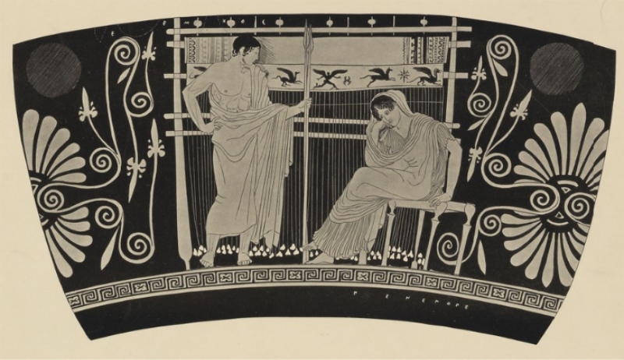
Figure 2: Drawing of an Attic red-figure skyphos with Telemachos and Penelope in front of a warp-weighted loom from in Chiusi, Ceramic, 450-400 BCE, Vase: Chiusi, Museo Archeologico Nazionale, Drawing: Williams College Archives , 63.564. Image by Williams College Archives, Artstor Fair Use This image can be found here: https://library-artstor-org.ezproxy.library.wisc.edu/public/SS7731005_7731005_10814239, Artstor Fair UseThis image can be found here: https://library-artstor-org.ezproxy.library.wisc.edu/public/SS7731005_7731005_10814239.
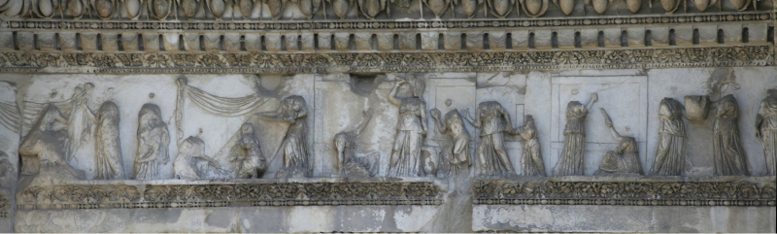
Figure 3: Women weaving on two beam upright looms from the Forum Transitorium in Rome, Marble, 85–97 CE. Image by Cassius Ahenobarbus, CC BY-SA This image can be found here: https://commons.wikimedia.org/wiki/File:Forum_nerva_frise1.jpg, CC BY-SAThis image can be found here: https://commons.wikimedia.org/wiki/File:Forum_nerva_frise1.jpg.
Figure 4: Scene including a woman in front of an upright two beam loom from the tomb of the Aurellii in Rome, Fresco, Early-third century CE. Image by David MacchiThis image can be found here: http://romapedia.blogspot.com/2014/02/hypogeum-of-aurelii-family.html. (Image withheld due to inadequate legal permissions.)
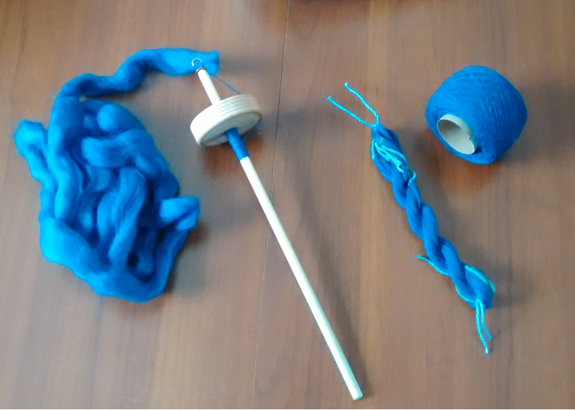
Figure 5: Spindle from experimental archaeological study by author, Wool, wood, copper hook. Image by Morgan Lemmer-Webber, Creative Commons Attribution-Share Alike 4.0 International.
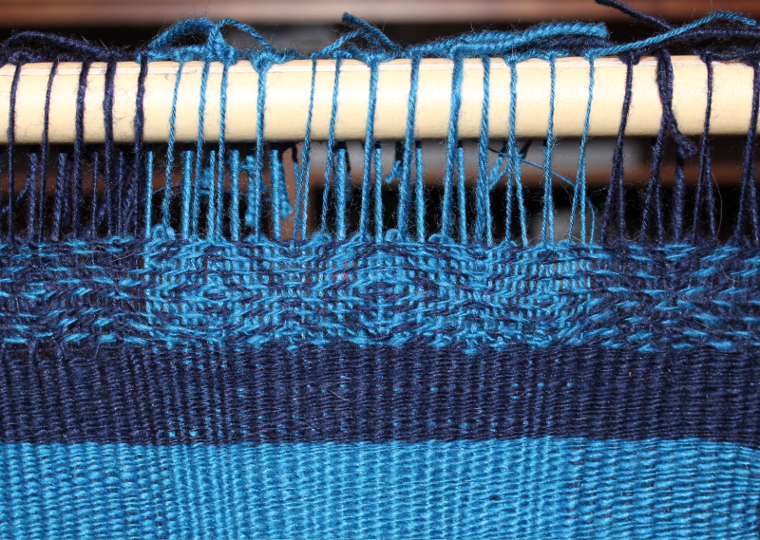
Figure 6: Tablet woven border with 3-ply s-spun warp and single z-spun weft from experimental archaeological study by author, Wool. Image by Morgan Lemmer-Webber, Creative Commons Attribution-Share Alike 4.0 International.
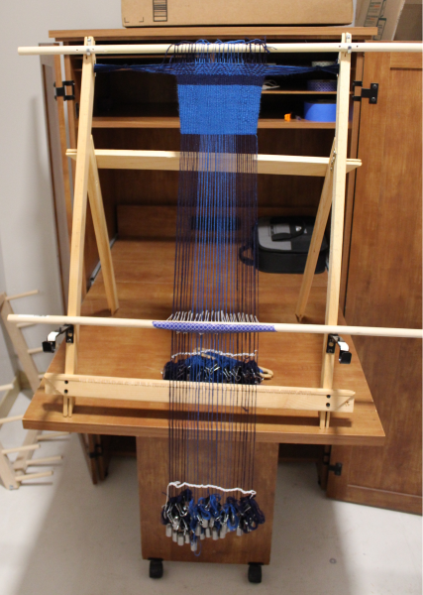
Figure 7: Small warp-weighted loom using a simple 1-1 tabby weave from experimental archaeological study by author, Wood, metal fittings, wool. Image by Morgan Lemmer-Webber, Creative Commons Attribution-Share Alike 4.0 International.
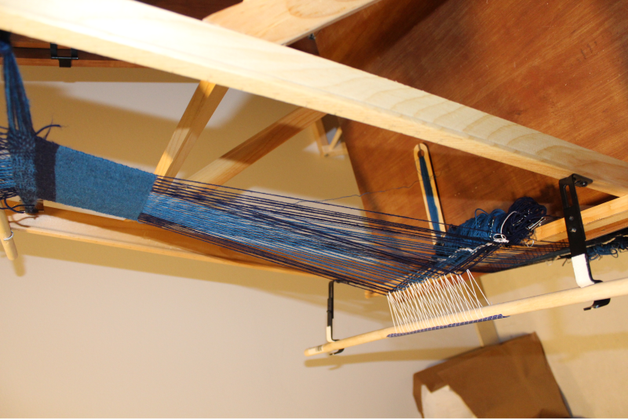
Figure 8: Side-view of warp-weighted loom demonstrating the open shed from experimental archaeological study by author, wood, wool. Image by Morgan Lemmer-Webber, Creative Commons Attribution-Share Alike 4.0 International.
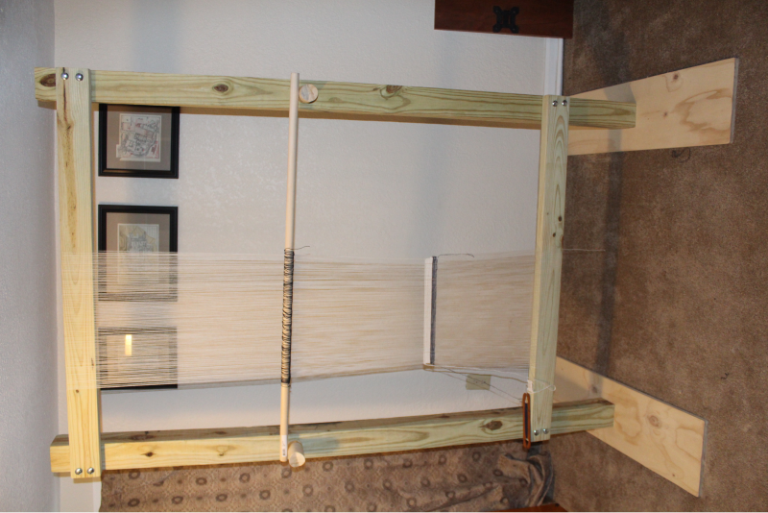
Figure 9: Two-beam upright loom from experimental archaeological study by author, Wood, wool. Image by Morgan Lemmer-Webber, Creative Commons Attribution-Share Alike 4.0 International.
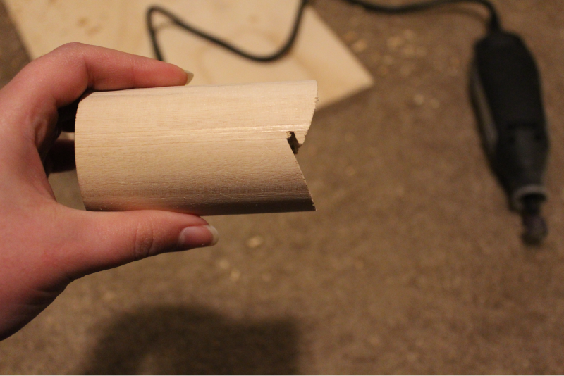
Figure 10: Side-view of a Heddle Jack from experimental archaeological study by author, Wood. Image by Morgan Lemmer-Webber, Creative Commons Attribution-Share Alike 4.0 International.
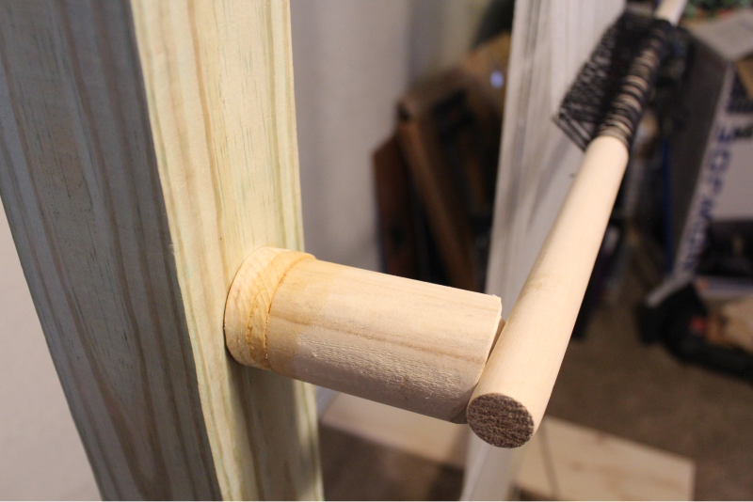
Figure 11: Extension of Heddle Jack from experimental archaeological study by author, wood. Image by Morgan Lemmer-Webber, Creative Commons Attribution-Share Alike 4.0 International.
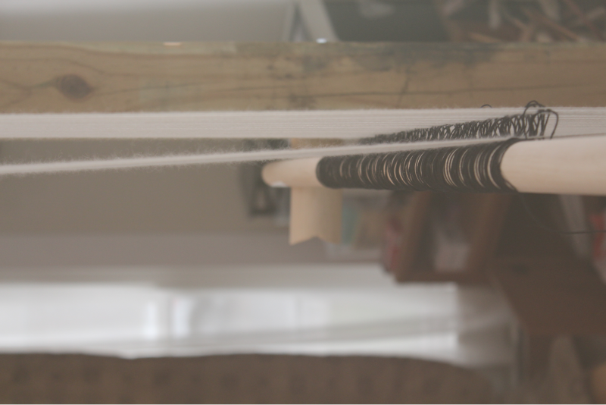
Figure 12: Shed of upright loom when heddle is lowered from experimental archaeological study by author, wool. Image by Morgan Lemmer-Webber, Creative Commons Attribution-Share Alike 4.0 International.
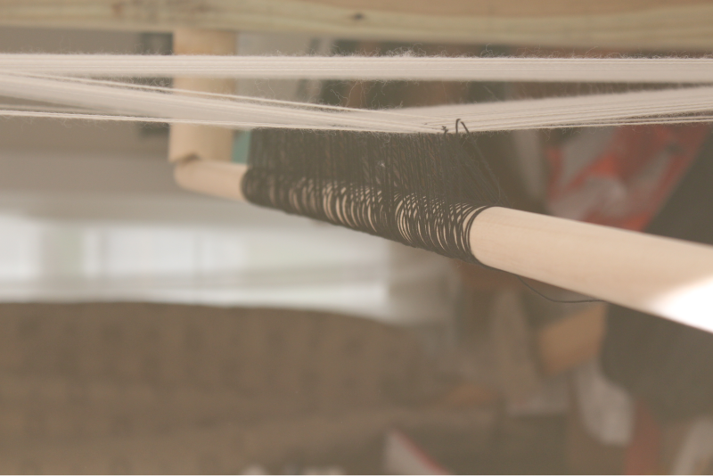
Figure 13: Shed of upright loom when heddle is raised from experimental archaeological study by author, wool. Image by Morgan Lemmer-Webber, Creative Commons Attribution-Share Alike 4.0 International.
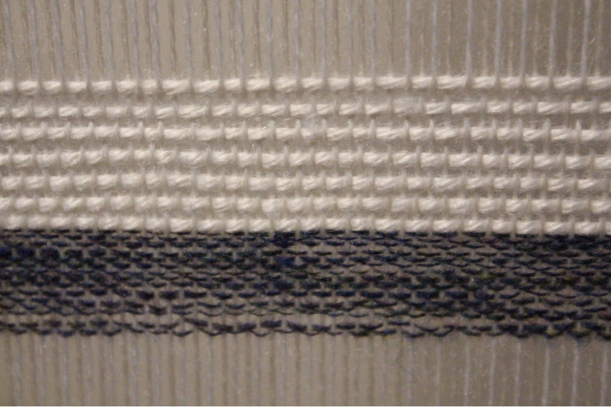
Figure 14: Sample weaving with a single ply homespun blue wool and a commercially purchased acrylic yarn from experimental archaeological study by author, wool, acrylic yarn. Image by Morgan Lemmer-Webber, Creative Commons Attribution-Share Alike 4.0 International.
Figure 15: Shears from a house in Karanis, Iron, 1st through 5th Centuries CE, Kelsey Museum of Archaeology, 3638. The Kelsey Museum of Archaeology is currently writing a catalog of the Karanis textile tools and has asked me not to publish these artifacts until after the catalog is published. Image by Morgan Lemmer-Webber with permission of the Kelsey Museum of Archaeology (Image withheld due to inadequate legal permissions.)
Figure 16: Unwashed Fleece from a rubbish pit in Karanis, Wool, 1st through 5th Centuries CE, Kelsey Museum of Archaeology, 13095. Image by The University of Michigan Library.This image can be found here: https://www.lsa.umich.edu/kelsey/galleries/Exhibits/textiles/objects/km13095.html. (Image withheld due to inadequate legal permissions.)
Figure 17: Washed Fleece from a house in Karanis, Wool, 1st through 5th Centuries CE, Kelsey Museum of Archaeology, 29768. Image by The University of Michigan Library.This image can be found here: https://www.lsa.umich.edu/kelsey/galleries/Exhibits/textiles/objects/km29768.html. (Image withheld due to inadequate legal permissions.)
Figure 18: Spindle and Whorl from a house in Karanis, Wood, 1st through 5th Centuries CE, Kelsey Museum of Archaeology, 3801ab. The Kelsey Museum of Archaeology is currently writing a catalog of the Karanis textile tools and has asked me not to publish these artifacts until after the catalog is published. Image by Morgan Lemmer-Webber with permission of the Kelsey Museum of Archaeology (Image withheld due to inadequate legal permissions.)
Figure 19: Spindle and Whorl from an unknown context in Egypt, Wood, Bone, Late Antique, Kelsey Museum of Archaeology, 88638. The Kelsey Museum of Archaeology is currently writing a catalog of the Karanis textile tools and has asked me not to publish these artifacts until after the catalog is published. Image by Morgan Lemmer-Webber with permission of the Kelsey Museum of Archaeology (Image withheld due to inadequate legal permissions.)
Figure 20: Spindle with remains of hook from a house in Karanis, Wood, Iron, 1st through 5th Centuries CE, Kelsey Museum of Archaeology, 3674. The Kelsey Museum of Archaeology is currently writing a catalog of the Karanis textile tools and has asked me not to publish these artifacts until after the catalog is published. Image by Morgan Lemmer-Webber with permission of the Kelsey Museum of Archaeology (Image withheld due to inadequate legal permissions.)
Figure 21: Spindle Whorl from a house in Karanis, Wood, 1st through 5th Centuries CE, Kelsey Museum of Archaeology, 3791. The Kelsey Museum of Archaeology is currently writing a catalog of the Karanis textile tools and has asked me not to publish these artifacts until after the catalog is published. Image by Morgan Lemmer-Webber with permission of the Kelsey Museum of Archaeology (Image withheld due to inadequate legal permissions.)
Figure 22: Spindle Whorl from a house in Karanis, Glass, 1st through 5th Centuries CE, Kelsey Museum of Archaeology, 5975. The Kelsey Museum of Archaeology is currently writing a catalog of the Karanis textile tools and has asked me not to publish these artifacts until after the catalog is published. Image by Morgan Lemmer-Webber with permission of the Kelsey Museum of Archaeology (Image withheld due to inadequate legal permissions.)
Figure 23: Spindle Whorl from a house in Karanis, Bone, 1st through 5th Centuries CE, Kelsey Museum of Archaeology, 21889. The Kelsey Museum of Archaeology is currently writing a catalog of the Karanis textile tools and has asked me not to publish these artifacts until after the catalog is published. Image by Morgan Lemmer-Webber with permission of the Kelsey Museum of Archaeology (Image withheld due to inadequate legal permissions.)
Figure 24: Spindle Whorl from a house in Karanis, Ivory, Paint, 1st through 5th Centuries CE, Kelsey Museum of Archaeology, 21890. The Kelsey Museum of Archaeology is currently writing a catalog of the Karanis textile tools and has asked me not to publish these artifacts until after the catalog is published. Image by Morgan Lemmer-Webber with permission of the Kelsey Museum of Archaeology (Image withheld due to inadequate legal permissions.)
Figure 25: Spindle and Whorl from a street in Karanis, Wood, Clay, 1st through 5th Centuries CE, Kelsey Museum of Archaeology, 7641ab. The Kelsey Museum of Archaeology is currently writing a catalog of the Karanis textile tools and has asked me not to publish these artifacts until after the catalog is published. Image by Morgan Lemmer-Webber with permission of the Kelsey Museum of Archaeology (Image withheld due to inadequate legal permissions.)
Figure 26: Spindle Whorl from a house in Karanis, Wood, Yarn, 1st through 5th Centuries CE, Kelsey Museum of Archaeology, 23970ab. The Kelsey Museum of Archaeology is currently writing a catalog of the Karanis textile tools and has asked me not to publish these artifacts until after the catalog is published. Image by Morgan Lemmer-Webber with permission of the Kelsey Museum of Archaeology (Image withheld due to inadequate legal permissions.)
Figure 27: Spun Thread from a house in Karanis, Yarn, 1st through 5th Centuries CE, Kelsey Museum of Archaeology, 22605. Image by The University of Michigan Library.This image can be found here: https://www.lsa.umich.edu/kelsey/galleries/Exhibits/textiles/objects/km22605.html. (Image withheld due to inadequate legal permissions.)
Figure 28: Loom Weight from a house in Karanis, Unfired Clay, 1st through 5th Centuries CE, Kelsey Museum of Archaeology, 3338. The Kelsey Museum of Archaeology is currently writing a catalog of the Karanis textile tools and has asked me not to publish these artifacts until after the catalog is published. Image by Morgan Lemmer-Webber with permission of the Kelsey Museum of Archaeology (Image withheld due to inadequate legal permissions.)
Figure 29: Loom Weight from an unknown context in Karanis, Unfired Clay, 1st through 5th Centuries CE, Kelsey Museum of Archaeology, 7699. The Kelsey Museum of Archaeology is currently writing a catalog of the Karanis textile tools and has asked me not to publish these artifacts until after the catalog is published. Image by Morgan Lemmer-Webber with permission of the Kelsey Museum of Archaeology (Image withheld due to inadequate legal permissions.)
Figure 30: Loom Weight from a house in Karanis, Mud, 1st through 5th Centuries CE, Kelsey Museum of Archaeology, 24011. The Kelsey Museum of Archaeology is currently writing a catalog of the Karanis textile tools and has asked me not to publish these artifacts until after the catalog is published. Image by Morgan Lemmer-Webber with permission of the Kelsey Museum of Archaeology (Image withheld due to inadequate legal permissions.)
Figure 31: Loom Weight from a house in Karanis, Limestone, 1st through 5th Centuries CE, Kelsey Museum of Archaeology, 25788. The Kelsey Museum of Archaeology is currently writing a catalog of the Karanis textile tools and has asked me not to publish these artifacts until after the catalog is published. Image by Morgan Lemmer-Webber with permission of the Kelsey Museum of Archaeology (Image withheld due to inadequate legal permissions.)
Figure 32: Loom Weight from a house in Karanis, Stone, Rope, 1st through 5th Centuries CE, Kelsey Museum of Archaeology, 25789. The Kelsey Museum of Archaeology is currently writing a catalog of the Karanis textile tools and has asked me not to publish these artifacts until after the catalog is published. Image by Morgan Lemmer-Webber with permission of the Kelsey Museum of Archaeology (Image withheld due to inadequate legal permissions.)
Figure 33: Shuttle from a house in Karanis, Wood, 1st through 5th Centuries CE, Kelsey Museum of Archaeology, 25789. Image by The University of Michigan Library.This image can be found here: http://quod.lib.umich.edu/k/kelsey/x-0000.00.3905/0000_00_3905p02.tif. (Image withheld due to inadequate legal permissions.)
Figure 34: Weavers Comb from a house in Karanis, Wood, 1st through 5th Centuries CE, Kelsey Museum of Archaeology, 3352. The Kelsey Museum of Archaeology is currently writing a catalog of the Karanis textile tools and has asked me not to publish these artifacts until after the catalog is published. Image by Morgan Lemmer-Webber with permission of the Kelsey Museum of Archaeology (Image withheld due to inadequate legal permissions.)
Figure 35: Weavers Comb from a house in Karanis, Wood, 1st through 5th Centuries CE, Kelsey Museum of Archaeology, 3787. The Kelsey Museum of Archaeology is currently writing a catalog of the Karanis textile tools and has asked me not to publish these artifacts until after the catalog is published. Image by Morgan Lemmer-Webber with permission of the Kelsey Museum of Archaeology (Image withheld due to inadequate legal permissions.)
Figure 36: Weavers Comb from a house in Karanis, Wood, 1st through 5th Centuries CE, Kelsey Museum of Archaeology, 3788. The Kelsey Museum of Archaeology is currently writing a catalog of the Karanis textile tools and has asked me not to publish these artifacts until after the catalog is published. Image by Morgan Lemmer-Webber with permission of the Kelsey Museum of Archaeology (Image withheld due to inadequate legal permissions.)
Figure 37: Weavers Comb from a house in Karanis, Wood, 1st through 5th Centuries CE, Kelsey Museum of Archaeology, 3789. The Kelsey Museum of Archaeology is currently writing a catalog of the Karanis textile tools and has asked me not to publish these artifacts until after the catalog is published. Image by Morgan Lemmer-Webber with permission of the Kelsey Museum of Archaeology (Image withheld due to inadequate legal permissions.)
Figure 38: Heddle from a house in Karanis, Wood, Rope, 1st through 5th Centuries CE, Kelsey Museum of Archaeology, 26501. The Kelsey Museum of Archaeology is currently writing a catalog of the Karanis textile tools and has asked me not to publish these artifacts until after the catalog is published. Image by Morgan Lemmer-Webber with permission of the Kelsey Museum of Archaeology (Image withheld due to inadequate legal permissions.)
Figure 39: Heddle Jack from a house in Karanis, Wood, 1st through 5th Centuries CE, Kelsey Museum of Archaeology, 3779. The Kelsey Museum of Archaeology is currently writing a catalog of the Karanis textile tools and has asked me not to publish these artifacts until after the catalog is published. Image by Morgan Lemmer-Webber with permission of the Kelsey Museum of Archaeology (Image withheld due to inadequate legal permissions.)
Figure 40: Tunic from a house in Karanis, Linen, Wool, 1st through 5th Centuries CE, Kelsey Museum of Archaeology, 482. Image by The University of Michigan Library.This image can be found here: http://quod.lib.umich.edu/k/kelsey/x-0000.01.0482/0000_01_0482p01.tif. (Image withheld due to inadequate legal permissions.)
Figure 41: Textile Fragment from a house in Karanis, Wool, 1st through 5th Centuries CE, Kelsey Museum of Archaeology, 3409. Image by The University of Michigan Library.This image can be found here: http://quod.lib.umich.edu/k/kelsey/x-0000.00.3409/0000_00_3409p01.tif. (Image withheld due to inadequate legal permissions.)
Figure 42: Textile from a house in Karanis, Flax, 1st through 5th Centuries CE, Kelsey Museum of Archaeology, 10479. The Kelsey Museum of Archaeology is currently writing a catalog of the Karanis textile tools and has asked me not to publish these artifacts until after the catalog is published. Image by Morgan Lemmer-Webber with permission of the Kelsey Museum of Archaeology (Image withheld due to inadequate legal permissions.)
Figure 43: Textile from a house in Karanis, Textile, 1st through 5th Centuries CE, Kelsey Museum of Archaeology, 11192. The Kelsey Museum of Archaeology is currently writing a catalog of the Karanis textile tools and has asked me not to publish these artifacts until after the catalog is published. Image by Morgan Lemmer-Webber with permission of the Kelsey Museum of Archaeology (Image withheld due to inadequate legal permissions.)
Figure 44: Rag Doll from a street in Karanis, Textiles, 1st through 5th Centuries CE, Kelsey Museum of Archaeology, 3648. The Kelsey Museum of Archaeology is currently writing a catalog of the Karanis textile tools and has asked me not to publish these artifacts until after the catalog is published. Image by Morgan Lemmer-Webber with permission of the Kelsey Museum of Archaeology (Image withheld due to inadequate legal permissions.)
Figure 45: Loom Fragment from a house in Karanis, Wood, 1st through 5th Centuries CE, Kelsey Museum of Archaeology, 24863. The Kelsey Museum of Archaeology is currently writing a catalog of the Karanis textile tools and has asked me not to publish these artifacts until after the catalog is published. Image by Morgan Lemmer-Webber with permission of the Kelsey Museum of Archaeology (Image withheld due to inadequate legal permissions.)
Figure 46: Loom Fragment from an unknown context in Karanis, Wood, Paint, 1st through 5th Centuries CE, Kelsey Museum of Archaeology, 24866. The Kelsey Museum of Archaeology is currently writing a catalog of the Karanis textile tools and has asked me not to publish these artifacts until after the catalog is published. Image by Morgan Lemmer-Webber with permission of the Kelsey Museum of Archaeology (Image withheld due to inadequate legal permissions.)
Figure 47: Loom Fragment from a house in Karanis, Reed, 1st through 5th Centuries CE, Kelsey Museum of Archaeology, 26544. The Kelsey Museum of Archaeology is currently writing a catalog of the Karanis textile tools and has asked me not to publish these artifacts until after the catalog is published. Image by Morgan Lemmer-Webber with permission of the Kelsey Museum of ArchaeologyDon’t publish until approved by museum. (Image withheld due to inadequate legal permissions.)
Figure 48: Sculpture from a house in Karanis, Copper Alloy, 1st through 5th Centuries CE, Kelsey Museum of Archaeology, 10728. The Kelsey Museum of Archaeology is currently writing a catalog of the Karanis textile tools and has asked me not to publish these artifacts until after the catalog is published. Image by Morgan Lemmer-Webber with permission of the Kelsey Museum of Archaeology (Image withheld due to inadequate legal permissions.)
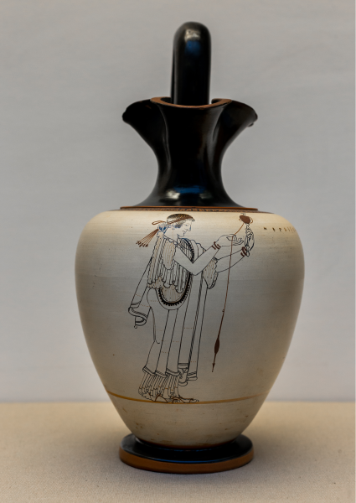
Figure 49: Attic red-figure white-ground oinochoe of a woman spinning from Locri in Italy, Clay, 500-400 BCE, British Museum, 1873,0820.304. Image by ArchaiOptix via Wikimedia Commons, Creative Commons Attribution-Share Alike 4.0 International This image can be found here: https://commons.wikimedia.org/wiki/File:Foundry_Painter_ARV_403_38_woman_spinning.jpg, Creative Commons Attribution-Share Alike 4.0 InternationalThis image can be found here: https://commons.wikimedia.org/wiki/File:Foundry_Painter_ARV_403_38_woman_spinning.jpg.
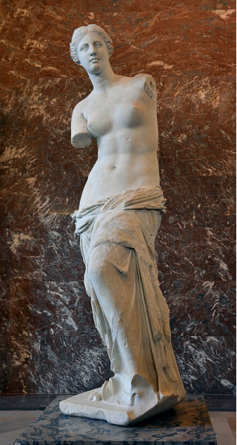
Figure 50: Statue of Aphrodite/Venus from Melos, marble, 100 BCE, Louvre, LL 299. Image by Livioandronico2013 via Wikimedia CommonsCreative Commons Attribution-Share Alike 4.0 International This image can be found here: https://commons.wikimedia.org/wiki/File:Front_views_of_the_Venus_de_Mil o.jpgCreative Commons Attribution-Share Alike 4.0 InternationalThis image can be found here: https://commons.wikimedia.org/wiki/File:Front_views_of_the_Venus_de_Mil o.jpg.
Figure 51: Drawing reconstructing the arms of the Venus de Milo with a spindle and distaff from Elizabeth Waylan Barber in Barber 1994, Figure 10.1. See figure 10.1 in Barber 1994, 237. (Image withheld due to inadequate legal permissions.)
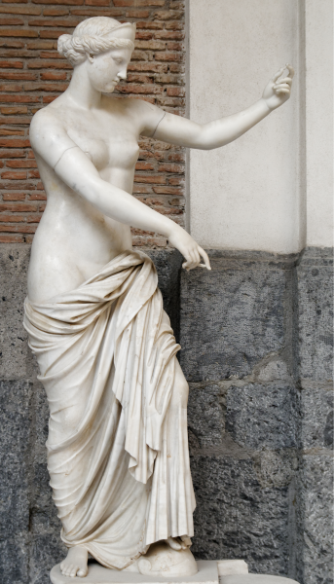
Figure 52: Venus of Capua from Santa Maria Capua Vetere, Marble, Late 4th Century - 3rd Century BCE, Naples Archaeological Museum, 6017. Image by Marie-Lan Nguyen, Creative Commons Attribution 2.5 Generic This image can be found here: https://commons.wikimedia.org/wiki/File:Venus_of_Capua_MAN_Napoli_Inv6017_n01.jpg, Creative Commons Attribution 2.5 GenericThis image can be found here: https://commons.wikimedia.org/wiki/File:Venus_of_Capua_MAN_Napoli_Inv6017_n01.jpg.
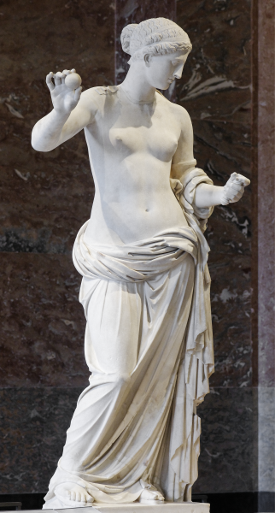
Figure 53: Venus of Arles from Theater in Arles, Marble, End of the 1st Century BCE, Louvre, MR 365. Image by Marie-Lan Nguyen, Creative Commons Attribution 2.5 Generic This image can be found here: https://commons.wikimedia.org/wiki/File:Venus_of_Arles_Louvre_Ma439_n01.jpg, Creative Commons Attribution 2.5 GenericThis image can be found here: https://commons.wikimedia.org/wiki/File:Venus_of_Arles_Louvre_Ma439_n01.jpg.
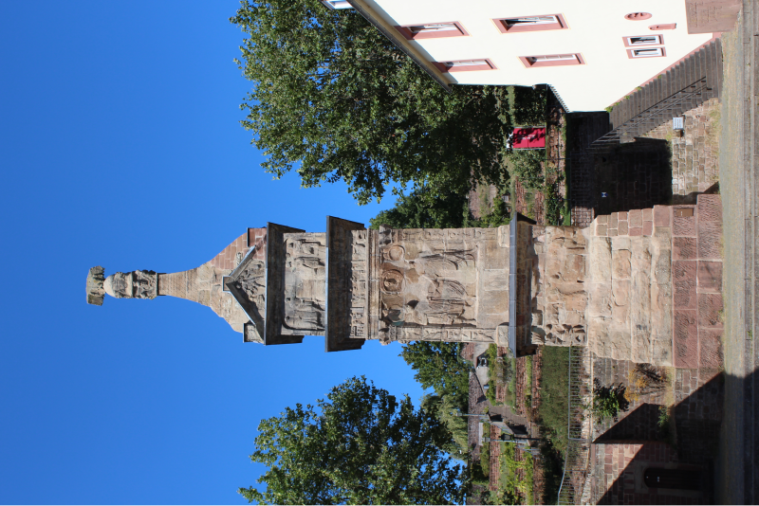
Figure 54: South side of the Igel Monument, full view from Igel in Germany, Sandstone, Early to mid-3rd Century CE. Image by Morgan Lemmer-Webber, Creative Commons Attribution-Share Alike 4.0 International.
Figure 55: Drawing of all four sides of the Igel Monument from E. Zahn in Trierer Zeitschrift 31, 1968, Sandstone, Early to mid-3rd Century CE, Igel, Germany. Drawings of the Igel Monument from E. Zahn in Trierer Zeitschrift 31, 1968. (Image withheld due to inadequate legal permissions.)
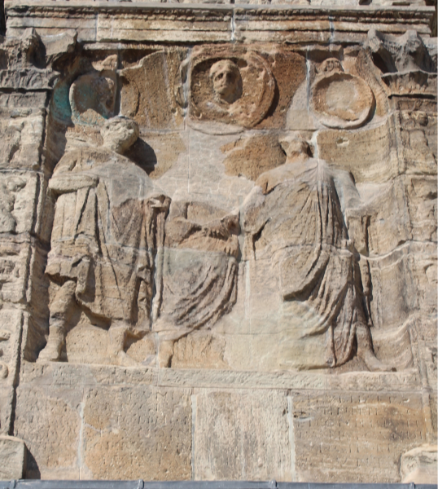
Figure 56: Portraits from the southern primary panel of the Igel Monument from Igel in Germany, Sandstone, Early to mid-3rd Century CE. Image by Morgan Lemmer-Webber, Creative Commons Attribution-Share Alike 4.0 International.
Figure 57: Drawing of the portraits from the southern primary panel of the Igel Monument from E. Zahn in Trierer Zeitschrift 31, 1968, Sandstone, Early to mid-3rd Century CE, Igel, Germany. Drawings of the Igel Monument from E. Zahn in Trierer Zeitschrift 31, 1968. (Image withheld due to inadequate legal permissions.)
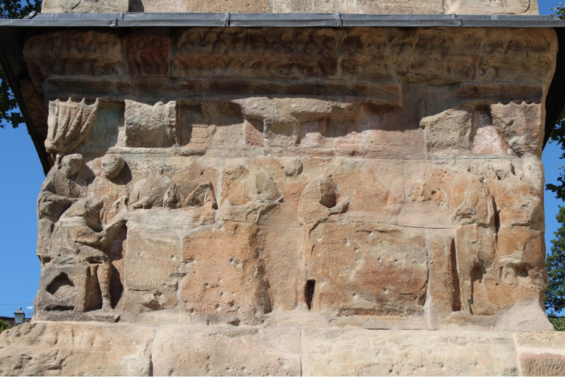
Figure 58: Tuchladen/Salesroom scene from the southern base panel of the Igel Monument from Igel in Germany, Sandstone, Early to mid-3rd Century CE. Image by Morgan Lemmer-Webber, Creative Commons Attribution-Share Alike 4.0 International.
Figure 59: Drawing of the Tuchladen/Salesroom scene from the southern base panel of the Igel Monument from E. Zahn in Trierer Zeitschrift 31, 1968, Sandstone, Early to mid-3rd Century CE, Igel, Germany. Drawings of the Igel Monument from E. Zahn in Trierer Zeitschrift 31, 1968. (Image withheld due to inadequate legal permissions.)
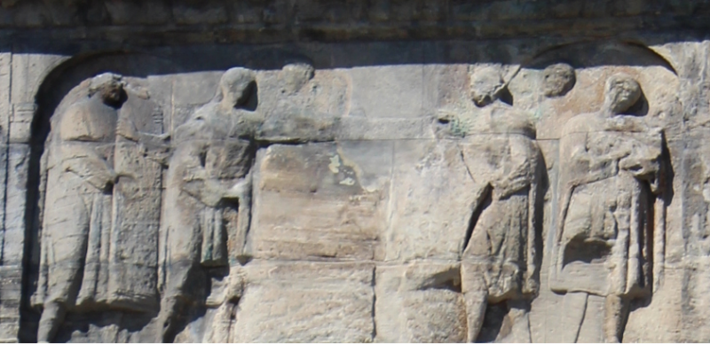
Figure 60: Tuchprobe/Quality Control scene from the southern attic panel of the Igel Monument from Igel in Germany, Sandstone, Early to mid-3rd Century CE. Image by Morgan Lemmer-Webber, Creative Commons Attribution-Share Alike 4.0 International.
Figure 61: Drawing of the Tuchprobe/Quality Control scene from the southern attic panel of the Igel Monument from E. Zahn in Trierer Zeitschrift 31, 1968, Sandstone, Early to mid-3rd Century CE, Igel, Germany. Drawings of the Igel Monument from E. Zahn in Trierer Zeitschrift 31, 1968. (Image withheld due to inadequate legal permissions.)
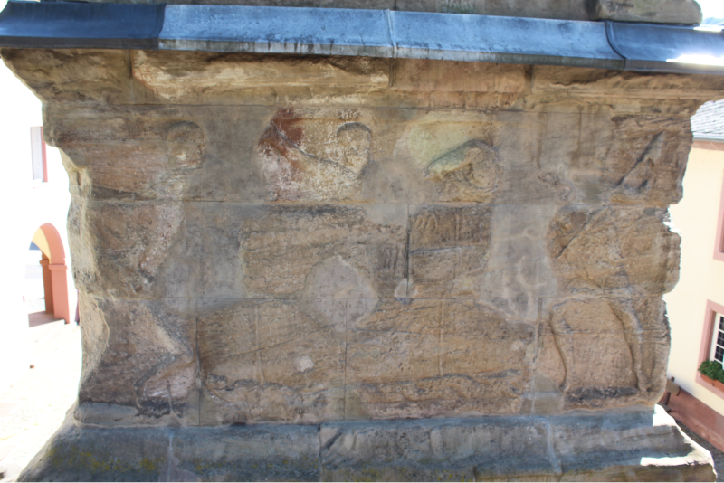
Figure 62: Verschnürung/Baling scene from the northern base panel of the Igel Monument from Igel in Germany, Sandstone, Early to mid-3rd Century CE. Image by Morgan Lemmer-Webber, Creative Commons Attribution-Share Alike 4.0 International.
Figure 63: Drawing of the Verschnürung/Baling scene from the northern base panel of the Igel Monument from E. Zahn in Trierer Zeitschrift 31, 1968, Sandstone, Early to mid-3rd Century CE, Igel, Germany. Drawings of the Igel Monument from E. Zahn in Trierer Zeitschrift 31, 1968. (Image withheld due to inadequate legal permissions.)
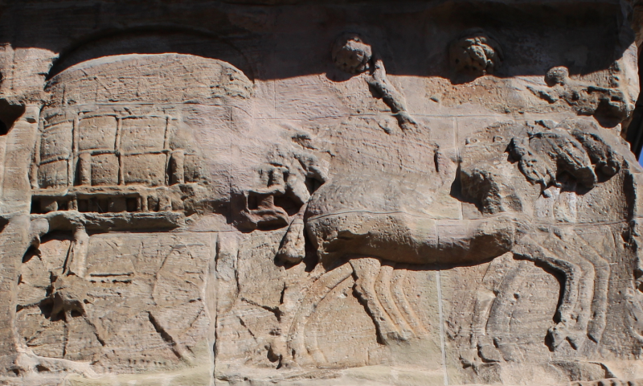
Figure 64: Lastwagen/Goods Cart scene from the western base panel of the Igel Monument from Igel in Germany, Sandstone, Early to mid-3rd Century CE. Image by Morgan Lemmer-Webber, Creative Commons Attribution-Share Alike 4.0 International.
Figure 65: Drawing of the Lastwagen/Goods Cart scene from the western base panel of the Igel Monument from E. Zahn in Trierer Zeitschrift 31, 1968, Sandstone, Early to mid-3rd Century CE, Igel, Germany. Drawings of the Igel Monument from E. Zahn in Trierer Zeitschrift 31, 1968. (Image withheld due to inadequate legal permissions.)
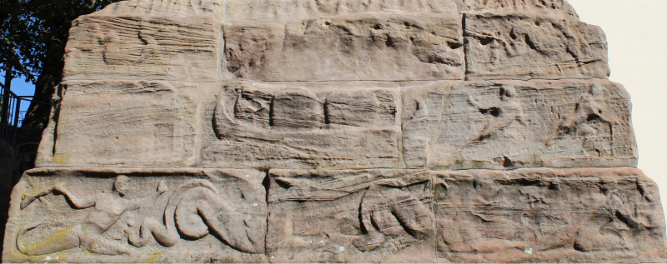
Figure 66: Treidelfahrt auf der Mosel/Mosel River Barge scene from the western socle panel of the Igel Monument from Igel in Germany, Sandstone, Early to mid-3rd Century CE. Image by Morgan Lemmer-Webber, Creative Commons Attribution-Share Alike 4.0 International.
Figure 67: Drawing of the Treidelfahrt auf der Mosel/Mosel River Barge scene from the western socle panel of the Igel Monument from E. Zahn in Trierer Zeitschrift 31, 1968, Sandstone, Early to mid-3rd Century CE, Igel, Germany. Drawings of the Igel Monument from E. Zahn in Trierer Zeitschrift 31, 1968. (Image withheld due to inadequate legal permissions.)
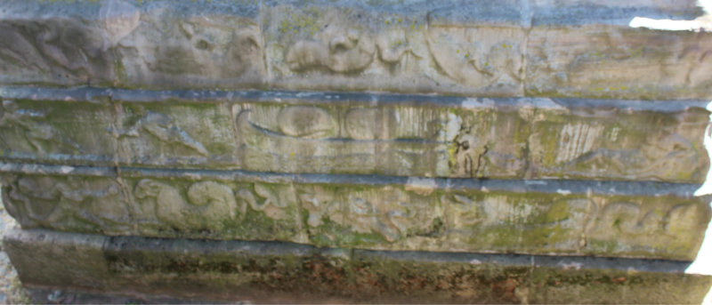
Figure 68: Treidelfahrt auf der Mosel/Mosel River Barge scene from the northern socle panel of the Igel Monument from Igel in Germany, Sandstone, Early to mid-3rd Century CE. Image by Morgan Lemmer-Webber, Creative Commons Attribution-Share Alike 4.0 International.
Figure 69: Drawing of the Treidelfahrt auf der Mosel/Mosel River Barge scene from the northern socle panel of the Igel Monument from E. Zahn in Trierer Zeitschrift 31, 1968, Sandstone, Early to mid-3rd Century CE, Igel, Germany. Drawings of the Igel Monument from E. Zahn in Trierer Zeitschrift 31, 1968. (Image withheld due to inadequate legal permissions.)
Figure 70: Drawing of the Kontor/Counting house scene from the eastern attic panel of the Igel Monument from E. Zahn in Trierer Zeitschrift 31, 1968, Sandstone, Early to mid-3rd Century CE, Igel, Germany. Drawings of the Igel Monument from E. Zahn in Trierer Zeitschrift 31, 1968. (Image withheld due to inadequate legal permissions.)
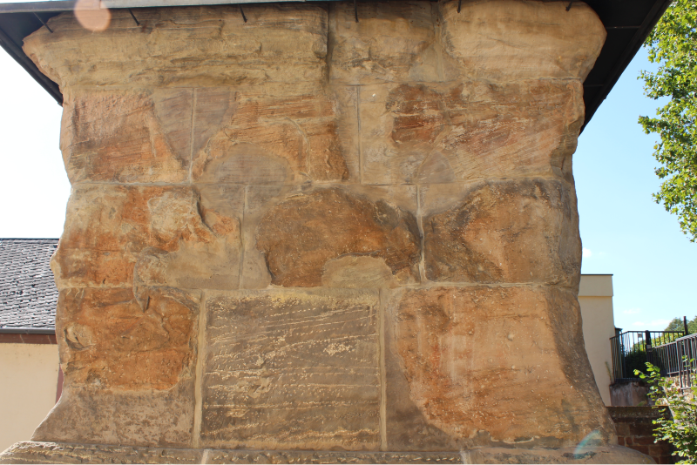
Figure 71: Badly damaged eastern base panel of the Igel Monument from Igel in Germany, Sandstone, Early to mid-3rd Century CE. Image by Morgan Lemmer-Webber, Creative Commons Attribution-Share Alike 4.0 International.
Figure 72: Reconstruction of the Tuchwerkstatt/Weaving Shop scene on the eastern base panel of the Igel Monument from Dragendorff and Krüger in Das Grabmal von Igel, 1924, Sandstone, Early to mid-3rd Century CE, Igel, Germany. Reconstruction from Dragendorff and Krüger. 1924. (Image withheld due to inadequate legal permissions.)
Figure 73: Fragment of a funerary relief with a Tuchprobe/Quality Control scene from Trier from Lothar Schwinden in Gallo-römisches Textilgewerbe, 1989, Late 2nd/early 3rd Century CE, Rheinisches Landesmuseum. See Abb. 5a in Schwinden 1989, 294. (Image withheld due to inadequate legal permissions.)
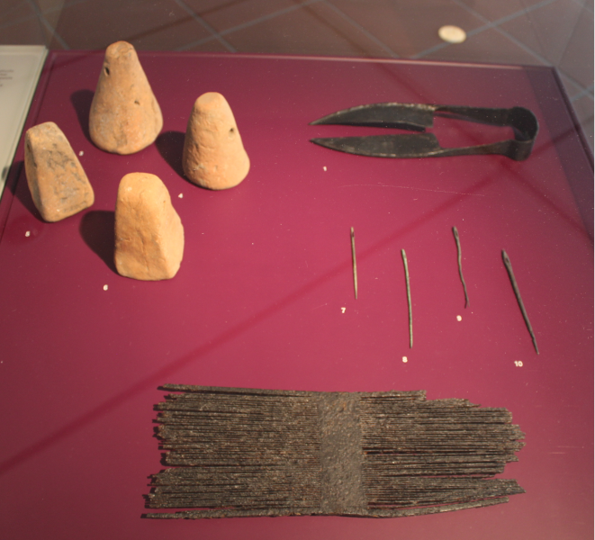
Figure 74: Display case of Textile tools from Rheinisches Landesmuseum in Trier, 1st-4th Century CE. Image by Morgan Lemmer-Webber, Creative Commons Attribution-Share Alike 4.0 International.
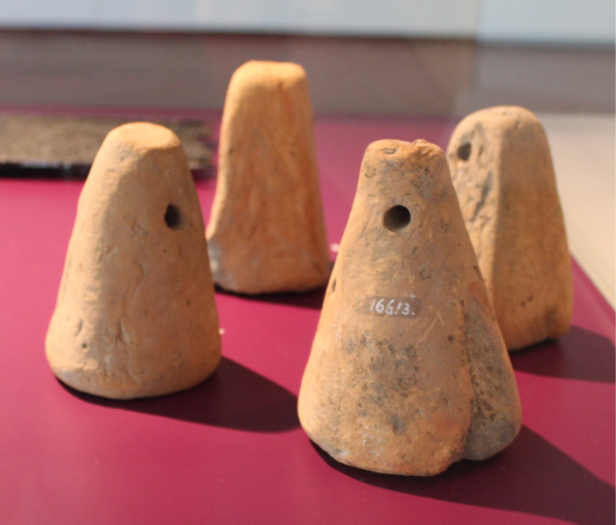
Figure 75: Four loomweights from an unknown context in Trier, Ceramic, 1st-4th Century CE, Rheinishces Landesmuseum. Image by Morgan Lemmer-Webber, Creative Commons Attribution-Share Alike 4.0 International.
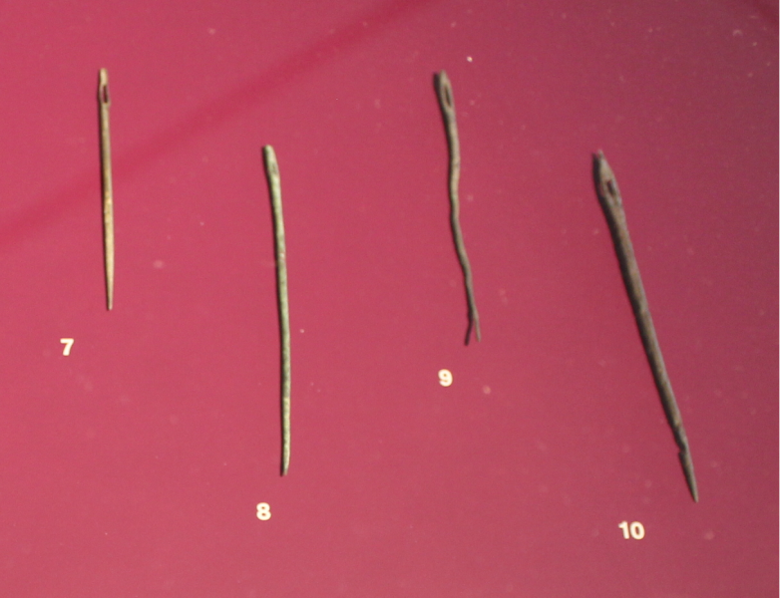
Figure 76: Four sewing needles from Trier and Newel in Germany, Bronze, 1st-4th Century CE, Rheinishces Landesmuseum. Image by Morgan Lemmer-Webber, Creative Commons Attribution-Share Alike 4.0 International.
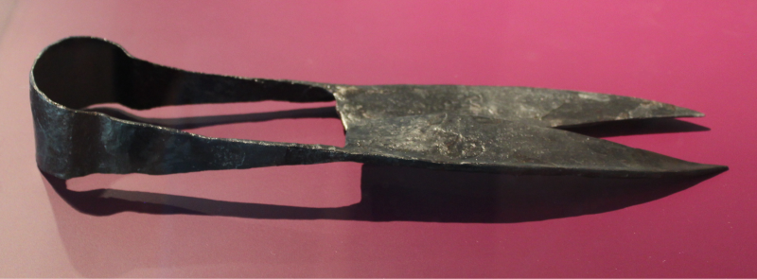
Figure 77: Sheers from Lautenbach in Germany, Iron, 2nd-4th Century CE, Rheinishces Landesmuseum. Image by Morgan Lemmer-Webber, Creative Commons Attribution-Share Alike 4.0 International.
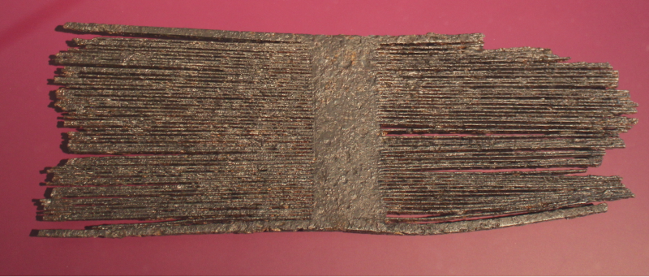
Figure 78: Flat Comb from Hontheim, Entersburg in Germany, Iron, 353 CE, Rheinishces Landesmuseum. Image by Morgan Lemmer-Webber, Creative Commons Attribution-Share Alike 4.0 International.
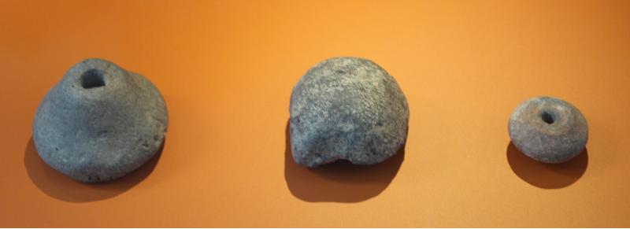
Figure 79: Three Spindle Whorls from Bundenbach, Altburg in Germany, Ceramic, 4th-1st Century BCE, Rheinishces Landesmuseum. Image by Morgan Lemmer-Webber, Creative Commons Attribution-Share Alike 4.0 International.
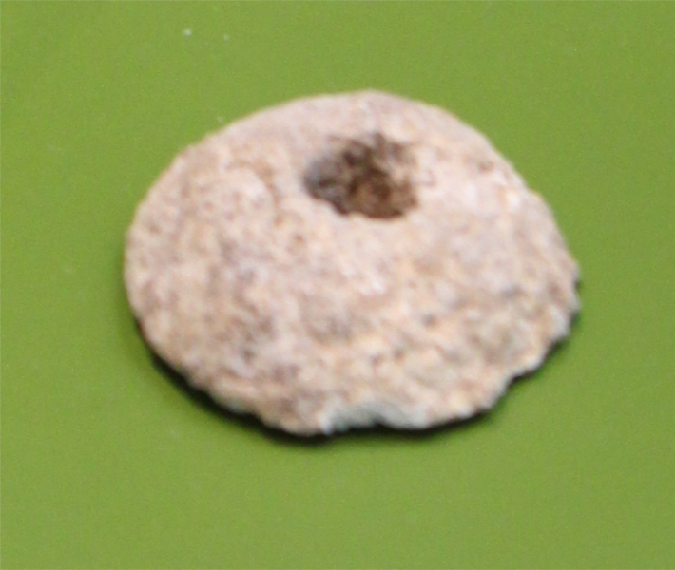
Figure 80: Spindle Whorl from a funerary context in Trier, Bone, 6th Century CE, Rheinishces Landesmuseum. Image by Morgan Lemmer-Webber, Creative Commons Attribution-Share Alike 4.0 International.
Figure 81: from . (Image withheld due to inadequate legal permissions.)
Figure 82: Spindle Whorl from Hanghaus 2 in Ephesus, Stone, Mid-third century CE, GHD, Ki 79/7. Image from Thür and Rathmayr 2014, Kat.-Nr. B80. (Image withheld due to inadequate legal permissions.)
Figure 83: Spindle Whorl from Hanghaus 2 in Ephesus, Stone, Mid-third century CE, EM, HH2/WE 6/31aN/SE-18, Fn 04/461. Image from Thür and Rathmayr 2014, Kat.-Nr. B 81. (Image withheld due to inadequate legal permissions.)
Figure 84: Spindle Whorl from Hanghaus 2 in Ephesus, Stone, Mid-third century CE, GHD, Ki 78/26. Image from Thür and Rathmayr 2014, Kat.-Nr. B 343. (Image withheld due to inadequate legal permissions.)
Figure 85: Spindle Whorl from Hanghaus 2 in Ephesus, Clay, Mid-third century CE, GHD, Ki 73/1a. Image from Thür and Rathmayr 2014, Kat.-Nr. B 444. (Image withheld due to inadequate legal permissions.)
Figure 86: Spindle Shaft (?) from Hanghaus 2 in Ephesus, Bone, Mid-third century CE, EM, Ki 78/12. Image from Thür and Rathmayr 2014, Kat.-Nr. B 409. (Image withheld due to inadequate legal permissions.)
Figure 87: Spindle Hook from Hanghaus 2 in Ephesus, Bronze, Mid-third century CE, EM, Ki 88/13.14.15. Image from Thür and Rathmayr 2014, Kat.-Nr. B 35. (Image withheld due to inadequate legal permissions.)
Figure 88: Spindle Hook from Hanghaus 2 in Ephesus, Bronze, Mid-third century CE, GHD, Ki 76/19/1. Image from Thür and Rathmayr 2014, Kat.-Nr. B 203. (Image withheld due to inadequate legal permissions.)
Figure 89: Spindle Hook from Hanghaus 2 in Ephesus, Bronze, Mid-third century CE, GHD, Ki 78/26/5. Image from Thür and Rathmayr 2014, Kat.-Nr. B 261. (Image withheld due to inadequate legal permissions.)
Figure 90: Loom Weight from Hanghaus 2 in Ephesus, Clay, Mid-third century CE, GHD, Ki 73/7. Image from Thür and Rathmayr 2014, Kat.-Nr. B 220. (Image withheld due to inadequate legal permissions.)
Figure 91: Loom Weight from Hanghaus 2 in Ephesus, Clay, Mid-third century CE, GHD, Ki 75/8e/2. Image from Thür and Rathmayr 2014, Kat.-Nr. B 182. (Image withheld due to inadequate legal permissions.)
Figure 92: Loom Weight (?) from Hanghaus 2 in Ephesus, Clay, Mid-third century CE, GHD, Ki 75/8e/2. Image from Thür and Rathmayr 2014, Kat.-Nr. B 181. (Image withheld due to inadequate legal permissions.)
Figure 93: Loom Weight (?) from Hanghaus 2 in Ephesus, Clay, Mid-third century CE, GHD, Ki 76/21. Image from Thür and Rathmayr 2014, Kat.-Nr. B 208. (Image withheld due to inadequate legal permissions.)
Figure 94: Pyramidal Loom Weights from Hanghaus 1 in Ephesus, Lead, Mid-third century CE. Image from Trinkl 2008, Fig. 13.2. (Image withheld due to inadequate legal permissions.)
Figure 95: Pyramidal Loom Weight with ЄР inscription from Hanghaus 1 in Ephesus, Lead, Mid-third century CE. Image from Trinkl 2008, Fig. 13.3. (Image withheld due to inadequate legal permissions.)
Figure 96: Lentoid Loom Weights from Outside of Hanghaus2 in Ephesus, Clay, Mid-third century CE. Image from Trinkl 2008, Fig. 13.1. (Image withheld due to inadequate legal permissions.)
Figure 97: Spools from Hanghaus 2 in Ephesus, Iron, Mid-third century CE, GHD, Ki 78/27/1-2. Image from Thür and Rathmayr 2014, Kat.-Nr. B 135. (Image withheld due to inadequate legal permissions.)
Figure 98: Weaving Tablet (?) from Streets of Curetes in Ephesus, Bone, Mid-third century CE. Image from Trinkl 2008, Fig. 13.6. (Image withheld due to inadequate legal permissions.)
Figure 99: Thimble from Hanghaus 2 in Ephesus, Bronze, Mid-third century CE, EM, Ki 88/18. Image from Thür and Rathmayr 2014, Kat.-Nr. B 41. (Image withheld due to inadequate legal permissions.)
Figure 100: Needle from Hanghaus 2 in Ephesus, Bone, Mid-third century CE, GHD, Ki 04/416. Image from Thür and Rathmayr 2014, Kat.-Nr. B 109. (Image withheld due to inadequate legal permissions.)
Figure 101: Needle from Hanghaus 2 in Ephesus, Bone, Mid-third century CE, EM, 50/56/73. Image from Thür and Rathmayr 2014, Kat.-Nr. B 185. (Image withheld due to inadequate legal permissions.)
Figure 102: Needle from Hanghaus 2 in Ephesus, Bronze, Mid-third century CE, EM, Ki 88/44. Image from Thür and Rathmayr 2014, Kat.-Nr. B 49. (Image withheld due to inadequate legal permissions.)
Figure 103: Distaff with statuette of Venus from Hanghaus 2 in Ephesus, Bone, Mid-third century CE, Efes Müzesi, 16/25/75. Image from Trinkl 2004, Fig. 1A-b. (Image withheld due to inadequate legal permissions.)
Figure 104: Distaff with statuette of Venus from Hanghaus 2 in Ephesus, Bone, Mid-third century CE, Efes Müzesi, 137/60/78. Image from Trinkl 2004, Fig. 4A-b. (Image withheld due to inadequate legal permissions.)
Figure 105: Distaff with fragment of a bust from Hanghaus 2 in Ephesus, Bone, Mid-third century CE, Missing, Fundnr. 74/69. Image from Trinkl 2004, Fig. 2. (Image withheld due to inadequate legal permissions.)
Figure 106: Distaff fragment from Hanghaus 2 in Ephesus, Bone, Mid-third century CE, Depot des österreichischen Grabungshauses in Selçuk, Fundnr. 72/110. Image from Trinkl 2004, Fig. 3. (Image withheld due to inadequate legal permissions.)
Figure 107: Distaff fragment from Hanghaus 2 in Ephesus, Bone, Mid-third century CE, Efes Müzesi, Fundnr. H2/80/65. Image from Trinkl 2004, Fig. 6. (Image withheld due to inadequate legal permissions.)
Figure 108: Distaff fragment from Hanghaus 2 in Ephesus, Bone, Mid-third century CE, Missing, Fundnr. 86/81. Image from Trinkl 2004, Fig. 5. (Image withheld due to inadequate legal permissions.)
Figure 109: Distaff fragment from Hanghaus 2 in Ephesus, Bone, Mid-third century CE, Depot des österreichischen Grabungshauses in Selçuk, Fundnr. c, K 1/69. Image from Trinkl 2004, Fig. 7. (Image withheld due to inadequate legal permissions.)
Figure 110: Distaff fragment from Hanghaus 2 in Ephesus, Bone, Mid-third century CE, Missing, Fundnr. 9; 24. 8. Image from Trinkl 2004, Fig. 8. (Image withheld due to inadequate legal permissions.)
Figure 111: Distaff fragment from Hanghaus 2 in Ephesus, Bone, Mid-third century CE, Depot des österreichischen Grabungshauses in Selçuk. Image from Trinkl 2004, Fig. 9. (Image withheld due to inadequate legal permissions.)
Figure 112: Spindle, Whorl, and Distaff from Sarcophagus, Damianosstoa in Ephesus, Bone, Mid-third century CE, Efes Müzesi, 172/51/91. Image from Trinkl 1994, Fig. 1. (Image withheld due to inadequate legal permissions.)
Figure 113: Distaff from Sarcophagus, Damianosstoa in Ephesus, Bone, Mid-third century CE, Efes Müzesi, 172/51/91. Image from Trinkl 2004, Fig. 10. (Image withheld due to inadequate legal permissions.)
Figure 114: Distaff fragment from Staatsmarkt, Basilika in Ephesus, Bone, Mid-third century CE, Depot des österreichischen Grabungshauses in Selçuk, Fundnr. 9230. Image from Trinkl 2004, Fig. 11. (Image withheld due to inadequate legal permissions.)
Figure 115: Distaff fragment from Staatsmarkt, Basilika in Ephesus, Bone, Mid-third century CE, Depot des österreichischen Grabungshauses in Selçuk, Fundnr. 60/19. Image from Trinkl 2004, Fig. 12. (Image withheld due to inadequate legal permissions.)
Figure 116: Distaff fragment from Staatsmarkt, Basilika in Ephesus, Bone, Mid-third century CE, Depot des österreichischen Grabungshauses in Selçuk. Image from Trinkl 2004, Fig. 13. (Image withheld due to inadequate legal permissions.)
Figure 117: Distaff fragment from Magnesian Gate in Ephesus, Bone, Mid-third century CE, Unknown, K 4/79. Image from Trinkl 2004, Fig. 14. (Image withheld due to inadequate legal permissions.)
Figure 118: Distaff fragment from Unknown context in Ephesus, Bone, Mid-third century CE, Efes Müzesi, 05/25/73. Image from Trinkl 2004, Fig. 15. (Image withheld due to inadequate legal permissions.)
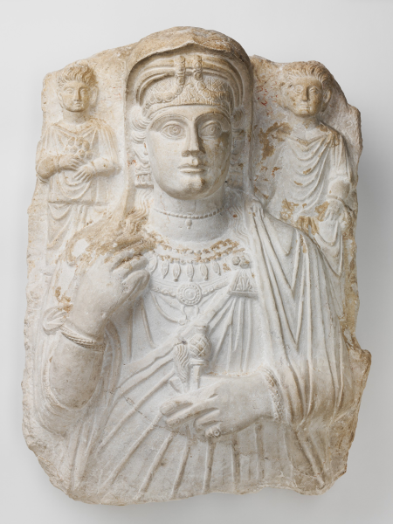
Figure 119: Funerary relief of a woman with a finger distaff and two children from in Palmyra, Limestone, c. 150 CE, Harvard Art Museums.
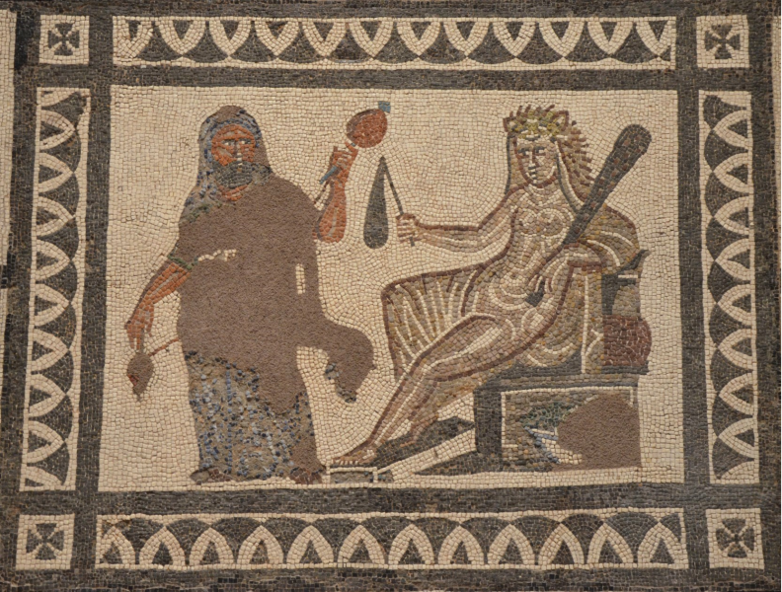
Figure 120: Hercules (standing) dressed as a woman, holding a spindle and distaff and Omphale (seated) wearing the lion skin and holding the club of Hercules from in Llíria, Mosaic, 3rd century CE, National Archaeological Museum of Spain, Madrid. Image by Carole Raddato, Attribution-NonCommercial-ShareAlike 2.0 Generic This image can be found here: https://commons.wikimedia.org/wiki/File:Hercules_and_Omphale,_central_panel_of_the_Mosaic_with_the_Labors_of_Hercules,_3rd_century_AD,_found_in_Ll%C3%ADria_(Valencia),_National_Archaeological_Museum_of_Spain,_Madrid_(15457429395).jpg, Attribution-NonCommercial-ShareAlike 2.0 Generic This image can be found here: https://commons.wikimedia.org/wiki/File:Hercules_and_Omphale,_central_panel_of_the_Mosaic_with_the_Labors_of_Hercules,_3rd_century_AD,_found_in_Ll%C3%ADria_(Valencia),_National_Archaeological_Museum_of_Spain,_Madrid_(15457429395).jpg.
Figure 121: Distaff fragment with statuette of a mother and child from Unknown context in Pannonia, Bone, 3rd-4th centuries CE. Image by Bíró 1994a, plate LXXXVI.851 via Pasztokai Szeoke. Image by Bíró 1994a, plate LXXXVI.851 via Pasztokai Szeoke (Image withheld due to inadequate legal permissions.)
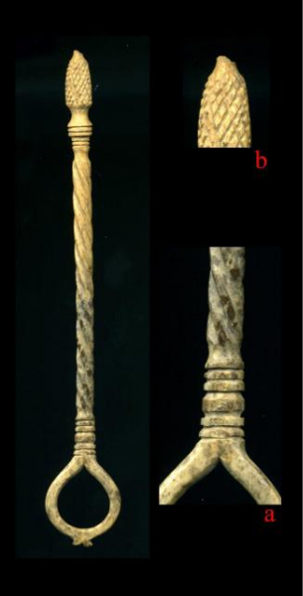
Figure 122: Distaff and distaff fragment from Grave in Viminacium, Bone, 3rd-4th centuries CE.
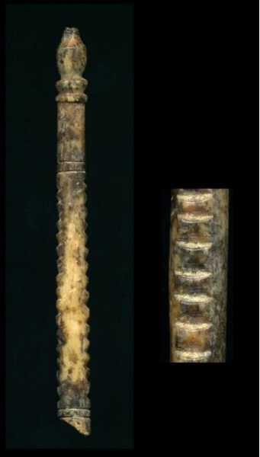
Figure 123: Distaff fragments from Grave in Viminacium, Bone, 3rd-4th centuries CE.
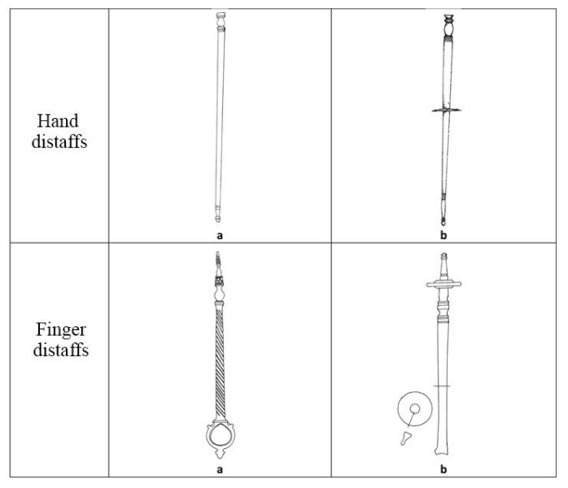
Figure 124: Distaff types from Viminacium from in Viminacium, 3rd-4th centuries CE.
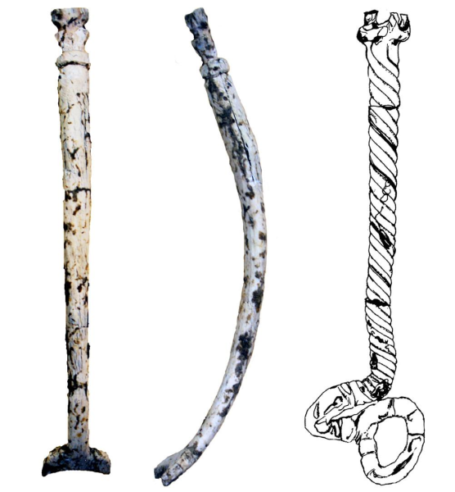
Figure 125: Bone and glass distaffs that had been exposed to high temperatures from Grave in Viminacium, Bone, Glass, 3rd-4th centuries CE.
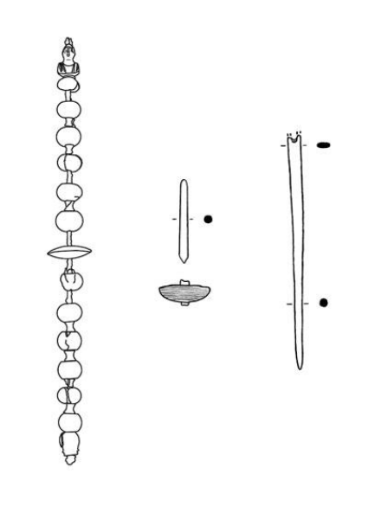
Figure 126: Grave assemblage with distaff, spindle, and needle from Grave in Viminacium, 1st through 3rd century CE.
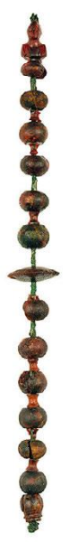
Figure 127: Amber distaff with female bust from Grave in Viminacium, Amber, 1st through 3rd century CE.
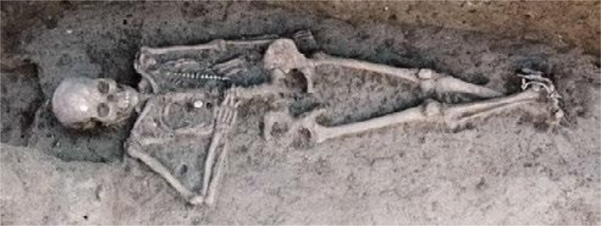
Figure 128: Grave of a woman with spinning equipment from Grave in Viminacium, 1st through 3rd century CE.
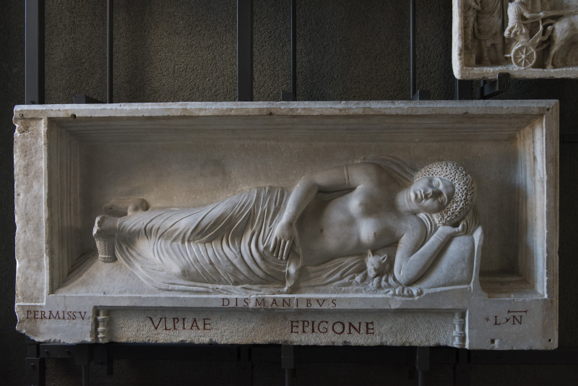
Figure 129: Funerary relief of Ulpia Epigone with wool basket by her feet from the tomb of the Volusii, Via Appia in Rome, Marble, late 1st or early 2nd century CE, Vatican Museum.
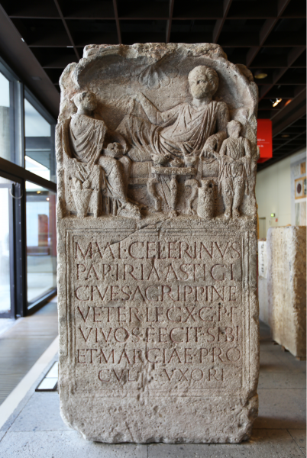
Figure 130: Gravestone of Marcus Valerius Celerinus and Marcia Procula with wool basket, distaffs, and spindle from in Cologne, Marble, c. 100 CE, Römisch-Germanisches Museum. Image by Willy Horsch, Attribution-ShareAlike 4.0 International This image can be found here: https://commons.wikimedia.org/wiki/File:Grabstein_des_Veteranen_Marcus_Valerius_Celerinus_und_seiner_Gemahlin_Marcia_Procula.jpg, Attribution-ShareAlike 4.0 InternationalThis image can be found here: https://commons.wikimedia.org/wiki/File:Grabstein_des_Veteranen_Marcus_Valerius_Celerinus_und_seiner_Gemahlin_Marcia_Procula.jpg.
Figure 131: Sarcophagus depicting a man and woman reclining on a kline with a wool basket, spindle, and distaff from Konca-Mesar in Bithynia, Marble. Image from Trinkl 1994, Fig. 3. (Image withheld due to inadequate legal permissions.)
Figure 132: Gravestone of Regina with spindle and distaff in her left hand and a wool basket at her feet from in Arbeia, Stone, Second half of the 2nd century CE, Roman Fort and Museum, TWCMS : T765. Image from Caroll 2013 Illus. 1. (Image withheld due to inadequate legal permissions.)
Figure 133: Funerary portrait of Veriuga with a spindle and distaff from in Dunaújváros, Stone, First half of the 2nd century CE, Hungarian National Museum. Image from Caroll 2013 Illus. 8. (Image withheld due to inadequate legal permissions.)
Figure 134: Funerary relief of Gaius Cafurnius Antiochus and Veturia Deutera with a sheep from in Rome, Marble, Palazzo di Fide. Image from Larsson Lovén 2002, Cat. No 1.1.1. (Image withheld due to inadequate legal permissions.)
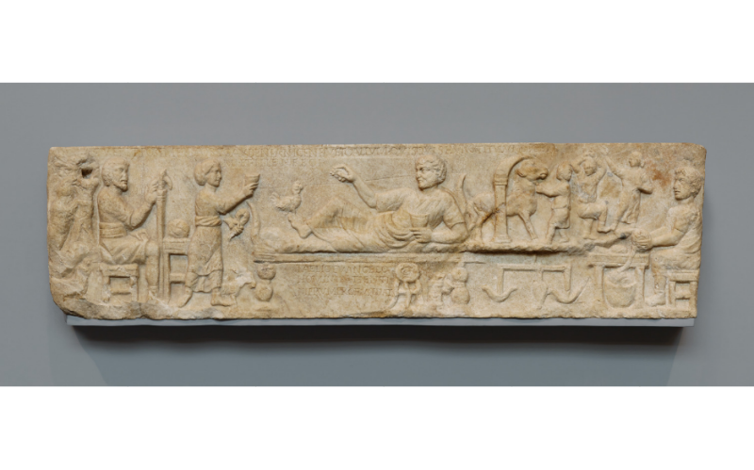
Figure 135: Banquet scene of Titus Aelius Evangelus and his wife Gaudenia Nicene, with scene of wool combing on left and wool gathering on right from in Italy (provenance unknown), Marble, About 180 CE, J. Paul Getty Museum, 86.AA.701. Image by Getty Open Content Program, Public Domain This image can be found here: http://www.getty.edu/art/collection/objects/12845/unknown-maker-front-panel-from-a-sarcophagus-roman-about-ad-180/, Public DomainThis image can be found here: http://www.getty.edu/art/collection/objects/12845/unknown-maker-front-panel-from-a-sarcophagus-roman-about-ad-180/.
Figure 136: Presentation of completed textiles (potentially representing a vestiarius) from in Rome, Marble, Galleria degli Uffizzi. Image from Larsson Lovén 2002, Cat. No 4.2.2. (Image withheld due to inadequate legal permissions.)
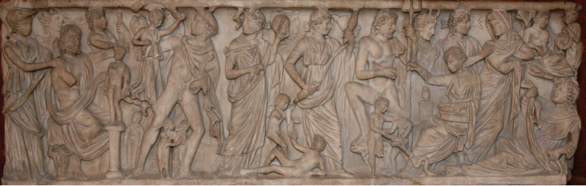
Figure 137: Sarcophagus depicting Prometheus creating man, various deities including Clotho spinning the fate of man from in Arles, Marble, ca. 240 CE, Louvre, Ma 339. Image by Jastrow, Public Domain This image can be found here: https://commons.wikimedia.org/wiki/File:Sarcophagus_Prometheus_Louvre_Ma339.jpg, Public DomainThis image can be found here: https://commons.wikimedia.org/wiki/File:Sarcophagus_Prometheus_Louvre_Ma339.jpg.
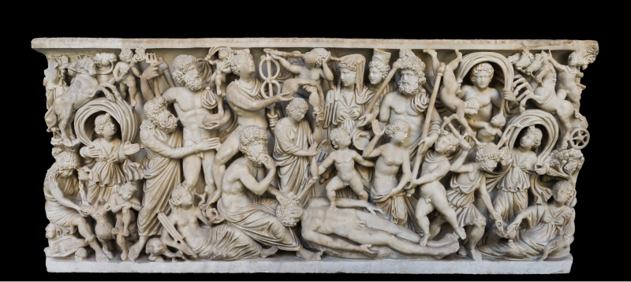
Figure 138: Sarcophagus depicting Prometheus creating man, various deities including Clotho spinning the fate of man from in Puteoli, Marble, Fourth century CE, Museo Archeologico Napoli, 6705. Image by Jebulon, CC0 1.0 (Public Domain) This image can be found here: https://commons.wikimedia.org/wiki/File:MANNapoli_6705_creation_of_the_man_sarcophagus.jpg, CC0 1.0 (Public Domain)This image can be found here: https://commons.wikimedia.org/wiki/File:MANNapoli_6705_creation_of_the_man_sarcophagus.jpg.
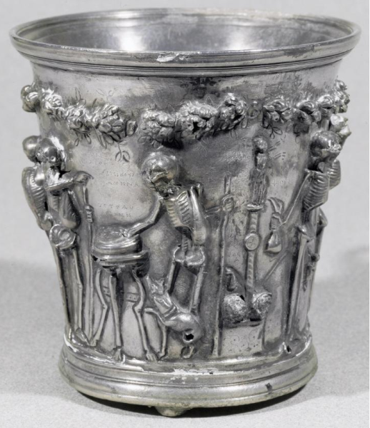
Figure 139: Skeletons labeled as Greek philosophers, Clotho on column spinning from in Boscoreale, Silver, End of the first century BCE to the first half of the first century CE, Louvre, Bj 1923. Image by Erich Lessing Culture and Fine Arts Archives/ART RESOURCE, N.Y., Artstor Fair Use This image can be found here: https://library-artstor-org.ezproxy.library.wisc.edu/#/asset/LESSING_ART_10311441200, Artstor Fair UseThis image can be found here: https://library-artstor-org.ezproxy.library.wisc.edu/#/asset/LESSING_ART_10311441200.
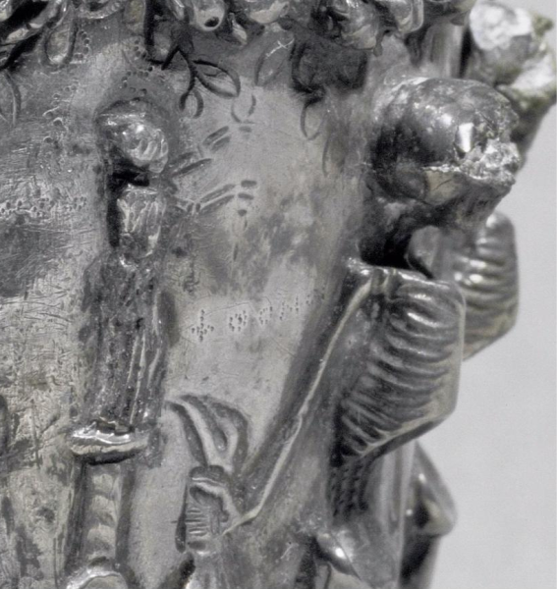
Figure 140: Detail of Clotho spinning atop a column from in Boscoreale, Silver, End of the first century BCE to the first half of the first century CE, Louvre, Bj 1923. Image by Erich Lessing Culture and Fine Arts Archives/ART RESOURCE, N.Y., Artstor Fair Use This image can be found here: https://library-artstor-org.ezproxy.library.wisc.edu/#/asset/LESSING_ART_10311441200, Artstor Fair UseThis image can be found here: https://library-artstor-org.ezproxy.library.wisc.edu/#/asset/LESSING_ART_10311441200.
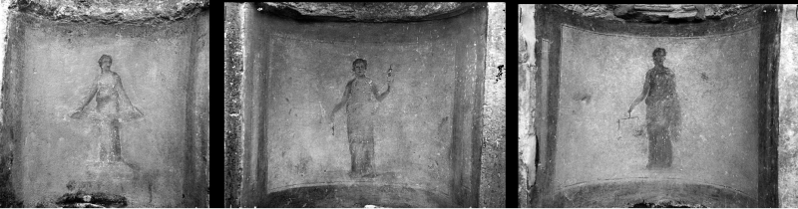
Figure 141: The Parcae: Atropos, Clotho, Lacheis from Tomb in Ostia Antica, Fresco, Ostia Antica Virtual Museum, E16995, E16996, E6994.

Bibliography
Allison, P.M.. 2006. "Mapping for Gender: Interpreting Artefact Distribution Inside 1st and 2nd century A.D. forts in Roman Germany." In Archaeological Dialogues. 13:1-20
Allison, Penelope. 2010. "Soldiers’ Families in the Early Roman Empire." In Companion to Families in the Greek and Roman Worlds, 161-182. Wiley.
Allison, Penelope M.. 2004. Pompeian Households: an Analysis of Material Culture. Cotsen Institute of Archaeology, University of California.
Andreau, Jean. 2012. "Twenty Years After Moses I. Finley's The Ancient Economy." In The Ancient Economy, . Taylor and Francis.
Bammer, Anton. 1982. "Forschungen im Artemision von Ephesos von 1976 bis 1981." In Anatolian Studies. 32:61-87
Barber, Elizabeth. 1994. Women’s Work: the Firist 20,000 Years: Women, Cloth, and Society in Early Times. New York : Norton.
Benda-Weber, Isabella. 2013. "Textile Production Centres, Products and Merchants in the Roman Province of Asia." In Making Textiles in Pre-Roman and Roman Times: People, Places, Identities, 171-191. Oxbow Books.
Boak, A.E.R, and E.E. Peterson. 1931. Karanis, Topographical and Architectural Report of Excavations during the seasons 1924-28. Ann Arbor : University of Michigan Press.
Boeke, J.H.. 1942. The Structure of the Netherlands Indian Economy. New York : International Secretariat, Institute of Pacific Relations.
Boeke, J.H.. Economics and Economic Policy of Dual Societies as Exemplified by Indonesia. New York : International Secretariat, Institute of Pacific Relations.
Bogadóttir, Ragnheidur. 2012. "Fleece: Imperial Metabolism in the pre-Columbian Andes." In Ecology And Power : Struggles over Land and Material Resources in the Past, Present and Future, 83-96. Routledge.
Borgard, Ph., and M.P. Puybaret. 2004. "Le travail de la laine au début de l'empire: l'apport du modèle pompéien. Quels artisans? quels équipements? quellles techniques?." In Purpureae vestes I. Actas I symposium tin. sobre textiles y tintes del Mediterráneo en época romana, 47-59. Consell insular d'Eivissa i Formentera.
Breitner, G., and K-P Goethert. 2008. "Ein Altar für Augustus und Roma in Trier." In Funde und Ausgrabungen im Bezirk Trier. 40:7-13
Buchli, Victor. 2004. Material Culture : Critical Concepts in the Social Sciences. London : Routledge.
Bundrick, Sheramy D.. 2012. "Housewives, Hetairai, and the Ambiguity of Genre in Attic Vase Painting." In Phoenix. 66:11-35
Börker, C.. 1979. Die Inschriften von Ephesos. Bonn : Habelt.
Cahill, Nicholas. 2002. Household and City Organization at Olynthus. Yale University Press.
Carr, K.. 2000. "Women's Work. Spinning and Weaving in the Greek Home." In Archéologie des Textiles. Des Origines au Ve Siècle. Actes du Colloque de Lattes, Octobre 1999, 163-166. Éditions Monique Mergoil.
Carroll, Maureen. 2013. "‘The Insignia of Women ’: Dress, Gender and Identity on the Roman Funerary Monument of Regina from Arbeia." In Archaeol. J.. 169:281-311
Cartledge, Paul. 2012. "The Economy (Economies) of Ancient Greece." In The Ancient Economy, . Taylor and Francis.
Classical Art Research Centre. 2017. Beazley Archive Pottery Database. https://www.beazley.ox.ac.uk/pottery/default.htm
Cottica, Daniela. 2006. "The Symbolism of Spinning in Classical Art and Society." In Cosmos. 20:185-209
Cottica, Daniela. 2007. "Spinning in the Roman World: From Everyday Craft to Metaphor of Destiny." In Ancient Textiles. Production, Craft and Society. 220-228
Crowfoot, Grace M. 1941. "The Vertical Loom in Palestine and Syria." In Palestine exploration quarterly. 73:141-151
D'Ambra, Eve. 1989. The Cult of Virtues and the Funerary Relief of Ulpia Epigone. http://www.jstor.org/stable/41541120
D'Ambra, Eve. 1993. Private Lives, Imperial Virtues: The Frieze of the Forum Transitorium in Rome. Princeton, N.J. : Princeton University Press.
D'Ambra, Eve. 2007. Roman Women. Cambridge University Press.
D'Ambra, Eve. 2012. "Women on the Bay of Naples." In A Companion to Women In the Ancient World, 400-413. Wiley-Blackwell.
Danković, Ilija. 2019. "Burial of a woman with an amber distaff at Viminacium." In Starinar. 69:215-229
Danković, Ilija. 2020. "Roman Bone Distaffs and Spindles: Could They Have Been Used for Spinning?." In Гласник Српског археолошког друштва. 36:79-98
Dannehl, Karen. 2009. "Object Biographies: From Production to Consumption." In History and Material Culture: A Student’s Guide to Approaching Alternate Sources, 123-138. Routledge.
Diocletian. 2016. "An English translation of the Edict on Maximum Prices, also known as the Price Edict of Diocletian." Translated by Antony Kropff. Unpublished : Academia.edu. https://www.academia.edu/23644199/New_English_translation_of_the_Price_Edict_of_Diocletianus?source=swp_share
Dixon, Suzanne. 2000. "How Do You Count Them If They’re Not There? New perspectives on Roman cloth production." In ORom. 25-26:7-17
Dixon, Suzanne. 2001. Reading Roman Women: Sources, Genres and Real Life. Duckworth.
Dragendorff, H., and E. Krüger. 1924. Das Grabmal von Igel. Trier : J. Lintz.
Drexel, F.. 1920. "Die Bilder der Igeler Säule." In Deutsches Archaologisches Institut: Römische Abteilung: Mitteilungen. 35:83-142
Drinkwater, J.F.. 1982. "The Wool Textile Industry of Gallia Belgica and the Secundinii of Igel: Questions and Hypotheses." In Textile History. 33:1:111-128
Ely, Carol Alexandra. 1999. Domestic Economies: Household textile manufacture and the family in Massachusetts, 1620-1830. Waltham, Massachusetts : Brandeis University (Dissertation).
Fairley, W.. 1897. Notitia Dignitatum or Register of Dignitaries. University of Pennsylvania Press.
Fauve-Chamoux, Antoinette. 2001. "Continuity and change among the Rhemish proletariat: Preindustrial textile work in family perspective." In History of the Family. 6:167-185
Finley, Moses I.. 1999. The Ancient Economy. Berkeley : University of California Press.
Fischer, Marina. 2013. "Ancient Greek Prostitutes and the Textile Industry in Attic Vase Painting." In CW. 106:219-259
Flemming, Rebecca. 1999. "Quae Corpore Quaestum Facit: The Sexual Economy of Female Prostitution in the Roman Empire." In The Journal of Roman Studies. 89:38-61
Flohr, M.. 2013. "The Textile Economy of Pompeii." In JRA. 26:53-78
Flohr, Miko. 2011. "Reconsidering the Atrium House: domestic fullonicae at Pompeii." In Book Title, 88-102. Oxbow.
Flohr, Miko. 2013. The World of the Fullo : Work, Economy, and Society in Roman Italy. Oxford : Oxford University Press.
Flohr, Miko. 2016. "Textiles, Trade and the Urban Economies of Roman Asia Minor." In BYZAS. 22:21-41
Franquemont, Ed. 2011. "Andean Spinning." In Handspindle Treasury: Spinning Around the World, 13-14. Interweave Press.
Gazda, Elaine K.. 1983. Karanis: an Egyptian town in Roman times ; discoveries of the Univ. of Michigan expedition to Egypt. Ann Arbor : University of Michigan Press.
Gines Taylor, Catherine. 2018. Late Antique Images of the Virgin Annunciate Spinning. Leiden : Brill.
Gkika, G.. 2012. "The Clay Loomweights of Ancient Messene: Types, Decoration, Distribution." In Textiles and Dress in Greece and the Roman East: A Technological and Social Approach, 69-76. Ta Pragmata.
Gleba, M.. 2009. "Textile Tools and Specialisation in Early Iron Age Female Burials." In Gender Identities in Italy in the First Millennium B.C., 69-78. British Archaeological Reports.
Guilleux, Nicole. 2016. "Of Metaphorical Matrices and their Networks: Generally Speaking, and in the Field of Textile Activities." In Spinning Fates and the Song of the Loom: The Use of Textiles, Clothing and Cloth Production as Metaphor, Symbol and Narrative Device in Greek and Latin Literature, 1-16. Oxbow.
Gullickson, Gay. 1981. "The Sexual Division of Labor in Cottage Industry and Agriculture in the Pays de Caux: Auffay, 1750-1850." In French Historical Studies. 12:177-199
Hafter, Daryl M.. 1985. "Artisans, Drudges, and the Problem of Gender in Pre‐Industrial France." In Annals of the New York Academy of Sciences. 441:71-88
Hareven, Tamara. 2002. The Silk Weavers of Kyoto : Family and Work in a Changing Traditional Industry. Berkeley : University of California Press.
Harlow, Mary. 2016. "Textile Crafts and History." In Traditional Textile Craft: An Intangible Heritage?, 137-145. Centre for Textile Research, University of Copenhagen.
Hasegawa, Kinuko. 2005. The Familia Urbana during the Early Empire: A Study of Columbaria Inscriptions. Oxford : Archaeopress.
Hemelrijk, Emily. 2004. "Masculinity and Femininity in the 'Laudatio Turiae'." In The Classical Quarterly. 54:1:185-197
Hendon, Julia A.. 2007. "Living and Working at Home: The Social Archaeology of Household Production and Social Relations." In A Companion to Social Archaeology, 272-286. Blackwell Publishing Ltd.
Hitchner, Robert Bruce. 2012. "Olive Production and the Roman Economy: The Case for Intensive Growth in the Roman Empire." In The Ancient Economy, . Taylor and Francis.
Hoffman, M.. 1964. The Warp-Weighted Loom: Studies in the History and Technology of an Ancient Implement. Universitetsforlaget.
Husselman, E. M.. 1979. Karanis excavations o f the University o f Michigan in Egypt, 1928-35: Topography and architecture. Ann Arbor : Kelsey Museum of Archaeology.
Jones, A.H.M.. 1960. "The Cloth Industry under the Roman Empire." In The Economic History Review. 13:183-192
Jongman, W.. 2000a. "Wool and the Textile Industry of Roman Italy. A Working Hypothesis." In Mercati Permanenti et Mercati Periodici nel Mondo Romano. Atti degli Incontri capresi di storia dell’economia antica, Capri 13 - 15 ottobre 1997., 187-197. L'Erma di Bretschneider.
Jongman, W.. 2000b. "Wool and the Textile Industry of Roman Italy. A Working Hypothesis." In Mercati permanenti e mercati periodici nel mondo romano. Atti degli Incontri capresi di storia dell’economia antica, Capri 13-15 ottobre 1997, 187-197.
Jongman, Willem. 1988. The Economy and Society of Pompeii. Amsterdam : J.C. Gieben.
Kelsey Museum of Archaeology, . 1929. Record of Objects, Karanis. University of Michigan Press.
Kelsey Museum of Archaeology, and Thelma K. Thomas. 2001. Textiles from Karanis, Egypt, in the Kelsey Museum of Archaeology : artifacts of everyday life. Kelsey Museum of Archaeology, University of Michigan.
Kleijwegt, Marc. 2002. "Textile Manufacturing for a Religious Market. Artemis and diana as Tycoons of Industry." In After the Past. Essays in Ancient History in Honour of H.W. Pleket, 81-134. Brill.
Kropff, Antony. An English translation of the Edict on Maximum Prices, also known as the Price Edict of Diocletian. 2016.
Kuhnen, P.H.. 2004. "Trèves-Augusta Treverorum." In La marque de Rome: Samarobriva et les villes du nord de la Gaule, 63-72. Musée de Picardie.
Kumarappa, J.C.. 1944. "Handicrafts and Cottage Industries." In The anals of the American Academy of Political and Social Science. 233:106-112
Larsson Lovén, L.. 2002. The Imagery of Textile Making. Gender and Status in the Funerary Iconography of Textile Manufacture in Roman Italy and Gaul. University of Gothenburg.
Larsson Lovén, Lena. 1998a. ""Lanam fecit". Woolworking and female virtue." In Aspects of women in antiquity. Proceedings of the First Nordic Symposium on Women’s Lives in Antiquity, Göteborg 12 - 15 June 1997, 85-95.
Larsson Lovén, Lena. 1998b. "Male and Female Professions in the Textile Production of Roman Italy." In Textiles in European Archaeology. :73-78
Larsson Lovén, Lena. 2007. "Wool Work as a Gender Symbol in Ancient Rome. Roman Textiles and Ancient Sources." In Ancient Textiles : Production, Craft and Society : Proceedings of the First International Conference on Ancient Textiles, Held at Lund, Sweden, and Copenhagen, Denmark, on March 19-23, 2003, 229-236. Oxbow.
Larsson Lovén, Lena. 2013. "Female Work and Identity in Roman Textile Production and Trade: A Methodological Discussion." In Making Textiles in Pre-Roman and Roman Times. People, Places, Identities. Oxbow Books.
Larsson Lovén, Lena. 2016. "Women, Trade, and Production in the Urban Centres of Roman Italy." In Urban Craftsmen and Traders in the Roman World, 205-218. Oxford University Press.
Laufer, Berthold. 1915. "The Story of the Pinna and the Syrian Lamb." In The Journal of American Folk-lore. 28:103-128
Lauffer, S.. 1971. Diokletians Preisedikt. Berlin : de Gruyter.
Lipkin, Sanna.. 2012. Textile-making in central Tyrrhenian Italy from the final Bronze Age to the Republican Period. Archaeopress.
Lyapustin, B.S.. 1985. "Women in the textile industry. Production and morality.." In Journal of Ancient History. 174:36-46
Lyding Will, Elizabeth. 1979. "Women in Pompeii." In Archaeology. 32:5:34-43
Marianne Kleibrink, Jan Kindberg Jacobsen, and Søren Handberg. 2004. "Water for Athena: Votive Gifts at Lagaria (Timpone della Motta, Francavilla Marittima, Calabria)." In World Archaeology. 36:43-67
Massaro, Matteo. 2018. "Questioni di autenticità di iscrizioni metriche (o affettive)." In Spurii lapides: I falsi nell’epigrafia latina, 93-136. Biblioteca Ambrosiana.
Mau, A. 1892. "Osservazioni sull'edificio di Eumachia in Pompei." In RomMitt. 7:113-143
Meskell, Lynn. 2001. "Archaeologies of Identity." In Archaeological Theory Today, 187-213. Blackwell.
Meyers, G.E.. 2013. "Women and the Production of Ceremonial Textiles. A Reevaluation of Ceramic Textile Tools in Etrusco-Italic Sanctuaries." In AJA. 117:247-274
Milnor, Kristina. 2005. Gender, Domesticity, and the Age of Augustus: Inventing Private Life. Oxford University Press.
Moeller, Walter O.. 1969. "The Male Weavers at Pompeii." In Technology and Culture. 10:561-566
Moeller, Walter O.. 1972. "The Building of Eumachia: A Reconsideration." In AJA. 73:3:323-327
Moeller, Walter O.. 1976. The Wool Trade of Ancient Pompeii. Brill.
Monteix, Nicholas. 2010. Les Lieux De Métier : Boutiques Et Ateliers d’Herculanum.. Rome :École fran-caise de Rome.
Möller-Wiering, S., and J. Subbert. 2012. "Germany: Roman Iron Age." In Textiles and Textile Production in Europe: From Prehistory to AD 400. Oxbow.
Möller-Wiering, Susan. 2015. "External examination of spinning and weaving samples." In Tools, Textiles and Contexts: Textile Production in the Aegean and Eastern Mediterranean Bronze Age, 101-126. Oxbow.
Nevett, L.C.. 1995. "Gender Relations in the Classical Greek Household: The Archaeological Evidence." In BSA. 90:363-381
Olofsson, Linda, Eva Andersson Strand, and Marie-Louise Nosch. 2015. "Experimental testing of Bronze Age textile tools." In Tools, Textiles and Contexts: Textile Production in the Aegean and Eastern Mediterranean Bronze Age, 75-100. Oxbow.
Pfahl, S., and H.P. Kuhnen. 2007. "Orient und Okzident. Römische Körpergräber in Trier.." In Körpergräber des 1.-3. Jahrhunderts in der römischen Welt: internationales Kolloquium, Frankfurt am Main 19.-20. November 2004, 383-401. Archäologisches Museum Frankfurt.
Pinchbeck, Ivy. 2004. "Textile Industries - The Domestic System." In Women Workers in the Industrial Revolution, 111-128. Taylor & Francis Group.
Pollard, Nigel. 1998. "The Chronology and Economic Condition of Late Roman Karanis: An Archaeological Reassessment." In Journal of the American Research Center in Egypt. 35:147-162
Postrel, Virginia. 2020. The Fabric of Civilization : How Textiles Made the World. New York : Hachette Book Group.
Prentice, Guy. 1983. "Cottage Industries: Concepts and Implications." In Midcontinental Journal of Archaeology. 8:17-48
Prown, Jules. 1993. "The Truth of Material Culture: History or Fiction." In History from Things: Essays on Material Culture, 1-19. Smithsonian Institution Press.
Pásztókai-Szeőke, J.. 2011. ""The Mother Shrinks, the Child Grows. What is it?" The Evidence of Spinning Implements in Funerary Context From the Roman Province of Pannonia." In Mujer y vestimenta. Aspectos de la identidad femenina en la antigüedad, 125-140. Publicacions de la Universitat de València.
Quercia, A, and Lin Foxhall. 2015. "Temporality, materiality and women's networks. The production and manufacture of loom weights in the Greek and indigenous communities of southern Italy.." In Knowledge networks and craft traditions in the ancient world. Material crossovers., 62-82. Routledge.
Rathmayr, Elisabeth. 2014. "Kleinfunde." In Hanghaus 2 in Ephesos Die Wohneinheit 6, 639-706. Austrian Academy of Sciences Press.
Richlin, Amy. 2014. Arguments with Silence : Writing the History of Roman Women. Ann Arbor : University of Michigan Press.
Rodenwaldt, G.. 1932. "Spinnende Hetären." In AA. 7-21
Rolfe, J.C., and Suetonius. 1913. Lives of the Twelve Caesars. Cambridge, Mass : Harvard University Press.
Roth, U.. 2011. "Textile Production and Gender in Ancient Italy. The Case of the "Oscan" Loom Weights." In Ostraka. 20:143-162
Roth, Ulrike. 2007. "Chapter 3: On Gendered Grounds - Spinning a Different Story." In Bulletin of the Institute of Classical Studies. 50:53-87
Saller, Richard. 2007. "Household and Gender." In The Cambridge Economic History of the Greco-Roman World, 87-112. Cambridge University Press.
Schwaiger, Helmut. 2017. "Domestic Architecture in Ephesus from the Hellenistic Period to Late Antiquity." In Mediterranean Families in Antiquity: Households, Extended Families, and Domestic Space, 79-91. John Wiley & Sons.
Schwinden, L.. 1989. "Gallo-römisches Textilgewerbe nach Denkmälern aus Trier und dem Treverland." In Trierer Zeitschrift für Geschichte und Kunst des Trierer Landes und seiner Nachbargebiete. 52:279-318
Seeck, Otto. 1962. Notitia dignitatum; accedunt Notitia Urbis Constantinopolitanae et latercula provinciarum. Frankfurt am Main : Minerva.
Sinnigen, William G.. 1963. "Barbaricarii, Barbari and the Notitia Dignitatum." In Société d’Études Latines de Bruxelles. 22:806-815
Smart Martin, Ann. 1997. "Shaping the Field: The Multidisciplinary Perspectives of Material Culture." In American Material Culture : the Shape of the Field, 1-20. University of Tennessee Press.
Suetonius. 2014. Life Of Augustus = Vita Divi Augusti. Oxford : Oxford University Press.
Treggiari, Susan. 1975. "Jobs in the Household of Livia." In Papers of the British School at Rome. 43:48-77
Treggiari, Susan. 1976. "Jobs for Women." In AJAH. I:76-104
Treggiari, Susan. 1991. Roman Marriage : Iusti Coniuges from the Time of Cicero to the Time of Ulpian. Oxford : Clarendon Press.
Trier, Rheinisches Landesmuseum. 1984. Trier, Augustusstadt der Treverer: Stadt und Land in vor- und frührömischer Zeit. Mainz : Von Zabern.
Trinkl, Elisabeth. 1994. "Ein Set aus Spindel, Spinnwirtel und Rocken aus einem Sarkophag in Ephesos.." In ÖJh. 63:81-86
Trinkl, Elisabeth. 2004. "Zum Wirkungskreis einer kleinasiatischen Matrona anhand ausgewählter Funde aus dem Hanghaus 2 in Ephesos." In Jahreshefte des Österreichischen archäologischen Instituts in Wien. 73:281-303
Trinkl, Elisabeth. 2008. "Artifacts related to preparation of wool and textile processing found inside the Terrace Houses of Ephesus, Turkey." In Ancient Textiles. Production, craft and society. Proceedings of the First international conference on ancient textiles, held at Lund, Sweden, and Copenhagen, Denmark on March 19-23, 2003., 81-86. Oxbow.
Trivedi, Lisa. 2007. Clothing Ghandi’s Nation: Homespun and Modern India. Bloomington : Indiana University Press.
Ulrich, Laurel Thatcher. 2001. The Age of Homespun: Objects and Stories in the Creation of an American Myth. New York : Vintage Books.
Wightman, Edith Mary. 1970. Roman Trier And the Treveri. London: Hart-Davis.
Wilburn, Andrew. 2019. Karanis Housing Project. http://karanishousingproject.org/index.ghtml
Wild, J.P.. 1976a. "Textiles." In Roman Crafts, 167-177. New York University Press.
Wild, J.P.. 1976b. "The Gynaecea." In Aspects of the Notitia dignitatum : papers presented to the conference in Oxford, December 13 to 15, 1974, 51-58. British Archaeological Reports, 1976..
Wild, J.P.. 1976c. "The Gynaecea." In Aspects of the Notitia Dignitatum : Papers Presented to the Conference in Oxford, December 13 to 15, 1974, 51-58. British Archaeological Reports.
Wild, J.P.. 1999. "Textile manufacture. A Rural Craft?." In Artisanat et productions artisanales en milieu rural dans les provinces du nord-ouest de l’empire romain. Actes du colloque, Erpeldange (Luxembourg) les 4 et 5 mars 1999., 29-37. M. Mergoil.
Wild, J.P.. 2002. "The Textile Industries of Roman Britain." In Britannia, 1-42.
Wild, John Peter. 1970. Textile manufacture in the Northern Roman Provinces. Cambridge [Eng.] : University Press, 1970..
Wilson, Andrew. 2004. "Archaeological evidence for textile production and dyeing in Roman North Africa." In Book Title, 155-64. Publicaciones de la Universidad de Valencia.
Wilson, Lillian May., and University of Michigan.. 1933. Ancient textiles from Egypt in the University of Michigan collection. University of Michigan Press.
Wipszycka, E.. 1965. L’industrie Textile Dans L’égypte Romaine.. Zaklad Narodowy.
Zahn, E.. 1968. Die Igeler Säule bei Trier. Neuss : Gesellschaft für Buchdruckerei.

Index
Right click, update index

In this context, I am using the term performative to refer to rituals or traditions in which textile tools and production are used as a symbol or attribute referencing traditional feminine virtues and roles.
Wild 2002, 29.
This stage of processing may have included combing the wool so that the fibers faced in a uniform direction, though this step was not necessary, Wild 1976a, 168
Lipkin 2012, 37.
Wild 2002, 9.
It is possible that the movement of the wool over stone and bone distaffs would have created a higher polish or sheen, but this is hard to determine.
Wild 1976a, 170.
According to Catullus, Carmina 64 305-320. However, it is unclear whether this would have been a common practice among spinners or if Catullus was using it as a literary device. The impurities in wool would have consisted of whatever the sheep got into such as straw, dirt, and feces. Catullus is not known to shy away from visceral imagery.
Guilleux 2016, 8.
Catullus, Carmina 64 305-320
Wild 2002, 10.
Timing myself, it took 12h 25m to spin .8 oz of wool and produce 128 yards of thread, a Roman pound is roughly 11.6 oz of wool
Harlow 2016, 139.
Roth 2007, 81.
Franquemont 2011, 13.
Bogadóttir 2012, 51.
Postrel 2020, 49.
Wild 2002, 10.
Hoffman 1964.
For the most basic tabby weave the threads would simply alternate one front, one back Lipkin 2012, 20
A similar effect can be accomplished without the A-frame by leaning a rectangular frame against the wall without back supports.
Wild 1976a, 172.
Wild 1976a.
Seneca, Epistulae Morales 90.20
Carr 2000, 165.
Roth 2007, 82.
Harlow 2016, 139.
Larsson Lovén 1998b, 75.
While somewhat unclear, the Latin word harundo (a reed or cane), translated here as ’sley’, likely refers to the heddle. Ovid, Metamorphoses 6.1.55
Diocletian’s Price Edict lists prices for both unprocessed silk and wool as well as spun silk and wool dyed purple Diocletian, Edictum de pretiis rerum venalium XXIV.1, if this was done at these stages for purple dye, was presumably done at various stages in other colors as well. Wild 1976a, 168
Flohr 2013, 60.
Wild 2002, 22.
Flohr 2013, 62.
Wild 2002, 22.
Hendon 2007.
Meskell 2001.
Richlin 2014.
Finley 1999.
Cartledge 2012.
Andreau 2012.
It is of no little significance to this research that these economic histories often omit women entirely from their analysis. Of the mere six times that Finley mentions women in The Ancient Economy, four are in the context of slavery.
A more detailed discussion of cottage industry systems will follow in chapter 6. See Boeke 1942, Boeke ??? and Prentice 1983
Prown 1993, 1.
For more comprehensive histories of material culture as a field of study see Buchli 2004 and Smart Martin 1997
Dannehl 2009, 124.
Hoffman 1964; Barber 1994; Wild 1976a
This data is cross referenced with data on wages and cost of materials recorded in Diocletian’s Price Edict in Chapter 6.
Trinkl 2008.
I am unsure whether Trinkl has any experiential knowledge of spinning, and do not mean to imply that she does not, though I didn’t see any mention of an experiential approach in her research; I am merely sharing my insights from my own experiental crafting experience. I have further plans to test this assumption via the use of reproduction distaffs using clay, but the current state of self-isolation brought on by the COVID-19 pandemic means I do not have access to the tools and materials to complete the project
Roth 2007, 82.
Lipkin 2012; Roth 2011
Barber 1994.
Cahill 2002; Nevett 1995
Bundrick 2012.
Gleba 2009.
Marianne Kleibrink et al. 2004.
Quercia and Foxhall 2015.
Lipkin 2012.
Jones 1960.
Jongman 1988; Jongman 2000b; Jongman 2000b; Flohr 2013; Flohr 2013; Flohr 2016
Wild 2002; Wild 1999; Wild 1976a; Wild 1970; Wild 1976c
Larsson Lovén 2007; Larsson Lovén 2016; Larsson Lovén 1998b; Larsson Lovén 1998a
Dixon 2000.
Cottica 2006.
Allison 2006.
Cottica 2006.
Lipkin 2012, 12.
Richlin 2014, 1.
Gazda 1983, 8.
Kelsey Museum of Archaeology and Thomas 2001, 5.
Kelsey Museum of Archaeology and Thomas 2001, 4.
Following the initial findings of Boak and Peterson, the abandonment has been traditionally cited as the 4th century CE based on a lack of coinage and other artifacts finds from after that period. Boak and Peterson 1931. Pollard’s in-depth analysis of the pottery from Karanis suggests habitation at least until the 6th century, possibly into the 7th.Pollard 1998
Kelsey Museum of Archaeology and Thomas 2001, 21.
Kelsey Museum of Archaeology and Thomas 2001, 4.
Gazda 1983, 8.
This quote is from an unpublished manuscript: Kelsey, Francis W 1926, University of Michigan Near East Research Committee: Memorandum 14
The records published by the Kelsey Museum of Archaeology in the Record of Objects, Karanis, include both the nearly 44,000 artifacts in the Kelsey collections as well as those in the Cairo Museum and have been transcribed into a CSV database, Kelsey Museum of Archaeology 1929
Michael Koletsos and Drew Cabaniss, PhD students at the University of Michigan are currently working with the Kelsey Museum to write a catalog of the textile implements from Karanis. In addition to the catalog, they are conducting research on the physical construction of the surviving textiles and using experimental archaeology to confirm that the implements found on site are compatible with the textiles found on site. These publications are forthcoming.
Gazda 1983, 14.
The records published by the Kelsey Museum of Archaeology in Record of Objects, Karanis, include both the nearly 44,000 artifacts in the Kelsey collections as well as those in the Cairo Museum and have been transcribed into a CSV database. Access to this database, graciously provided to me by the Kelsey Museum of Archaeology, has been crucial in my analysis of the textile tools and artifacts from Karanis.
The excavation database does not consistently list the materials for all of the spindle whorls, so I cannot report a full breakdown of the proportions of each material. However, I will include here a breakdown of the materials of the 74 spindle whorls listed on the Kelsey Museum’s website. Wood: 46; Glass: 12; Bone; 6; Ivory: 4; Stone: 4; Clay: 2
Variations on this motif can be found on spindle whorls from the first through eight centuries CE in Egypt**
For the types of looms used in Roman Egypt see Wipszycka 1965, 49-50. For more in-depth discussions of the types of looms used in the ancient world see Hoffman 1964, Wild 1976a
In the Kelsey Museum’s Karanis database, at least 239 objects were identified as loom weights (three entries merely indicated loom weights with no specific number)Kelsey Museum of Archaeology 1929
The Karanis database uses the term ’unfired mud’ but for the purposes of this study I will use the more common ’unfired clay’ Kelsey Museum of Archaeology 1929
Of the 239 objects listed as loom weights in the Karanis database, 219 total and all sets of ten or more loom weights found together were made of clay. Other objects possibly identified as loom weights were made of varied materials, however none of these come close to representing a usable set (Table 2). It is important to note the difficulty in distinguishing between loom wights and other objects such as weights for fishing nets. The clay weights were unlikely to be used for fishing as they would disintegrate rapidly in water, however the five weights from Karanis that have rope or cord still attached suggest some function other than weaving clothing.Kelsey Museum of Archaeology 1929
This quantity is seemingly disproportionate compared to the numbers of spindle whorls and loom weights found at the site, perhaps they were left behind when the site was abandoned
Kelsey Museum of Archaeology and Thomas 2001, 17.
KM8151, not pictured here
Husselman 1979.
Gazda 1983, 19.
In later cultures which relied on cottage industry, looms were passed on to the next generation. For this practice in eighteenth century France, see Fauve-Chamoux 2001, 167
For example, many individual or small groupings of loom weights and some weaver’s combs were found in unknown contexts or in the street, but of the seven sets of ten or more loom weights, six were discovered in domestic contexts. Kelsey Museum of Archaeology 1929
The Karanis Housing Project has made a GIS map of the site of Karanis and is currently populating the map with artifacts from the University of Michigan excavations. When their data entry is complete, this project will provide better visualizations for artifact dispersal and object groupings in Karanis. Wilburn 2019
Kelsey Museum of Archaeology 1929.
Gazda 1983.
Wilson and University of Michigan. 1933.
As translated in Kelsey Museum of Archaeology and Thomas 2001
This was one of the ’rewards’ of the lex Iulia de maritandis ordinibus to promote women to have more children, see Milnor 2005, 152
As translated in Kelsey Museum of Archaeology and Thomas 2001
Wipszycka 1965, 84.
Kelsey Museum of Archaeology and Thomas 2001, 18.
Gazda 1983, 15.
For other vases representing women spinning with their hands at nearly even height, see the following vases from the Beazley Archive Pottery Database: Beazley 209084, Beazley 208940, Beazley 209043, Beazley 208920, Beazley 202937. Classical Art Research Centre 2017.
Barber 1994, , 236-238.
Kuhnen 2004, 63.
Trier 1984, 180.
Breitner and Goethert 2008.
Wightman 1970, 43.
Kuhnen 2004, 69.
Pfahl and Kuhnen 2007, 384.
Larsson Lovén 2002, 30.
For this reason, I have included both photographs taken by the author in 2019 as well as drawings of the reliefs from Zahn 1968
Larsson Lovén 2002, 31.
Drexel 1920 and Dragendorff and Krüger 1924
Zahn 1968.
Drinkwater 1982.
The object is unclear, it is not likely a book, perhaps a scroll or a smaller piece of fabric he is inspecting
Dragendorff and Krüger 1924.
Schwinden 1989, 294-295 and Larsson Lovén 2002 4.3.2
There are no images of this relief as it was most likely destroyed in WWII, unfortunately I have no more information about it at present than stated here Larsson Lovén 2002, 50
Notitia Dignitatum Oc XI 58
Notitia Dignitatum Oc XI 77; Fairley 1897 32
Seeck 1962 151 and Fairley 1897 31
Wild 1976c.
Fairley 1897, 31.
Wild 1976c, 51.
This could include criminals as discussed below, or women whose debt lowered their social status such as Aurelia Taesis from Karanis, P. Mich. Inv. 2819
Wild 1976c.
Wild 1976c.
This fits in with the convention of the spinning hetairai
Möller-Wiering and Subbert 2012.
Wild 1970, 40.
Wild 1970, 131.
Schwinden 1989, 281.
CIL XIII 558
CIL 13.542; CIL 13.2008; CIL 13.2033, see Schwinden 1989, 286
See discussion of job titles on funerary inscriptions in Chapter 6.3, **pgs. #-#
Möller-Wiering and Subbert 2012, 168.
In response to my request to view any spindles, spindle whorls, loom weights, distaffs, or other spinning and weaving tools in their collections from Trier, Dr. Korana Deppmeyer, a collections research fellow at the Rheinisches Landesmuseum, informed me that they had few of such artifacts in their collections.
While the short, blunt teeth of the weaver’s combs from Karanis would have been used to pack the weft strands tightly, the long thin teeth of this comb would more likely have been used to process the wool prior to spinning.
CIL XIII. 10019/17, Wild 1970, 33
Wild 1970, 141.
Wild 1970, 125.
Schwaiger 2017, 80.
Strab. 14.1.24
Trinkl 2004, 282.
Schwaiger 2017, 82.
Trinkl 2008, 82.
Trinkl 2004, 281.
Trinkl 2004, 283.
Rathmayr 2014, 651.
Rathmayr 2014, 651.
Rathmayr 2014, 651.
Rathmayr 2014, 651.
Trinkl 2008, 83.
Trinkl 2008, 83.
Trinkl 2008, 85.
This argument is based on precedents of sets of four weights found in situ in Pompeii Allison 2004, 157
Rathmayr 2014, 652.
For an analysts of spools from Khania as loom weights, see Olofsson et al. 2015, 92
Trinkl 2008, 84.
Rathmayr 2014, 652.
Trinkl 2004, 289.
Trinkl 1994, 81.
Trinkl 1994, 82.
Trinkl 1994, 81.
Trinkl 2004, 286.
Trinkl 2004, 288.
Efes Müzesi Inv. 25/68/89, Trinkl 2008 86
Bammer 1982.
Kleijwegt 2002.
Benda-Weber 2013, 178.
Börker 1979, 179.
Her., Hist. 5, 49
Benda-Weber 2013, 171.
Unfortunately, I have not had the opportunity to view these objects in person and take detailed measurements and the publication gives only the overall length. Measuring off of the publication image and accounting for the ratio, I measured the workspace of this distaff at 7.8cm.
Barber 1994, Cottica 2006, Larsson Lovén 2002
Larsson Lovén 2007 230, Larsson Lovén 2002 8
Praise for historical methods of textile production in reference to an idealized past has been utilized for political gains repeatedly throughout history. Some examples include prioritizing ’homespun’ cloth over imported fabrics during the American Revolution, see: Ulrich 2001, and Mahatma Gandhi’s return to traditional Indian textile techniques, see: Trivedi 2007.
Ovid, Fasti 2.722-751
Livy, History of Rome 1.57.9
Ovid, Fasti 2.768-772
Ovid, Fasti 4.687-714
Suetonius, Life of Augustus 73 as translated in Rolfe and Suetonius 1913. Also discussed in Larsson Lovén 2007 124
Suetonius 2014, 450.
Indeed, records from Livia’s household after Augustus’s death include a high number of servants specifically for wardrobe maintenance and textile-production; Treggiari 1975
According to Ulrike Roth’s calculations, the total labor required to spin and weave a single tunic would amount to roughly 159-170 hours total, or the equivalent of one person’s devoted labor for an entire month. Roth 2007 81-82
Columella, On Agriculture 12.preaf.9-10
Philo, Special Laws 172-5
While there are no epitaphs from any of the three case-studies discussed in this work, I felt that the practice within the empire as a whole was still relevant to discuss in the synthesis chapter.
CIL 6.11602
Treggiari 1976, 82.
CIL 6.10230
Hemelrijk 2004, 185.
CIL 6.1527 As Translated by S. Treggiari
Hemelrijk 2004, 186.
CIL 1.1211
Massaro 2018, 107.
Saller 2007, 90.
Cottica 2007.
Lyapustin 1985.
Livy, History of Rome 1.57.9
P. Mich. Inv. 2819
P. Mich. Inv. 5191
Saller 2007, 109.
Saller 2007, 106.
Quercia and Foxhall 2015, 62.
Lipkin 2012.
141 loom weights from Roman Villa A, XVII/6 out of over 1000 loom weights total from the site as a whole Gkika 2012, 74
Flohr 2013, 66.
Allison 2004, 157.
Roth 2007, 79.
Wild 1976a.
Allison 2004, 69, D'Ambra 2007, 97
Trinkl 2004, 292.
Trinkl 2004, 302.
Flohr 2016, 24.
Hafter 1985, 74.
Boeke 1942.
Boeke ???, 100.
See Prentice 1983, 18-24 for a discussion of various interpretations of cottage industries.
Gullickson 1981, 179.
Historically, cottage industries have existed alongside centralized production centers elsewhere. For example, see: Hareven 2002, 56.
Hitchner 2012, 75-76.
Hitchner 2012, 76.
Diocletian 2016 XXIII.1 5
And, in keeping in the theme of this dissertation, absence of evidence where we must ask where our biases filled in the gaps.
For a discussion of fullonicae connected to atrium houses, see Flohr 2011
Wild 1970, 83.
Flohr 2013, 62.
Flohr 2013, 62.
Flohr 2013, 26.
Wilson 2004, 237.
Diocletian’s Price Edict lists prices for both unprocessed silk and wool as well as spun silk and wool dyed purple; Diocletian, Edictum de pretiis rerum venalium XXIV.1, if this was done at these stages for purple dye, was presumably done at various stages in other colors as well.
Flohr 2013, 60.
The term lanifricariae was coined by Moeller based off of a reference to a lanifricarius in a graffito near one of these shops, it is not an ancient term.Moeller 1976 This identification has been backed up archaeologically based on comparisons of the workbenches to Pliny’s descriptions of a method for collecting grease from the wool, NH 29.35, Borgard and Puybaret 2004. This identification is contested by Jongman 1988, 167 and Flohr 2013, 59 due to insufficient and occasionally conflicting evidence
Flohr 2013, 57.
Moeller 1976, 33.
Flohr 2013, 65.
Wild, for example, mentions the complete lack of dye-works in the northern provinces, whether this is due to regional variations in practices, survival bias, or that sites such as Pompeii and Ostia were in fact production centers is unknown, Wild 1970, 81.
Flohr 2013, 66, Flohr 2016, 24
Lipkin 2012, 43.
Tabernae I 6, 10, VII 16, 19, and IX 2, 5, Monteix 2010, 186, Flohr 2013, 66
Wild 1976a.
CIL 6:9495, 9849a, 9840. Treggiari 1976 82, Larsson Lovén 1998b 75
Dixon 2000, 12.
CIL 6:6339-6346 (MS), Treggiari 1976, 82 Hasegawa 2005, 31
Larsson Lovén 1998b, 75.
CIL 6360-6362, Treggiari 1976 82.
Larsson Lovén 1998b, 75.
Treggiari 1976, 82.
CIL 3976-3977 (ML), 6300 (MS), 37755, 8870, 9495
CIL 9496, 9497, 9498, 34273, 37721
Treggiari 1976, 83.
CIL 6:9936
CIL 4:7812; 5:997; 6:33861
CIL 4:864
Larsson Lovén 1998b, 74.
CIL 6:9498
CIL 5:1041, 3217; 6:7468; 11:3209, 6228
Larsson Lovén 1998b, 74.
CIL 6:9846, CIL 637820, Dixon 2001
Lintearia is a variation of the word linaria, CIL 2.4318a
CIL 5:5923. Larsson Lovén 1998b, 75
Treggiari 1976, 84.
CIL 6:2825, 4044, 4196, 4476, 9962-70; 4:3130; 5:324, 3460, 7379-80; 9:1712; 10:3959-60, 3963; 11:868-69, 6839. Larsson Lovén 1998b, 76
CIL 6:8557, 9961, Treggiari 1976 85; Larsson Lovén 1998b, 76
CIL 5206, 9980, 9744, Treggiari 1976, 84
CIL 6:4028 (ML), 9038, 8903, 3988, 4029 (ML), 5357, 4467, 9039, 4434, 4468, 9037, 6349-6451, Treggiari 1976, 85
Plautus, Aul 505-522
Though the relatively small number of inscriptions that Treggiari is basing this interpretation could cloud the issue. It is also possible that male and female slaves had similar domestic tasks that they performed in their daily lives but their commemorations were chosen to fit gender stereotypes. Treggiari 1976, 83
CIL 6.9489
Larsson Lovén 2013, 119-120.
Flohr 2013.
CIL X 810
Lyding Will 1979, 38.
D’Ambra 2012, 401.
CIL X 812
Moeller 1972, 323.
Mau 1892, 119.
Jongman 1988, 178.
Moeller 1972, 325.
Moeller 1969, 566.
SEG 34,1124; Kleijwegt 2002, 106
Sinnigen 1963, 806.
Notitia Dignitatum Oc XI 58
Notitia Dignitatum Oc XI 77
Wild 1976c.
Sinnigen 1963, 807.
P. Mich. Inv. 5191
P. Mich. 81
P. Mich. Inv. 2819
Flohr 2013, 18.
Strabo, Geogr. 13.4.14
Kropff 2016.
Diocletian 2016 XXIV 1 for Purple dyed silk, XXXIV 1 for the lion
Wild 1976a, 169.
This extremely fine fiber was collected from secretions from Pinna nobilis mollusks Laufer 1915, 104
An unica is a Roman ounce and is 27.28 grams, see: Lauffer 1971, 54.
A Roman pound is 327.45 grams, Lauffer 1971, 54-55
Jongman 2000b, 191.
inferring a cost for the dye and labor of dyeing that silk to at 138,000 denarii
**calculate amount of time it takes to spin/weave.
Wild 1976a, 169.
Larsson Lovén 2013, 118.
Find exact example in Larsson Lovén 2002
Find exact example in Larsson Lovén 2002
Larsson Lovén 2013, 119-120.
Larsson Lovén 1998b, 77.
Jones 1960 Andreau 2012, 41
Jongman 2000b, 194.
Flohr 2013.
Wild 1976a, 169.
Roth 2007, 86.
Roth 2007, 85.
The extent to which textile production could be managed alongside childcare has been a source of debate. In a first-person account, a textile worker and her husband from Kyoto recall that she worked in a factory until the birth of their first child, at which point she switched to weaving from home in a putting out system, see: Hareven 2002, 54. In eighteenth century France,
Roth 2007, 77.
This practice was used in eighteenth century France, where the poorest laborers even purchased the wool on credit which was paid off once they sold their fabric. Fauve-Chamoux 2001, 169
Similar to the Chinbata system of late nineteenth and early twentieth-century Japan the manufacturer provided the materials and sometimes even leased looms to laborers so they could weave from their homes. Hareven 2002, 55 This putting-out system grew in popularity over the previous system where weavers lived and worked in the manufacturer’s home because it saved the manufacturer the cost of maintenance of both the machinery and the laborers.
Drinkwater 1982, 120.
See examples from England: Pinchbeck 2004, France: Hafter 1985, America: Ely 1999
Larsson Lovén 1998a, 92.
I unfortunately do not have an image of this cup to share, but it is cited in Pásztókai-Szeőke 2011, 128
Cassius Dio, LXXX,14,4 and LXXX, 16, 7)Pásztókai-Szeőke 2011, 128
For example, it is entirely probable that male domestic servants and slaves would have participated in the traditionally feminine gendered tasks of textile production if their master’s required it. The obvious lampoons listed here may be closer to modern mockery of male nurses.
See examples from 18th century France: Gullickson 1981, 183, post-colonial India: Kumarappa 1944, 109, and 20th century Japan: Hareven 2002, 51
Cottica 2006, 203.
Treggiari 1991, 161-170.
D’Ambra 2007, 73.
Varro LL 5.61; Plut. QR 1; Treggiari 1991, 166
Pliny NH 28.142,29,30; Plut. QR 31; Treggiari 1991, 168; D'Ambra 2007, 74
Larsson Lovén 2013, 230.
Cottica 2006, 191.
Cottica 2006, 200.
Larsson Lovén 2013, 122.
Allison 2010, 173.
Lipkin 2012, 25.
Lipkin 2012, 38.
Lipkin 2012, 48.
Lipkin 2012, 59.
Pásztókai-Szeőke 2011, 126.
Pásztókai-Szeőke 2011, 133.
Danković 2020, 89.
Danković 2020, 87.
Danković 2020, 88.
Danković 2019, 217.
Cottica 2006, 203.
Larsson Lovén 2002 83 and D'Ambra 1989
Carroll 2013, 301.
Ilija Dankovic mis-identifies the provenance of this sarcophagus as Ephesus in both Danković 2020, 87 and Danković 2019 219; though in both cases she sites Trinkl 1994, 86. Trinkl identifies the provenance of the sarcophagus as Bithynia, though she uses it as a visual representation of set of tools (spindle, whorl, and distaff) discovered in the women’s tomb in Ephesus that her article focuses on.
Carroll 2013, 288.
Carroll 2013, 296.
Larsson Lovén 1998a, 91.
Larsson Lovén 2007, 231.
See figures 1.2.1 - 1.2.4 in Larsson Lovén 2002, 40
See figures 1.2.5 - 1.2.9 in Larsson Lovén 2002, 42
See discussion of this inscription in Chapter 6 ** CIL 6.9489
Larsson Lovén 2002, 69.
Larsson Lovén 2002, 45.
See figures 3.1.1 - 3.2.2 and 3.4.1 - 3.4.3 in Larsson Lovén 2002, 55
See figures 4.1.1 - 4.1.12 in Larsson Lovén 2002, 59
See figures 4.2.1 - 4.3.2 in Larsson Lovén 2002, 55
Wild 1976a.
Hom. Od. 19.137-158
Ov. Met. 6.87
Barber 1994, 235-236, 245
See Gines Taylor 2018 Fig. 5, pg. 22-24 for a mid-second century Roman sarcophagus lid and Fig. 7, pg. 28 for a second century Roman child’s sarcophagus both representing the fates mingled with scenes of daily life.
Cottica 2006.
Meyers 2013.
Plutarch, Questiones Romanae 30
Kleijwegt 2002.
See Wild 1970 plates IV a for the spinners.
Wild 1970, 69.
D’Ambra 1993, 104.
Proverbs 31.24
Protevangelium of James, 10:1-2, 11:1-2, as quoted in Gines Taylor 2018, 4
Gines Taylor 2018.
Trinkl 2004.
Forthcoming: I intend to test this theory by making scale-models of a sampling of these artifacts and testing their usability. Unfortunately, this process is on hold until stay at home orders ease up and I have access to a kiln.
Dannehl 2009, 124.
Two beam upright looms would have been made nearly entirely out of wood and therefore leave no discernable archaeological evidence and wooden spindle whorls would have been a more cost efficient choice in a workshop over the stone, glass, or ivory spindle whorls that are often found in domestic and funerary contexts.
Nonetheless, some readers may see the phrase "shape of the missing evidence" scattered repeatedly throughout this dissertation and assert that this is not "proof". But an absence of proof leads to assumptions in both cases, so the question is, where is "the burden of proof"? Why then is the default for the burden of proof to assume that women did not play a role?
CIL 6:6339-6346 (MS); Treggiari 1976, 83. CIL XIII 558
CIL 6:6339-6346 (MS) as cited in Treggiari 1976, 82. See also the graffito from the house of Eudoxus in Pompeii which lists ten women’s names alongside the quantity of wool to be spun for warp and weft threads.Moeller 1969, 566
Juv. 3.66; Ov., Am. 3.I4; Mart. I.34. Flemming 1999, 48
Flemming 1999, 41.
Flemming 1999, 48.
Rodenwaldt 1932.
Barber 1994, 278.
Fischer 2013, 231.
Ovid, Fasti 2.768-772
For example, a Dutch engraving which shows a girl spinning accompanied by a sexually suggestive inscription, see: Postrel 2020, 47
One need only look at computer programming to see a field where women were the primary workers (particularly since computer programming was perceived as secretarial work) up until the point where it was considered serious business, and then were quickly written out and pushed aside. Final published copy will include more refrences and may expand on these observations since much of early computer programming and hardware design had significant overlap with textile work, but here is a simple start: https://www.nytimes.com/2019/02/13/magazine/women-coding-computer-programming.html (TODO: **add more looking at the recent F&C show notes)
Bristol Renaissance Faire in Kenosha, WI, https://renfair.com/bristol/
Wild 1970, 35.
The SCA is an inter-connected group of reenactment communities that fit within national and international networks. The local group in Madison, WI is the Barony of Jararvellir in the Kingdom of Northshield https://www.jararvellir.org/.
Wild 1970, 157.
I gave a presentation on spinning while spinning at the Historical Craft Symposium held by the University of Wisconsin, Madison Material Culture Focus Group in November 2016, gave live-demonstrations and tutorials of spinning at the Irish Rose Alpaca Farm open farm days events in 2017 and 2018 (https://www.irishmeadowsalpacafarm.com/), and gave a presentation on Fiber Arts, Nostalgia, and Political Movements at Penguicon 2020.
Wild 1970, 46.
I believe this method contributed to my issues in regulating the spacing of the warp threads
To cut this divot, I used a miter saw pulled partially through the dowel on each side. I would not recommend this technique since it is difficult to secure a round dowel rod as a workpiece on a miter saw. As I was making the last cut, the workpiece shifted, the saw bound, and my finger was trapped between the dowel and the fence, severely bruising and spraining my middle finger. Because this injury took months to heal, I have not had as much time to work on this project as I would have liked.
For another example using this method, see Möller-Wiering 2015, 124 figure 4.3.12
Crowfoot 1941, 141.

