Signing PhET simulations

Chris Malley (cmalley@pixelzoom.com)
October 1, 2008

1. Introduction

For the PhET “update” and “tracking” features, simulations need to perform secure Java features. Sims that are run via Web Start can be provided with access to secure features by signing JAR files.

This document describes the process of obtaining a digital certificate, how to sign a JAR, and what the end-user sees when they encounter a signed JAR.

Throughout this document, secure information (passwords, keys, etc.) has been replaced with ****.

2. Signing and PhET sims

2.1. What is signing

Quoting from http://ciardhubh.de/node/4:
“Java applications can be deployed via the Internet using Web Start. Web Start manages the installation and execution of applications. A self-contained Java application can be run without any further prerequisites besides its JAR and the Web Start deployment descriptor, the JNLP-file. However if you want advanced rights on the executing computer, you need to sign your application before you can deploy it.”

Signing affects JAR files invoked via Web Start; it is not relevant to double-clickable offline JAR files.

Signing a JAR adds a digital signature to the JAR file, indicating that the contents of the JAR have verified by a trusted party, and it's OK to allow that JAR to perform secure functions.

- Why do sims need to be signed?

If sim JAR files are signed and the user accepts the certificate, then sims will have access to all secure functions.

The secure functions currently need by sims are:
- communication with the update service
- communication with the statistics tracking service
- access to the local filesystem for the Save/Load feature

2.2. What happens if we don't sign PhET sims?

If PhET sims are not signed, then the user will be prompted for permission to proceed each time a secure function is encountered. For example, here is the dialog a user sees when they attempt to use the sim Save feature on Mac OS 10.5 with Java 1.5.0_13 (this may look different on other platforms):

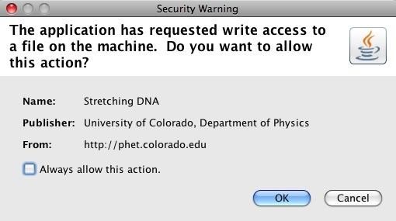

3. What's the process for signing PhET sims?

Signing PhET JAR files requires that we:

- obtain a digital certificate
- create a keystore
- sign JAR files
- add a security entry to JNLP files

3.1. Obtaining a digital certificate

A certificate typically costs hundreds of dollars per year, and is issued by a trusted certificate authority (e.g., VeriSign).

To test the signing process, I obtained a free certificate that works the same way, but does not properly identify the certificate owner. Thawte (www.thawte.com) is one organization that issues such free certificates, and I obtained one for use with Firefox. When Thawte issues a certificate, you receive an email, click a link in the email, and the certificate is added to Firefox. (If you want your identity to be identified in your certificate, you need to join the Thawte Web of Trust. See http://www.thawte.com/secure-email/web-of-trust-wot/index.html.)

3.2. Creating a keystore

A keystore is a file that contains one or more digital certificates. When you are issued a certificate by a trusted certificate authority, you must typically create a keystore that contains the certificate.

To create a keystore containing the certificate I received from Thawte, I had to export the certificate from Firefox. The export steps for Firefox 2.0 were:

- choose File>Preferences>
- select Advanced tab
- select Encryption tab
- press View Certificates button
- select Your Certificates tab
- select the certificate in the list
- press Backup button
- use Save dialog to save to a keystore file in PKCS12 format
- choose a keystore password

For the examples that follow, I exported my certificate to a keystore named pixelzoom.p12.

3.3. Signing a JAR

Before you can sign a JAR, you need to know the certificate's alias in the keystore. From a command line shell, use the Java keytool utility:

% keytool -list -keystore pixelzoom.p12 -storetype pkcs12
Enter keystore password: ****
Keystore type: pkcs12
Keystore provider: SunJSSE
Your keystore contains 1 entry
thawte freemail member's thawte consulting (pty) ltd. id, Oct 1, 2008, keyEntry,
Certificate fingerprint (MD5): ****
%

The alias is “thawte freemail member's thawte consulting (pty) ltd. id”.

Now we have everything needed to sign a JAR. Here's an example for the command line, using the Java jarsigner utility:

% jarsigner -keystore pixelzoom.p12 -storetype pkcs12 ph-scale.jar "thawte freemail member's thawte consulting (pty) ltd. id"
Enter Passphrase for keystore: ****
%

Relative to other parts of the PhET build process, signing is fast. For PhET sims tested, signing took less than 2 seconds.

Signing also increases JAR file size, 5% to 10% for tested sims.

3.4. Configuring a JNLP file

An additional security entry must be added to sim JNLP files, which tells Web Start that the JAR file must be signed. Here's the entry:

<security>
<all-permissions/>
</security>

4.0. The user experience

What does the user see when they run a signed Java application? Here's the bad news... What the user sees varies wildly by platform and by Java version. Let's look at some examples.

If you want to test drive this for yourself, see
http://www.colorado.edu/physics/phet/dev/temp/signing-jars/

4.3. Mac OS with Java 1.5

From a sim's web page, the user clicks “Run Now” on a sim. Web Start downloads the JAR file, and then this dialog is displayed:

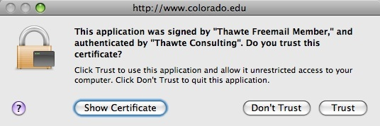

If “Trust” is pressed, the sim will start, and it will be able to perform all trusted functions. Note that there is no option here to “always accept” certificates from this publisher.

If “Don't Trust” is pressed, the sim is not started, and Web Start exits.

If “Show Certificate” is pressed, this dialog is displayed:

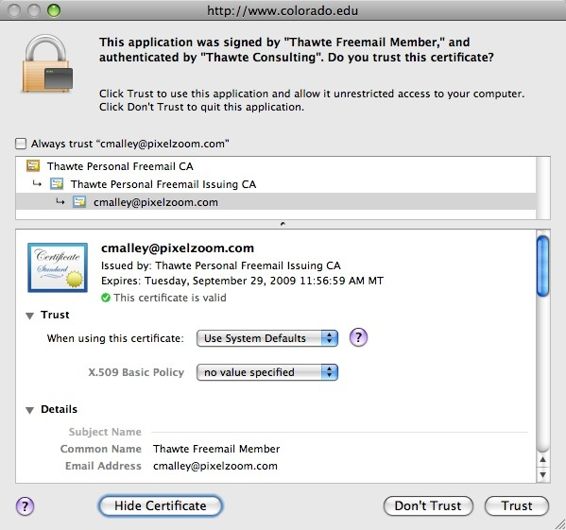

The “Trust” and “Details” portions of this dialog are initially closed. I've opened them so that you can see what they contain.

The small “Always trust...” check box at the top is what the user needs to check if they want to always trust certificates from this provider. This check box is off by default (there is no way for us to change this) and it is difficult to see (I missed it the first few times.)

The Trust combo box contains an “Always Trust” option, which seems to function identically to the “Always trust...” check box.

Electing to always trust (either via the check box or combo box) means that all applications from this publisher will be trusted. There is no option to always trust a single application.

If you choose to always trust, then this dialog is displayed:

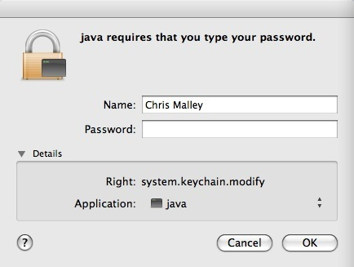

Always trusting a provider involves adding their certificate to your keychain. A keychain consolidates various passwords and passphrases in one place and makes them accessible through a master password. In this case, the master password is your login password.

4.1. Windows with Java 1.4

From a sim's web page, the user clicks “Run Now” on a sim. Web Start downloads the JAR file, and then this dialog is displayed:

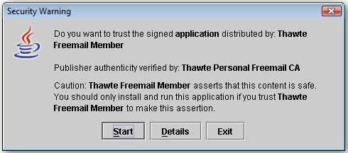

If “Start” is pressed, the sim will start, and it will be able to perform all trusted functions. Note that there is no option here to “always accept” certificates from this publisher. If you press “Start”, this specific sim will always be trusted, and you'll never see this dialog again for this sim.

If “Exit” is pressed, the sim is not started, and Web Start exits.

If “Details” is pressed, this dialog is displayed:

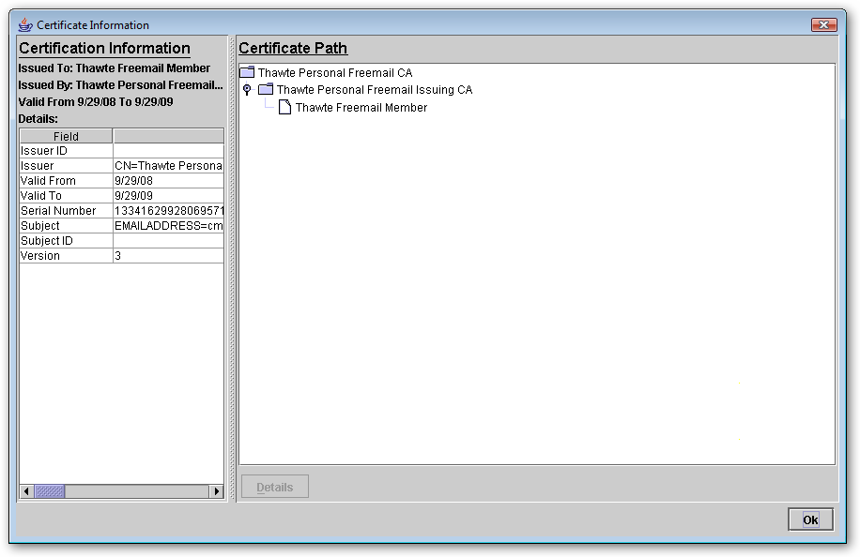
Note that this dialog has no option to “always trust” this provider. That functionality seems to be missing on Windows with Java 1.4.

4.2. Windows with Java 1.5 & 1.6

From a sim's web page, the user clicks “Run Now” on a sim. Web Start downloads the JAR file, and then this dialog is displayed:

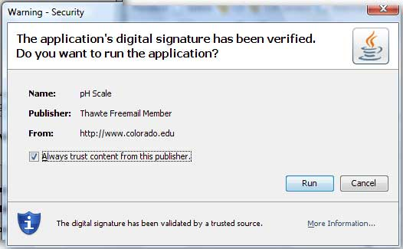

If “Run” is pressed, the sim will start, and it will be able to perform all trusted functions. If you press “Run”, this specific sim will always be trusted, and you'll never see this dialog again for this sim.

If “Cancel” is pressed, the sim is not started, and Web Start exits.

“Always trust content from this publisher” is checked by default. If it is left checked, then the user will never see this security warning again for any application from this publisher. The publisher's certificate is presumably added to the user's keychain, but there is no password process involved as there is for Mac OS.

If “More Information” is pressed, this dialog is displayed:

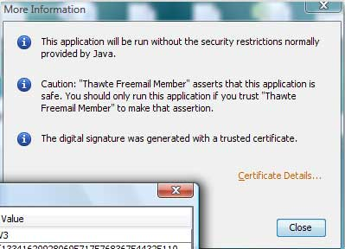

If “Certificate Details” is pressed, this dialog is displayed:

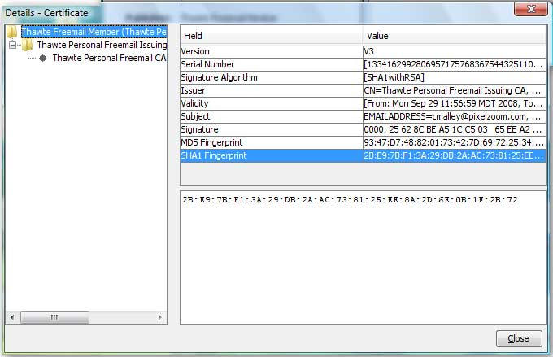

5. Deleting Certificates

What if the user decides they no longer want to automatically trust an application or publisher? The certificate must be deleted from the user's keychain, and the process for doing so varies by platform.

On Windows, certificates can be deleted via the Java Control Panel.

On Mac OS, certificates can be deleted using the Keychain Access utility (a graphical user interface). This utility is accessible from either via the Java Control Panel, or directly from the /Applications/Utilities folder.

6. Conclusions

Signing a JAR is straightforward. Getting a certificate is straightforward. Java provides decent tools for signing. And it should be fairly easy to add to PhET's build process.

The user experience varies widely across platforms. This makes it harder for PhET to provide support, debug, etc.

The “always trust” feature is inconsistent. The “always trust” feature is hidden on Mac OS, and nonexistent on Windows with Java 1.4. This is an important feature for PhET, since we don't want to bother users or scare them away with certificates.

The concept of trust is inconsistent across platforms. If you trust an application once on Windows, it will always be trusted. Mac OS is different; there is no way to trust one application; unless you choose to trust all applications from a publisher, you will always be prompted when running a signed application.

Signing increases JAR file size. For every file in the JAR, a checksum is computed and stored in the JAR. For PhET sims tested, the increase was in the 5% to 10% range.

The process for deploying translations must be modified. Signing a JAR file adds the certificate to the JAR's manifest. The JAR itself is not signed, but instead every file inside the archive is listed along with its checksum; it is these checksums that are signed. This prevents potentially malicious code from being inserted into the JAR. It also prevents us from inserting translation files into a JAR after it has been signed and deployed. We will have to modify our translation deployment process so that JAR files are re-signed after adding translations.

7. Credits

Thanks to Sam Reid for Windows testing, Windows screenshots and document review.

