Discussion of "Glaciers" Sim Design
October 2007

Edited by:
Chris Malley, October 22, 2007
Archie Paulson, October 24, 2007
...

Note: Separate issues are divided by horizontal lines, with some sort of title for the issue at the top of each section.

Display aspect ratio

Chris (Oct 22):
(1) Graphics cannot spill outside of play area. We can either shrink the graphics or crop.

Archie (Oct 24):
This may be a difficult issue. Visualization of glacier motion must be horizontally oriented, and can get very long. The figure in the design document is already stretched vertically (see the coordinates in slide 14), and too much stretching would surely lead to student misconceptions about the slope of the mountain. The problem is that we will need to show the glacier at zero-length and at great length. For example, the following three figures show a glacier in the Sierra Nevada at various stages of growth (see the middle valley; the figures display 50km by 50km):
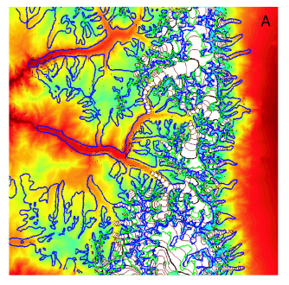
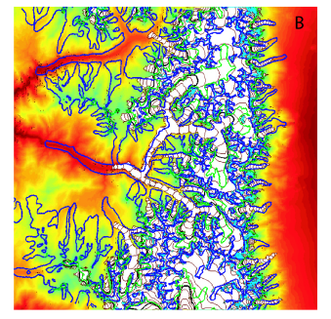
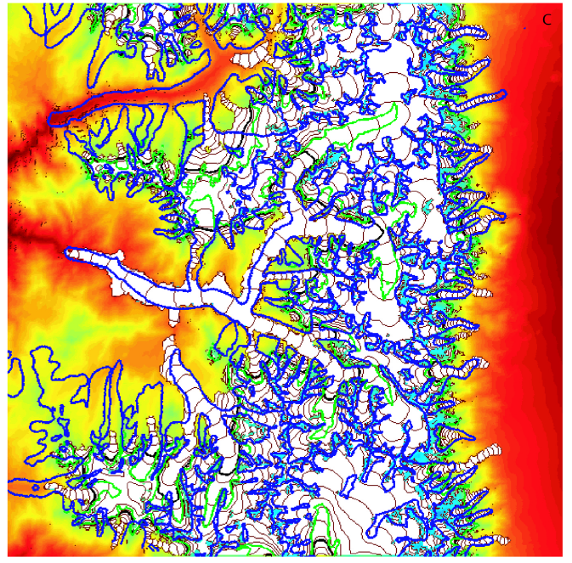
The thing starts from nothing and grows to about 30 km in length. The glacier is about 2km wide and the altitude change over its final length is about 2km.

Here's an idea. We could have two panels: a top panel shows a zoomed-in view of the glacier and valley, looking pretty much like what it currently shown in the design document (version 0.1); the bottom panel shows the entire region into which the glacier may grow, looking something like the figures above. I made a rough sketch below. Perhaps the user could click on the lower panel to show that segment of the glacier in the upper panel.

Anyone have any other ideas?

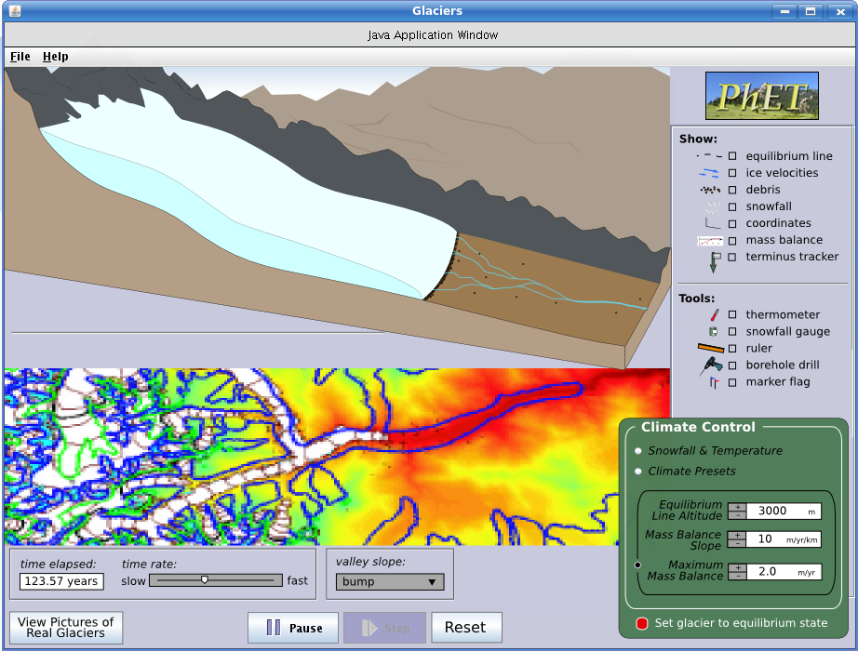

Multiple snow/temp gauges

Chris (Oct 22):
(2) Is there any need to have multiple thermometers or snowfall gauges? The current interface only allows you to have one of each. It seems like it would be useful to measure these things at multiple points along the glacier for comparison.

Archie (Oct 24):
I don't think we need multiple gauges. At any given time the user could drag around a gauge and see the spatial dependence. If there's an easy way to have multiple gauges, that would be fine, too.

How are the marker flags planted

Chris (Oct 22):
(3) How are the marker flags planted? The control for flags is a checkbox, so what we have is an interface for showing/hiding flags; we don't have an interface for planting flags.

Archie (Oct 24):
I imagine clicking the check box, having the pointer change to a flag, then a click on the play area plants a flag (if it's not below ground or ice). This would mean, I suppose, that only one tool should be selectable at a time. Should we put radio buttons there instead of check boxes?

Borehole drill

Chris (Oct 22):
(4) Slide #19 describes the borehole drill. Need more information for this, I don't understand what you're expecting to see here. How do we "show the shape of the vertical velocity profile"? Can I drill multiple holes, and if so how does this affect what we're showing? Can I delete holes that I've drilled? How does the user know what to do with this tool?

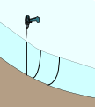
Archie (Oct 24):
Selecting the drill, then clicking on the glacier cross-section should draw a vertical line in the cross-section (a vertical hole bored into the ice). As the ice moves, the top of the glacier flows faster than the bottom, so the vertical line deforms according to the vertical velocity profile. You can drill several holes at the same place, and they should look something like the figure at the right. I'm not immediately sure how to make its use clear to the user, except that boreholes are a common glaciological tool.

Quantitative measurements

Chris (Oct 22):
(5) The user can make quantitative measurements of snowfall, temperature, distance and time. How will they use these measurements? Do the measurements need to be quantitative?

Archie (Oct 24):
I think the quantitative measurements are needed to learn about glacier evolution. Eg: thickness versus time, temperature versus altitude or time, length versus time, steady-state length for given climates, mass balance as a function of snowfall and temperature, etc.

Other glacier types

Chris (Oct 22):
(6) Is it sufficient to handle only "Valley" type glaciers? Is there any reason why you might want to allow the user to change glacier type? (eg, cirque, Piedmont, tidewater).

Archie (Oct 24):
The physics of the valley glaciers are best understood. Nobody really knows, for example, precisely how the basal lubrication of tidewater glaciers works. Maybe a glacier expert should weigh in here.

Sublimation

Chris (Oct 22):
(7) Is it necessary to show a visual representation of sublimination? We are showing snowfall and melt water, but are not showing sublimiation (conversion to water vapor).

Archie (Oct 24):
My opinion is no. We could just call it ablation (a common term in glaciology) and leave it at that. Besides, I don't think anyone knows precisely how much is melt and how much is sublimation.

Labels for accumulation and ablation zones

Chris (Oct 22):
(8) Do we need to visually represent the accumulation and ablation zones? The equilibrium line separates these zones, but show the zones be labeled?

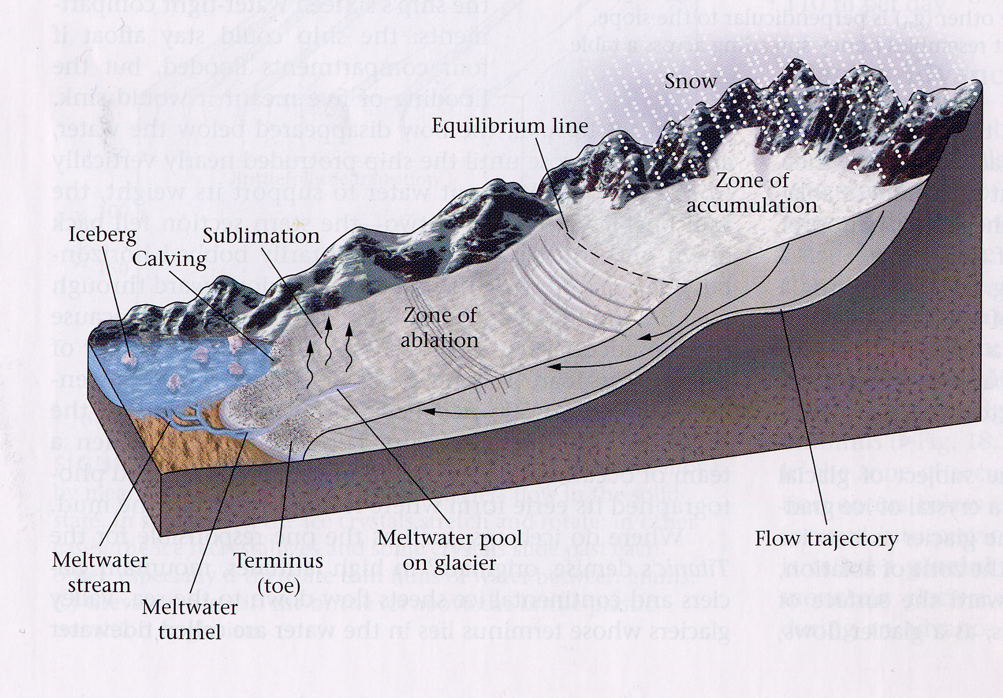
Archie (Oct 24):
I think we could do something like is done in the figure here (sorry, difficult to see). Namely, the accumulation zone looks white due to snowfall and the ablation zone looks like dirty ice due to melt. That would be a nice addition.

Glacial budget graph

Chris (Oct 22):
(9) Would it be useful to show a graph of "glacial budget" (accumulation vs ablation) over time?

Archie (Oct 24):
I'll defer; I don't know if that would be useful.

Tool for slope measure

Chris (Oct 22):
(10) Do we need a tool for measuring steepness of the slope?

Archie (Oct 24):
I don't think that is necessary.

Sediment in runoff

Chris (Oct 22):
(11) Do we need to show how the amount of sediment in meltwater runoff varies? Perhaps by changing the color of the meltwater runoff?

Archie (Oct 24):
As I understand it, the sediment content of the runoff varies mostly by season (high in the summer and low/zero in the winter). Thus any color change would occur on a timescale much faster than glacial motion. Watching the glacier move, then, would be accompanied by a rapidly flashing runoff color.

Long-term effects

Chris (Oct 22):
(12) Any need to include the long-term effects of plate tectonics and/or orbital dynmamics on glaciation? Or is our time scale small enough to ignore these factors?

Archie (Oct 24):
Those effects would be captured in the climate model.

Multiple tabs

Chris (Oct 22):
(13) Does this simulation have only one panel? (ie, it doesn't have multiple tabs across the top)

Archie (Oct 24):
I don't see any reason to include multiple tabs. But I guess we should be sure of that in case we freeze the feature out, right? Anyone else?

3D model

Chris (Oct 22):
(Development issues) (1) 3D perspective of a moving/evolving glacier will be a challenging (expensive?) programming task.
Challenges include:
- modeling a dymanic 3D shape (and rendering it using 2D programming techniques)
- fragmentation of the shape (crevasses?) as the glacier recedes
- mapping the 3D shape onto a 3D shape of the valley/mountains
- making the equilibrium line conform to the surface contour of the shape
- placing debris on the surface and cross-section of the shape
- forming an end moraine
- pacing vectors in the cross-section of the shape (and possibly on surface)
- can't use our existing ruler because this one needs to be in 3D perspective
- contour lines to show age of ice
(2) We may need to consider using a 3D library for this sim, something we haven't done in a PhET sim yet.
(3) An option to switch between perspective and side views (proposed on slide #20) could double the effort required for the "view" portion of this sim.

Archie (Oct 22):
The model is strictly two dimensional, with the third dimension being an extrusion of the other two.

Chris (Oct 22):
Showing a 3D perspective certainly doesn't require a 3D physical model. But showing a 3D perspective (even of a 2D model) has a whole set associated programming challenges in order to make the 3D look convincing. So regardless of whether the model is 2D or 3D, this will still be a challenging 3D project.

As for the model... Your assumption is that we can take a 2D model and simply extrude it into the third-dimension. But it's not clear to me that the model is totally 2D. For example, you're showing debris distributed across the top surface of the glacier. There needs to be a model of how the debris moves, how it's distributed across the surface, etc. And how about slides #5 & #6? When the glacier is close to "gone", you're showing patches of ice that are not representable by a 2D model; those are not 2D shapes that are extruded into 3D.

If the model is truly 2D, then we'll have to figure out how to fake some of the 3D visuals.

Climate controls

Chris (Oct 22):
(Suggested changes, 1) Climate controls are difficult to build as designed. A radio button can only have an associated label, not an entire panel. I suggest we have 3 radio buttons labeled "Snowfall & Temperature", "Climate Presets" and "Edit Mass Balance". When one of those buttons is selected, the controls related to that selection appear below the radio button. Controls associated with unselected buttons are hidden. (No need to redo your slides, we can simply note this change if it's acceptable.)

Archie (Oct 24):
Sounds good to me.

Placement of time slider

Chris (Oct 22):
(2) Move the time display and time rate slider to left of the Pause/Step/Play buttons. See (for example) "Bound States" simulation. All clock controls are generally grouped together, and this is a standard control (part of our common library) that we can reuse.

Archie (Oct 24):
Fine by me.

Placement of "View Pictures of Real Glaciers"

Chris (Oct 22):
(3) Move "View Pictures of Real Glaciers" button to main control panel (below Tools) or to Help menu. Other simulations put this kind of thing in the Help menu (for example, see Optical Quantum Control, Help>Explanation), but it's doubtful that users find this under the Help menu. So if we have room in the control panel, let's start by putting it there.

Archie (Oct 24):
Sure.

Reset / Restart

Chris (Oct 22):
(4) "Reset" button for clock controls show probably be "Restart" -- assuming that this sets time to zero. We use "Reset" in other contexts, and using Reset for the clock could cause confusion.

Archie (Oct 24):
Ok.

Snowfall/temp controls quantitative

Chris (Oct 22):
(Questions, 1) Snowfall and temperature have quantitative controls (no values, no units), but the tools used to measure them are quantitative (they have specific values and units). Should the controls also be quantitative?

Archie (Oct 24):
The amounts of snow and the temperature will vary with elevation. The user will change some constant value and the snowfall/temp will then be set according to some function of elevation. I suppose the control could say "set sea-level temperature," for example, but that seems unnecessary to me.

Valley slope

Chris (Oct 22):
(2) There are 3 options for "valley slope". The "bump" option is shown, and I assume that "linear" is just a straight line from the highest elevation to the valley floor. What does "simple curve" look like? And is this a fixed curve or is it somehow adjustable by the user?

Archie (Oct 24):
Yes, the "linear" is just what you said. The "simple curve" would probably be an inverted parabola. We could make the slope adjustable if that would help the learning goals. Any comments on that from the others?

"Set to equilibrium state" button

Chris (Oct 22):
(3) Is the "Set glacier to equilibrium state" button a toggle button? Or can it be pressed repeatedly to make the glacier go to the steady state shape?

Archie (Oct 24):
The latter. It's like a reset button, sending the glacier to its steady-state shape. The steady-state shape is a direct function of the current climate conditions.

"Reset All" button

Chris (Oct 22):
(4) We typically have a "Reset All" button at the bottom of the control panel. Pressing this button resets everything to it's default state (the initial state when the sim was started.) Do you want a "Reset All" button?

Archie (Oct 24):
Yes, that's sounds good.

Time-dependent climate control

Chris (Oct 22):
(5) I don't understand the last bullet item on slide #20 ("climate control should have...) Can you elaborate and show what the user interface would look like?

Archie (Oct 24):
This requires a little more thought on our part. At the moment, the climate controls are fixed values, constant in time. We should, I think, be able to have time-dependent controls (ie, setting a beginning state and and end state, then letting the sim slowly change the climate accordingly). I'll have to think more about the interface to that. But I think this is an important feature. I'll consider it a priority to develop the interface.

Debris show/hide

Chris (Oct 22):
(6) Does the "debris" checkbox simply show/hide debris that is always part of the model, or does it add/remove it from the model?

Archie (Oct 24):
Simply show/hide.

Physical model

Chris (Oct 22):
(7) What is the physical model for these things? :
- glacier's shape (3 dimensional)
- ice velocity at a point
- position of the equilibrium line
- how ice moves downslope due to internal deformation and basal sliding
- creation of debris by quarrying (plucking) and abrasion

Archie (Oct 24):
I'm working on the model presently.

Do models exist?

Chris (Oct 22):
(8) Do physical models exist for all of the things we want to model? Are they well understood?

Archie (Oct 24):
The models do exist, though they require some reformulation for our purposes. We have only included processes that are well understood.

