Glacier Sim
design version 3

Wendy Adams, Bob Anderson, Andrea Bair, Chris Malley,
Archie Paulson, Kathy Perkins, Dylan Ward

Nov 16, 2007

http://www.colorado.edu/physics/phet/dev/glaciers/webpage

Contents

Changes in Version 3 2
Sim Basics 3
Climate Controls 4
View Options 5
Toolbox 6
Learning Goals 8
Usage Scenarios 9

Changes in Version 3

We wanted a less-cluttered interface. Changes made to the climate controls are desired for new learning goals.

Changes: (in approximate order of importance)
- Two tab view (“basic” and “advanced”). The first tab has simpler climate controls, the second tab has the complete controls. See page 3 for description of tabs.
- New climate controls. Complex climate controls are only shown on the “advanced” tab, and are described starting on page 8. While the climate controls have changed substantially, the options are nearly the same as in version two. The only exception is an option to follow the historical climate record for the last 750,000 years (as published).
- New option (only in “advanced” tab) for popping up plots of various quantities (page 12).
- New option for showing age of ice (page 12).
- New tool “glacial budget meter” replaces the “snow gauge” (see page 16)
- The shape of valley will not be a constant linear slope, but will have some variability. The new valley slope (not shown in the figures) will be steep at very top, go (parabolically) to a less-than-average slope at a distance approximately one half of the main view from the top of the valley, and then assume a constant slope near the edge of the main screen and maintain that constant slope for the rest of the valley. Consider this a suggested shape for now – the actual shape may change on future iteration of this design. The valley floor shape will not be changeable by the user, but will stay constant in time.
- New interface for borehole drill – now a tool rather than a view option (page 16). This change was made due to the problems that students often have with tools which replace the mouse (Wendy), and because it really is a tool rather than a view option.
- Closeup-view (main glacier view panel) will follow the terminus of the glacier by default. Removed “view follows terminus” view.
- Top panel (whole-valley-view) is no longer a satellite photo, but a cartoon depiction of the entire valley (just a zoomed-out view of the main glacier view).
- No longer any “terminus tracker”. User can access this information with the plotting capabilities (page 12), or by watching the coordinates.
- Removed “mass balance” in view options. User can plot this (page 12) if desired.
- No more “ruler” in view options. Redundant with other capabilities.
- “View debris” is no longer an option; debris is always shown (page 3).
- There should be some graphical changes that cues the viewer to the fact that this is a perspective cross-section picture. No such changes are made in the figures shown here, but could include such things as texture within the rock and consistent shading of those surfaces within cross-section and those facing upward.
- “Set Glacier to Equilibrium” → “Set Glacier to Steady State” to avoid confusion with “equilibrium line” which has a different meaning
- “ice velocities” → “ice flow” for better clarity

Sim Basics

Layout:
Two tabs: “basic” and “advanced”
- the “basic” tab shows the view options (but not the plotting options) and simple climate controls (only snowfall and temperature sliders)
- the “advanced” tab shows all view options, plotting options, and sophisticated climate controls
- the first three learning goals (page 21) can be met on the “basic” tab
Two glacier-view panels: a thin whole-valley-view panel across the top, and a large closeup-view panel in the center
- there is a marker in the whole-valley-view that shows which part of the valley is visible in the closeup-view
- by default, the closeup-view will keep the end of the glacier (“terminus”) in the window
- the marker in the whole-valley-view can be dragged to change the region seen in the closeup-view
- arrows at the left and right edges of the closeup-view can be clicked to pan left and right
Glacier (in closeup-view):
- Animation should show rocks being lifted from the valley floor and entrained in the ice flow (so users get the notion that erosion is occuring). This replaces the version 2 option to show debris. Note this is not shown in the figures in this document.
- Toolbox in the play area (see page 16)
- closeup-view will follow the end of the glacier (terminus) until the user manually changes the view, at which point the closeup-view will stay at the same point in the valley (or move according to user control). If the user moves the terminus back into the closeup-view, the closeup-view will again follow the terminus.
Control panel:
- “view options” (page 12) are the same in both tabs; allow user to toggle visibility of certain features
- climate controls (page 8) are different in the two tabs
- in the advanced tab has options to plot various quantities (page 12)
Time controls:
- years tick by on the clock in the lower left
- the rate of time passage may be changed with the slider by the clock
- the “Reset All” button sets clock to zero
Window menu:
- “File” menu standard
- “Help” menu includes an option to show pictures of real glaciers. This will help the student transfer the objects seen in the sim to aspects of real glaciers.
Qualitative Physical Model:
The glacier's thickness (versus position and time) depends on (a) shape/slope of valley floor, (b) temperature (a linear function of elevation), and (c) precipitation rate (also a linear function of elevation).
Temperature and precipitation can be combined to form a function called the mass balance (or “glacial budget”), which equals growth (due to precip.) minus ablation (melt and sublimation). The mass balance gives the rate of change of glacier height per unit time as a function of elevation.
A mass balance which is constant in time results (eventually) in a steady-state glacier. In steady state, the glacier is flowing downhill as it gains ice over its upper half (positive mass balance) and loses ice over its lower half (negative mass balance). The line that divides these two regions is called the “equilibrium line”. Neither the thickness nor the length of the glacier changes in steady state.
The velocity of the ice (known throughout the glacier at all times) is nonzero at the bottom of the glacier (due to sliding), and increases with vertical height, as shown in the figure at the right. Thus a vertically-drilled borehole will change shape into something like the right-hand side of the letter 'U'.
“End moraines” are rock deposits that appear at the glacier's endpoint (“terminus”). An end moraine appears when a glacier is in steady state and is destroyed when the glacier overruns it's position.
Default State:
The following will be the initial state of the sim when started, as well as the state assumed when the user clicks 'Reset All'.
- starts in “basic tab”
- Glacier is at steady state, with a length that fits in the window
- climate controls are near the middle of their available range
- closeup-view will follow the end of the glacier (terminus) until the user manually changes the view.

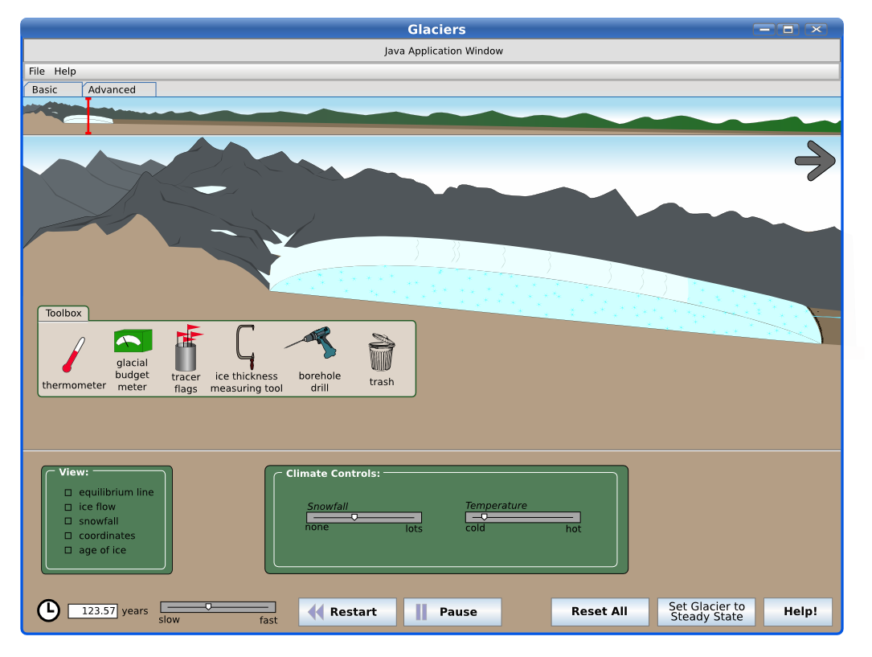
Marker shows location of close-up view below
Simple climate controls in “Basic” tab
Two tabs
Glacier color changes slightly at equilibrium line
User can click on arrow to pan the close-up view down the valley
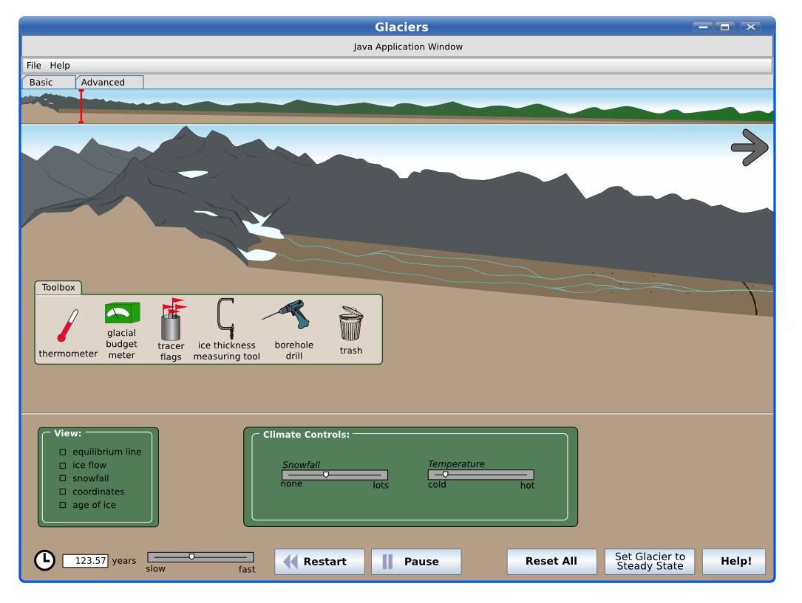
End moraine left behind.
After the glacier melts completely.
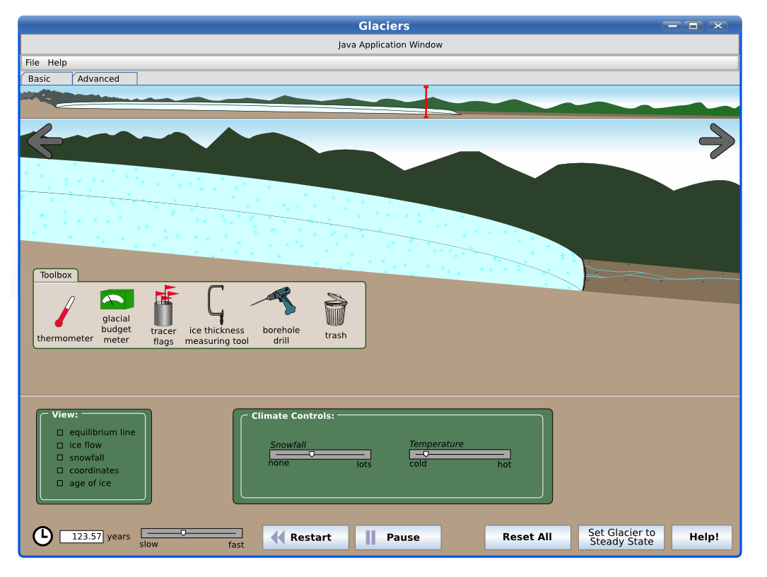
After some glacier growth
Indicator shows we're further down valley.
Left-panning arrow is available to shift view up-valley.

Climate Controls
Basic Tab:
This is the default initial state. The climate controls in the basic tab will be nothing more than two sliders: snowfall and temperature. These two sliders govern some reference values of snowfall and temperature (actual values depend are altitude dependent).
Advanced Tab:
The climate controls here offer (as in version 2) three ways to set the climate, with an additional control for time-dependence. Under the “Set To” label, the options change depending on which radio button is selected. When a climate setting is selected in the middle (“Set To”) section of the climate control panel, the climate will assume these settings at the time chosen under the “When?” section.
“Set To” offers the following climate settings
- “snowfall and temperature”: these are the same as in the basic tab
- “climate presets”
  - “modern climate”: current climate conditions
  - “ice age climate”: climate conditions at the time of the last glacial maximum (about 20,000 years ago)
  - “anticipated 2050 climate”: the climate anticipated by the IPCC to prevail in 2050
  - “750,000 year climate history”
- “mass balance”: the mass balance equation can be edited by hand with these options
“When?” describes when the climate will assume the settings prescribed under “Set To”. If it's not “now”, the snowfall and temperature will move linearly to that setting in the time prescribed. The drop-down options are “now”, “in 10,000 years”, “in 50 years” -- these options accommodate the options in the “climate presets”.
“Set Glacier to Steady State” button:
As described on page 3, any given climate setting has an associated “steady state” glacier. When the glacier is at steady state, its length and thickness do not change (although ice is accumulating, ablating and flowing as usual). Clicking this button will set the glacier immediately to the steady state appropriate for the current climate conditions.
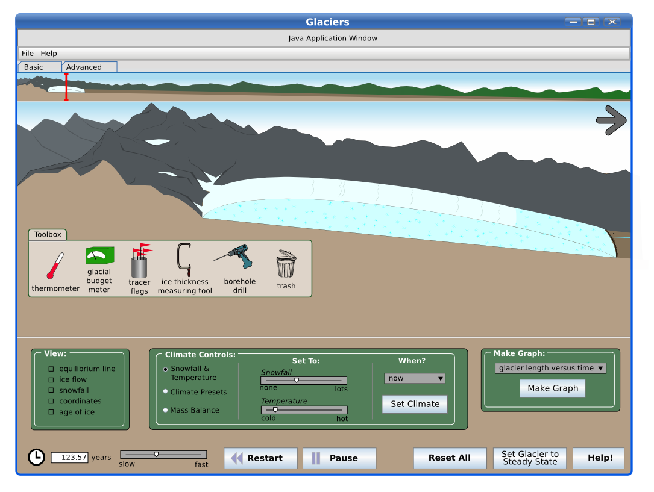
Now in “Advanced” tab.
Time-dependent climate controls available.
Make Graph options available.
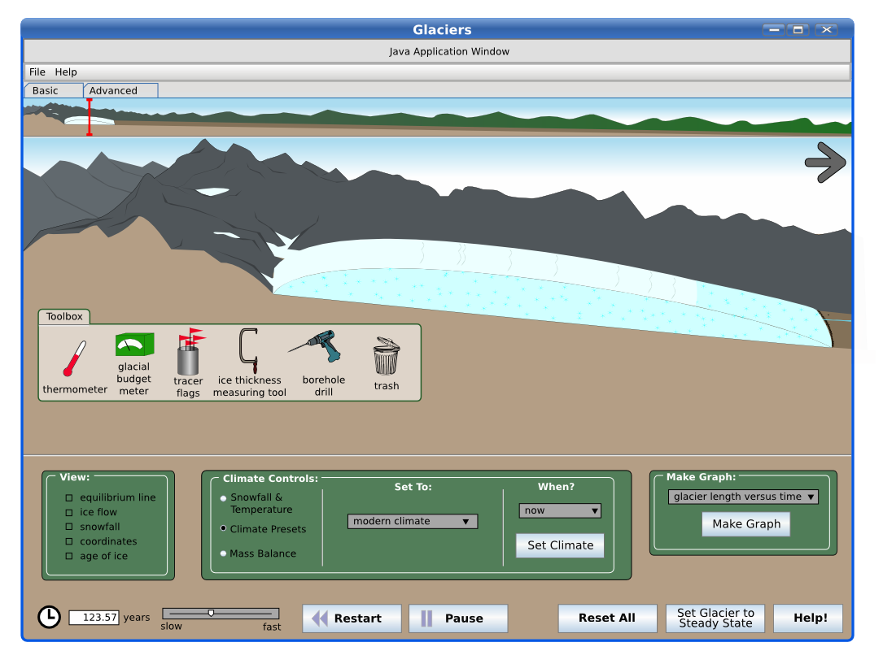
“Climate Presets” selected.
Select a climate preset.
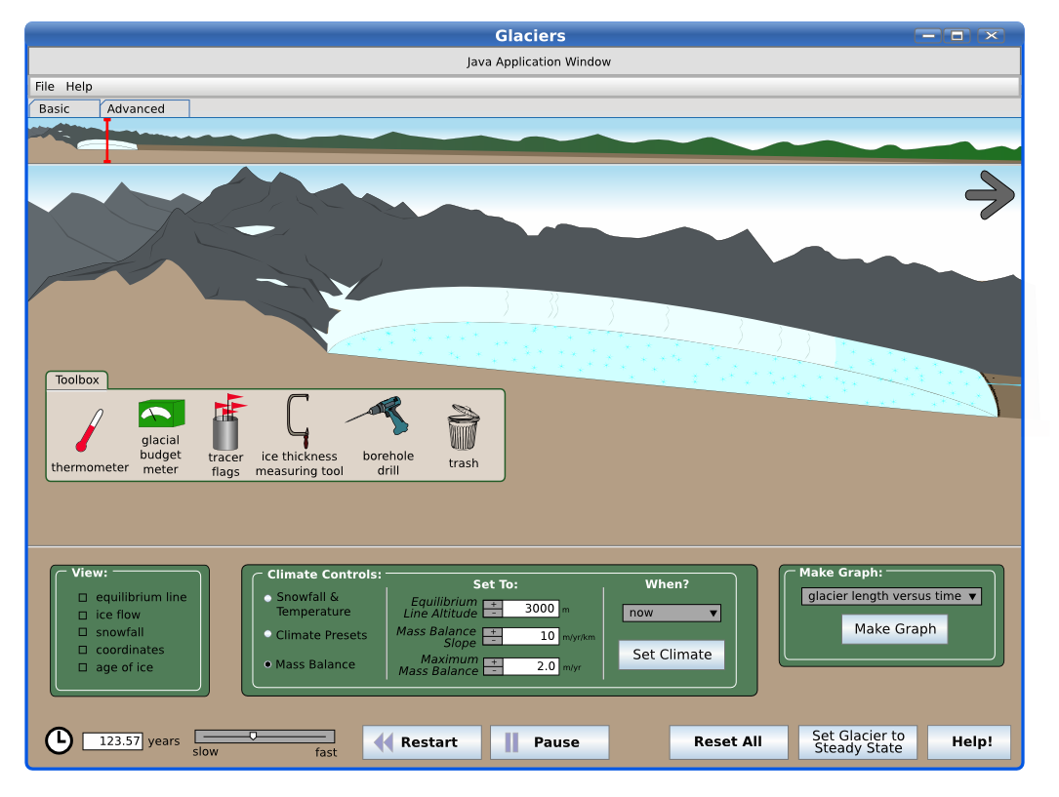
“Mass Balance” selected.
Directly edit the mass balance.

View Options

View options:

Options are checkboxes. They can have icons or not (as in version 2), if they're helpful.
- “equilibrium line” shows the altitude of zero mass balance.
- “ice flow” (formerly “ice velocities”) shows a vector field of current ice velocity at all positions within the ice.
- “snowfall” will show the animated falling snow at all elevations (heavier at higher elevations).
- “coordinates” will show elevation on the vertical axis and distance on the horizontal axis.
- “age of ice” will show contour lines in and on the glacier, indicating the age of the ice; this information should be easily derivable from the physical model

Make Graph:
On the “advanced” tab, the user can generate graphs (plots) of various quantities. The plots will appear in pop-up windows. The interface for selecting the quantities is comprised of a drop-down menu and a button to make the plot. Options in the drop-down menu are:
- glacier length v. time
- equilibrium line altitude v. time
- accumulation v. altitude
- ablation v. altitude
- mass balance/ glacial budget v. altitude
- temperature v. altitude
- valley floor v. altitude
All these quantities can be derived directly from the physical model. The time axis will be set to zero at the last time the user clicked “Restart” or “Reset All”.

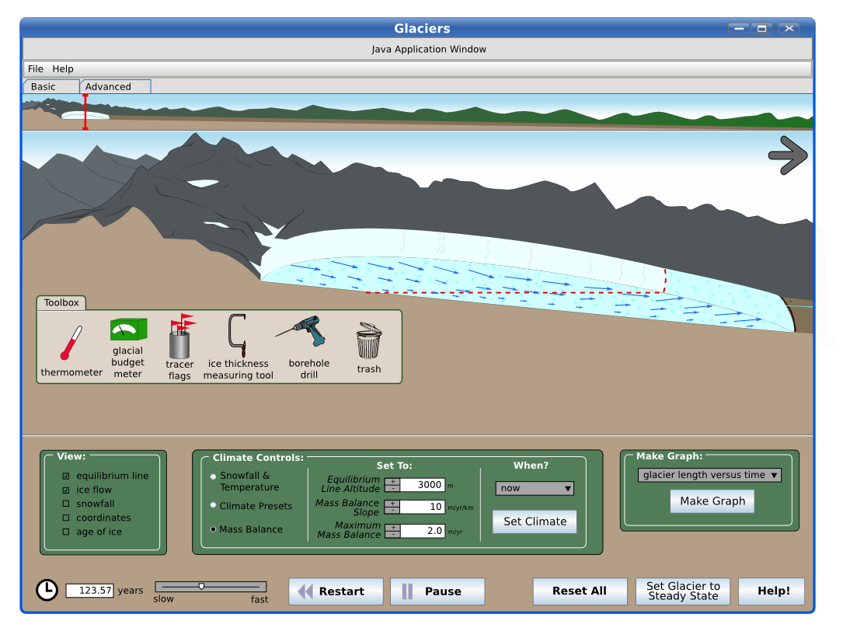
View equilibrium and ice flow are checked..
Ice velocities shown as vectors.
Equilibrium line altitude
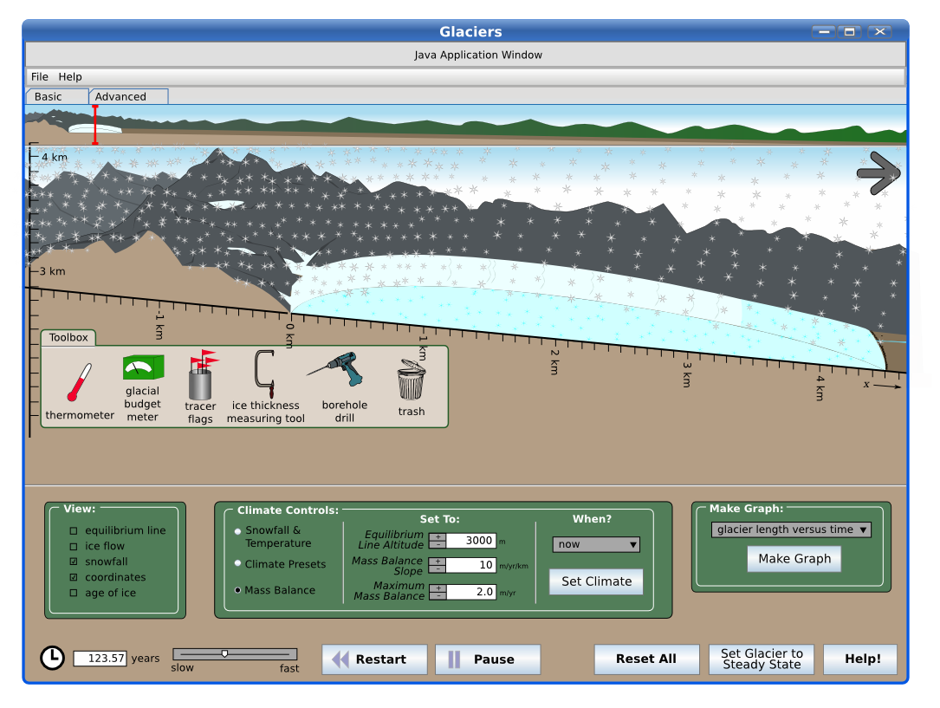
Snowfall and coordinates are checked..
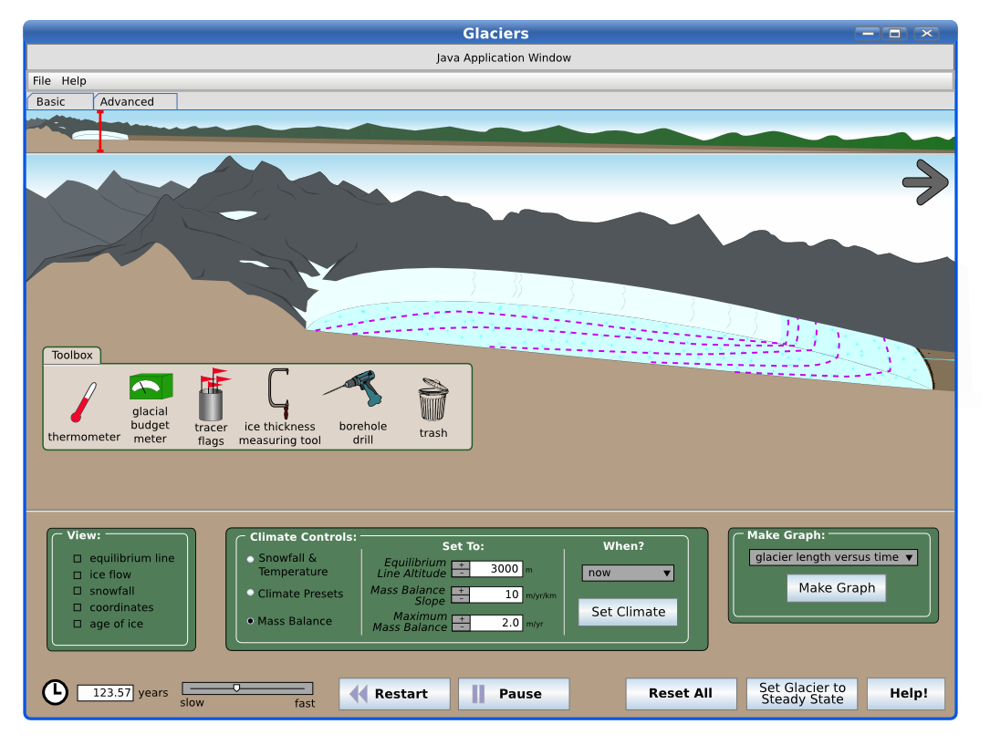
“Age of ice” checked..

Toolbox

In the “Toolbox” the user sees various tools that can be dragged onto the glacier. There can be multiple instances of any tool on the glacier. Tools are removed by dragging to the trash, or dragging back to the toolbox.
Tools:
- “thermometer” (unchanged from version 2) gives a temperature-measuring tool. It reports the atmospheric temperature wherever it is dropped. It should be excluded from the cross-section region since we don't keep track of ice temperatures.
- “tracer flags” (replacing “marker flags” from version 2) allow the user to plant flags in and on the ice. Once planted, the flag will move with the ice flow, including into its interior if that's where the ice is moving. A flag can also be planted within the glacier, and also moves with the flow. If a flag is dropped above the glacier, it will fall onto the ice and then behave as before.
- “glacial budget meter” (replaces the “snow gauge” from version 2) looks like a generic meter. It can be dragged onto the ice and reports three local values: the net snow accumulation, the net ablation (melting plus sublimation), and their difference (called the “mass balance” or the “glacial budget”)
- “ice thickness measuring tool” (unchanged from version 2) can be placed on the glacier to read out its thickness at some point
- “borehole drill” is a tool to drill vertical boreholes in the ice (in the “view options” in version 2). Since this really is a tool, it makes more sense to have it in the toolbox. It can be dragged to the ice surface and when released it will drill a hole through the glacier to the ground and then disappear (or zip back to the toolbox). The hole drilled will start out as a vertical column and then deform according to the local ice velocities (thereby showing the differential velocities of the ice flow)
- “trash” is not a tool, but a place to drag tools off the glacier for removal. Tools are also removed if they're dropped anywhere in the toolbox.

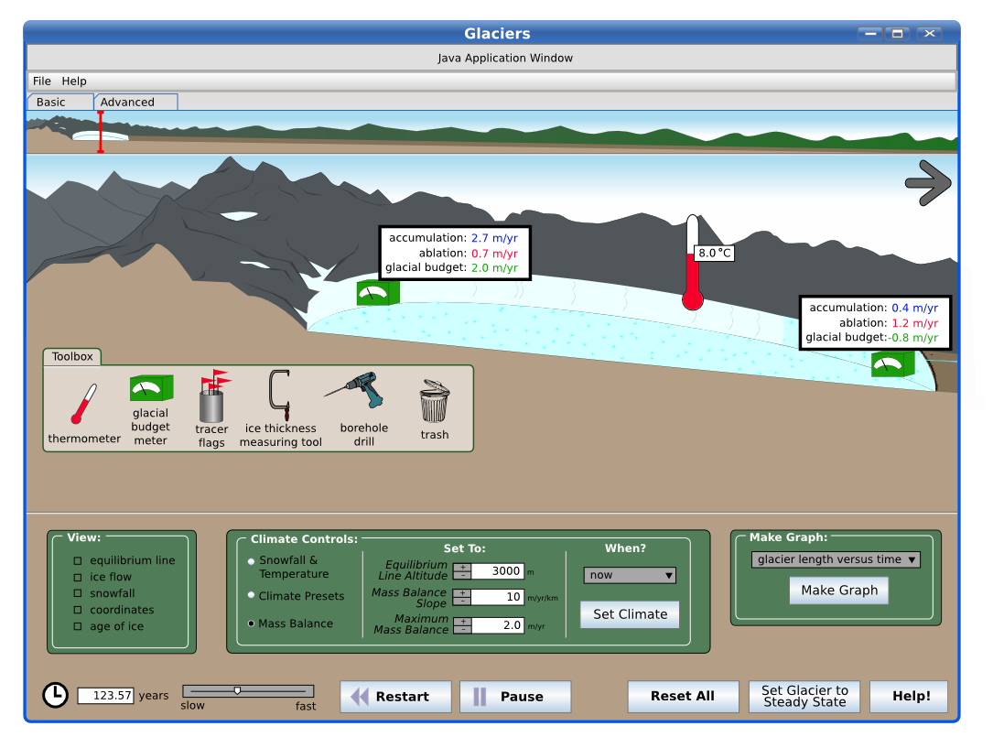
glacial budget meters show mass balance values at a single point on the glacier
thermometer
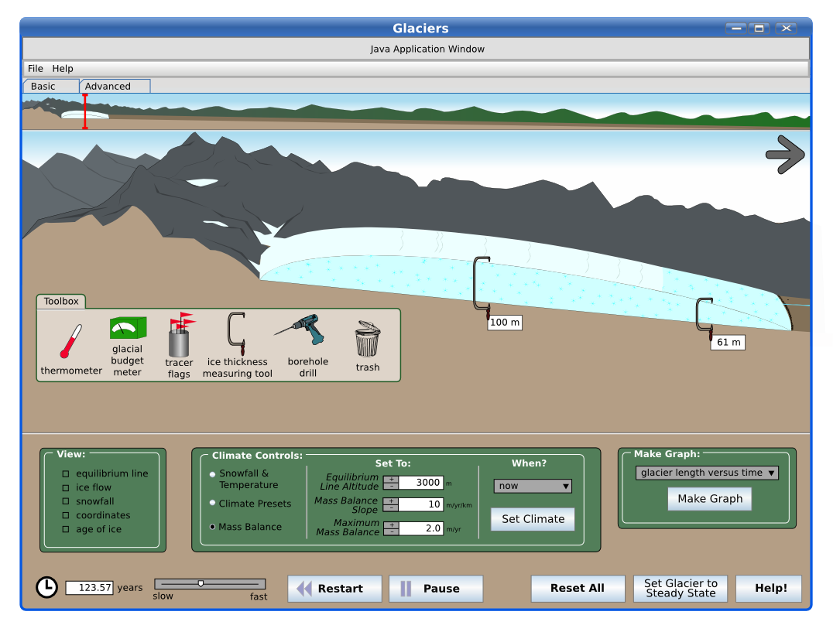
Readout of ice thickness at one point.
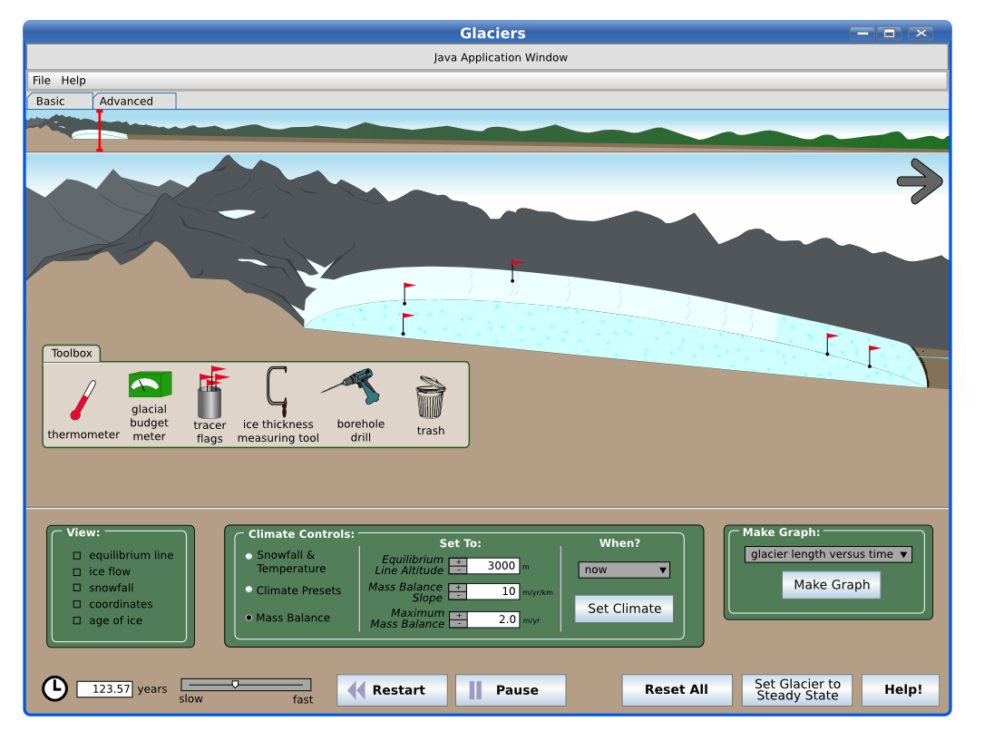
Tracer flag placed on the surface.
Flags remain on top of ice after following the flow up to the top of the glacier
Flags can be placed at any depth.
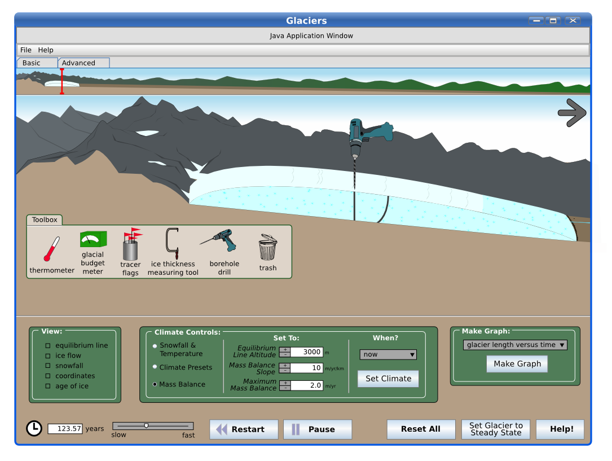
Old borehole shows relative ice velocities.
Newly drilled borehole.

Learning Goals

1. Explain how environmental conditions (Temperature and precipitation) impact glacial mass balance (or the glacial budget), and identify where snow accumulates in a glacier and justify why.

a. Locate where net ablation and net accumulation occur in relation to the Equilibrium Line Altitude (ELA) in a glacier at equilibrium.

b. Describe how temperature and precipitation affect the mass balance of the glacier (sometimes called the glacial budget), starting with a glacier at equilibrium.

2. Explain how ice moves within a glacier (describe and illustrate flow within a glacier).

a. Describe the relationship between the speed of ice flow and vertical position within the glacier.

b. Predict where ice is oldest.

3. Glacier growth and retreat.

a. Explain or illustrate (demonstrate) how glaciers (i) stay at equilibrium, (ii) grow/advance, (iii) shrink/retreat, and (iv) form, and compare climatic conditions leading to each.

b. Compare the motion of ice when a glacier is a glacier is (i) at equilibrium, (ii) advancing, (iii) retreating.

4. Determine and illustrate how multiple advance-retreat cycles affect the record of glacial moraines (end moraines).

5. Design an experiment to test how glaciers respond (magnitude), and how long it takes for glaciers to change (rate of change) in response to climate change, and interpret the results.

Usage Scenarios

(numbers correspond to learning goals, page 21)

1.a. User begins with default glacier, and with the ELA marked on the glacier. User chooses the "snowfall gauge" and can examine values of snow accumulating in different places on the glacier. The snowfall gauge should return values of snow actually falling (short-term) and long-term accumulation (falling-melting)? User should note that snow falls both above and below ELA (maybe even at same rate of short-term accumulation) but the overall patterns are net ablation below ELA and net accumulation above.

1.b. User begins with a glacier at equilibrium (neither advancing nor retreating; this should be the default setting, with moderate values for both T and Precip, so they can be changed in both directions), with the ELA marked on the glacier. User chooses different values for T and precip, and observes the location of the ELA and size of glacier. Hopefully, user will choose extreme values...user may be directed to try particular combinations of values, or to record values chosen and response.

2.a. User begins with default glacier. User selects the option to show ice velocities to view the flow paths. User pauses the sim and places tracer flags on and in the glacier. The sim is un-paused relative motion of the flags is observed.

2.b. User begins with default glacier. User observes ice velocity as in 2.a. User selects option to show age of ice.

3.a.i. User begins with glacier at equilibrium. User then can adjust the temperature and snowfall conditions to change size of glacier

3.a.ii. User begins with a glacier at equilibrium (with moderate values for both T and Precip), and adjusts T and Precip trying to get the glacier to grow. User may be asked to make measurements of the length of the glacier to judge whether it is changing size, and somehow to get an idea of the size of the ablation/accumulation zones relative to the total mass or length - I think what happens is that we can 'see' the zone of ablation getting bigger relative to the whole glacier, until the glacier reaches equilibrium.

3.a.iii. User begins with a glacier at equilibrium (with moderate values for both T and Precip), and adjusts T and Precip trying to get the glacier to shrink. I think what happens is that we can 'see' the zone of accumulation getting bigger relative to the whole glacier, until the glacier reaches equilibrium.

3.a.iv. User begins with no glacier (with temperature and snowfall conditions set at equilibrium with no glacier forming). User then adjusts the temperature and snowfall conditions to create a glacier. Suspect that novice users will first decrease the temperature, so good if default temperature is moderate but snowfall is nil. User should have to increase snowfall to cause formation of glacier. Eventually the glacier will come to equilibrium and stay the same size.

3.b.i. User starts with the default glacier at equilibrium; either we expect them to know at this point how to adjust the climate variables to produce advancing and retreating glaciers, or there needs to be an option to directly set the behavior (and somewhere read off the climate variable values). Some quantitative measure of motion may be necessary. The user should discover that ice moves faster when it is thicker, so they will need to measure the ice thickness too.

4. Users choose the 2nd panel, in which they can select a particular climate history or set of conditions. This particular goal can be met by using ice core data that is available for the last ~700,000 years (proxy for temperature), and running the sim like a movie. We'll need to consult with Bob about the appropriate values of snowfall.

Users should be able to view a graph of the length of the glacier over time, along with moraine deposition and preservation (some sort of indication of which moraines are preserved right on the graph.)

5. Users choose the advanced tab, and can choose particular climate histories/ trajectories, or choose to directly select the climate change (options: a ramp, simple oscillation, or the ice core-driven data described above).

Remaining Issues
Not necessarily a complete list here...
- reset clock when clock rate is changed (for purposes of plotting)? or change horizontal plotting scale?
- how to get rid of all instances of a particular tool?
- what to do when glacier gets too long or thick?
- is there a way to know when the glacier is at equilibrium?

