################################################
# To Do
################################

• Bug: On test laptop, Java 1.5, during user interaction with the platform, clock is not able to tick
• Bug: Beetle graph appears empty before beetle is on the platform
• Bug: Transparency is not being used correctly on Mac.
• Invert coordinate frame so that +x and +y are in 1st quadrant
• Improve performance
• On graph readouts should have a better (fixed) layout.

There is still a very large delay on the v and a vectors when dragging the bugs around on my machine … it makes it look like the arrows are pointing outwards for acceleration, not inwards when I move in a circle by hand.

Its pretty easy to get a discontinuity in the drawing of the lines for the wheel which makes it look odd.
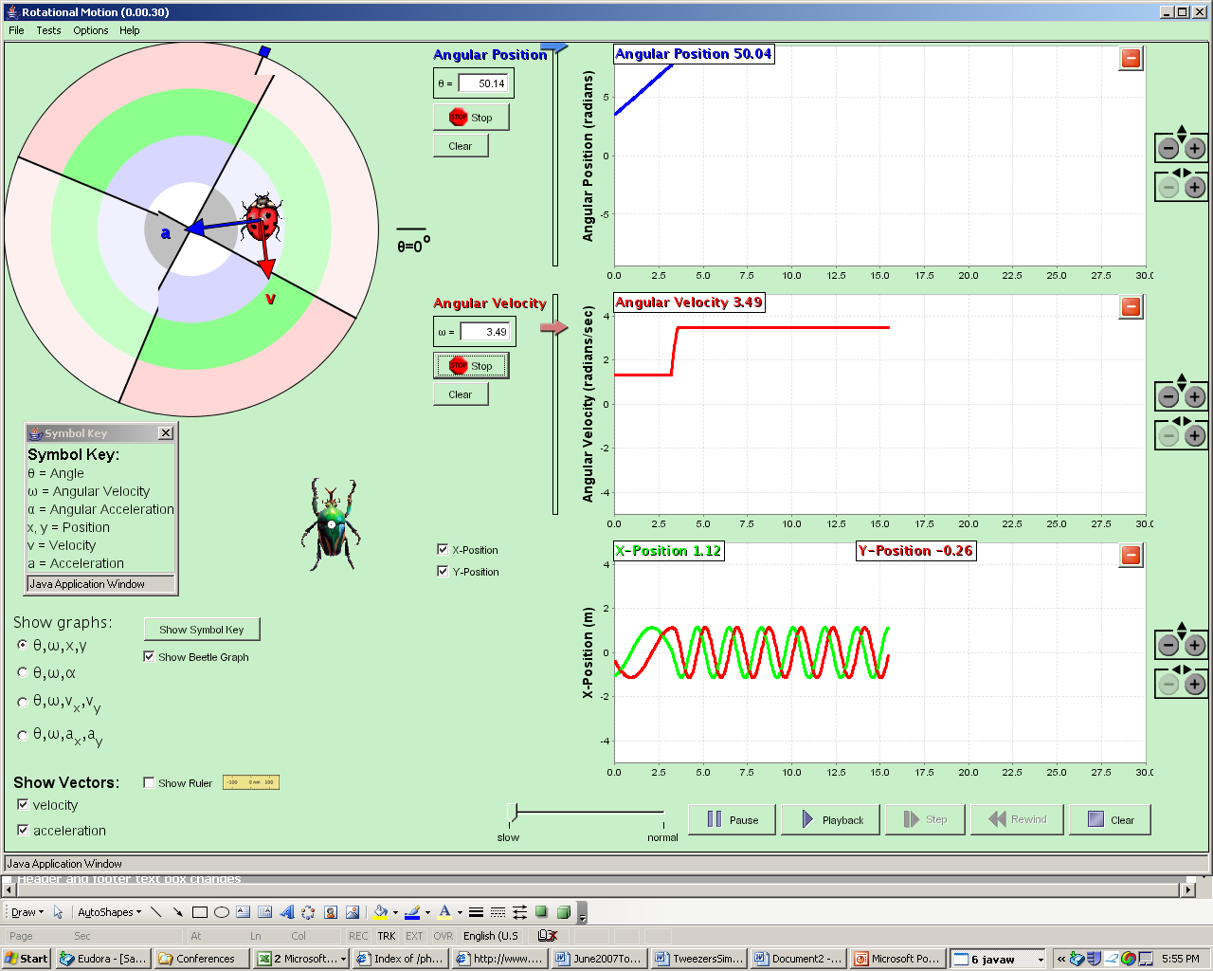

I think we need units on the readouts on the graphs … radians or rads? m, and rads/sec

There is still a performance leak. After about 10-15 minutes it is now crawling.

Weird bug: If I run it as below … so stationary with bug at one x,y, but then I pause, grab cursor and move back in time, but will move instead of be stationary. (NOTE: I’ve now seen other instances of incorrect playback of what is on the graphs as well). (CLUE??? It looks like it might be playing back POSITION from start of time, but playing back v and a vectors, etc., from start of graph?)
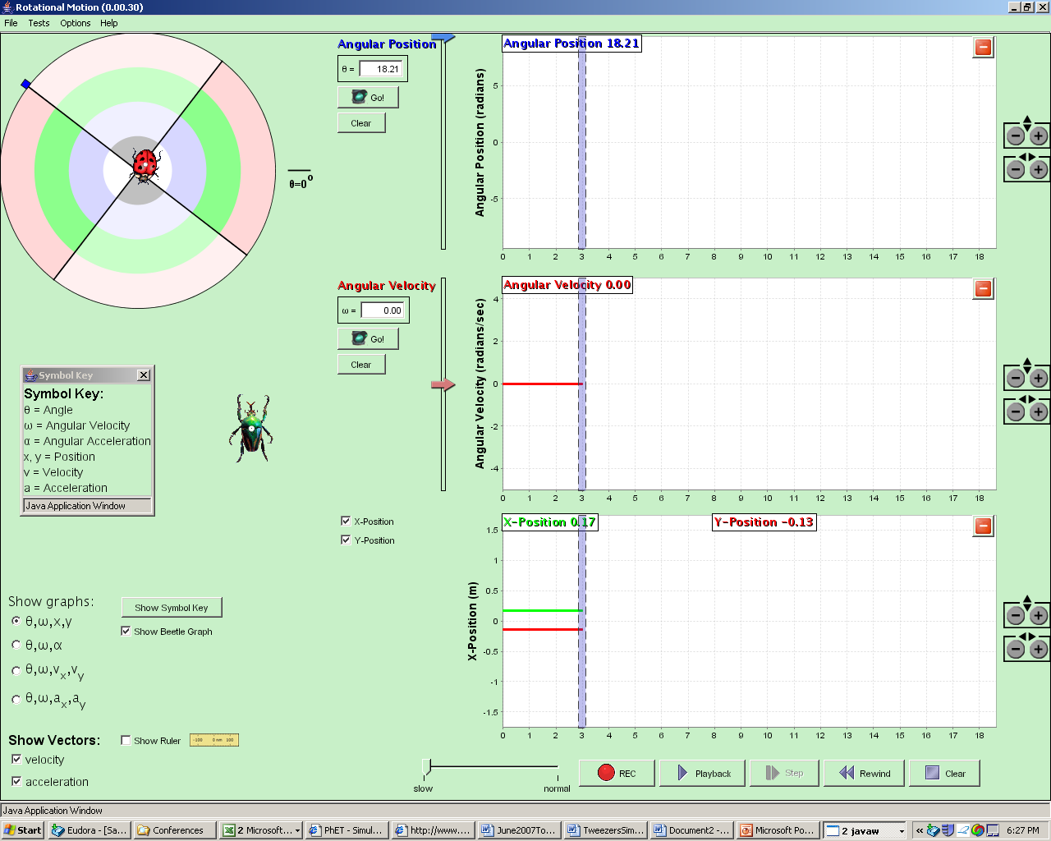

Slow-normal time slider needs to be calibrated. Right now “normal” is actually super fast mode.

Sim needs a “reset all”

At start up, graphs do not reliably come up with x-axes aligned so now cursor and tick marks for 3rd graph do not align. If I resize in x this will fix itself.
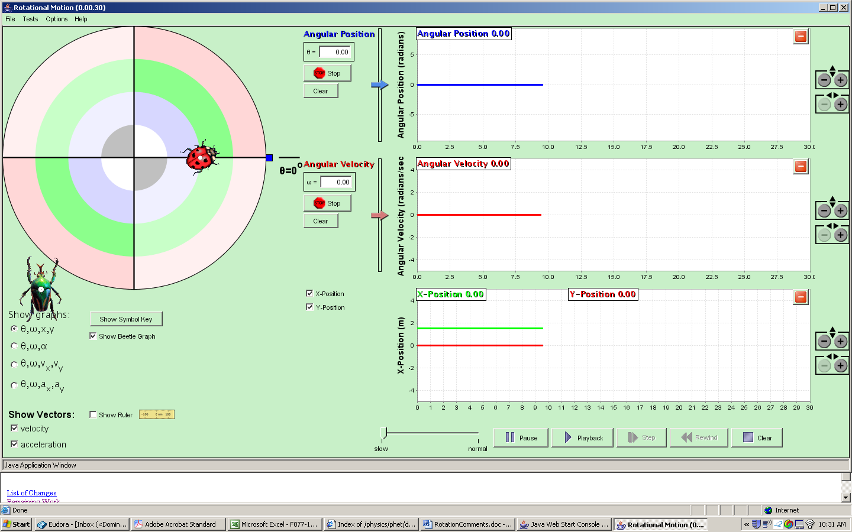

I think it would be nice if “Show symbol key” button would switch to “Hide symbol key” if symbol key is showing.

On X-position graph, please change label to just read “Position (m)” If space, can you have the check boxes read “Show X-position” OR put a “Show:” just above the 2 check boxes. (Same comment about velocity graph)

Note this sim has redraw problems if I switch to word and then back, a good fraction of the screen will remain grey until I resize or something else.

I think I would prefer 4 subtick marks on ruler so they would be at 1.2, 1.4, 1.6, 1.8, … instead of 3. This would be consistent with tweezers, and more consistent with metric markings?

When “Show beatle 2 graph” checked, the labels overlap. Maybe it would be good to show corresponding values just below values for lady bug?

When you set angular position by hand … currently only lady-bug position affected… should we make similar change in theta to 2nd bug if he is on graph? So if ladybug is at 100 rads and other bug is at 110 rads, then set rads to 0, end up with ladybug at 0 rads and other but at 10 rads??? NOT sure about this?

Lower Priority:
• Bug: Mouse gets disassociated from ladybug character after trying to drag out of bounds.
• Shadow projections should be considered after AAPT.
• Possible interview question: bug icon at tip of graph to improve conceptual connection
• Torque mode: Should be able to "spin" the wheel (i.e. drag, let go, and have it continue to spin, at least in friction mode)
• Consolidate MovingMan, Forces1D, Ramp, Rotation, Torque into a single codebase.
• Symbol key should appear near the mouse when "show symbol key" pressed

################################################
# Implementation issues
################################
• Factor MotionBodyState and MotionBodySeries into a single object
• Implementation for setting platform angle by setting character angle is fragile
• RotationBody should have internal representation for angular velocity and angular acceleration instead of relying on RotationPlatform's instance?

################################################
# Questions:
################################
• Got rid of abbreviations like (vx) on charts, do we want to show abbreviations (e.g. symbol for theta) for other series?
• Use colors from the color chart: how to handle components and multiple bodies?
-Current implementation uses:
o vector magnitude for 1st character = color from Moving Man
o x and y components are other main colors (red, green, blue)
o second body is same as above but darker
• Time should stop at the end of available graphing space (if any graphs maximized)? What did we do in Moving Man, Energy Skate Park, etc?
• Support for "missing values" in the series data (for when characters are being dragged by the user and don't have values for angular data series)
-Current implementation linearly interpolates between previous and subsequent values
-It would be fairly difficult to add a "missing value" feature

################################################
# Postponed:
################################
• Investigate acceleration model from Motion2D simulation as a possibility for replacing the implementation in rotation.

