MRI
Some small percentage of hydrogen atoms have a net non-zero spin. This gives them a dipole. In normal circumstances, their dipole alignment is random:
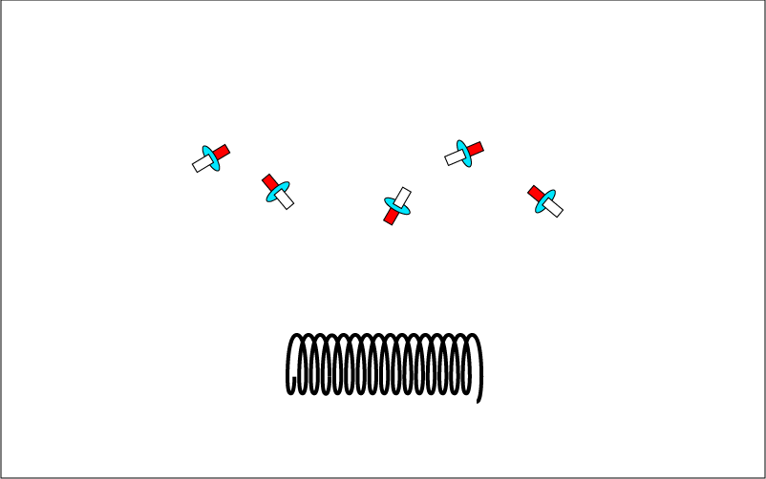

The dipole makes them respond to a sufficiently large magnetic field by aligning with the field.
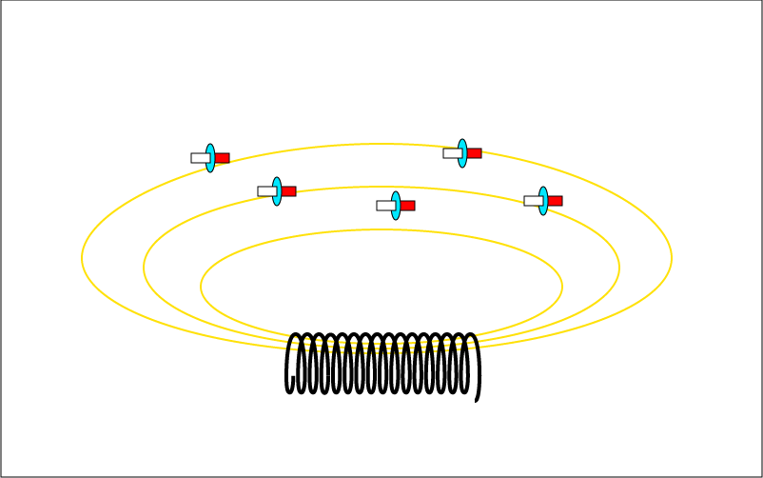

If a hydrogen atom aligned with the field is hit by a photon of a certain energy, it will absorb the photon and got to a higher energy state with different alignment. (The frequency of the photon needed to change the alignment of the hydrogen atom is related somehow to the frequency at which the atom precesses in the presence of the magnetic field.)
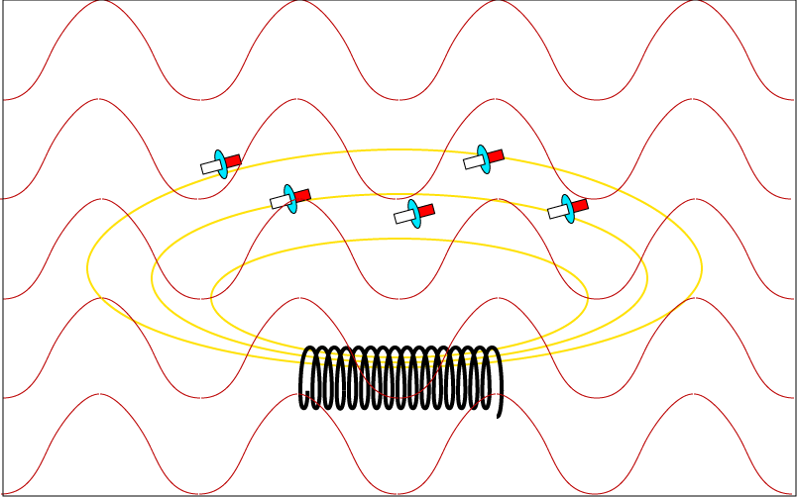
When the atoms are allowed to fall to its earlier, lower energy state, photons with energy equal to the difference between the states is emitted. The emitted photons are collected by detectors. The number of photons collected is an indication of the number of hydrogen atoms and, by implication, the nature of the material being observed.
