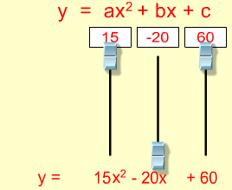**Tips for controls:**

* The sliders can be used to make changes in the coefficients or numbers can be typed into the boxes.
* The sim can be easily used for linear equations by encouraging students to set a=0
* Be aware that students may enter values which move the curve off-screen.
* 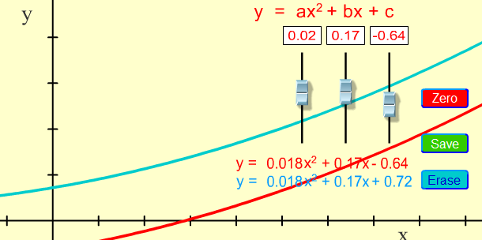One equation may be **Saved** to compare with another equation. The saved equation and curve will change to a **blue color**.
* 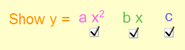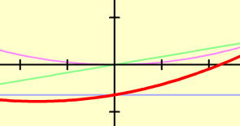The check boxes provide colored-coded curves which show the curve for a single term in the equation (the other two terms are zero).

**Important modeling notes / simplifications:**

* The slider ranges are optimized to fit the curve on the screen. Ranges: a (5.05 to -5.05), b (6.31 to -6.31), c (4 to -4).

**Suggestions for sim use:**

* For tips on using PhET sims with your students see: [**Guidelines for Inquiry Contributions**](http://phet.colorado.edu/teacher_ideas/contribution-guidelines.php)and [**Using PhET Sims**](http://phet.colorado.edu/teacher_ideas/classroom-use.php)
* The simulations have been used successfully with homework, lectures, in-class activities, or lab activities. Use them for introduction to concepts, learning new concepts, reinforcement of concepts, as visual aids for interactive demonstrations, or with in-class clicker questions. To read more, see [**Teaching Physics using PhET Simulations**](http://phet.colorado.edu/phet-dist/publications/Teaching_physics_using_PhET_TPT.pdf)
* For activities and lesson plans written by the PhET team and other teachers, see: [**Teacher Ideas & Activities**](http://phet.colorado.edu/teacher_ideas/index.php)