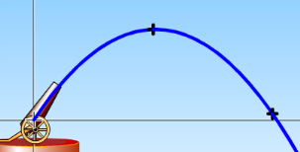**Tips for controls:**

* The indicate the projectiles position every one second.

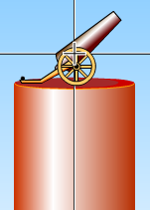

* 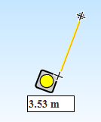The cannon has crosshairs to mark the initial location of the projectile. The cannon is on a ***pedestal*** whose height can easily be adjusted by dragging. The initial height can be measured with the ***realistic tape measure*** which is adjustable and movable.

**Important modeling notes / simplifications:**

* We used quadratic drag (Fdrag  ∝ v2) which is valid in the high Reynold’s number limit appropriate for macroscopic objects like baseballs. Linear drag (Stoke's Law) is only valid in the very low Reynold's number limit (like micron-sized droplets in air).

**Insights into student use / thinking:**

* Students usually find all the things they need without prompting, like typing in initial conditions, moving the target, and changing the height of the cannon.
* Here's something fun: make the diameter of the projectile very large, like one meter, turn off air resistance, fire the ball, then turn on air resistance while the ball in flight.
* Some students don’t notice that the projectile’s initial position is not at ground level, which can lead to confusion. The cannon is meant to be realistic, so it makes sense that the projectile doesn’t start at zero height.

**Suggestions for sim use:**

* For tips on using PhET sims with your students see: [**Guidelines for Inquiry Contributions**](http://phet.colorado.edu/teacher_ideas/contribution-guidelines.php)and [**Using PhET Sims**](http://phet.colorado.edu/teacher_ideas/classroom-use.php)
* The simulations have been used successfully with homework, lectures, in-class activities, or lab activities. Use them for introduction to concepts, learning new concepts, reinforcement of concepts, as visual aids for interactive demonstrations, or with in-class clicker questions. To read more, see [**Teaching Physics using PhET Simulations**](http://phet.colorado.edu/phet-dist/publications/Teaching_physics_using_PhET_TPT.pdf)
* For activities and lesson plans written by the PhET team and other teachers, see: [**Teacher Ideas & Activities**](http://phet.colorado.edu/teacher_ideas/index.php)