**Tips for controls:**

* The **Supports** allow students/teachers to set up a system and make predictions; when the **Supports** are off, the system will rotate according to the sum of the torques.
* Objects can be mixed and multiple objects can be put on the plank. For example, bricks can be used to balance people or Mystery objects.
* Students can use the **Level** tool to check; it will turn green if the plank is balanced.

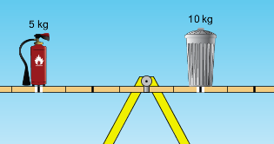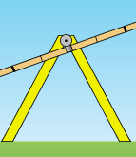

Figure A

Figure B

**Important modeling notes / simplifications:**

* The pivot point is slightly vertically offset from the center of mass of the plank. This was done so that if the plank is in an unbalanced situation like shown in Figure A, and then the student makes the total torque zero like in Figure B, the plank will level. In a centered pivot situation, a zero torque would not cause motion.
* Object mass is considered to be centered and in the plank; the white line below the object shows the location.
* The Mystery Objects have varying mass which is not related to the size. We have been asked by teachers to not publish the masses, so students cannot cheat by reading the Tips.
* The Force vectors are shown as initiating at the base of the objects instead of from center of mass to help beginning students build their own ideas easily.
* A more advanced version of this sim is being designed. It will include vector representations and the pivot point is centered in the plank so students can easily determine the level arm length.

**Information regarding the game tab:**

* The game is scaffolded; if students start on level 4, you may want to encourage them to try lower levels.

**Insights into student use / thinking:**

* The games are provided to help students build skills, some students toggle back to the first tab to test their ideas and this seems helpful.
* Middle school students tend to put many objects on the board. The first tab was added to help simplify the investigation. It may be helpful to have a discussion about how position of a heavy object can be used to balance a light one.

**Suggestions for sim use:**

* For tips on using PhET sims with your students see: [**Guidelines for Inquiry Contributions**](http://phet.colorado.edu/teacher_ideas/contribution-guidelines.php)and [**Using PhET Sims**](http://phet.colorado.edu/teacher_ideas/classroom-use.php)
* The simulations have been used successfully with homework, lectures, in-class activities, or lab activities. Use them for introduction to concepts, learning new concepts, reinforcement of concepts, as visual aids for interactive demonstrations, or with in-class clicker questions. To read more, see [**Teaching Physics using PhET Simulations**](http://phet.colorado.edu/phet-dist/publications/Teaching_physics_using_PhET_TPT.pdf)
* For activities and lesson plans written by the PhET team and other teachers, see: [**Teacher Ideas & Activities**](http://phet.colorado.edu/teacher_ideas/index.php)