**Tips for controls:**

* 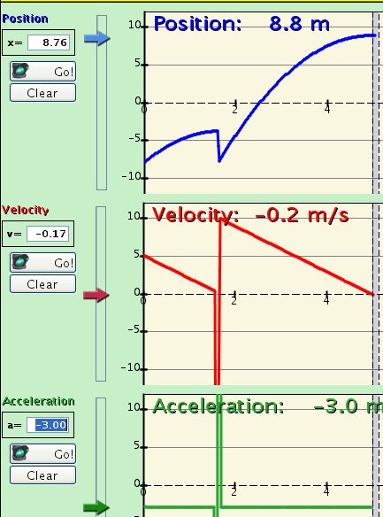Try all the different tabs at the top of the simulation. The tabs are designed to help teachers scaffold lessons or make lessons age appropriate by using only some tabs.
* If you want to make specific graphs to represent motion as students might see in a text, like the ones shown on the right: use **Pause,** then set the parameters using the sliders, then press **Play.**
* If you are doing a lecture demonstration, set your screen resolution to 1024x768 so the simulation will fill the screen and be seen easily.
* 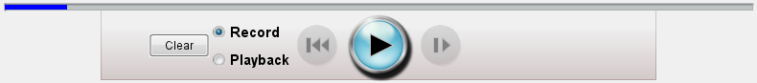Use the controls on the bottom to **Pause, Step**, or **Record** and **Playback** the motion. You must select **Record** before you start an experiment if you want it saved.
* On the Introduction Tab, 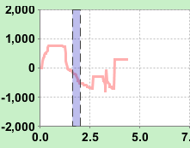the 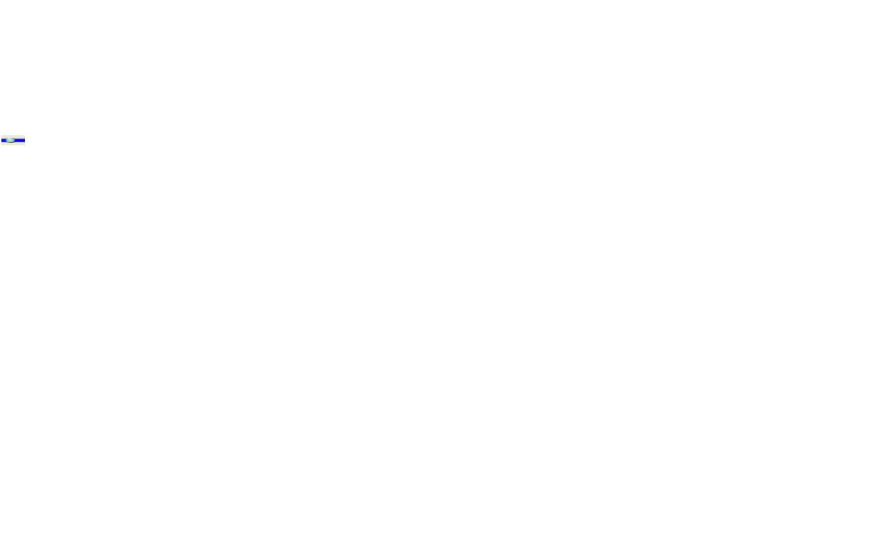 is grabbable in **Playback** mode to help student to make sense of the man’s motion.
* On the **Chart** tab, the vertical gray lines in the charts are grabbable in **Playback** mode to help students to relate the Man's motion to the graphs.
* Under the **Special Features** menu, Mathematical Expression and Reverse axis are advanced features. If the man stops at the wall, the function no longer applies, but is still visible.

**Important modeling notes / simplifications:**

* When dragging the mouse, samples are taken about 24 frames per second.  Four samples are averaged to set the position of the man character; this creates a slight lag between the mouse location and the man location.  To compute the velocity at time t-dt, a linear fit is made of the 3 points (t-2*dt, t-dt, t), and the slope is identified.  The acceleration is computed as the first derivative of velocity using the same algorithm, not a direct second derivative of the position data.  To compute integrals, such as position from a specified velocity, forward Euler integration is used.

**Insights into student use/thinking:**

* The Tree and House are included to help you ask questions to which students can easily relate like “Predict what the chart would look like if the man starts at the tree and moves toward the house with constant velocity.”
* Some students may try to make changes while in the **Playback** mode and then hit **Play**; the sim will not run until **Record** is selected.

**Suggestions for sim use:**

* We designed the motion sims to be used in the following order: Moving Man, Forces & Motion, then The Ramp.
* Two related sims are Ladybug Revolution and Ladybug Motion 2D.
* For tips on using PhET sims with your students see: [**Guidelines for Inquiry Contributions**](http://phet.colorado.edu/teacher_ideas/contribution-guidelines.php)and [**Using PhET Sims**](http://phet.colorado.edu/teacher_ideas/classroom-use.php)
* The simulations have been used successfully with homework, lectures, in-class activities, or lab activities. Use them for introduction to concepts, learning new concepts, reinforcement of concepts, as visual aids for interactive demonstrations, or with in-class clicker questions. To read more, see [**Teaching Physics using PhET Simulations**](http://phet.colorado.edu/phet-dist/publications/Teaching_physics_using_PhET_TPT.pdf)
* For activities and lesson plans written by the PhET team and other teachers, see: [**Teacher Ideas & Activities**](http://phet.colorado.edu/teacher_ideas/index.php)