**Tips for controls:**

* You can move the popup in the game. This allows students to compare the scales or the charts to the molecules in the boxes if they click on “Show Why.” You can also use the "Hide Why" button for the same purpose. The only way to get rid of the popup entirely is to click on the yellow button for “Next.” We chose not to include a close button based on student interviews.
* Look for the “Hide molecules” feature in the Options menu. If you select this feature, the message “molecules are hidden” will appear in the boxes for *both* tabs. You can use this feature to force students to balance the equations using only the symbols.

**Important modeling notes / simplifications:**

* The three levels in the game are in order of difficulty. The equations in Level 1 include one reactant or one product. Those in level 2 include two reactants and two products. Those in Level 3 are hard to balance and have large coefficients. The game selects five equations at random.
* The “Show Why” feature gives a different representation for each level. Level 1 uses balance scales, Level 2 is random, and Level 3 uses bar charts.
* 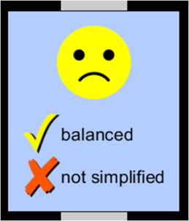We expect least coefficients in the game, but we do not specify this up front. When the equation is balanced but not with the lowest coefficients (for example, 2A + 2B → 2AB), we count the answer as wrong and give students the prompt:

**Insights into student use / thinking:**

* We chose not to show scales or charts on startup because we find that students rely on the scales to balance the equation in the first tab. Many students use trial-and-error. We want their focus to be on the molecules in the boxes. If you see this happen with your own students, you can tell them to click on “Reset All” and try to balance the equations with the “Bar Charts” or with “None.”

**Suggestions for sim use:**

* You may want to use [**Reactants, Products and Leftovers**](http://phet.colorado.edu/en/simulation/reactants-products-and-leftovers) after this sim. We are working on a “Build a Molecule” sim that could be used before this sim.
* For tips on using PhET sims with your students, see: [**Guidelines for Inquiry Contributions**](http://phet.colorado.edu/teacher_ideas/contribution-guidelines.php)and [**Using PhET Sims**](http://phet.colorado.edu/teacher_ideas/classroom-use.php)
* The sims have been used successfully in homework, lectures, in-class activities, and lab activities. Use them for introduction to concepts, learning new concepts, reinforcement of concepts, as visual aids for interactive demonstrations, or with in-class clicker questions. To read more, see [**Teaching Physics using PhET Simulations**](http://phet.colorado.edu/phet-dist/publications/Teaching_physics_using_PhET_TPT.pdf)
* For activities and lesson plans written by the PhET team and other teachers, see: [**Teacher Ideas & Activities**](http://phet.colorado.edu/teacher_ideas/index.php)