**Tips for controls:**

* Try all the different tabs at the top of the simulation. The tabs are designed to help teachers scaffold lessons or make lessons age appropriate by using only some tabs.
* **Reset All** resets only the tab that you are presently using.
* The **Pressure** tab is also available as a single sim called [**Under Pressure**](https://phet.colorado.edu/en/simulation/under-pressure)
* 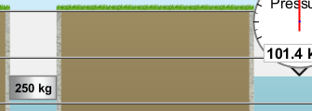The **Grid** option is provided to help students see relative fluid height easily.
* The masses can only be set on the left column of water.
* 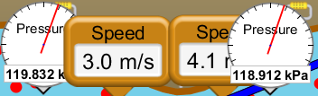Multiple tools can be used to make comparisons.
* 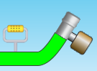You can **Pause** the sim and then use **Step** to incrementally analyze.
* The hose on the **Water Tower** tab has 2 controls. The handle moves the hose vertically and the gold knob rotates the nozzle.
* 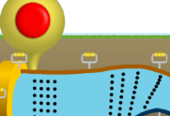The red button tool allows students to make qualitative observations. Turning off the **Dots**  may be helpful.
* 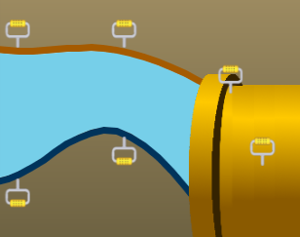The handles on the **Flow** tab let you change the shape/height of the water tube and end pipes.

**Important modeling notes / simplifications:**

* The **Pressure** tab shows a thin slice of an underground basin with fluid in it. We used an underground situation where the top of the basin is at sea level
* The sensors are very sensitive, so you may expect some variations in answers.
* The **Flow** tab assumes that there is a “pressure head” at ground level.

**Insights into student use / thinking:**

* 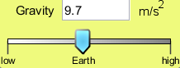Because the Gravity slider has few tick marks, it is easy for a student to think they have set the meter back to Earth but not have exactly 9.8 m/s2.For example: Exact values between 1.0 and 20.0 can be typed in the white readout box.

**Suggestions for sim use:**

* For tips on using PhET sims with your students see: [**Guidelines for Inquiry Contributions**](http://phet.colorado.edu/teacher_ideas/contribution-guidelines.php)and [**Using PhET Sims**](http://phet.colorado.edu/teacher_ideas/classroom-use.php)
* The simulations have been used successfully with homework, lectures, in-class activities, or lab activities. Use them for introduction to concepts, learning new concepts, reinforcement of concepts, as visual aids for interactive demonstrations, or with in-class clicker questions. To read more, see [**Teaching Physics using PhET Simulations**](http://phet.colorado.edu/phet-dist/publications/Teaching_physics_using_PhET_TPT.pdf)
* For activities and lesson plans written by the PhET team and other teachers, see: [**Teacher Ideas & Activities**](http://phet.colorado.edu/teacher_ideas/index.php)
* Related sims: [**Under Pressure**](http://phet.colorado.edu/en/simulation/under-pressure)**,** [**Density**](http://phet.colorado.edu/en/simulation/density)**,** [**Buoyancy**](http://phet.colorado.edu/en/simulation/buoyancy)