**Tips for controls:**

* You can **Pause** the sim and then use **Step** to incrementally analyze.
* If you are doing a lecture demonstration, set your screen resolution to 1024x768 so the simulation will fill the screen and be seen easily.
* After the **Polonium** nucleus decays to **Lead**, press **Reset** to start over with a new Polonium nucleus.
* **Reset Nucleus** shows a new atom nucleus. The decay time for each atom varies to demonstrate the randomness of decay. If several trials are run or the **Multiple Atoms** tab is used, students should be able to observe that the average decay time is represented by the Half Life.
* The **Custom** atom allows Half Life to be varied using the top graph. Students can drag the red Half Life marker to help make more general sense about what half-life represents. 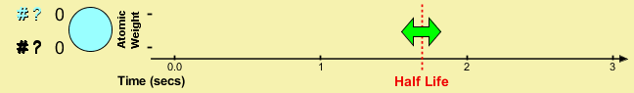

**Important modeling notes / simplifications:**

* In the **Single Atom** tab, the lower graph shows the average **total energy** of any single alpha particle in the nucleus. When the nucleus decays, the alpha particle that leaves carries away energy, so that the total energy of the remaining alpha particles drops.

**Insights into student use / thinking:**

* In interviews, we found that even students with no science background were able to figure out the basics of nuclear physics by playing with this simulation. However, students were not able to make sense of the graphs without instruction.

**Suggestions for sim use:**

* For tips on using PhET sims with your students see: [**Guidelines for Inquiry Contributions**](http://phet.colorado.edu/teacher_ideas/contribution-guidelines.php)and [**Using PhET Sims**](http://phet.colorado.edu/teacher_ideas/classroom-use.php)
* The simulations have been used successfully with homework, lectures, in-class activities, or lab activities. Use them for introduction to concepts, learning new concepts, reinforcement of concepts, as visual aids for interactive demonstrations, or with in-class clicker questions. To read more, see [**Teaching Physics using PhET Simulations**](http://phet.colorado.edu/phet-dist/publications/Teaching_physics_using_PhET_TPT.pdf)
* For activities and lesson plans written by the PhET team and other teachers, see: [**Teacher Ideas & Activities**](http://phet.colorado.edu/teacher_ideas/index.php)