**Tips for controls:**

* You can **Pause** the sim and then use **Step** to incrementally analyze.
* Try all the different tabs at the top of the simulation. The tabs are designed to help teachers scaffold lessons or make lessons age appropriate by using only some tabs.
* 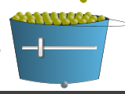The returns all the nuclei to carbon-14 or uranium-238 and resets the graph.
* On the **Decay Rate** Tab, the slider on the bucket allows students to easily vary the number of atoms that they want to observe.
* 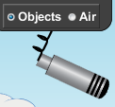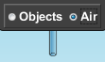The meter can be dragged to any object, but reads just air because interviews showed students did not understand how to take measurements of air.
* The **Custom** atom allows Half Life to be varied using the top graph. Students can drag the red Half Life marker to help make more general sense about what half-life represents. 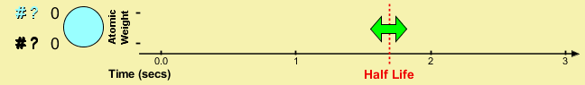

**Important modeling notes / simplifications:**

* Time is relative. For a living object, time zero is the time of the objects death. For a rock, the time zero for a volcanic rock is when it has cooled.
* Carbon-14 is considered to be constantly zero for rocks and Uranium-238 is constantly zero for organic objects.

**Information regarding the game tab:**

* There are no points awarded, nor is there a way to tell how many times a student has tried to estimate the value. The objects do not vary. The game is just meant to help students test their own ideas.
* When students estimate a time, they can click on the time box, the value will be erased and they have another opportunity.
* 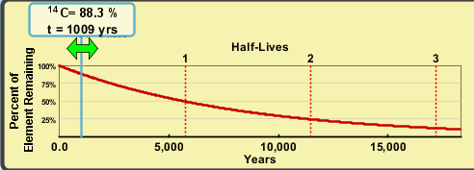Student can use the graph to help them estimate by moving the green arrow

**Suggestions for sim use:**

* For tips on using PhET sims with your students see: [**Guidelines for Inquiry Contributions**](http://phet.colorado.edu/teacher_ideas/contribution-guidelines.php)and [**Using PhET Sims**](http://phet.colorado.edu/teacher_ideas/classroom-use.php)
* The simulations have been used successfully with homework, lectures, in-class activities, or lab activities. Use them for introduction to concepts, learning new concepts, reinforcement of concepts, as visual aids for interactive demonstrations, or with in-class clicker questions. To read more, see [**Teaching Physics using PhET Simulations**](http://phet.colorado.edu/phet-dist/publications/Teaching_physics_using_PhET_TPT.pdf)
* For activities and lesson plans written by the PhET team and other teachers, see: [**Teacher Ideas & Activities**](http://phet.colorado.edu/teacher_ideas/index.php)