**Tips for controls:**

* The sim is like looking down on an air hockey table Instead of hitting the puck, this sim makes it move by using charged bodies like the charged balloons.
* Use the *Practice* mode for testing their ideas about how charge affects motion.
* The difference between *Clear* (everything is zeroed) and *Reset* (the puck is brought back to starting point with same charges)*.*
* The *Trace* tool is helpful to make reasoning about what affects the charges have.
* The puck in negatice by default, but there is a *Puck is Positive* option.
* The *Antialias* feature is just a programming tool; if you turn it on the resolution is better, but the program runs more slowly (less realistic).
* You may want to demonstrate how using multiple charges can be used to make a goal.

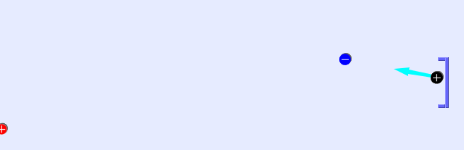Goal!!

**Important modeling notes / simplifications:**

Static electricity and inertia are the only things affecting the pucks motion

**Suggestions for sim use:**

* For tips on using PhET sims with your students see: [**Guidelines for Inquiry Contributions**](http://phet.colorado.edu/teacher_ideas/contribution-guidelines.php)and [**Using PhET Sims**](http://phet.colorado.edu/teacher_ideas/classroom-use.php)
* The simulations have been used successfully with homework, lectures, in-class activities, or lab activities. Use them for introduction to concepts, learning new concepts, reinforcement of concepts, as visual aids for interactive demonstrations, or with in-class clicker questions. To read more, see [**Teaching Physics using PhET Simulations**](http://phet.colorado.edu/phet-dist/publications/Teaching_physics_using_PhET_TPT.pdf)
* For activities and lesson plans written by the PhET team and other teachers, see: [**Teacher Ideas & Activities**](http://phet.colorado.edu/teacher_ideas/index.php)
* Gold Star Activities: