**Tips for controls:**

* Clear All puts the vectors back in the bucket. If you want to “Reset All”, refresh your browser.
* 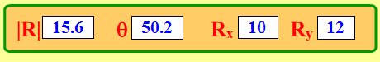The values in the top are for the vector that was last selected. Click on any vector to get its values. You may not enter values into the boxes; the vectors must be changed by dragging.
* 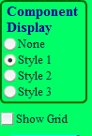The Sum vector is Green. 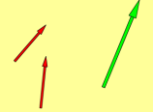
* There are several ways for students to make their own sense of vectors. They may use just the vectors, one of the Component Displays, or the Grid.
* The vectors are represented in both magnitude/degrees and Rx,Ry components.

If you are doing a lecture demonstration, set your screen resolution to 1024x768 so the simulation will fill the screen and be seen easily.

**Important modeling simplifications:**

* This sim only allows whole numbers values of the x- and y-components. Consequently, you cannot exactly set the values of magnitude and direction. For example, if students are asked to represent a vector that is 15 units long at 45 degrees, they will have to choose values that are near like 14.9 unit at 47.7 degrees.
* The vectors can be easily translated, which is an important learning goal for this sim.

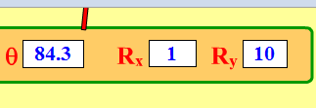**Insights into student use / thinking:**

* Students may have a vector out of the bucket, but only partially in the play area. This may cause confusion about the **Sum** vector.
* 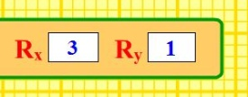If students are given opportunity to explore the sim without explicit directions, they will discover which vector representation makes the most sense for them. They may use different representations for different problems.
* 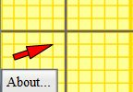Students sometimes confuse the sign (+ or −) of the vector components with sign of the (x, y) location of the vector. For instance, an (x,y) position in the 3rd quadrant, has negative x and y values, but a vector located in the 3rd quadrant can have any sign components.

**Suggestions for sim use:**

* For tips on using PhET sims with your students see:**[Guidelines for Inquiry Contributions](http://phet.colorado.edu/teacher_ideas/contribution-guidelines.php)** and[**Using PhET Sims**](http://phet.colorado.edu/teacher_ideas/classroom-use.php)
* The simulations have been used successfully with homework, lectures, in-class activities, or lab activities. Use them for introduction to concepts, learning new concepts, reinforcement of concepts, as visual aids for interactive demonstrations, or with in-class clicker questions. To read more, see [**Teaching Physics using PhET Simulations**](http://phet.colorado.edu/phet-dist/publications/Teaching_physics_using_PhET_TPT.pdf)
* For activities and lesson plans written by the PhET team and other teachers, see: [**Teacher Ideas & Activities**](http://phet.colorado.edu/teacher_ideas/index.php)
* Gold Star Activities: [Vector Addition 1- Introduction to Vector Math by Trish Loeblein](https://phet.colorado.edu/en/contributions/view/2840); [Vector Addition 2 – Understanding Equilibrium Forces by Trish Loeblein](https://phet.colorado.edu/en/contributions/view/2904)