The [Sugar and Salt Solutions](http://phet.colorado.edu/en/simulation/sugar-and-salt-solutions) sim is designed to help students visualize how ionic and covalent compounds dissolve in water. In an interview, one student said the Macro tab is the “what”, the Micro tab is the “why”, and the Water tab is the “how”.

**Macro Tab**

In this tab, students learn that salt water conducts but sugar water does not.

Shakers: You can shake in salt or pour in sugar. The max amount of each solute is 100 grams.

Faucets: You can add water (top faucet) or remove solution (bottom faucet). Some students think the bottom faucet only removes water until they notice the concentration is constant. The shakers refill when you remove solution.

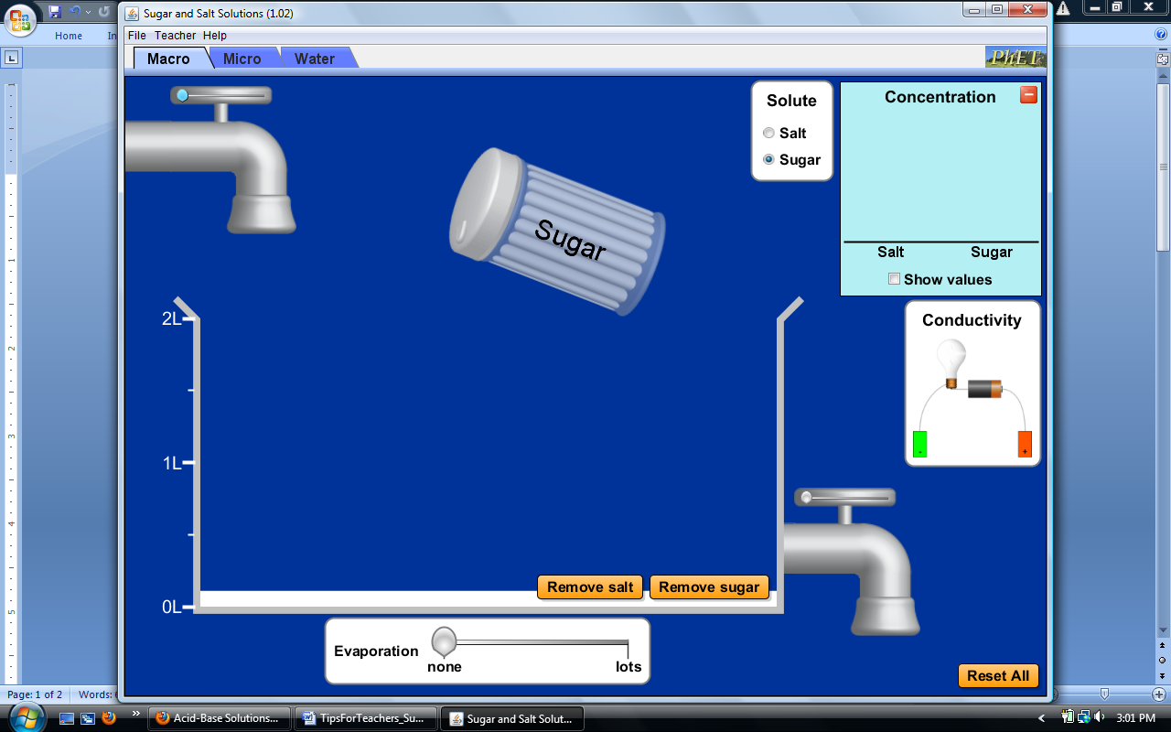

Evaporation: If you evaporate all of the water in a solution, the solid solute reappears. You can also add solute to an empty beaker.

Concentration: You can add solute, add water, and evaporate water to change the concentration. You can hide the concentration box to ask prediction questions. You can also “show values” to calculate the amount of solute.

**ALERT**: The concentration is computed as solute amount divided by *water* volume instead of *solution* volume. The sim ignores the volume of the dissolved solute because having the salt concentration change when adding sugar could be confusing to students.

Conductivity: You can drag out the meter to test the conductivity. The brightness of the bulb depends on the concentration of ions. You can leave the meter in the solution while you change the concentration. You can also drag it back in to the box. The meter shorts out if the battery or bulb touches salt water. You can move each probe up or down. For more on conductivity, see the [Acid & Base Solutions](http://phet.colorado.edu/en/simulation/acid-base-solutions) sim.

**Micro Tab**

In this tab, students learn that salts break up into ions in water but sugars do not.

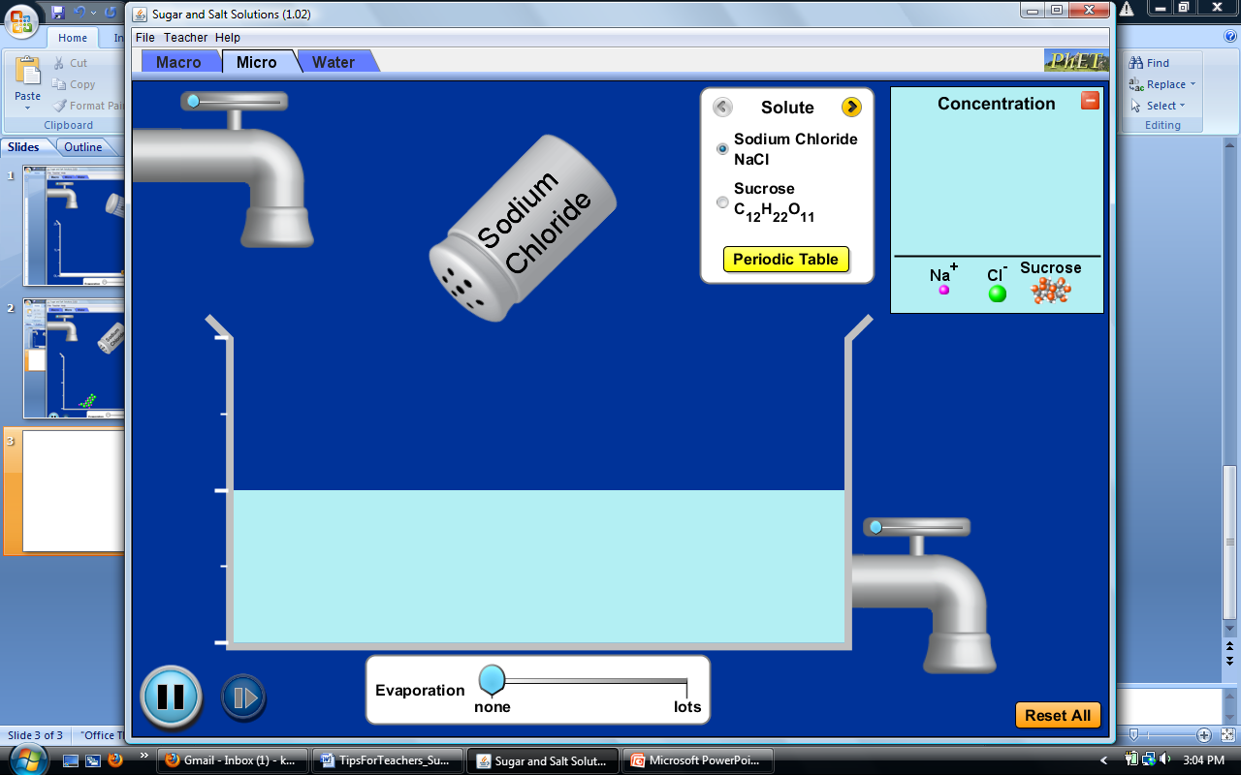Shakers: The max amount of each solute is 12 formula units.

Solute kits: The yellow arrows give you different pairs of solutes and clear the solution. Many students do not find the kits; you may need to give students more direction. The solutes are NaCl, CaCl2, NaNO3, sucrose and glucose. The atoms/ions use [CPK](http://en.wikipedia.org/wiki/CPK_coloring) colors and the correct radii.

Periodic table: The table appears in a new window. You can keep the window open as you select different solutes. You can also resize the window.

Concentration: The chart shows the concentration for each particle in solution. The values are not shown because of the different scales for solute particles and water.

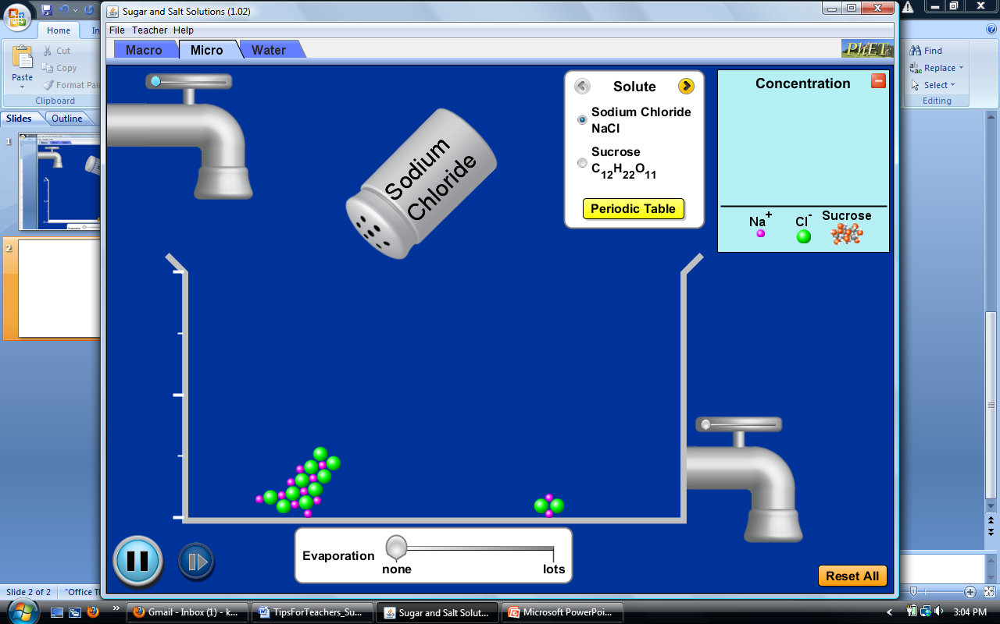

Evaporation: You can evaporate all the water and see the solute crystallize above its saturation point. For more on saturation of salts, see the [Salts & Solubility](http://phet.colorado.edu/en/simulation/soluble-salts) sim.

|  |  |  |  |
| --- | --- | --- | --- |
| **Solute** | **Formula** | **Molar mass** (g/mol) | **Solubility** (mol/L) |
| Sodium chloride | NaCl | 58.44 | 6.14 @ 25°C |
| Calcium chloride | CaCl2 | 111.0 | 6.71 @ 20°C |
| Sodium nitrate | NaNO3 | 85.99 | 10.8 @ 25°C |
| Sucrose | C12H22O11 | 342.3 | 5.84 @ 25°C |
| Glucose | C6H12O6 | 180.2 | 5.05 @ 25°C |

**Water Tab**

In this tab, you can explore the role of water.

Buckets: You can drag the salt and/or sugar into the water. You can also drag the sugar molecules back into the bucket.

Water: The sim uses a modified [SPC](http://en.wikipedia.org/wiki/Water_model) model with periodic boundary conditions. For more on the *shape* of water, see the [Molecule Shapes](http://phet.colorado.edu/en/simulation/molecule-shapes) sim. For more on the *polarity* of water, see the [Molecule Polarity](http://phet.colorado.edu/en/simulation/molecule-polarity) sim.

Sugar: The sugar molecules are highlighted to set apart the sugar and water atoms. The 3D button opens a Jmol window. You can resize the window and rotate the sugar molecule.

**General**

For tips on using PhET sims with your students and for lesson plans written by the PhET team and other teachers, see our [For Teachers](http://phet.colorado.edu/en/for-teachers) page.

Reset all: The Reset button returns the tab to its initial state. In the Water tab, for example, it returns the salt and sugar to the buckets.

Play/Pause: You can pause the animations in the Micro and Water tabs. You cannot interact with certain features, such as sliders, when the sim is paused.

White background: In the Teacher menu, you can change the background color to white for photocopying and/or projecting.