**Non-obvious controls:**

* Use the **Save/Load** feature in the **File** menu to save a configuration for lecture or homework.
* You can **Pause** the sim and then use **Step** to incrementally analyze.
* **Restart** will return a wave packet to its initial configuration.
* You can change the configuration of the potential and total energy by dragging the lines on the graph, clicking or **Configure Energy**, or using the **Potential** menu.
* Use the buttons in the upper left corner of the graphs to vertically zoom in and out on the **Wave Function** and **Probability Density**.
* If you want to look at the time-independent real part of the wave function as it is shown in most textbooks, **Pause** and then press **Restart** to reset the phase.
* If you reverse **Direction of incoming wave** for a wave packet, you will probably also want to move **initial position** of wave packet center to the other side of the screen.
* Use the **Colors** menu to change the color scheme.
* If you are doing a lecture demonstration, set your screen resolution to 1024x768 so the simulation will fill the screen and be seen easily.

**Important modeling notes / simplifications:**

* Unlike a plane wave, a wave packet does not have a single definite total energy, but is a superposition of states with many different energies. The total energy of a wave packet is therefore represented as a smeared green region. The brightness roughly corresponds to the probability of the electron having a given energy.
* In plane wave mode, it is possible to set up situations where the amplitude of the transmitted wave is greater than the amplitude of the incoming wave:

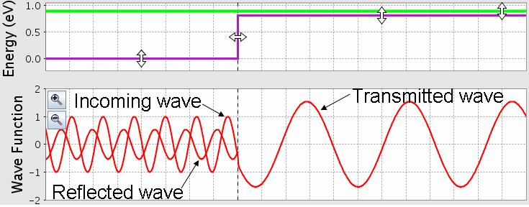This is such a surprising result that many experts think there is a bug in the simulation when they first see it. It is not a bug, but the result of the fact that the probability density is proportional to both |ψ|² and the group velocity (vgroup = k/m). In these situations, the transmitted probability density is still less than the incoming probability density because the group velocity of the transmitted wave is less than that of the incoming wave. This often does not appear to be the case, however, because the *phase* velocity (vphase = k/2m + V/k) of the transmitted wave is *larger* than that of the incoming wave, and this is what is observable in the simulation.

* **Make Quantum Measurement** makes a measurement of the position of the electron with a small uncertainty, so that rather than collapsing to a delta function, the wave function collapses to a gaussian wave packet with a width of about 0.1mm. In **plane wave** mode, **Make Quantum Measurement** always makes the wave disappear – since a plane wave is spread out over infinite space, the probability of the electron being measured in the small region shown on the screen is zero. If students are confused by this behavior, try asking, “How far does a plane wave extend in space?”
* If a measurement finds the electron in the forbidden region, the measurement adds just enough energy so that the electron is no longer forbidden to be in that region.[1]
* In **wave packet** mode, the simulation solves the 1D Schrodinger equation numerically in real time. In plane wave mode, it uses the exact solutions. In both cases, the mass is set to the electron mass, so you can use this mass to do calculations.
* The wave function is normalized so that the total probability is 1 in **wave packet** mode, and so that the amplitude of the incoming wave is 1 in **plane wave** mode.
* If you zoom all the way in and wait for a very long time, you will see some strange behavior due to reflection off the walls, which are further out than the edge of the graphs, but not infinitely far. After the wave function becomes sufficiently small in the visible region, it will disappear.

**Insights into student use / thinking:**

* For most students, wave packets are much easier to understand conceptually than plane waves. We recommend starting the discussion of tunneling with wave packets, since these can be related to localized particles, and introducing plane waves later as a special case of a very wide wave packet.
* Many students are initially confused by the messy interference pattern that occurs while a wave packet is in the process of being reflected from a step or barrier. We have found that if we ask students to go to plane wave mode and explain the difference between the **sum** and **separate** views, and then ask them to go back and explain what the wave packet behavior, they are able to explain wave packet reflection in terms of the simpler reflection patterns they saw for plane waves.
* Students often have difficulty understanding the meaning of complex wave functions. This can perhaps best be illustrated by the observation that students frequently ask, “What is the physical meaning of the imaginary part of the wave function?” (Students never ask about the physical meaning of the real part!) Using both the real part and the imaginary part in the simulation can help students understand how the two are related and see that they are both equally important.
* The simulation includes additional representations of the wave function which show the **magnitude** as a black curve and the **phase** as a color included within the magnitude curve. In interviews, we found that *none* of the students were able to make sense of this representation without significant help from the interviewer, including one student who had taken a class where the representation was used extensively. We note that this “phase color” representation is the *only* representation used in most quantum mechanics simulations, both commercial and free. Please use this representation with caution!

**Suggestions for sim use:**

* For tips on using PhET sims with your students see: [**Guidelines for Inquiry Contributions**](http://phet.colorado.edu/teacher_ideas/contribution-guidelines.php)and [**Using PhET Sims**](http://phet.colorado.edu/teacher_ideas/classroom-use.php)
* The simulations have been used successfully with homework, lectures, in-class activities, or lab activities. Use them for introduction to concepts, learning new concepts, reinforcement of concepts, as visual aids for interactive demonstrations, or with in-class clicker questions. To read more, see [**Teaching Physics using PhET Simulations**](http://phet.colorado.edu/phet-dist/publications/Teaching_physics_using_PhET_TPT.pdf)
* For activities and lesson plans written by the PhET team and other teachers, see: [**Teacher Ideas & Activities**](http://phet.colorado.edu/teacher_ideas/index.php)
* Set **Potential** to **constant** to explore the properties of plane waves and wave packets without the added complications of reflection and transmission.
* Try asking students why the probability density for a plane wave incident on a step potential is wavy on one side and flat on the other. If they can’t explain it, ask them to look at the **separate** view and think about how the pieces add up to the **sum** view.
* If you are using **Make Quantum Measurement** in a lecture demo, it is much easier for students to follow the measurements if you tell them just before you hit the button.
* You can demonstrate the Quantum Zeno Effect by making quantum measurements in quick succession in **wave packet** mode.
* If your goal is to help students understand the phase color representation, it is helpful to superimpose the real and imaginary parts on top of it. You can then point out that the color is always red at the peaks of the real part and always yellowish green at the peaks of the imaginary part. Thus, the color is a measure of where you are in the cycle of real and imaginary.
* With a **double barrier** you can set up a resonance in which the wave function gets trapped between the barriers. For example, in **plane wave** mode, starting with the default setting for **double barrier**, try setting the total energy to 0.39eV and the potential energy in between the barriers to -0.20eV.

1. This is based on the model in: A. M. Steinberg, “On energy transfer by detection of a tunneling atom,” Journal of the Korean Physical Society 35 (3), 122 (1999); <http://xxx.lanl.gov/abs/quant-ph/9904098>