**Tips for controls:**

* The velocities are changeable by grabbing the green vectors. When the velocity vector becomes too small to see, a dark circle appears on the ball. The circle is grabbable to change the velocity.
* The balls’ location can be changed by grabbing the balls.
* The Momentum graph is a display of the momentum. You cannot change the momentum vectors using the graph, only by changing the mass or velocity.
* Turning off **Reflecting Borders** enables students to focus on “ball- ball” collisions which do conserve Momentum. “Ball-wall” collisions do not conserve momentum
* Mechanical energy changes can be determined using the **Kinetic Energy** display.
* **Elasticity** affects the ball-wall and ball-ball collisions.
* You can **Pause** the sim and then use **Step** to incrementally analyze. The Back button only functions for perfectly elastic collisions, so it is disabled if the elasticity is less than 100%.
* 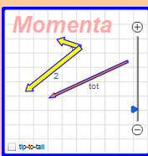If you are doing a lecture demonstration, set your screen resolution to 1024x768 so the simulation will fill the screen and be seen easily.
* **Tip-to-Tail** can be unchecked to enable more understanding about vectors because the students can translate the vectors.

**Important modeling notes / simplifications:**

* 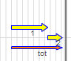Time step is variable according to ***Sim Speed*** slider
* The balls are non-rotating.
* In one dimension, the vectors are not technically tip-to-tail: the vectors are offset, so that the students can see the vectors more easily.
* The **More Data** section can be useful after qualitative investigations to design specific experiments by typing in the table.

**Insights into student use / thinking:**

* Students preferred to start the sim in one dimension and with no walls. The new first tab implements this as the default.
* 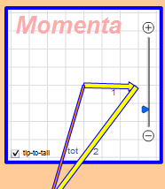If students vary the **Elasticity,** they can observe varying amounts of mechanical energy.
* The vector representations in the Momentum diagram can extend beyond the grid. Students can use the zoom to make the grid spacing change if they like.

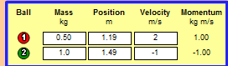

**Suggestions for sim use:**

* Explosions can be explored by setting the balls next to one another and adjusting initial velocities so that the initial total momentum is zero.
* For tips on using PhET sims with your students see: [**Guidelines for Inquiry Contributions**](http://phet.colorado.edu/teacher_ideas/contribution-guidelines.php)and [**Using PhET Sims**](http://phet.colorado.edu/teacher_ideas/classroom-use.php)
* The simulations have been used successfully with homework, lectures, in-class activities, or lab activities. Use them for introduction to concepts, learning new concepts, reinforcement of concepts, as visual aids for interactive demonstrations, or with in-class clicker questions. To read more, see [**Teaching Physics using PhET Simulations**](http://phet.colorado.edu/phet-dist/publications/Teaching_physics_using_PhET_TPT.pdf)
* For activities and lesson plans written by the PhET team and other teachers, see: [**Teacher Ideas & Activities**](http://phet.colorado.edu/teacher_ideas/index.php)

**For Experts:** Elasticity, a number between 0 and 1, indicates the amount of kinetic energy lost during collisions. If the elasticity = 1, the collision is perfectly elastic, and kinetic energy is conserved. Elasticity < 1 affects the magnitude of the component of the velocity along the “line of action” between two colliding balls. The line of action is the line connecting the centers of the balls at the moment of collision. If the elasticity is, say, 0.3, then the speed along the line of action after collision is 0.3 of the value it would have had in an elastic collision. The speed perpendicular to the line of action is not affected. Since these balls are non-rotating, changing the speed perpendicular to the line of action would violate Conservation of Angular Momentum.