**Tips for controls:**

* The tools and features are very easy to use according to our interviews.
* Tools and objects can be dragged out of the “tool box” and then returned.
* The objects in the **Prism Break** tab can be rotated by dragging the handle
* In the **Prism Break** tab, the protractor rotates and the laser translates.
* All the tools work in both **Ray** and **Wave** mode, but some are easier to use in **Wave** mode because the region where the tool can read is larger.
* Try all the different tabs at the top of the simulation. The tabs are designed to help teachers scaffold lessons or make lessons age appropriate by using only some tabs.
* In the Intro and More Tools tabs, the waves speed may make understanding difficult: you can **Pause**   the sim and then use **Step** to incrementally analyze. Also, the sim speed tool  allows the time increment of the simulation to be decreased, but the speed tool still functions to provide appropriate measurements.

**Important modeling notes / simplifications:**

* Snell’s Law was used to determine angles and wavelengths.
* Intensities are calculated assuming a parallel polarized incident beam:
  + Reflected: 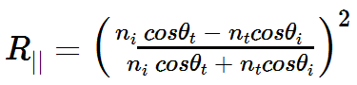
  + Transmitted: 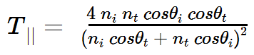
* There are many types of Glass; we used an index of 1.50.

**Insights into student use / thinking:**

* Students explored lots of features. They may need guidance to relate the bending of light to the indices of refraction and also how light wavelength effects index.

**Suggestions for sim use:**

* For tips on using PhET sims with your students see: [**Guidelines for Inquiry Contributions**](http://phet.colorado.edu/teacher_ideas/contribution-guidelines.php)and [**Using PhET Sims**](http://phet.colorado.edu/teacher_ideas/classroom-use.php)
* The simulations have been used successfully with homework, lectures, in-class activities, or lab activities. Use them for introduction to concepts, learning new concepts, reinforcement of concepts, as visual aids for interactive demonstrations, or with in-class clicker questions. To read more, see [**Teaching Physics using PhET Simulations**](http://phet.colorado.edu/phet-dist/publications/Teaching_physics_using_PhET_TPT.pdf)
* For activities and lesson plans written by the PhET team and other teachers, see: [**Teacher Ideas & Activities**](http://phet.colorado.edu/teacher_ideas/index.php)