Students that we interviewed had great success using the simulation with no directions. These teacher tips are meant to help you quickly understand the game operation. We have provided multiple representations to help them with their sense making; they may not use all the representations. Our studies show that student exploration, not explicit directions enable the students to get the most value from this sim.

**Teacher Tips for controls:**

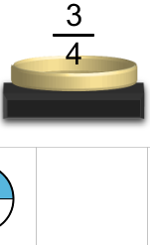

* Students can choose to work on any level or tab.
* The first tab has improper fractions and the second mixed numbers.
* Students drag objects or fractions onto the pan, but they can also drag them back to the bottom sections.

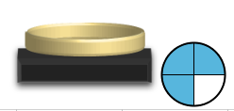

* Representations are randomly generated so students will get a variety of challenges enabling independent work.
* 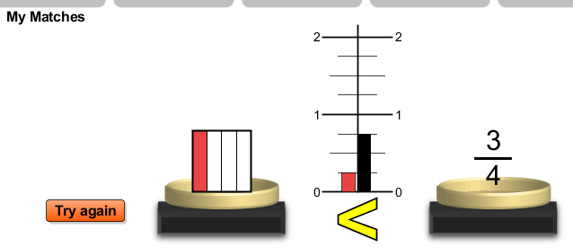They can check their answers and then a line chart shows up with an indication of relative number size and also a greater than or less than symbol. They will have to select and drag at least one of the objects back into the bottom and then drag something else up to try a new match.
* 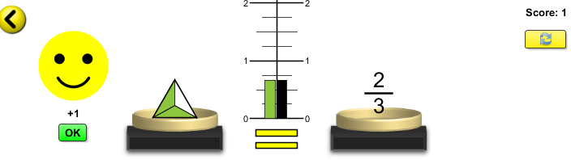When students get a set of equivalent numbers or representations, they see a smiley face and . The match set moves into the match boxes. They earn 2 points for a correct answer on first try and 1 point for a second try and 0 otherwise. Each game has 6 challenges for a possible total score of 12.
* The Refresh button  gives the students new objects in to use, but at the same level.
* The arrow  let the students or teacher scroll back to the front page where they can select levels to see what they have done or move to another level.
* When the students end a game (they don’t have to finish it to end), a representation for their score is shown by stars. Three full stars would mean they made all the matches on the first try. This representation indicates 10/12 points. This  indicates 6/12 points. If students re-do a level, the best score is shown until they close the program and restart. So a student can get a perfect score, but you will not know how many tries it took.
* Turning on the clock just maprovides another way for students to keep track of their progress. Students cannot save their results, but best time for the session is given.

**Suggestions for sim use:**

* Teachers may choose to assign levels or tabs using the Level Descriptions: Level 1 of both tabs has only circles and rectangles, exact matches, and simplified fractions. Beyond level 1, non-simplified fractions, (like 3/6) are included in numbers and shapes. Matching is defined as “equal values” like 3/6=1/2. Also, the complexity of the shapes increases with levels. More information is provided in the tables below.

Key: N = number value or value of representation

|  |  |  |  |  |  |
| --- | --- | --- | --- | --- | --- |
| Matching Game Tab | | | |  |  |
| level | denominator maximum | Value (N) Range | | fill |  |
| 1 | 4 | 0<N≤1 | | ordered |  |
| 2 | 6 | 0<N≤1 | | ordered |  |
| 3 | 8 | 0<N≤2 | | ordered |  |
| 4 | 9 | 0<N<2 | | ordered |  |
| 5 | 27 | 0<N<2 | | ordered |  |
| 6 | 45 | 0<N<2 | | random |  |
| 7 | 63 | 1<N<2 | | random |  |
| 8 | 81 | 1<N<2 | | random |  |
|  |  |  | |  |  |
| Mixed Numbers tab: No improper fractions | | | | | |
| level | denominator (D) maximum | Range (N) | numerator value in mixed number | | fill |
| 1 | 4 | 0<N≤2 | 1 | | ordered |
| 2 | 6 | 0<N≤2 | 1 | | ordered |
| 3 | 8 | 0<N≤2 | varies | | ordered |
| 4 | 9 | 0<N≤2 | varies | | ordered |
| 5 | 27 | 0<N≤2 | varies | | ordered |
| 6 | 45 | 0<N≤2 | varies | | random |
| 7 | 63 | 1<N≤2 | varies | | random |
| 8 | 81 | 1<N≤2 | varies | | random |

* For tips on using PhET sims with your students see: [**Guidelines for Inquiry Contributions**](http://phet.colorado.edu/teacher_ideas/contribution-guidelines.php)and [**Using PhET Sims**](http://phet.colorado.edu/teacher_ideas/classroom-use.php)
* The simulations have been used successfully with homework, lectures, in-class activities, or lab activities. Use them for introduction to concepts, learning new concepts, reinforcement of concepts, as visual aids for interactive demonstrations, or with in-class clicker questions. To read more, see [**Teaching Physics using PhET Simulations**](http://phet.colorado.edu/phet-dist/publications/Teaching_physics_using_PhET_TPT.pdf)
* For activities and lesson plans written by the PhET team and other teachers, see: [**Teacher Ideas & Activities**](http://phet.colorado.edu/teacher_ideas/index.php)