**Tips for controls:**

* Try all the different tabs at the top of the simulation. The tabs are designed to help teachers scaffold lessons or make lessons age appropriate by using only some tabs.
* 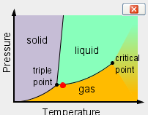On the first tab, as you toggle between chemicals, the phase will stay the same and the temperature will adjust realistically. So if you want to compare solids to solids it is very easy.
* On the second tab, as you toggle between chemicals, the material will be displayed with some liquid and some gas. The phase diagram starts in the same position.
* The “Adjustable Attraction” is designed to help students get a qualitative idea about how attraction effects phase. They will need to allow the simulation a few seconds to react. The change is not instantaneous.
* You can **Pause** the sim and then use **Step** to incrementally analyze.
* If you are doing a lecture demonstration, set your screen resolution to 1024x768 so the simulation will fill the screen and be seen easily.
* In the 2nd tab, the lid can be moved up and down by grabbing the handle or finger.
* If you want to keep heating or cooling without holding the slider 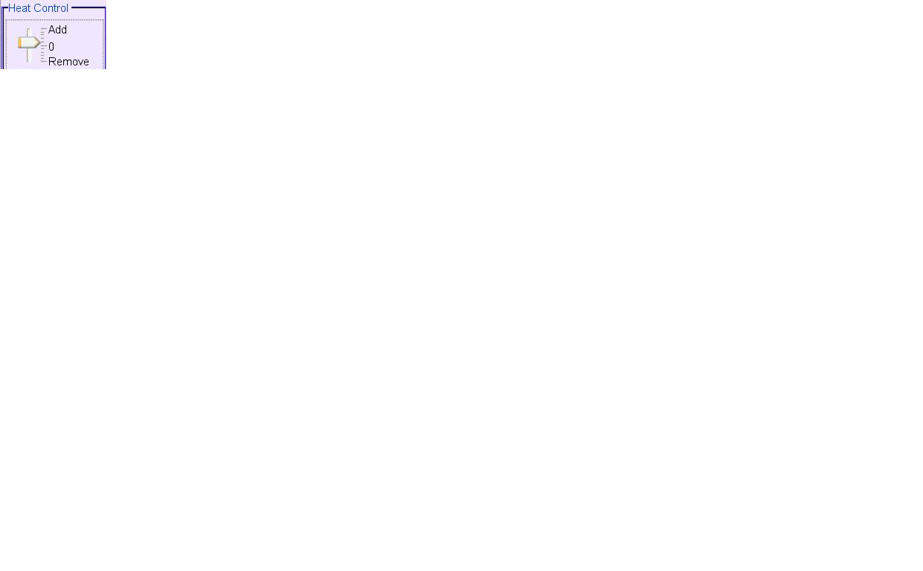 in the "Heat Control" with the mouse: click once on the slider and then use the up/ down arrow keys to set the slider where you want the arrow to stay.

**Important modeling notes / simplifications:**

* The Phase diagram axes do not have scales, but are meant to give students a general idea about understanding phase diagrams. On page 2 of these Tips, phase diagrams for water, neon, argon and oxygen are illustrated.
* For solid water, we wanted to show that there is space between the molecules. The correct structure of solid water requires a 3D view, but with minor compromises, we were able to show the situation qualitatively in 2D.

**Insights into student use / thinking:**

* Students can learn quite a bit about the basics of states of matter by just playing around with this sim.
* Advanced ideas, such as gas laws, may require a slightly more guided activity.

**Suggestions for sim use**

* There is a new simulation called ***Atomic Interactions*** that is like the third tab but has advanced features
* For tips on using PhET sims with your students see: [**Guidelines for Inquiry Contributions**](http://phet.colorado.edu/teacher_ideas/contribution-guidelines.php)and [**Using PhET Sims**](http://phet.colorado.edu/teacher_ideas/classroom-use.php)
* The simulations have been used successfully with homework, lectures, in-class activities, or lab activities. Use them for introduction to concepts, learning new concepts, reinforcement of concepts, as visual aids for interactive demonstrations, or with in-class clicker questions. To read more, see [**Teaching Physics using PhET Simulations**](http://phet.colorado.edu/phet-dist/publications/Teaching_physics_using_PhET_TPT.pdf)
* For activities and lesson plans written by the PhET team and other teachers, see: [**Teacher Ideas & Activities**](http://phet.colorado.edu/teacher_ideas/index.php)

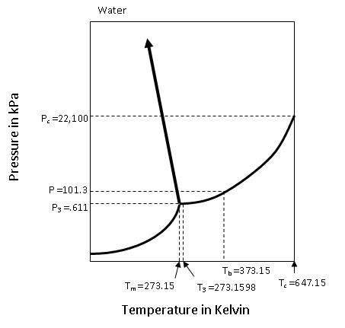

**Legend**

Tm = melting point

Tb = boiling point

T3 = triple point

Tc = critical point

P3 = triple point

Pc = critical point

