Course: COMP10666  
 Instructor: Mohammed Elliethy  
 SN: 000223441  
 Name: Michael Blair  
 Project: Assignment#2 – K.A. R  
 Katalon Automated Recorder

# Introduction.

The purpose of this assignment is to investigate our testing process, document the user experience on a provided example website hosted on the CSUNIX environment. The goal for these test suites designed and implemented via Katalon Automated Recorder, is to demonstrate reproducible, and expected results. All observations are recorded within this documents’ test case table. Any undesirable test case result which indicates a bug will be mentioned within the bug summary section of this report.

With respect to the site itself being tested, its main features are distinct permissions between the two different types of users, Members and Administrators. These main two users are distinguished by their granted access permissions, which has been tested to ensure that each type is meeting the access guidelines set by the designing developer and relayed to me. Moreover, member and admin accounts who have access to the site also have unique account creation capabilities, which must be fully screened with test cases, to ensure system stability. To fulfill these requirements, the following tests were done using Katalon Automated Recorder Extension for Google Chrome Browser, which allows for the recording of elements interacted with during the recorded window, and the subsequent log to be rerun allowing for reproducible observations. I’ve attached in a Katalon file format these test cases, within a compressed file along with this submission. Please see the test procedure at the end of this document, for a step-by-step process of how to access, load, and verify these results with (your preinstalled) Katalon recorder. This record will be subdivided into three test suites, ADMIN, USER, and CLEANUP (deletion). For this report, the hardware was not fulfilling any use in the context of what the stated website testable features are, and so differences in user hardware should not be considered relevant for the reproducibility of tests.

# Test Cases Table.

|  |  |  |  |  |  |
| --- | --- | --- | --- | --- | --- |
| **Unit Tests** | | | | | |
| **Test#** | **Test Name** | **Reason** | **Expected Result** | **Observed Result** | **P/F** |
| 1 | UserName Within Range [10 Chars] | Testing name length condition satisfied. | VerifyText: *Record Successfully Inserted* | VerifyText: *Record Successfully Inserted* | *P* |
| 2 | UserName Within Range [5 Chars] | Testing name length condition satisfied. | VerifyText: *Record Successfully Inserted* | VerifyText: *Record Successfully Inserted* | *P* |
| 3 | UserName Below Range [4 Chars] | Testing name length error message appears. | VerifyText: *Username not in right format. 5-15 chars. Letters, Numbers only.* | VerifyText: *Username not in right format. 5-15 chars. Letters, Numbers only.* | *P* |
| 4 | UserName Above Range [16 Chars] | Testing name length error message appears. | VerifyText: *Username not in right format. 5-15 chars. Letters, Numbers only.* | VerifyText: *Username not in right format. 5-15 chars. Letters, Numbers only.* | *P* |
| 5 | OptionalEmailIncluded | Test if email field added properly. | VerifyText: *Record Successfully Inserted* | VerifyText: *Record Successfully Inserted* | *P* |
| 6 | AdminUnActivated | Tests that the database shows user acct as un-activated, as selected. | VerifyText: *Record Successfully Inserted* | VerifyText: *Record Successfully Inserted* | *P* |
| 7 | Non-AdminUnactivated | Tests that the database shows user acct as activated, as selected. | VerifyText: *Record Successfully Inserted* | VerifyText: *Record Successfully Inserted* | *P* |
| 8 | UserNameMixedLetters&Digits ([0-9]) | Tests username to add that has digits first before numbers. | VerifyText: *Record Successfully Inserted* | VerifyText: *Record Successfully Inserted* | *P* |
| 9 | UserNameMixedLetters&Digits&SpecialChars | Tests that special characters do not work in username. Assumption is they will not. | VerifyText: *Password not in right format. Must be at least 8 chars and include 1 upper case, 1 lower case and 1 digit* | VerifyText: *Password not in right format. Must be at least 8 chars and include 1 upper case, 1 lower case and 1 digit* | *P* |
| 10 | UserNameWithSpaces | Tests that spaces do not work in username. Assumption is they will not. | VerifyText: *Password not in right format. Must be at least 8 chars and include 1 upper case, 1 lower case and 1 digit* | VerifyText: *Password not in right format. Must be at least 8 chars and include 1 upper case, 1 lower case and 1 digit* | *P* |
| 11 | UserNameDigitsOnly | Tests that a username with only digits works | VerifyText: *Record Successfully Inserted* | VerifyText: *Record Successfully Inserted* | *P* |
| 12 | PasswordNumberFirst-EightCharactersTotal | Check that password works as it meets the parameters specified with numbers first. | VerifyText: *Record Successfully Inserted* | VerifyText: *Password not in right format. Must be at least 8 chars and include 1 upper case, 1 lower case and 1 digit* | *F* |
| 13 | FollowUpOne-NumberLast-EightCharactersTotal | Follow up: Check with number to last char position, that number first password formatting isn’t the issue at play. | VerifyText: *Record Successfully Inserted* | VerifyText: *Password not in right format. Must be at least 8 chars and include 1 upper case, 1 lower case and 1 digit* | *F* |
| 14 | FollowUpTwo-NumberLast-NineCharactersTotal | Follow up: Confirmed, issue is not numbers it is that >=8 is inaccurate, and >8 is accurate. | VerifyText: *Record Successfully Inserted* | VerifyText: *Record Successfully Inserted* | *P* |
| 15 | PasswordSpaces | Tests that password should not be able to hold spaces. | VerifyText: *Password not in right format. Must be at least 8 chars and include 1 upper case, 1 lower case and 1 digit* | VerifyText: *Record Successfully Inserted* | *F* |
| 16 | FollowUpOne-SpacesAsLengthCount | Follow up: Confirmed that spaces are considered as characters, counting towards max character count. | VerifyText: *Password not in right format. Must be at least 8 chars and include 1 upper case, 1 lower case and 1 digit* | VerifyText: *Record Successfully Inserted* | *F* |
| 17 | CheckAdminDebugWorksLinkOn | Tests that admin navigation shows off option when on. | VerifyText: *Turn Debug Off* | VerifyText: *Turn Debug Off* | *P* |
| 18 | CheckAdminDebugWorksLinkOnOff | Tests that admin navigation shows on option when off. | VerifyText: *Turn Debug On* | VerifyText: *Turn Debug On* | *P* |
| 19 | EditUserUpdateAddEmail | Tests that admin edit function can add email | VerifyText: *Update was successful* | VerifyText: *Update was successful* | *P* |

|  |  |  |  |  |  |
| --- | --- | --- | --- | --- | --- |
| 20 | EditUserUpdateNewPassword | Tests that admin edit capability successfully changes password | VerifyText: *Update was successful* | VerifyText: *Update was successful* | *P* |
| 21 | EditUserUpdateRemoveEmail | Tests that admin edit capability can update a user and target account associated remove email. | VerifyText: *Update was successful* | VerifyText: *Update was successful* | *P* |
| 22 | EditUserChangeAdminToUser | Tests that admin edit capability can change admin to user. | VerifyText: *Update was successful* | VerifyText: *Update was successful* | *P* |
| 23 | EditUserChangeUserToAdmin | Tests that admin edit capability can change user to admin. | VerifyText: *Update was successful* | VerifyText: *Update was successful* | *P* |
| 24 | NonAdminActivatedForUserSuite | Tests user account creation with non admin permissions for usersuite. | VerifyText: *Record successfully inserted.* | VerifyText: *Record successfully inserted.* | *P* |
| 25 | NonAdminActivatedLoginGood | Tests created normal user login capability. | VerifyText: *User: yogferatu* | VerifyText: *User: yogferatu* | *P* |
| 26 | NonAdminActivatedNewsSection | Tests regular nonadmin access to member news section. | VerifyText: *Welcome to the Members Only Section* | VerifyText: *Welcome to the Members Only Section* | *P* |
| 27 | NonAdminActivatedDirectory | Tests ability to navigate of regular nonadmin access to search directory. | VerifyText: *Company Search* | VerifyText: *Company Search* | *P* |
| 28 | NonAdminActivatedSelectACity | Tests function to select and display stores based on city chosen first example. | VerifyText*: SEARS INDOOR CLEAN WIND SERVICES (20222222 ONTARIO INC./2222* | *VerifyText: SEARS INDOOR CLEAN WIND SERVICES (20222222 ONTARIO INC./2222* | *P* |
| 29 | NonAdminActivatedNewSearchClear | Tests function of button ‘New Search’ (clear) displayed stores by city. | VerifyNotText: *SEARS INDOOR CLEAN WIND SERVICES (20222222 ONTARIO INC./2222* | VerifyNotText: *SEARS INDOOR CLEAN WIND SERVICES (20222222 ONTARIO INC./2222* | *P* |
| 30 | NonAdminActivatedFAQ | Test’s ability to navigate to FAQ in member section. | VerifyText: *Frequently Asked Questions* | VerifyText: *Frequently Asked Questions* | P |
| 31 | NonAdminUnActivatedLoginTest | Check that non activated user accounts have no login functionality. | VerifyText: *Account has been disabled* | VerifyText: *Account has been disabled* | P |
| 32 | AdminUnActivatedLoginTest | Check that non activated admin accounts have no login functionality. | VerifyText: *Account has been disabled* | VerifyText: *Account has been disabled* | P |
| 33 | DELETE UserName Within Range [10 Chars] | Deletes the account | VerifyText: *User HiTestYUser1 was successfully deleted.* | VerifyText: *User HiTestYUser1 was successfully deleted.* | P |
| 34 | DELETE UserName Within Range [5 Chars] | Deletes the account | *User qurtA was successfully deleted.* | *User qurtA was successfully deleted.* | P |
| 35 | DELETE OptionalEmailIncluded | Deletes the account | *User ElenaFirebane1 was successfully deleted.* | *User ElenaFirebane1 was successfully deleted.* | P |
| 36 | DELETE UserName Mixed Letters&Digits ([0-9]) | Deletes the account | *User 97531tacklife was successfully deleted.* | *User 97531tacklife was successfully deleted.* | P |
| 37 | DELETE NonAdminUnactivated | Deletes the account | *User Falkor was successfully deleted.* | *User Falkor was successfully deleted.* | P |
| 38 | DELETE AdminUnactivated | Deletes the account | *User Grumpus was successfully deleted.* | *User Grumpus was successfully deleted.* | P |
| 39 | DELETE PasswordSpaces | Deletes the account | *User danicaYea1 was successfully deleted.* | *User danicaYea1 was successfully deleted.* | P |
| 40 | DELETE Password9DLength | Deletes the account | *User 999999999 was successfully deleted.* | *User 999999999 was successfully deleted.* | P |
| 41 | DELETE NonAdminActivated | Deletes the account | *User yogferatu was successfully deleted.* | *User yogferatu was successfully deleted.* | P |
| 42 | DELETE PasswordFollowUpTwo | Deletes the account | *User monicaYea1 was successfully deleted.* | *User monicaYea1 was successfully deleted.* | P |
| 43 | DELETE PasswordWhiteSpaces | Deletes the account | *User laurenYea1 was successfully deleted.* | *User laurenYea1 was successfully deleted.* | P |

# Bug Summary.

|  |  |  |  |
| --- | --- | --- | --- |
| **Test Case** | **Bug #** | **Description Of Bug** | **Supporting Test Cases** |
| 12 | 1 | The first bug was found to be a password character limit bug. Initially, this bug was caught during normal test-to-pass execution. It appeared at first to be the product of a `**numbers first limitation**`, but further supporting test cases seemed to indicate that this initial assessment was incorrect. The number of characters in which a user can be permitted - at minimum -must be **at greater than or equal to eight.** However, the actual permitted minimum range **was found to be higher than eight characters in length** including the digit, or nine characters in total. As a quality tester, I stress that while this could be intentional, it should be examined, and, if necessary - updated with an error message of more clarity to ensure that this was the intention by the developer. In conclusion, otherwise it should be accommodated in modifications to allow a combination of six lowercase letters, one uppercase letter, and one digit; Allowing for 8 characters total minimum to be submitted as a successful password entry. Suggest checking database varchar length associated for the password structure to confirm either of the two scenarios. | 13,14 |
| 15 | 2 | Second bug was found to be another password bug. **The password field accepted blank spaces as characters**. This was discovered during test to fail testing; In the follow up it was discovered that a **blank space in the password was being counted as a character towards the character limit.** This should not be allowed, and empty spaces in a password should be an immediate prompt -indicating that the requirement of a successful password would be to meet the criteria of greater than eight characters - including one digit, one uppercase letter and no special characters – and return a corresponding error message. In this case there was no error message, so it is treated as an outright confirmed bug and should be addressed in the next possible update. | 16 |

# Test Procedure.

* + 1. The user should begin by downloading the file containing the compressed katalon automated recorder test suites which accompany this document.
    2. *Graphical user interface

       Description automatically generated*Next, extract the file into a new folder in a suitable place called Test Suites.

*Fig1.1 Click the video to demonstrate how to extract the downloaded files.*

* + 1. Graphical user interface, application

       Description automatically generatedOpen up Katalon Automated Recorder Extension inside your Google Chrome Browser, by clicking on the red R icon.

*Fig 1.2 You may need to pin the recorder in your application settings.*

* + 1. You should see a screen that looks like this. Once it appears, click on the area ‘*Open Test Suite*’ (indicated by the red arrow below).

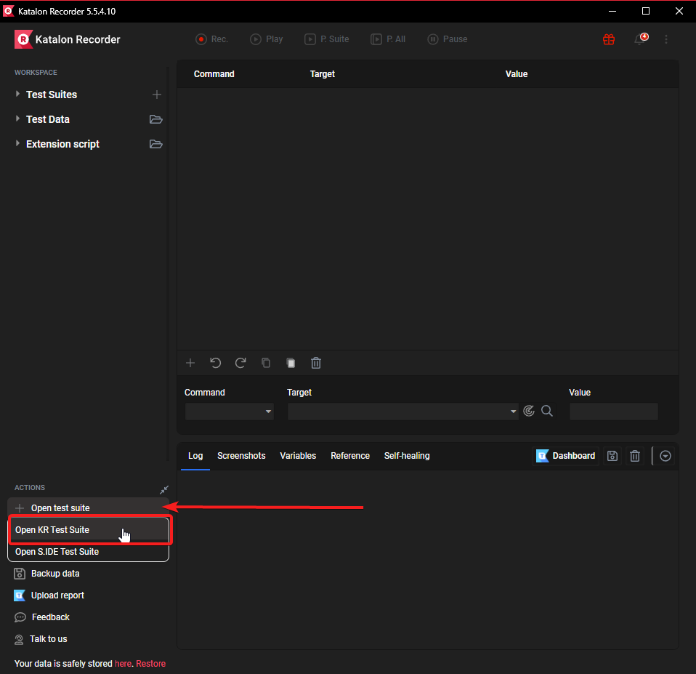

*Fig 1.3: Above Open S IDE test suite shown as highlighted in gray, selecting the ‘Open KR Suite’ option.*

* + 1. Graphical user interface

       Description automatically generatedFrom this point, follow the open file dialog, navigating to the location of folder in which the extracted files are located – and choose any file with a. krecorder extension.

*Fig 1.4: Ensure that the filetype in the lower-right is set to custom.*

* + 1. A screenshot of a computer

       Description automatically generated with medium confidenceRepeat step 4-5 for all three test suites included in the download, and your screen should now look something like this.

*Fig1.5: Top right shows three different test cases loaded into Katalon.*

* + 1. To play a test suite, click it top left, and next click the top P. Suite button at the top of Katalon window. The recorder will go through each test case in a suite, displaying them onscreen for your viewing.

*Fig1.6****:*** *Highlighted P. Suite plays all tests of a selected suite. P. All will play all loaded suites (3 in this case).*

* + 1. To pause playback at any time, click the pause button.



*Fig1.7: The pause button shown above will change to Resume after clicking, simply click to resume playback.*