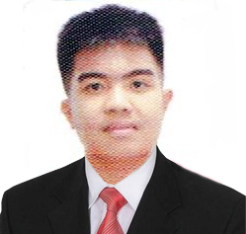

**Mark Lester T. Acak**

Blk 6A Lot 71 Phase 3 Cluster Mabuhay City,

Cabuyao, Laguna

0915-139-2944

mister6virgo@gmail.com

2” X 2” picture with white

background

**OBJECTIVE:**

*To learn and enhance my skills that motivates excellence, towards the organization that will strengthen my personal character, while gaining more experiences.*

**EDUCATION:**

**(Year Covered) STI College** –**(Campus) (for College) / STI (Campus) (for EC)**

2017 - 2019 ITMAWD22

High School Diploma

Awards:

2013 - 2017 Holy Redeemer School of San Isidro Laguna

Most Courteous

**WORK EXPERIENCE (if applicable):**

*N/A*

**SKILLS:**

* Oriented in Microsoft Office applications such as:
* Microsoft Office PowerPoint
* Microsoft Office Word
* Patient and good listener.
* Hardworking and a fast learner.
* Bilingual English / Tagalog

**EXTRA-CURRICULAR ACTIVITIES:**

*WIRCC Orientation – November 9, 2018 – 2PM onwards*

***REFERENCES:***

Jesus Elag Professional Teacher 09162497518

STI College Calamba

McWell Bunao IT Instructor 09197285167

STI College Calamba

I hereby certify that the above information is true and correct to the best of my knowledge and belief.

**MARK LESTER T. ACAK**

*Applicant*