Dieta

Ionic Docs can be accessed here: <https://ionicframework.com/docs/intro/installation/>

As a pre-requisite, you must install NodeJS first via <https://nodejs.org/en/> (Choose LTS version)

Once done, you can check if you have successfully installed NodeJS by running 2 command in the cmd.

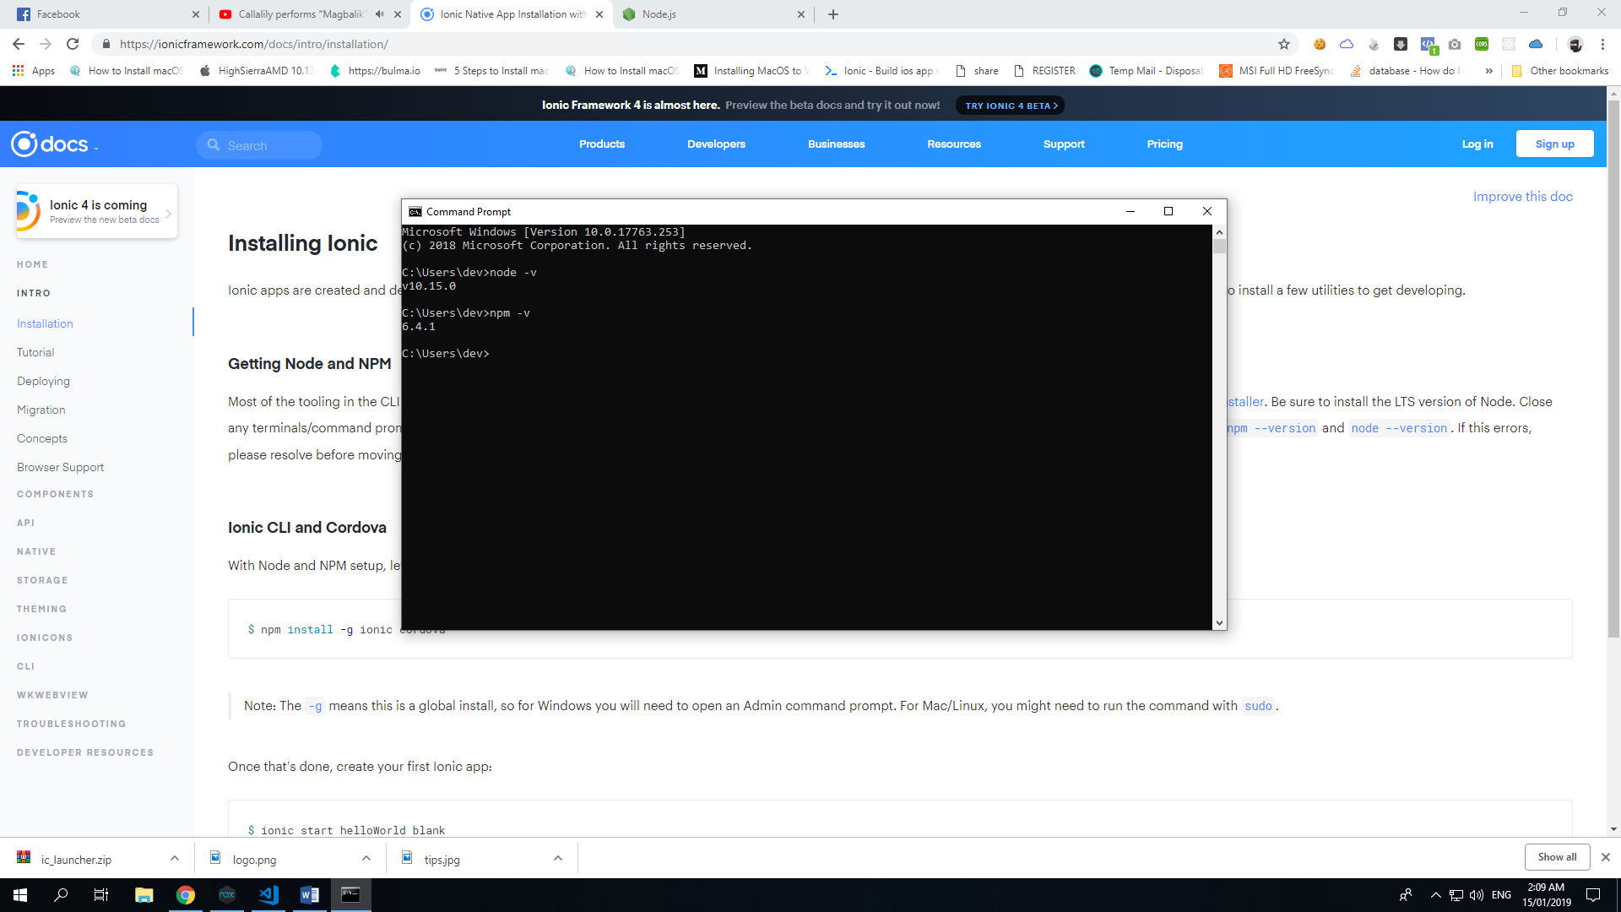

*node -v* and *npm -v*

If both command returned version numbers, then you can now proceed to next command.

To install ionic on your computer, run this command: *npm install -g ionic cordova*

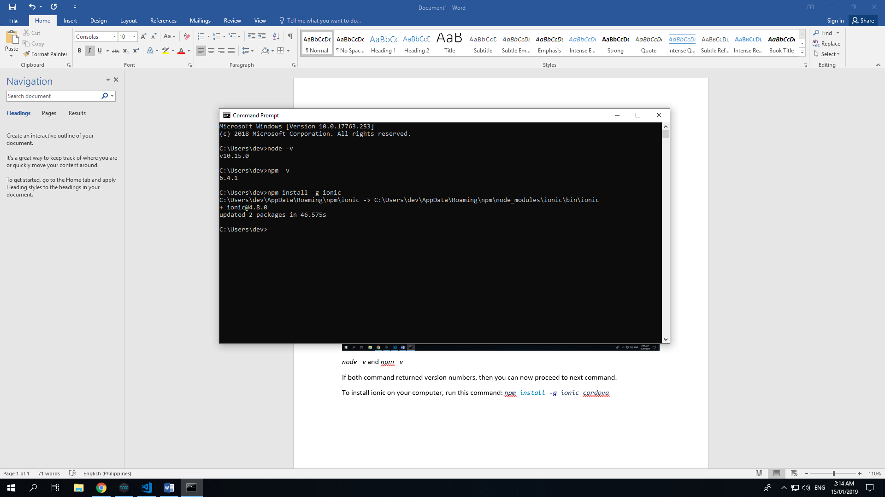

Once done, please download the project files and then extract it from .zip file.

To debug the project, go to your project directory on your cmd via *cd <location>*

Example: *cd C:\node_projects\diet_plan*

To install node_modules, please enter these two commands:

*npm install -g -unsafe-perm*

*npm install -unsafe-perm*

And then type *ionic serve*

It will open browser where you can live edit your app.

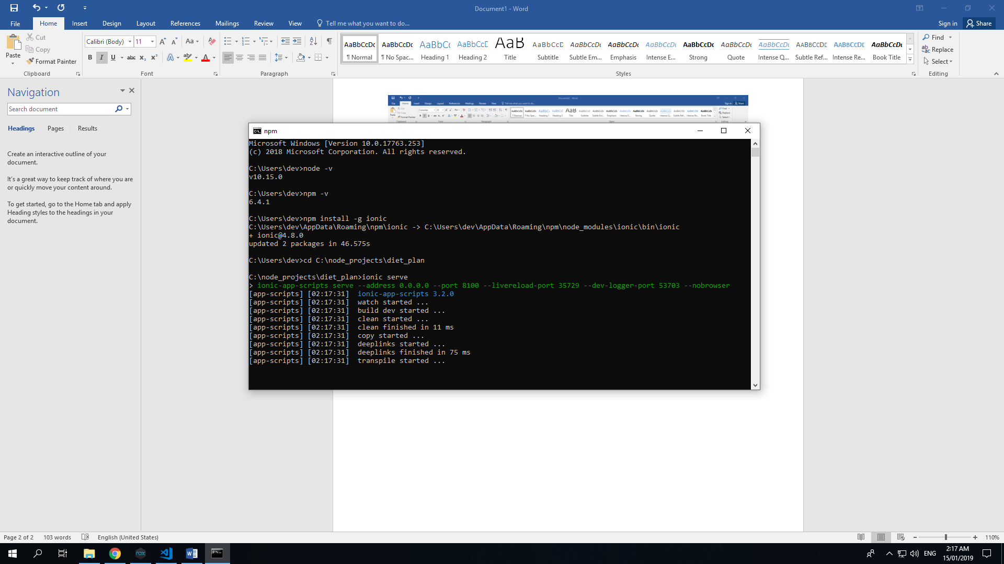

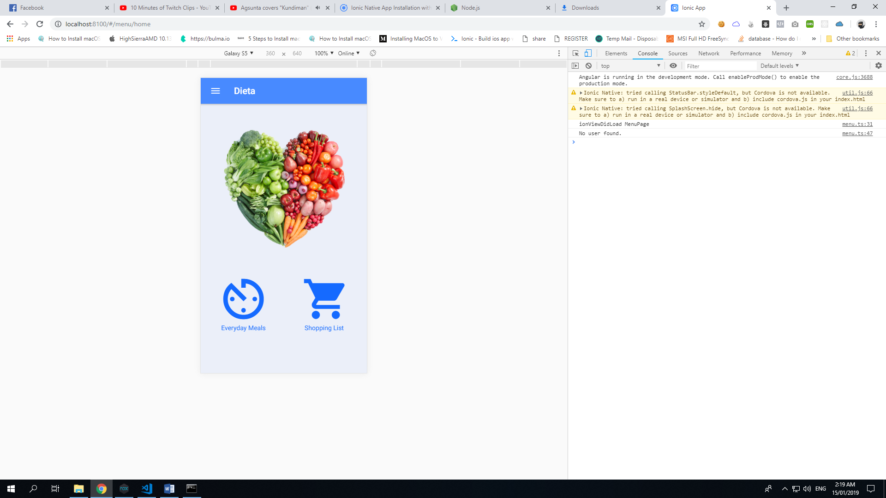

Once you are done debugging your app, you can now build your app nito .apk file which you can install on android devices.

But please do download android studio as it is a pre-requisite of building an app nito .apk file. <https://developer.android.com/studio/>

Once you are ready to build, just enter *ionic cordova build android*

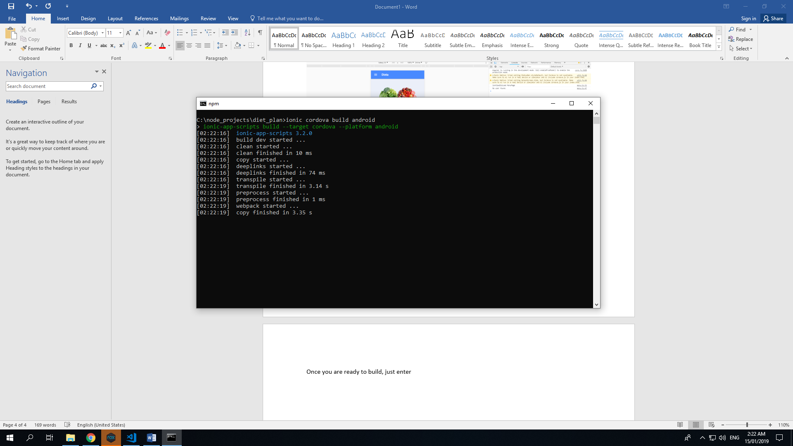

Just wait a few minutes and ionic will build the .apk file. After that, you can see where is the app’s location. You can now install it to any android.

