**CMSC203 Lab 1 Template**

Class: CMSC203 CRN 38511

 Program: Lab 1

Instructor: Prof. Grinberg

 Summary of Description: You will write the driver class to test the various methods provided in the data element class.

 Due Date: 02/20/2022

 Integrity Pledge: I pledge that I have completed the programming assignment independently.

 I have not copied the code from a student or any source.

**Complete the following three parts of Lab 1. Name your file as FirstInitialLastName_Lab1.docx**

**Turn in the following:**

**Task1:**

* MovieDriver.java from Task #1 and Movie.java (**NOT the .class files**; submit the .java files). Submit both files, even though you have not changed Movie.java.
* Screenshot of the running output

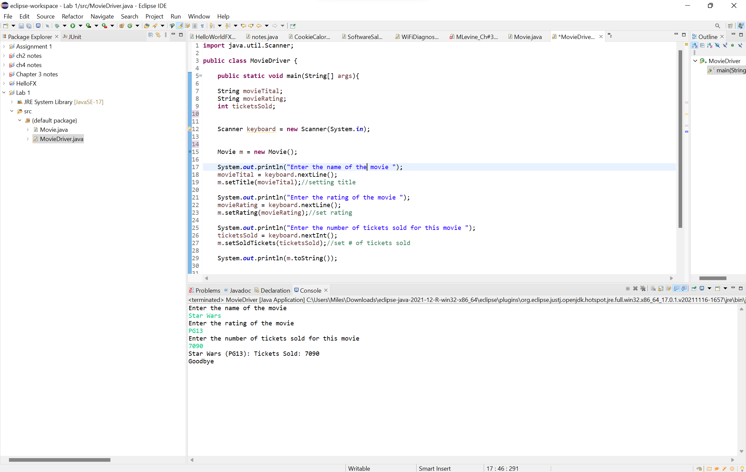

**Task2:**

* MovieDriver.java from Task #2 and Movie.java (**NOT the .class files**; submit the .java files). Submit both files, even though you have not changed Movie.java.
* Screenshot of the running output

**Task3:**

* Screenshot of the uploaded your java files to GitHub in a directory named CMSC203_Lab1

**Lessons Learned** <Provide answers to the questions listed below>**:**

Write about your Learning Experience, highlighting your lessons learned and learning experience from working on this assignment.

What have you learned?

I learned how to test a separate class through a driver class.

What did you struggle with?

I struggled with passing data between both classes. I was very confused with this concept. I needed to re-read the chapters in the textbook to successfully program the lab

What parts of this assignment were you successful with, and what parts (if any) were you not successful with?

I was successful with writing the loop for part 3 of the lab. I was worried that writing the while loop would be difficult, but it ended up being easier than predicted.

Provide any additional resources/links/videos you used to while working on this assignment.

**Check List:** <Provide answers to the column Y/N or N/A >**:**

|  |  |  |  |
| --- | --- | --- | --- |
| **#** |  | **Y/N** | **Comments** |
|  | **Assignment files:** |  |  |
|  | * FirstInitialLastName_Lab1.docx/pdf | **Yes** |  |
|  | * Source java files | **Yes** |  |
|  | **Program compiles** | **Yes** |  |
|  | **Program runs with desired outputs related to a Test Plan** | **Yes** |  |
|  | **Documentation file: Screenshots of** |  |  |
|  | * Task 1 | **Yes** |  |
|  | * Task 2 | **Yes** |  |
|  | * Task 3 | **yes** |  |
|  | * Lessons Learned | **Yes** |  |
|  | * Checklist is completed and included in the Documentation | **Yes** |  |