- Import the data table Download data table and look at it. Do you see any issues you should deal with? (HINT: there are some missing values)
Some of the countries years have data missing as N/A
- Create a histogram and a smoothed density estimate of the 2006, 2010, and 2013 scores.
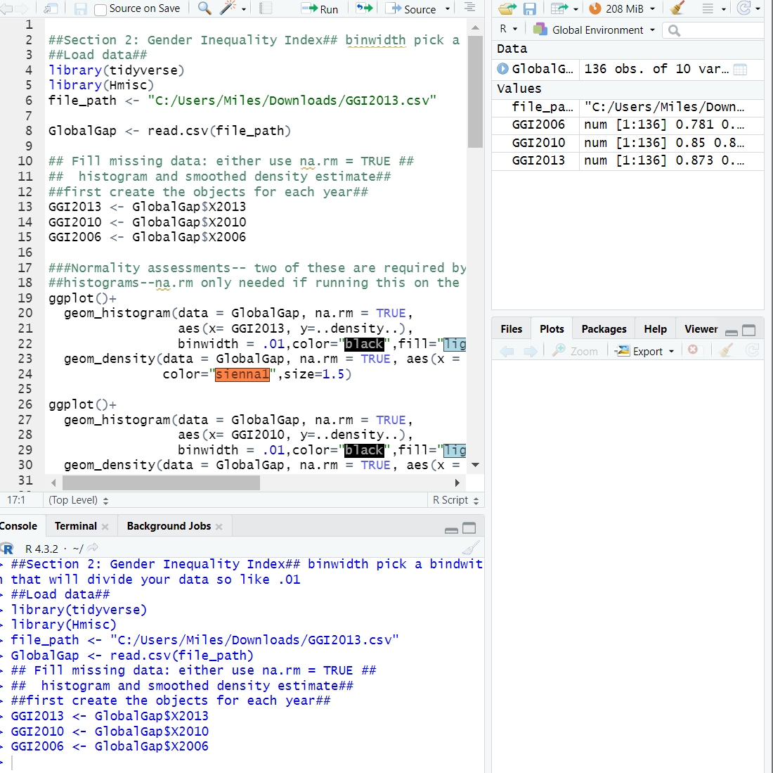
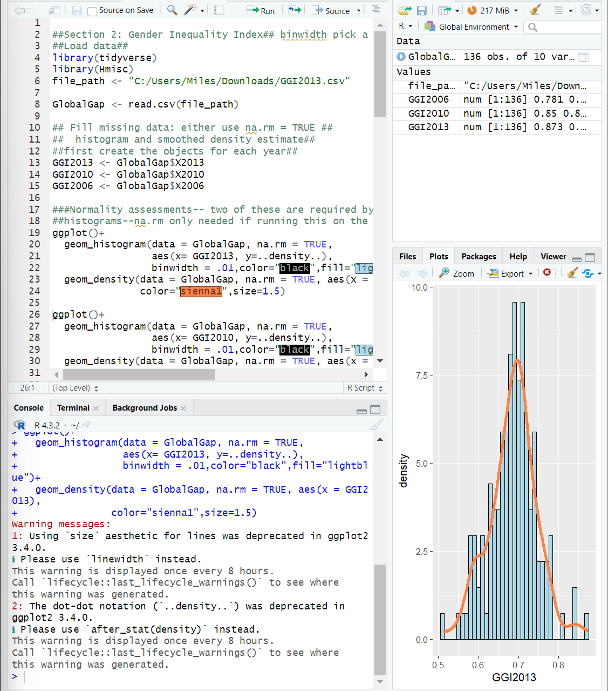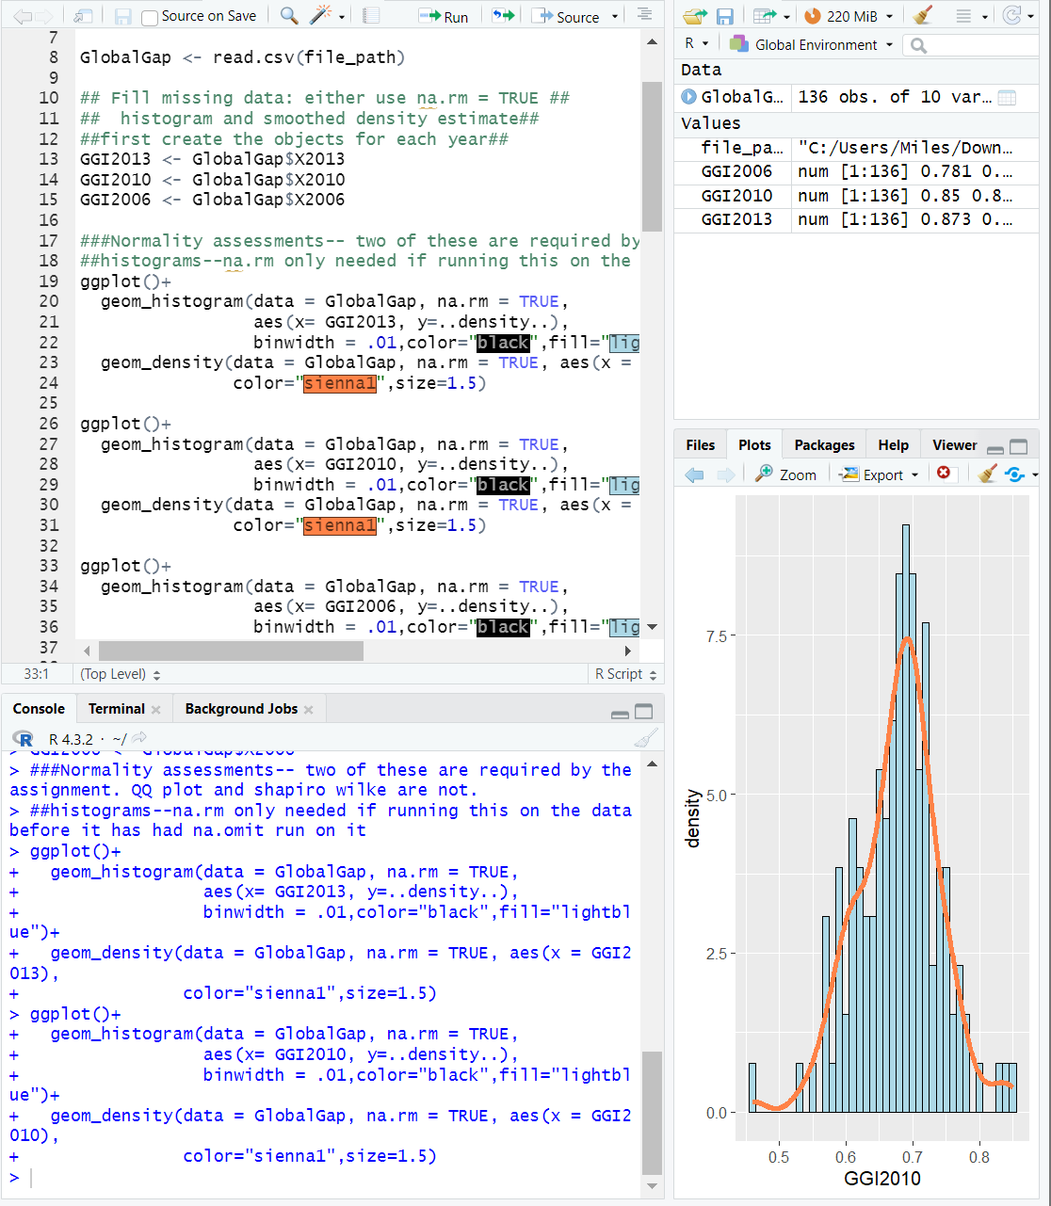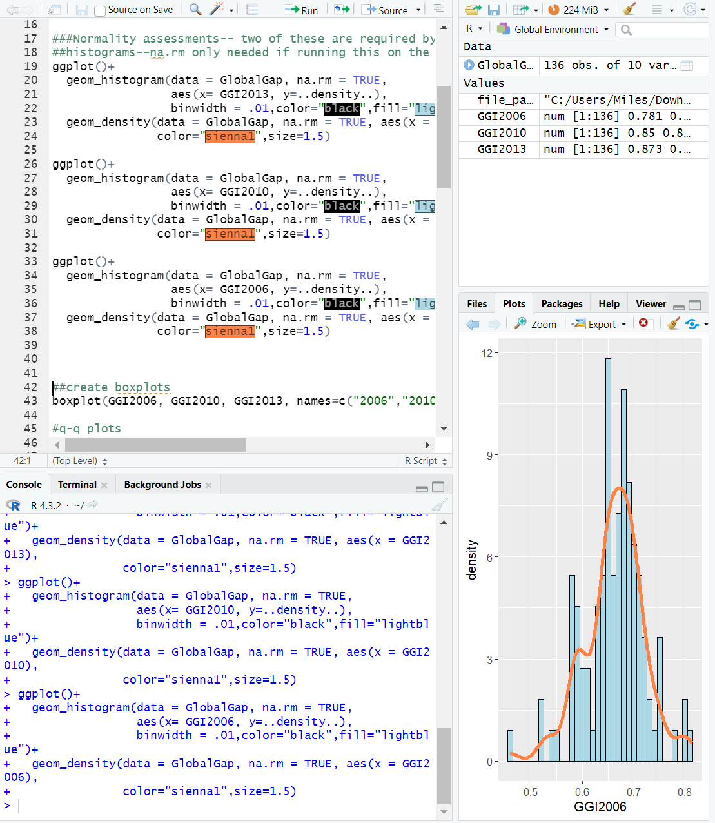
- Next create a box and whisker plot of the same data.
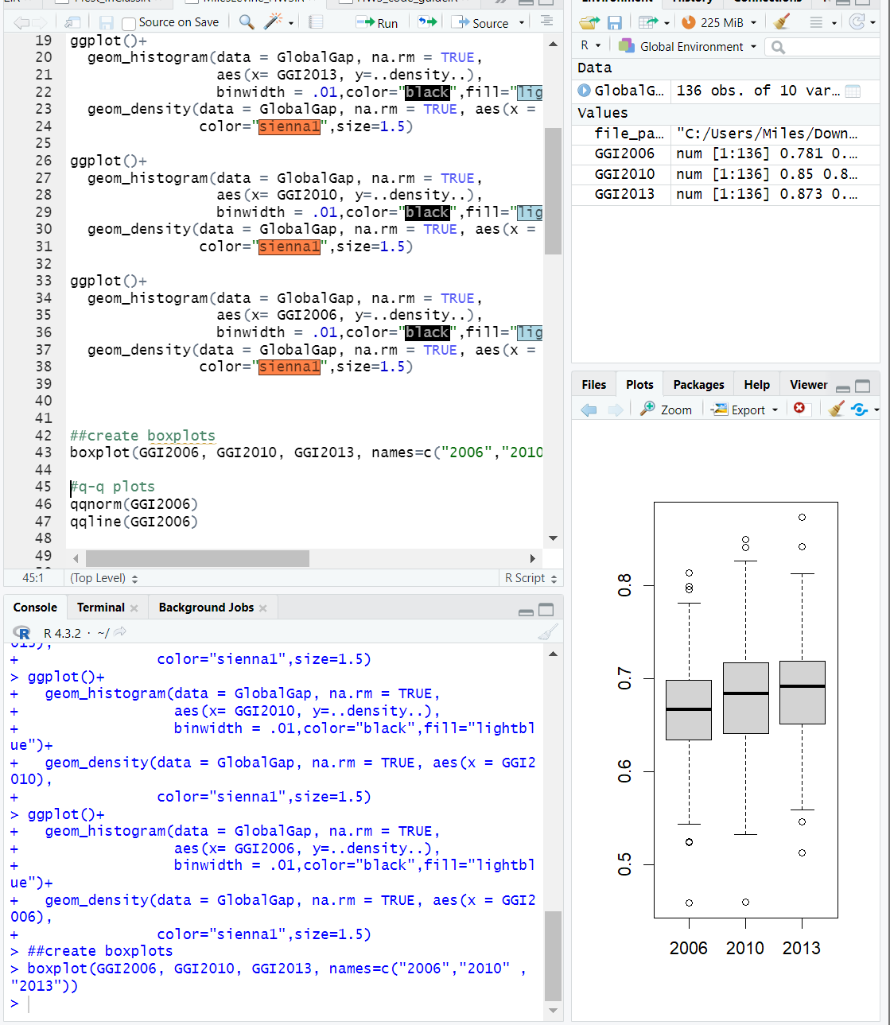
2006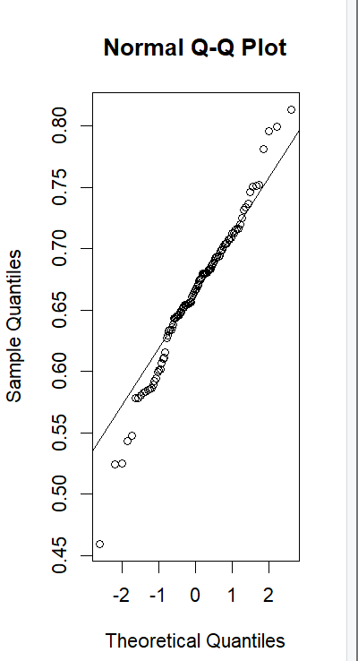2010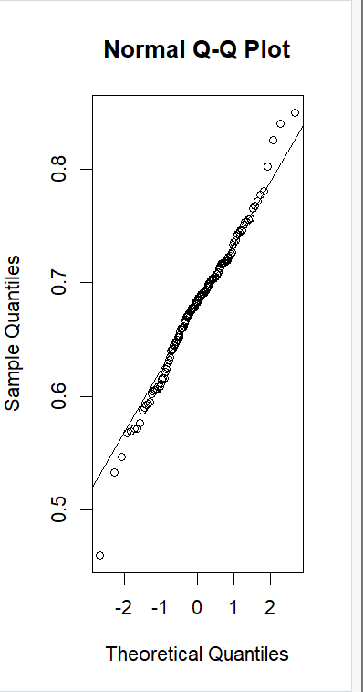
2013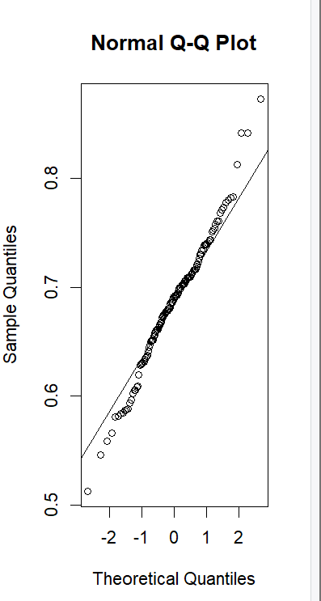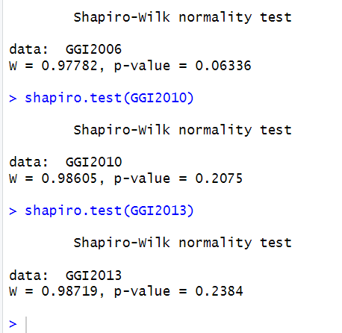
- Calculate summary data for each year you have plotted. Have the means changed over time? How about the standard deviations?
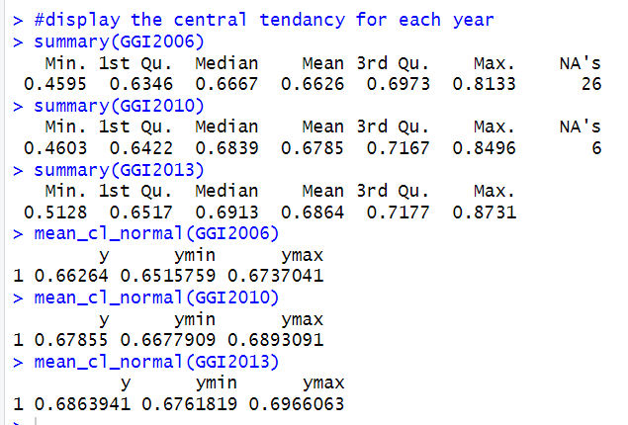
- Do the data look normally distributed based on what you know thus far?
Yes this data looks normally distributed because each year has similar values for min, 1st Qu, median, mean, 3rd Qu and max.
- Calculate the z-scores for each of the years (2006, 2010, 2013).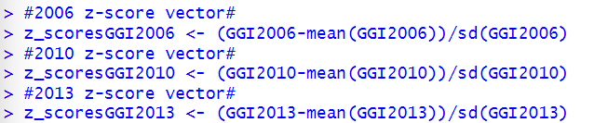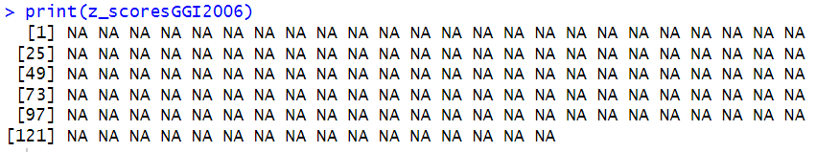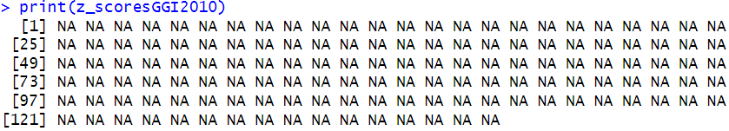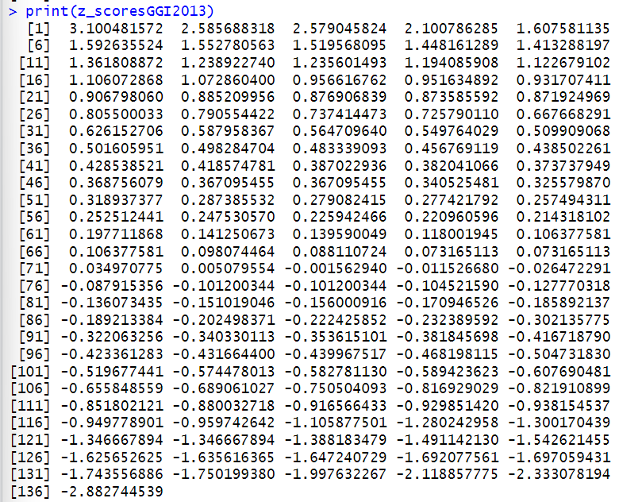
- Create a confidence interval for the mean for each of the years (2006, 2010, 2013).
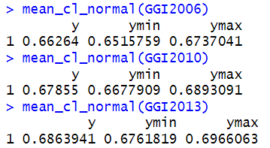
- Re-Import the data and remove the rows with missing data using na.omit if you haven't already. New z-scores for 2006 and 2010: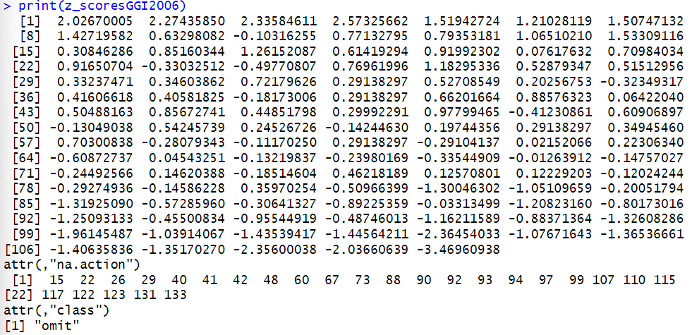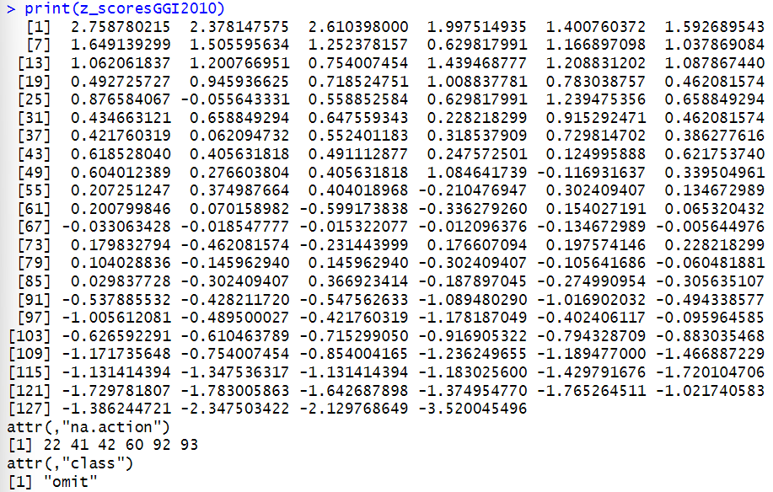
- What test would you use to compare the global average GII for 2006 to the global average GII for 2013 and why?
I would use a paired t-test and set the alternative to less
- Set up this test in words and mathematically as shown in class.
A paired t-test is appropriate since I am comparing the GII scores for the same set of countries between two different years, such as comparing the GII scores for the year 2006 with the scores for the year 2013. In this case, each country's GII score is paired across the two years, making it a paired design.
Setting the alternative hypothesis to "less" indicates that I’m testing whether the mean GII score for 2006 is less than the mean GII score for 2013. This makes sense because the hypothesis is that gender inequality has decreased over time, leading to lower GII scores in 2013 compared to 2006.
- Run this test. What are your results? Do your confidence intervals for these two years overlap?
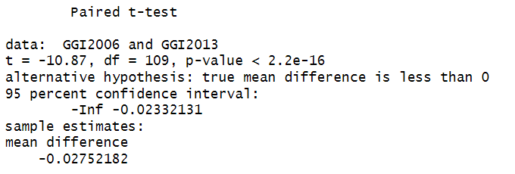
There is no overlap between the confidence intervals for 2006 and 2013.

