University of New Mexico
Eight Years of Neutrosophic Computing and Machine Learning: a Bibliometric Retrospective and a Neutrosophic Extension to Bibliometric Analysis (2018–2026)
Maikel Leyva Vazquez^{1*}, Yismandry Gonzalez Vargas², Florentin Smarandache³
¹ Universidad Bolivariana del Ecuador / Universidad de Guayaquil; Editor-in-Chief, Neutrosophic Computing and Machine Learning. E-mail: mleyvaz@gmail.com
² Asociacion Latinoamericana de Ciencias Neutrosoficas (ALCN), Cuba. E-mail: yismandrygonzalezvargas@gmail.com
³ University of New Mexico, USA; Editor-in-Chief, Neutrosophic Sets and Systems. E-mail: smarand@unm.edu
*Corresponding author: mleyvaz@gmail.com
Abstract
Neutrosophic Computing and Machine Learning (NCML) is the applied-methods journal of the neutrosophic publication ecosystem founded by Smarandache, with 42 volumes published between 2018 and 2026 (partial). No systematic bibliometric retrospective of the journal has been published, and the recent methodological critique of Woodall, Faltin and Reynolds (2025) raises three empirically-testable concerns about the neutrosophic field: methodological concentration, citational concentration, and limited external validation. This paper combines a classical bibliometric retrospective of NCML (Sections 4, 7) with a methodological contribution: the introduction of a neutrosophic bibliometric framework that promotes indeterminacy to a first-class component of measurement (Sections 3, 5).
We compiled a reproducible corpus of 762 articles through scraping, enriched with OpenAlex (671/719 DOIs) and DataCite (704/719), disambiguated 1 363 unique authors by union-find (four hierarchical rules), fitted the classical Lotka and Bradford laws, built the Louvain co-authorship network, and modeled 24 topics with multilingual embeddings plus UMAP and KMeans on 725 usable abstracts. The neutrosophic framework extends five classical indicators — h-index, Lotka exponent, Bradford zone membership, document-topic membership, and co-authorship edge weight — into single-valued neutrosophic triples (T, I, F) whose indeterminacy component is computed from the data rather than elicited from experts. The central operative test of the framework is a neutrosophic aggregated ranking of authors using the SVNWA operator.
Classical results confirm a rapidly growing journal with CAGR 42% (2018-2025), a Lotka exponent α = 2.03 (K-S rejected), a Bradford nucleus of five journals concentrating 33% of citations (17% self-citation to the neutrosophic ecosystem), a co-authorship graph of modularity 0.96 with only a 16% main connected component, a topical identity shift of -21.6 pp in the education topic between 2018-2020 and 2023-2025, and an order-of-magnitude discrepancy between citation sources (Google Scholar h5-index = 10 vs OpenAlex h = 1). The neutrosophic analysis decomposes these findings: N-h-index (T = 0.04, I = 0.50, F = 0.46), N-Lotka (T = 0, I = 1, F = 0), graded Bradford nucleus membership where only two journals reach T ≥ 0.85, 61% of documents with boundary-topic indeterminacy, and only 1.8% of co-authorship edges with verified-collaboration T ≥ 0.5. The SVNWA aggregated ranking of 146 authors diverges substantially from the classical article-count ranking (Kendall τ = 0.20, top-10 overlap 5/10), a divergence unreachable by fuzzy, intuitionistic-fuzzy, or probabilistic aggregation without introducing structure equivalent to the (T, I, F) triple. The paper closes with a fifteen-recommendation editorial roadmap organised on a three-year horizon.
Keywords: bibliometrics; neutrosophic logic; single-valued neutrosophic numbers; SVNWA aggregation; Lotka's law; Bradford's law; h-index; co-authorship network; topic modeling; Google Scholar Metrics; open-access journals; editorial retrospective; Neutrosophic Computing and Machine Learning.
1. Introduction
Bibliometric analyses of scientific journals fulfil a triple function in the editorial community: they document the historical evolution of a publication, they expose its collaborative structure, and they surface both strengths and systemic biases for the adjustment of editorial policy [2, 3]. When the signatories are the editors themselves, the exercise acquires the additional character of an internal audit, with the advantage of privileged access to data and the disadvantage of a manifest conflict of interest.
Emerging scientific journals in Spanish-speaking countries face a double challenge: demonstrating real impact in an ecosystem whose citation sources are not fully indexed by the commercial bibliographic databases (Scopus, Web of Science), and professionalising their editorial processes to access those databases. The asymmetries between sources — documented by Harzing and van der Wal [12] in the case of Google Scholar versus Web of Science, and extended by Martin-Martin et al. [13] to the Scholar-OpenAlex-Scopus contrast — are particularly severe for Iberoamerican social-science journals and for journals publishing through open-access repositories such as Zenodo or SciELO.
Classical bibliometric methods treat as crisp quantities that are fundamentally uncertain. Citation counts collapse when sources disagree by an order of magnitude; the Lotka exponent is reported as a point estimate even when the Kolmogorov-Smirnov (K-S) test rejects the shape hypothesis; Bradford zones partition journals into hard categories despite obvious boundary cases; document-topic assignments are reduced to winner-take-all labels even when soft clustering produces graded probabilities; and co-authorship edges weight a single-paper collaboration identically to a sustained five-paper partnership. This indeterminacy is not measurement noise — it is a genuine property of contemporary bibliographic data, and it is exactly the kind of phenomenon that neutrosophic logic was designed to treat [4].
1.1 The neutrosophic ecosystem
Neutrosophy, formalised by Smarandache in 1998 as a trivalent extension of fuzzy set theory [4, 5], has generated a specific editorial ecosystem articulated around the Neutrosophic Science International Association (NSIA). The doyen of the ecosystem is Neutrosophic Sets and Systems (NSS), founded in 2013 and indexed in Scopus in 2021, with a Google Scholar h5-index of 57 at the end of 2024. The International Journal of Neutrosophic Science (IJNS, 2019; h5-index 31) followed, and as an outlet for applications and computational methods, Neutrosophic Computing and Machine Learning (NCML) began publication in 2018 and to April 2026 accumulates 42 volumes.
NCML was conceived as the applied companion to NSS, emphasising case studies, multi-criteria decision-making methods, and software applications. During its early years it published 24-35 articles annually with strong Latin-American representation (principally Cuba and Ecuador). From 2022 onward the journal experienced an editorial expansion that brought production above 250 articles per year in 2025. To the authors' knowledge, no systematic bibliometric retrospective of NCML has been published.
1.2 Recent methodological critique: Woodall et al. (2025)
In April 2025, Woodall, Faltin, and Reynolds published in Quality Engineering a substantive critique of the inferential uses of neutrosophic sets in statistical process control and multi-criteria decision-making [18]. Their central concerns can be synthesised in three points: (i) most reported applications use standard AHP-TOPSIS configurations with neutrosophic numbers without justifying why indeterminacy should be modeled with three components; (ii) comparisons with classical fuzzy or Bayesian approaches are absent or superficial; (iii) the internal citation circle of the neutrosophic ecosystem limits external validation of the methods.
The critique provides a useful frame for a bibliometric study that documents empirically the three signals Woodall and co-authors denounce as indicative of a self-referential field: methodological concentration, citational concentration, and geographical concentration. The present study adopts this frame explicitly as a working hypothesis, without assuming a priori that the three patterns hold, and allowing the data to sustain, qualify, or refute them.
1.3 Objectives and research questions
The study has three articulated objectives:
1. Descriptive: document the editorial trajectory of NCML between 2018 and 2026, including annual volume, thematic agenda, geography of authorships, and co-authorship structure. 2. Analytical: fit classical bibliometric laws (Lotka, Bradford) and contrast the results against theoretical reference values and the comparative literature on Spanish-language social-science journals. 3. Methodological: propose a neutrosophic extension of five classical bibliometric indicators and demonstrate, via an aggregated author ranking using SVNWA, that the framework yields conclusions unreachable by alternative formalisms of comparable conceptual parsimony.
From these objectives we derive six research questions.
- RQ1. How did the editorial volume, geographic composition, and
institutional composition of NCML evolve across its 42 volumes?
- RQ2. How is the productivity of the 1 363 unique authors of the
corpus distributed, and what invisible-college structure emerges in the co-authorship network?
- RQ3. What dispersion pattern do the journals cited by NCML follow
and what is the self-citation rate within the neutrosophic ecosystem?
- RQ4. How many topics cluster NCML's production and how did each
topic's share evolve between 2018-2020 and 2023-2025?
- RQ5. How much do the signals of citational impact differ across
bibliometric sources and what lessons follow for the journal's indexing strategy?
- RQ6. Does a neutrosophic aggregate of the per-indicator (T, I, F)
profiles produce author-level or source-level rankings that differ from their classical crisp counterparts, and is the difference editorially interpretable?
1.4 Contribution and structure
The primary contribution is to equip the neutrosophic ecosystem with a first empirical baseline on NCML, built with a reproducible pipeline and explicitly-documented limitations. As a secondary contribution, the paper introduces a neutrosophic framework for bibliometric analysis that generalises to any journal with multi-source citation evidence, and validates the framework empirically on the NCML corpus. The code, intermediate datasets, figures, and SHA-256 checksums are released at https://github.com/mleyvaz/ncml-bibliometric-2026 under MIT (code) and CC-BY 4.0 (data) licences.
The paper is organised as follows. Section 2 reviews the theoretical background on neutrosophic logic and classical bibliometric indicators. Section 3 presents the framework and the data pipeline. Section 4 reports the classical bibliometric retrospective of NCML. Section 5 reports the neutrosophic analysis of the same corpus, culminating in the SVNWA aggregated author ranking that operationally distinguishes neutrosophy from alternative formalisms. Section 6 discusses implications and engages the Woodall et al. (2025) critique. Section 7 summarises fifteen editorial recommendations. Section 8 concludes.
2. Theoretical Background
2.1 Neutrosophic logic and single-valued neutrosophic numbers
Neutrosophic logic [4, 5] generalises fuzzy logic by introducing a separate indeterminacy component. A neutrosophic value is a triple (T, I, F) where T is the degree of truth, I the degree of indeterminacy, and F the degree of falsity, each in [0, 1]. Unlike intuitionistic fuzzy logic, the three components are independent: the constraint 0 ≤ T + I + F ≤ 3 holds, but no equality is imposed. A single-valued neutrosophic number (SVN) is a particular case where T, I, and F are explicit real numbers in [0, 1] [6]. SVNs admit standard algebraic operations (addition, multiplication, scalar multiplication) and several aggregation operators formalised for multi-criteria decision-making [7, 11].
We adopt the following notational convention. Given a population P of items and a property Q, the neutrosophic membership profile of P with respect to Q is the triple
N_Q(P) = ( T_Q, I_Q, F_Q ) (1)
where T_Q is the proportion of items for which Q is verified by direct positive evidence, I_Q is the proportion for which the evidence is ambiguous, and F_Q is the proportion for which Q is contradicted by explicit negative evidence.
2.2 Why neutrosophy fits bibliometric measurement
Three structural features of bibliographic data make neutrosophic treatment a natural rather than ornamental choice. First, multiple partially-overlapping sources of evidence (Crossref, Scopus, OpenAlex, Google Scholar, DataCite, Dimensions) disagree systematically, and the disagreement reflects genuine differences in scope rather than measurement noise. Second, soft assignments produced by clustering (UMAP + KMeans, BERTopic) yield probabilistic memberships that are routinely discarded by winner-take-all reporting. Third, asymmetric availability of negative evidence: confirming that an article was not cited requires exhaustive coverage that no single database provides. The (T, F, I) triple naturally captures this asymmetry: F reports the share of items where every consulted source agrees on absence, while I reports the share where coverage is insufficient to conclude.
This motivates the central methodological commitment of this paper: the indeterminacy component is computed from the data, not elicited from experts via linguistic scales. This distinguishes the framework from the family of neutrosophic AHP-TOPSIS papers where (T, I, F) are human judgements [7, 17] — and responds directly to the Woodall et al. (2025) concern that the choice of three components is seldom justified by the data structure [18].
2.3 Classical bibliometric indicators recalled
The h-index [19]. Given a set of articles with citation counts sorted non-increasing, h is the largest integer such that c_h ≥ h. The journal-level h5-index is h restricted to articles published in the past five years.
Lotka's law [14]. The number of authors n(x) producing exactly x publications follows n(x) ∝ x^(-α) with classical α ≈ 2. The exponent is fitted by maximum likelihood [15, eq. 3.1] and goodness-of-fit is evaluated with the Kolmogorov-Smirnov statistic against 1.36/√N at 5%.
Bradford's law [20]. When journals are ranked by descending number of citations received and the cumulative count is partitioned into three zones of equal citations, the counts follow a geometric progression: |Z_2| ≈ k · |Z_1|, |Z_3| ≈ k · |Z_2| for a Bradford multiplier k typically in [3, 5] for mature fields.
Topic modeling. Soft clustering (LDA, BERTopic, KMeans on embeddings) assigns each document a distribution over topics; bibliometric studies classically report the winner.
Co-authorship networks. Authors are nodes; an edge's weight is the count of shared articles. Centrality, community detection [16], and modularity are computed on the weighted graph, treating raw counts as if they conveyed only one kind of information.
3. The Neutrosophic Bibliometric Framework and Pipeline
3.1 Corpus and data pipeline
The empirical corpus consists of the 762 articles published by NCML in volumes 1 through 42 (2018 to April 2026). Article-level metadata (title, authors, volume, year, pages, DOI) were scraped from the official journal index at https://fs.unm.edu/NCML/Articles.htm on 19 April 2026, and enriched through OpenAlex (671 articles, 93.3%), DataCite (704 articles, 97.9%), and — for the journal-aggregate measures — Google Scholar Metrics. Full-text PDFs were retrieved for 728 of 762 articles (95.5% coverage; 33 URLs had corrupted encoding at source). For each PDF we extracted the abstract (Spanish resumen, 91.5% extraction rate; English abstract, 41%), the keyword list (94%), the email addresses (99%) and the references block (95%).
The 2 225 author-article pairs were disambiguated into 1 363 unique authors using a union-find algorithm with four hierarchical equivalence rules in decreasing order of strength: (i) shared ORCID; (ii) shared OpenAlex author identifier; (iii) shared canonical name (NFKD-normalised, lowercased, stop-token removed, alphabetised); (iv) initial-plus-surname key when no ORCID conflict exists. The disambiguation reduced 1 539 raw signatures by 9.9%. The top 100 clusters were inspected manually; no false merges were detected.
The full pipeline is implemented in Python 3.14 with twenty numbered scripts (01–20 plus helpers); the source code, intermediate data (CSV/JSONL), figures, and SHA-256 checksums are published at https://github.com/mleyvaz/ncml-bibliometric-2026 (code under MIT, data under CC-BY 4.0). The pipeline is idempotent and reproducible end-to-end in approximately 30 minutes on a modern laptop.
3.2 Neutrosophic extensions of classical indicators
The following five extensions apply the (T, I, F) triple to each classical indicator of Section 2.3. In each case, the classical indicator is recovered by collapsing the indeterminacy component, so the framework is strictly informationally richer than the classical baseline.
3.2.1 Neutrosophic *h*-index
For each article a_i with citation counts c_i^{(k)} from K independent sources, define the per-article evidence indicator e_i = |{ k : c_i^{(k)} ≥ 1 }| / K. Articles are classified as T-class (e_i = 1), I-class (0 < e_i < 1), or F-class (e_i = 0). The neutrosophic h-index profile of the journal is the triple N_h(J) = (h_T, h_I, h_F) where h_T is the h-index over T-class articles and h_I is the h-index over T-class + I-class articles. The classical h-index is recovered by the most-comprehensive-source choice.
3.2.2 Neutrosophic Lotka exponent
Let {x_1, …, x_N} be the productivity counts. For b = 1, …, B, bootstrap-resample with replacement and compute the MLE α̂_b and the K-S statistic D_b. The neutrosophic Lotka profile is
T = |{b: α̂_b ∈ [1.9, 2.1] AND D_b ≤ D_crit}| / B (2) I = |{b: α̂_b ∈ [1.9, 2.1] AND D_b > D_crit}| / B F = |{b: α̂_b ∉ [1.9, 2.1]}| / B
with D_crit = 1.36/√N. We use B = 1 000 and fixed random state 42.
3.2.3 Neutrosophic Bradford zone membership
The crisp Bradford partition is replaced with graded nucleus membership. For a journal with citation share s_j, let s be the share at which the cumulative reaches 1/3 (classical nucleus boundary) and κ = 0.4 · s a smoothing constant. Then
T_nuc(j) = σ( (s_j − s) / κ ) (3) I_nuc(j) = 0.4 · exp( −(s_j − s)² / (2 · (1.5κ)²) ) (4) F_nuc(j) = max( 0, 1 − T_nuc(j) − I_nuc(j) ) (5)
where σ is the logistic function. Equation (4) creates an indeterminacy peak at the boundary.
3.2.4 Neutrosophic topic membership
Let d_i be the Euclidean distance from document i to its assigned cluster centroid, d_i' the distance to the nearest other cluster, and σ̂ the median of {d_i} over the corpus. Then
T_topic(i) = exp( −d_i² / (2 σ̂²) ) (6) I_topic(i) = 0.5 · exp( −(d_i' − d_i)² / (2 (0.5 σ̂)²) ) (7) F_topic(i) = max( 0, 1 − T_topic(i) − I_topic(i) ) (8)
3.2.5 Neutrosophic co-authorship edge weight
For an edge (u, v) with w shared articles,
T_collab(u, v) = 1 − exp( −(w − 1) / 2 ) (9) I_collab(u, v) = 𝟙{w=1} · 0.5 + 𝟙{w>1} · 0.5 exp(−(w−1)/1.5) (10) F_collab(u, v) = max( 0, 1 − T_collab(u, v) − I_collab(u, v)) (11)
T saturates for verified collaboration; I peaks at w = 1 (single-article, possibly opportunistic); F is the residual.
3.3 Neutrosophic aggregation (SVNWA)
Aggregation of the per-indicator triples is performed with the Single-Valued Neutrosophic Weighted Arithmetic operator of Ye [11]:
SVNWA( (T_j, I_j, F_j); w_j ) = (12) ( 1 − ∏_j (1 − T_j)^{w_j}, ∏_j I_j^{w_j}, ∏_j F_j^{w_j} )
Score function (Smarandache) maps the aggregate to [0, 1]:
S(T, I, F) = (2 + T − I − F) / 3 (13)
3.4 Implementation and computational environment
All computations run on a single laptop (16 GB RAM) with Python 3.14, pandas, numpy, scipy, scikit-learn, sentence-transformers, umap-learn, networkx, python-louvain, matplotlib, and python-docx. Topic modeling uses the multilingual embeddings paraphrase-multilingual-MiniLM-L12-v2 [22] reduced to 5D by UMAP [23] and clustered with KMeans; the number of clusters K = 24 was selected by silhouette score (= 0.43) over K ∈ [10, 25]. Bootstrap resampling for the neutrosophic Lotka (B = 1 000) uses fixed random state 42. The composite pipeline is documented in twenty numbered scripts (01–20 and neutrosophic extensions 27–29).
4. Classical Bibliometric Retrospective of NCML
This section presents the classical bibliometric findings on the NCML corpus. Each subsection addresses one research question and references the corresponding figure. Section 5 will subsequently re-analyse the same corpus through the neutrosophic framework of Section 3.
4.1 Editorial growth and community formation (RQ1)
Between 2018 and 2026, NCML published 762 articles distributed across 42 volumes. Annual growth follows a marked exponential trajectory, with a compound annual growth rate (CAGR) of 42% between 2018 and 2025 (Figure 1A). The journal rose from 24 articles in 2018 to 250 in 2025, a ten-fold multiplier in seven years. The year 2026 appears as partial because the cutoff is April 2026.
Cumulative community formation grew in parallel (Figure 1B). Unique authors moved from 50 in 2018 to 1 363 in 2026, a factor of 27×. The rate of new authors per year was stable at ~50–65 between 2018 and 2021, then sextupled from 2023 onward (124 new authors in 2022, 323 in 2023, 316 in 2024, 349 in 2025), indicating an expansion of the collaborator pool that accompanied the volume growth.
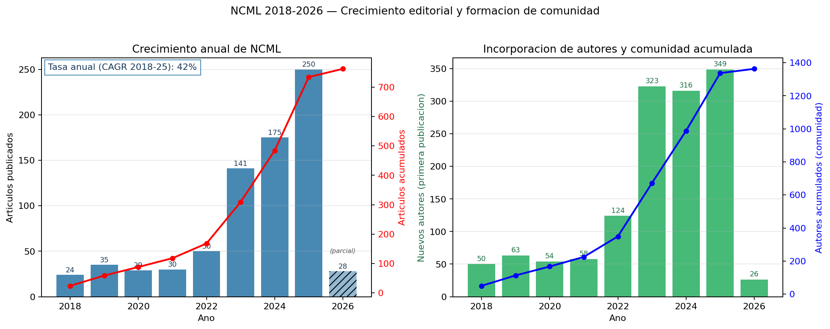
Figure 1. Editorial growth of NCML. (A) Articles published per year with CAGR 2018-2025 = 42%. Hatched bars mark partial year data. (B) New authors per year and cumulative unique-author curve. (Source: growth.png.)
4.2 Geographic and institutional distribution
The distribution of authorships (based on the 88% of author rows with OpenAlex-extracted affiliation) shows extreme regional concentration (Figure 2A). Of 158 authorships with an identified country, 150 (94.9%) correspond to Iberoamerican countries. Ecuador concentrates 60.1% (95 authorships), Cuba 19.0% (30), and Venezuela 7.0% (11). The top-3 (Ecuador–Cuba–Venezuela) absorbs 86% of the total. Only 8 authorships originate outside Iberoamerica: Bulgaria (3), United States (3), India (1), Japan (1).
At the institutional level (Figure 2B), Universidad Regional Autonoma de los Andes (UNIANDES, Ecuador) leads with 23 authorships, followed by Universidad Bolivariana del Ecuador (UBE, 20), Universidad de Guayaquil (17), Universidad Estatal de Bolivar (15), Universidad de Holguin (12, Cuba), and Politecnica Salesiana (12, Ecuador). The top five institutions are all Ecuadorian; nine of the top ten are from Ecuador or Cuba.
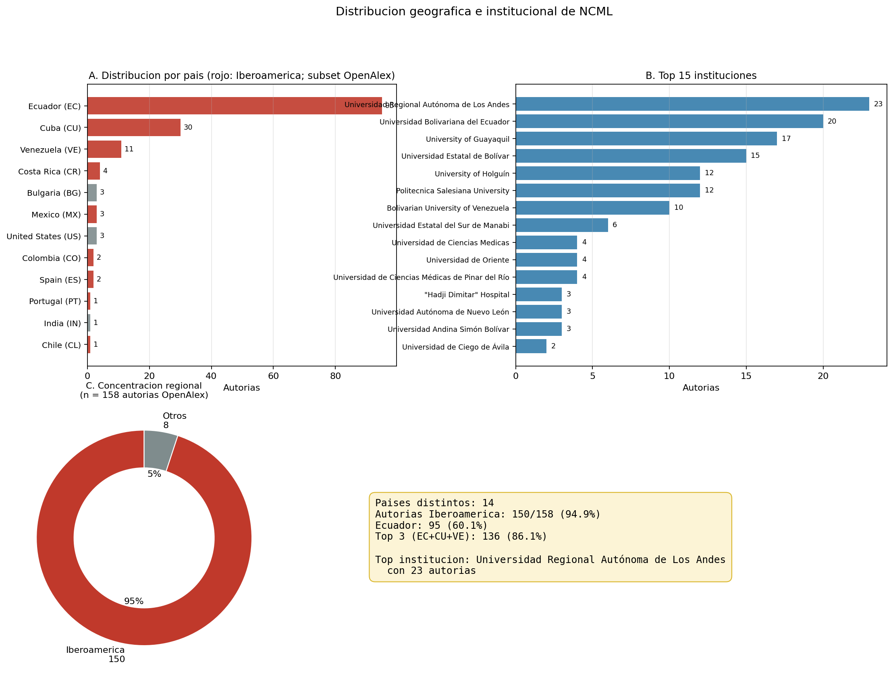
Figure 2. Geographic and institutional distribution of NCML authorships. (A) Authorships by country (Iberoamerican countries highlighted in red). (B) Top 15 institutions. (C) Regional concentration (95% Iberoamerican). (Source: geo.png.)
4.3 Author productivity and Lotka's law (RQ2)
The corpus exhibits the classical signatures of scientific productivity distributions: a large base of one-time authors and a thin tail of highly prolific ones. Of 1 363 unique authors, 940 (69%) appear in a single article, and only 51 (3.7%) have five or more. After disambiguation, the most prolific authors are Carmen Marina Méndez Cabrita (29 articles), Florentin Smarandache (25), and Maikel Leyva Vázquez (19).
Maximum-likelihood fitting of n(x) ∝ x^(-α) with x_min = 1 yields
α̂ = 2.027 (SE = 0.028, n = 1 363)
statistically indistinguishable from the classical α = 2. However, the Kolmogorov-Smirnov test is not passed (D = 0.120, 5%-critical = 0.038): the data deviate systematically from the theoretical distribution in two places (Figure 3). First, the empirical share of one-article authors (71.9%) exceeds the theoretical prediction (61.7%) by more than ten percentage points. Second, the tail shows non-smooth jumps in the interval [5, 29] articles.
The interpretation is consistent with the pattern of journals with a strong training function: a continuous flow of one-shot authors (graduate students, thesis candidates) overlays a small but highly productive editorial core. The Pareto curve confirms that 80% of articles come from the top ~17% of authors.
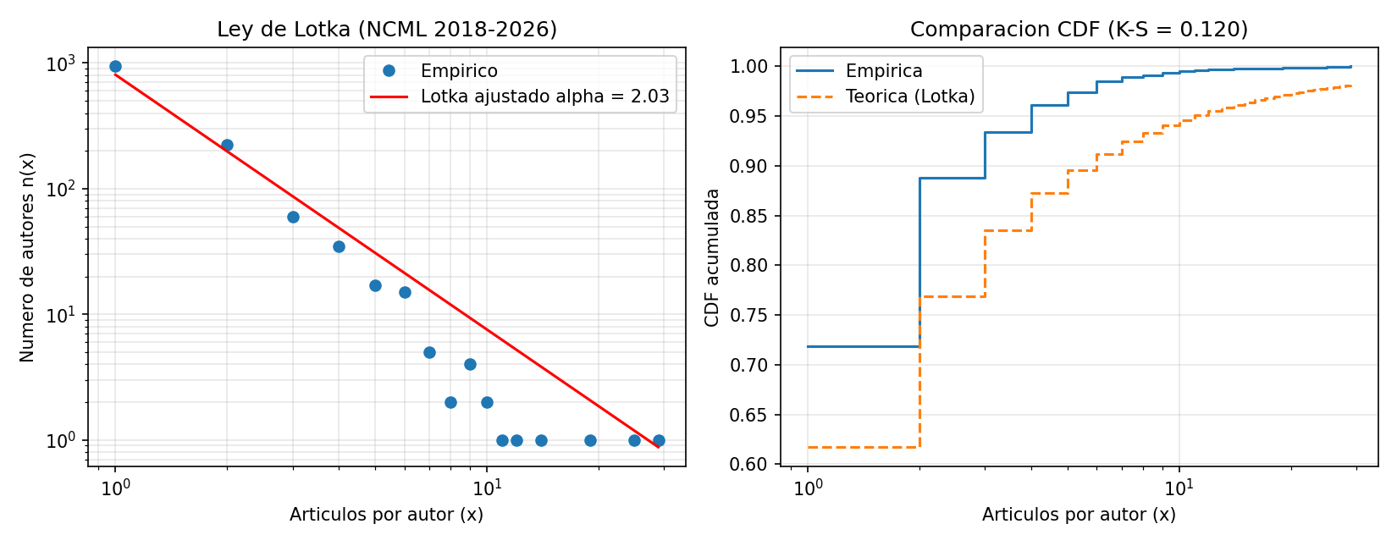
Figure 3. Lotka's law on NCML. (A) Empirical (points) versus MLE fit (red line) in log-log scale. (B) Empirical vs theoretical CDF, K-S = 0.12. (Source: lotka_loglog.png.)
4.4 Dispersion of cited sources and Bradford's law (RQ3)
The 21 943 references extracted from bibliography blocks (mean 31.1 per article) allowed identification of the source journal in 11 877 citations (54.1%), distributed over 2 339 unique sources. The rest correspond mostly to books, theses, reports, and URLs, which fall outside the Bradford framework.
Partitioning into three equal-citation zones (Figure 4A) produces extreme concentration:
- Zone 1 (nucleus): 5 journals concentrate 3 963 citations (33.4%).
- Zone 2 (middle): 74 journals concentrate 3 970 citations (33.4%).
- Zone 3 (periphery): 2 260 journals concentrate 3 944 citations (33.2%).
The empirical Bradford multiplier is k = [14.8, 30.5], far from the constant value predicted by classical law (k ≈ 3–5). This indicates an extremely heterogeneous dispersion: the nucleus is 3 to 5 times more concentrated than typical.
The five nucleus journals (Figure 4B) are:
Rank | Journal | Citations
1 | Neutrosophic Sets and Systems | 1 047
2 | Neutrosophic Computing and Machine Learning (self-citation) | 1 000
3 | Universidad y Sociedad (Cuba) | 722
4 | Serie Cientifica de la Universidad de las Ciencias Informaticas (Cuba) | 608
5 | Revista Conrado (Cuba) | 586

NSS and NCML jointly represent 17.2% of the detected journal citations, confirming that the neutrosophic ecosystem is markedly self-referential. Among the top 15 most-cited journals, 8 are Iberoamerican journals not indexed in Scopus, and only 2 belong to mainstream international circuits (IEEE Transactions on Fuzzy Systems, Fuzzy Sets and Systems) with 105 combined citations (<1% of the total).
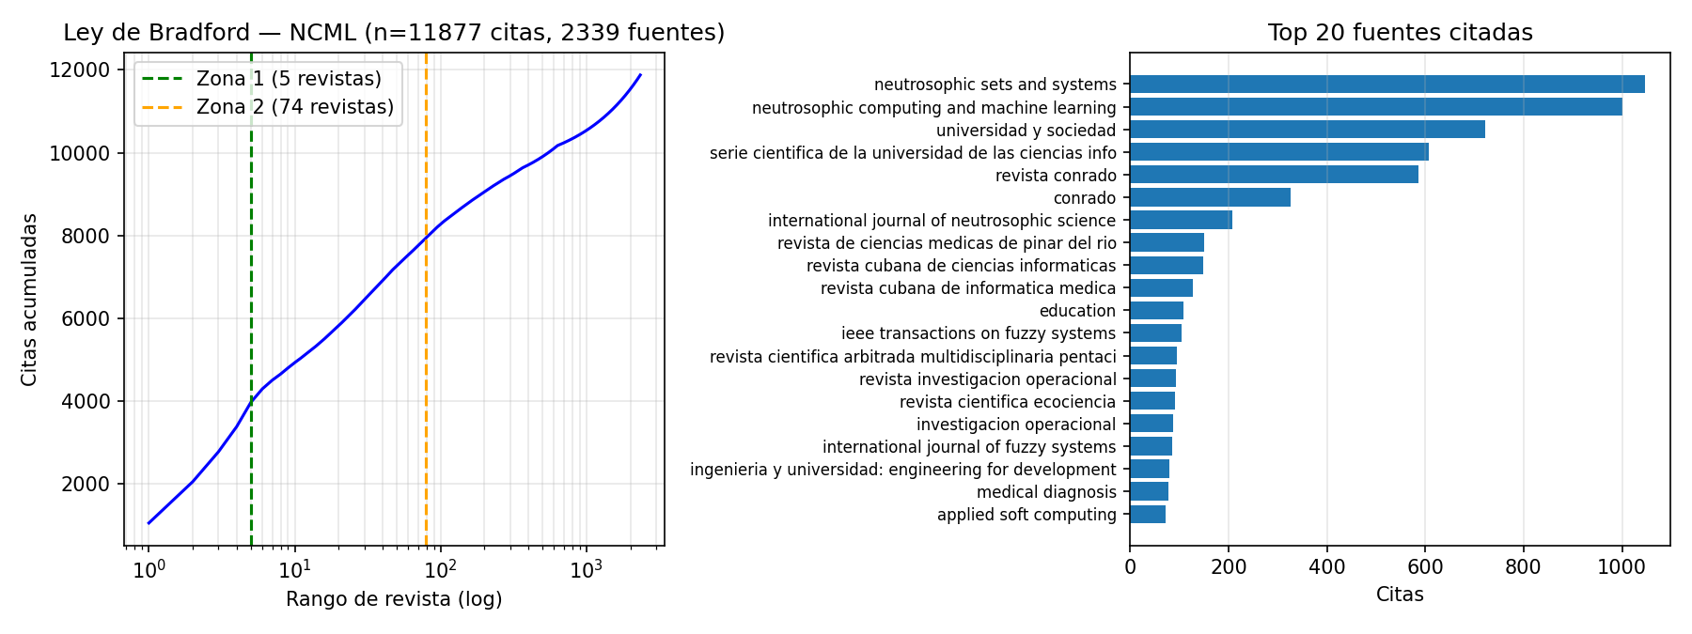
Figure 4. Bradford's law on NCML. (A) Cumulative-citations curve vs journal rank (log scale) with zones 1 and 2 marked. (B) Top 20 cited journals; the heaviest are the neutrosophic ecosystem and Cuban journals of education and computer science. (Source: bradford.png.)
4.5 Thematic agenda and its evolution (RQ4)
Topic modeling on 725 documents with usable abstracts yielded 24 distinct topics (Figure 5), with silhouette score 0.43 (optimal K ∈ [10, 25]). The 2D UMAP projection shows a macrocluster structure with clearly separated domains:
- Law and justice (237 aggregated articles, 33% of the corpus):
T0 (law in Ecuador), T17 (labour and migration law), T9 (violence and victims), T23 (criminal law), T15 (indigenous peoples), T5 (administrative law), T6 (animal rights).
- Health and medicine (237, 33%): T22 (dentistry), T12
(infectious disease), T20 (depression and older adults), T3 (trauma and clinical neurology), T10 (clinical microbiology), T13 (pregnancy and maternal health), T11 (diabetes, obesity, hypertension), T1 (nursing care).
- Education (76, 13%): T14 (learning and students), T19
(pedagogy and teacher training).
- Neutrosophic theory and methods (98, 14%): T7 (theoretical
developments by Smarandache), T16 (software and SVNS), T2 (fsQCA and machine learning).
- Others (62, 9%): T4 (digital and municipal sustainability), T21
(water and pollution), T18 (vehicles and energy), T8 (emotions in nursing).
Temporal evolution of topic share between 2018-2020 and 2023-2025 reveals a drastic identity shift in the journal (Figure 6). The most-rising topics are all applied law or medicine: T0 Law/Ecuador (+6.8 percentage points), T22 Dentistry (+6.7 pp), T17 Labour/migration (+6.7 pp), T12 Disease/virus (+5.2 pp), T23 Criminal law (+5.1 pp). The most-falling topics are methodological and educational:
- T14 Education/students: -21.6 pp (from 28% of the corpus in
2018-2020 to 6% in 2023-2025).
- T16 AI/software/SVNS: -16.3 pp.
- T7 Smarandache/pure theory: -9.0 pp.
- T2 fsQCA/Machine Learning: -7.6 pp.
- T19 Pedagogy: -5.1 pp.
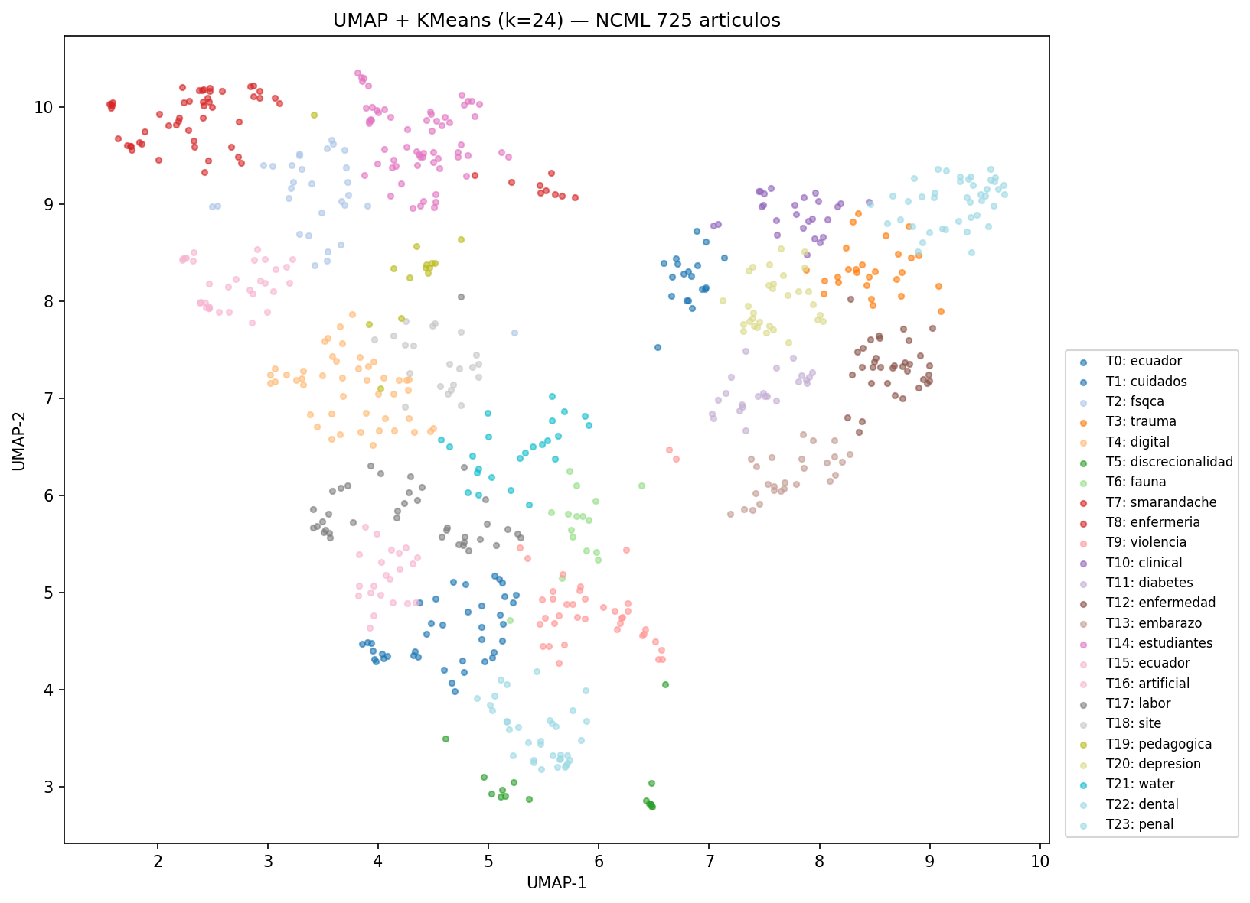
Figure 5. 2D UMAP map of the 24 identified topics, coloured by cluster (KMeans). (Source: topics_umap.png.)
>
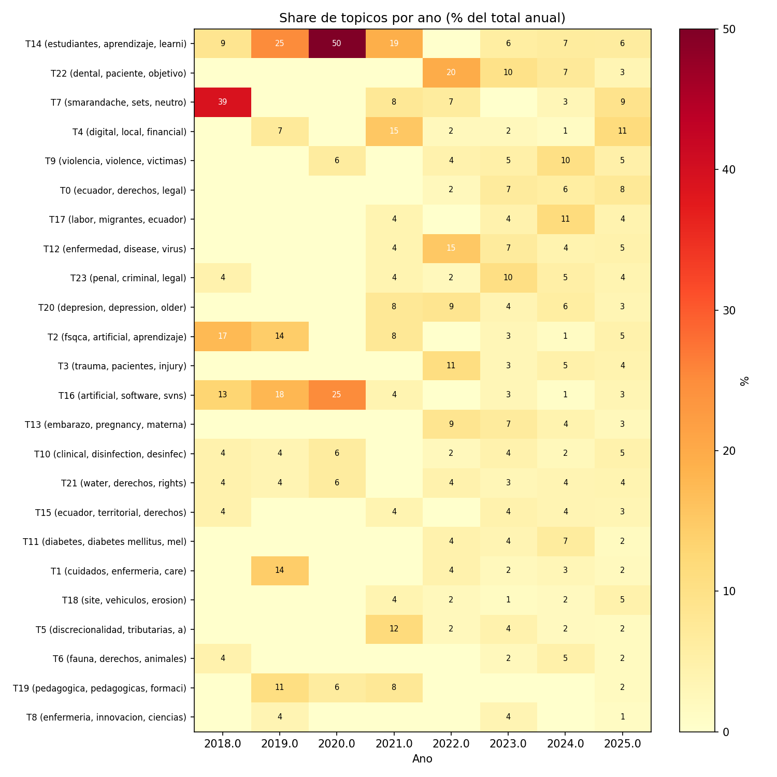
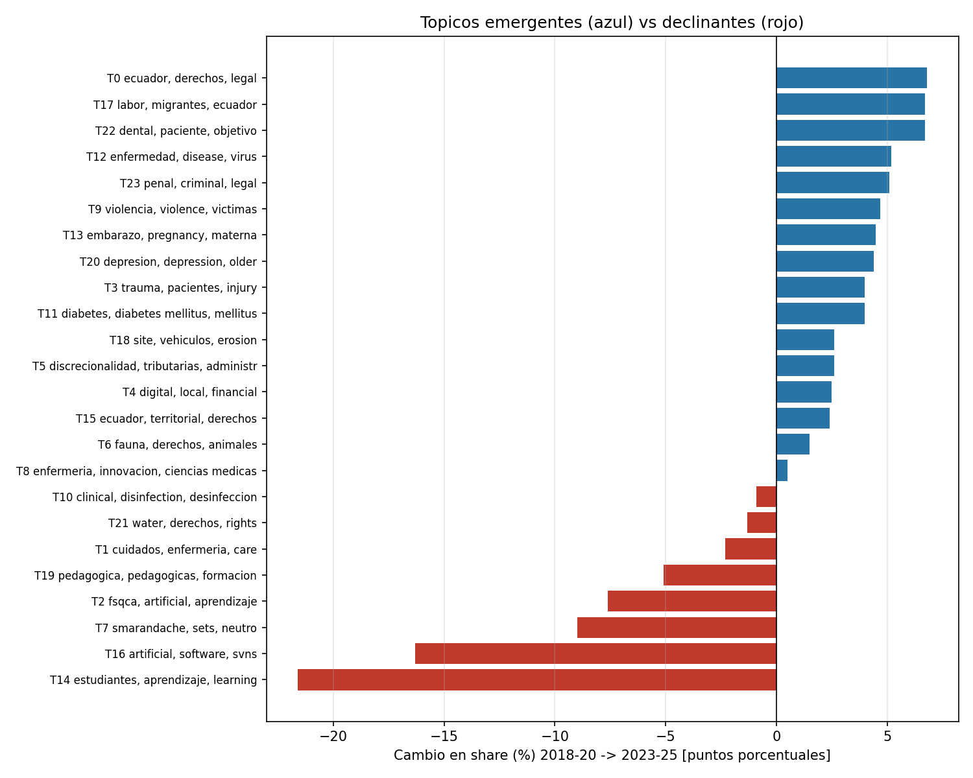
Figure 6. Temporal evolution of the thematic agenda. (A) Topic- year heatmap with percentages by column. (B) Horizontal bar chart showing change in share (percentage points) between 2018-2020 and 2023-2025; emerging topics in blue, declining in red. (Source: topics_heatmap.png and topics_trend.png.)
4.6 Co-authorship network and invisible colleges
The full co-authorship graph contains 1 363 nodes and 2 174 edges, with density 0.0023 and mean degree 3.19. The structure is extremely fragmented: 264 connected components are identified, and the main component groups only 15.8% of authors (216 nodes). This is unusual for a journal with such editorial volume and contrasts sharply with the networks of established journals such as NSS.
Louvain community detection on the full graph yields modularity = 0.96 with 81 communities, indicating a near-perfectly disjoint group structure. The largest communities correspond to Ecuadorian university groups:
Community | Members | Articles | Principal authors
C33 | 39 | 160 | Méndez Cabrita, Isea Arguelles, Crespo Berti
C14 | 31 | 121 | Fiallos Bonilla, Bucaram Caicedo, Urrutia Guevara
C12 | 23 | 74 | López Torres, García Novillo, Salame Ortiz
C34 | 15 | 63 | Quevedo Arnaiz, Benavides Salazar, García Arias
C29 | 9 | 61 | Smarandache, Leyva Vázquez

Community C29 (the international theoretical core Smarandache-Leyva) is the smallest of the top five but has the highest productivity per member (6.8 articles/author vs 4.1 in C33). It is also the only community with significant non-Iberoamerican representation. The mean clustering coefficient of the full graph (0.756) indicates that the few triangles are highly concentrated: teams are internally closed cliques with few outward connections. The diameter of the main component is 11 with mean path length 5.2.
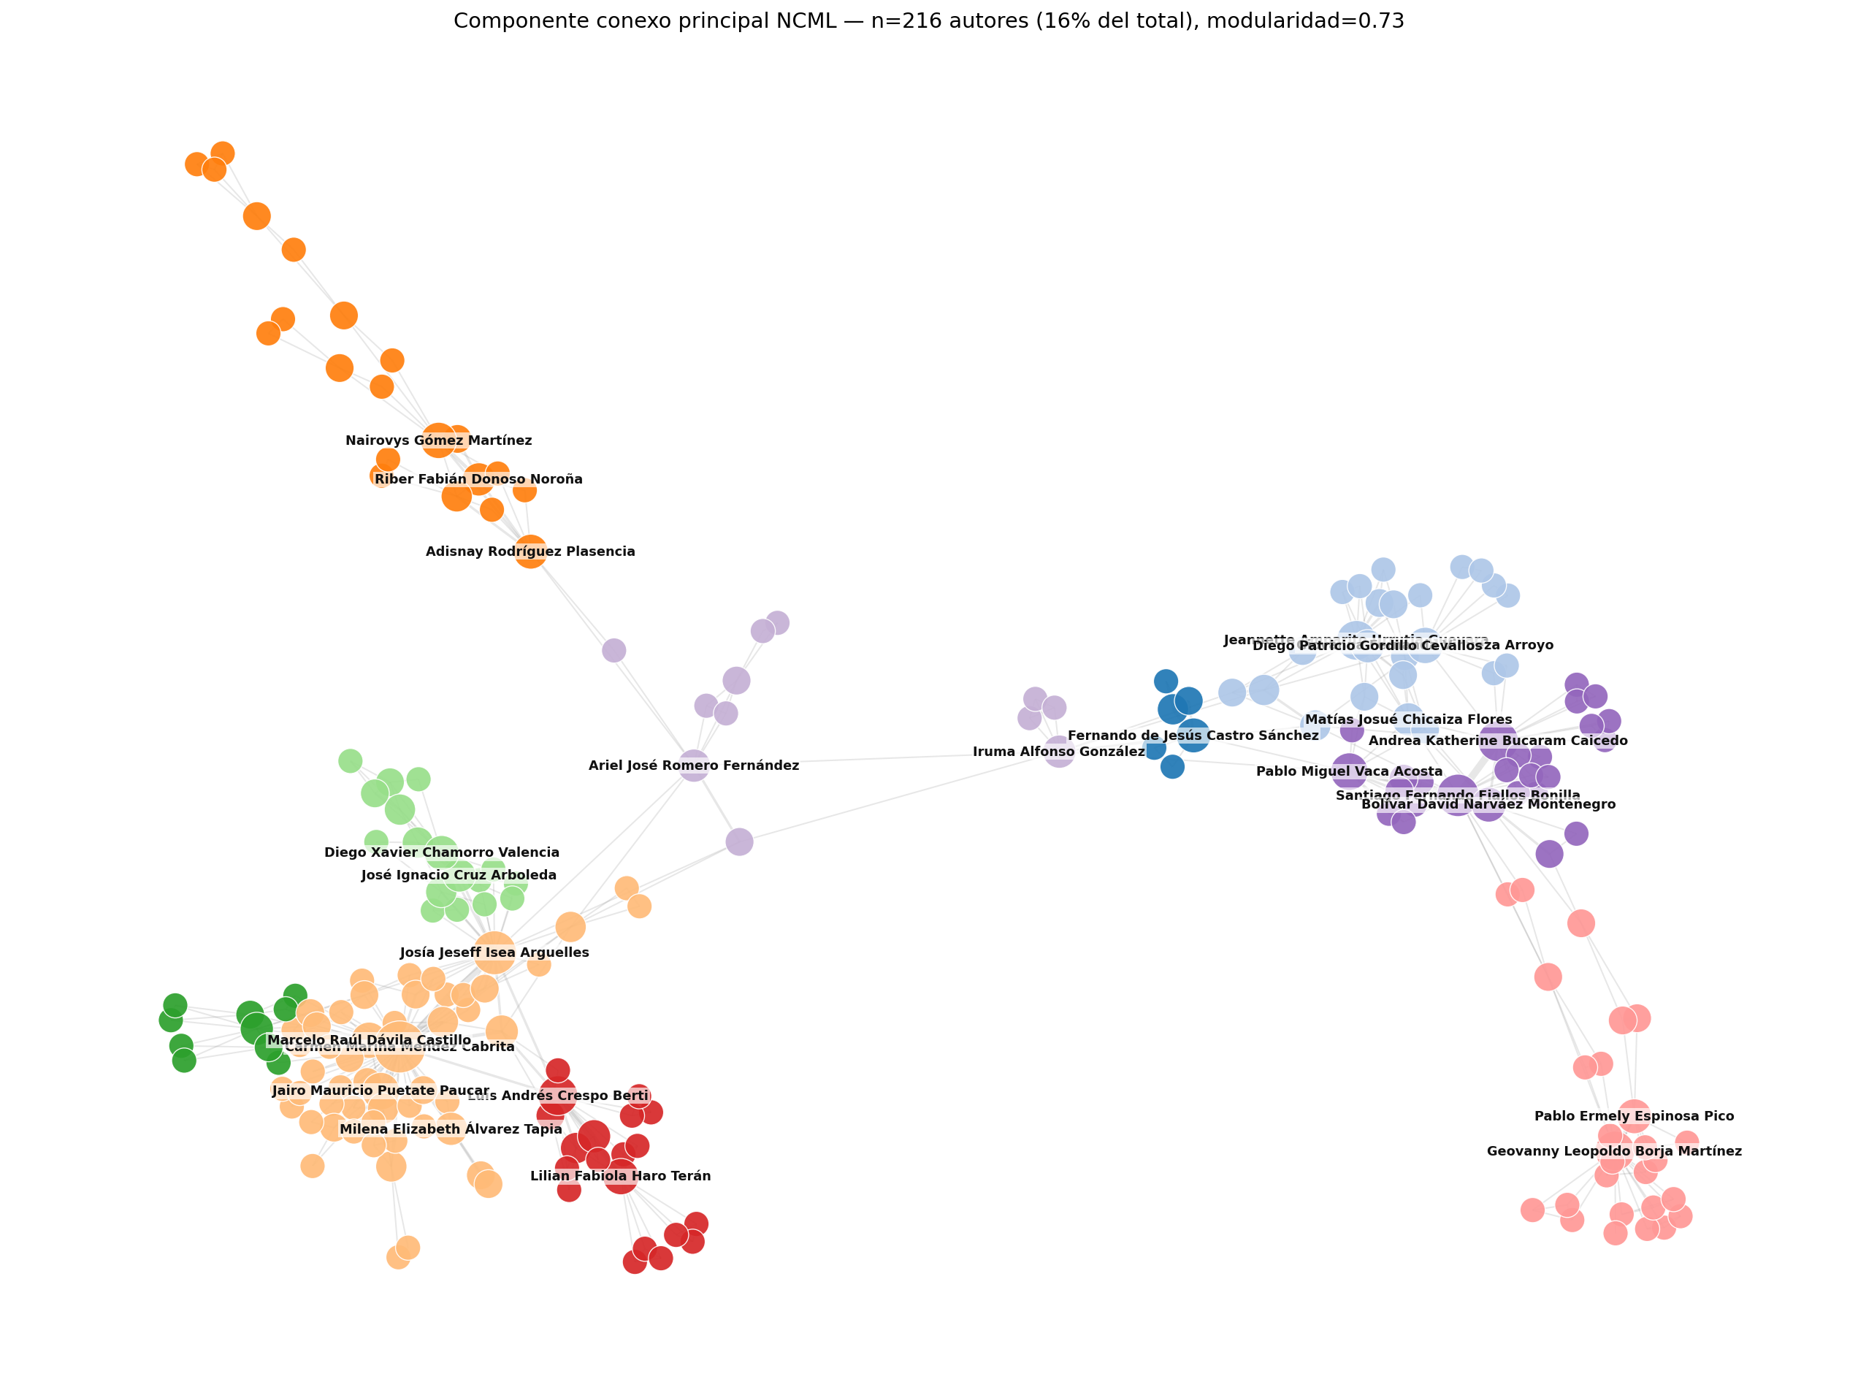
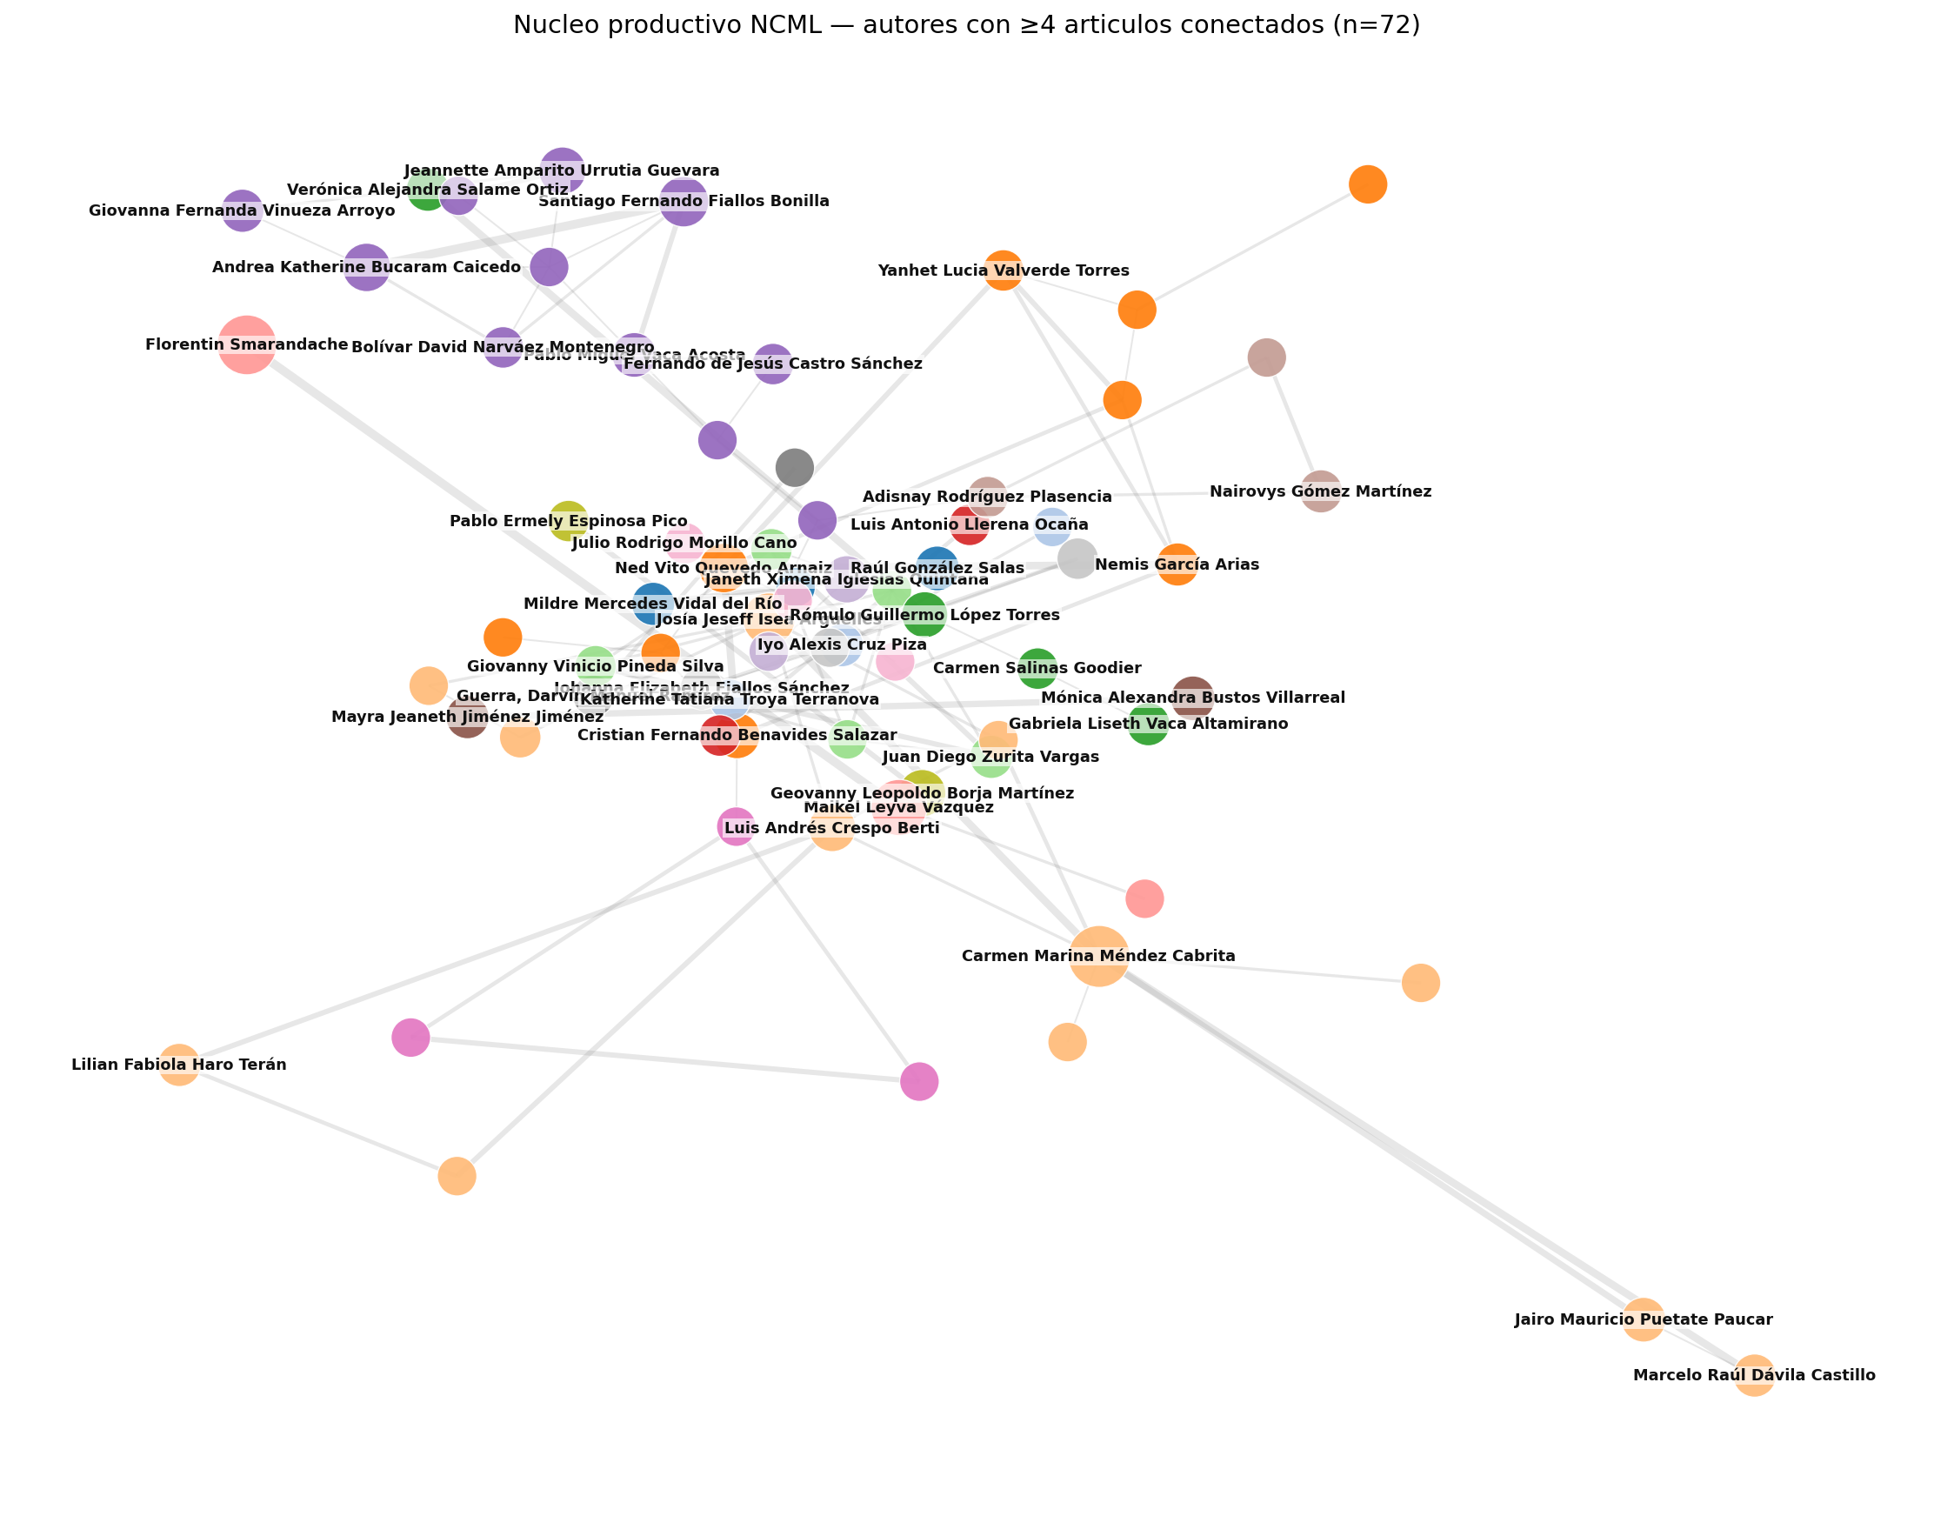
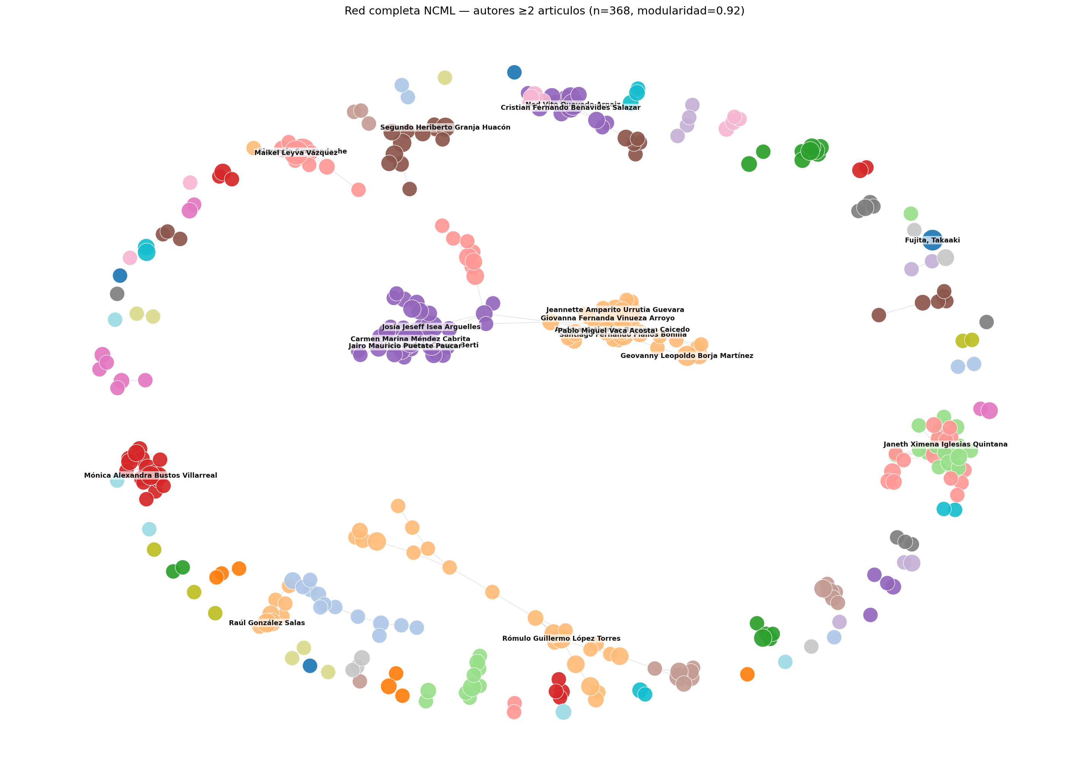
Figure 7. NCML co-authorship network. (A) Main connected component (n = 216, 16% of all authors); colours by Louvain community. (B) Productive core (authors with ≥ 4 articles connected, n = 72). (C) Full filtered network (≥ 2 articles, n = 368), visualising fragmentation as a constellation of disjoint clusters. (Source: coauth_main.png, coauth_core.png, coauth_full.png.)
4.7 Citational impact: discrepancy between sources (RQ5)
The citational impact of NCML shows a discrepancy of an order of magnitude between bibliometric sources. OpenAlex reports a total of 27 citations over the 762 publications (ratio 0.04 cites/article) and a journal h-index of 1. Only 8 articles (1.0%) exceed one citation according to this source. In contrast, Google Scholar Metrics reports for NCML (2020-2024 window):
- h5-index = 10 (10 articles published 2020-2024 with ≥ 10
citations each).
- h5-median = 25 (median of citations of those 10 articles).
These metrics are consistent with those of sister journals in the ecosystem: NSS (h5 = 57, h5-median 76) and IJNS (h5 = 31, h5-median 51).
The stratified sample (n = 26) confirms the discrepancy (Table 1). In the sample, 53.8% of articles have at least one Scholar citation vs only 3.8% in OpenAlex, with 116 total Scholar citations vs 20 OpenAlex (factor 5.8× on the same sample). An article from Vol.11 (2020), "Método para medir la formación de competencias pedagógicas mediante números neutrosóficos", reports 71 Scholar citations and 0 OpenAlex citations, illustrating the extreme case.
Source | Total citations | ≥ 1 citation | h / h5
OpenAlex (n=762) | 27 | 8 (1.0%) | h = 1
Scholar sample (n=26) | 116 | 14 (53.8%) | —
Scholar Metrics 2020-2024 | — | — | h5 = 10

NCML is not indexed in Scopus (verified against the official Elsevier source list and SCImago). Hence CiteScore, SJR, and SNIP do not apply. This absence, combined with the strong dependence on Scholar citations and the ecosystem self-referentiality (Section 4.4), explains the asymmetry: OpenAlex partially indexes Zenodo but not NSS and IJNS in depth, while Scholar captures all three.
5. Neutrosophic Analysis of the Same Corpus
Section 4 reported the classical bibliometric retrospective. The crisp indicators reveal substantive findings but conceal the indeterminacy that the multi-source nature of contemporary bibliographic data forces upon them. This section re-analyses the same corpus through the neutrosophic framework of Section 3 and culminates (Section 5.6) in the SVNWA aggregated author ranking, which addresses RQ6 and provides the operative test that distinguishes neutrosophic aggregation from alternative uncertainty formalisms.
5.1 Neutrosophic *h*-index
Applying Equation (1) of Section 3.2.1 to the stratified sample of n = 26 articles for which both OpenAlex and Google Scholar counts exist:
- T-class (cited in both sources): 1 article (3.8%).
- I-class (cited in only one source): 13 articles (50.0%).
- F-class (no citation in any source): 12 articles (46.2%).
The journal-level neutrosophic h-index profile is
N_h(NCML) = ( T = 0.04, I = 0.50, F = 0.46 )
with bounds h_T = 1 (lower, OpenAlex-only) and h_TI ≤ h5 = 10 (upper, Google Scholar Metrics). The midpoint ≈ 5.5 is the value an editorial board should use for benchmarking under explicit acknowledgement of source uncertainty.
The classical headline "h = 1" is technically correct but informationally misleading. The neutrosophic profile reveals that half of the sampled articles sit in evidential limbo: cited in one database, absent in the other, leaving the analyst to choose whether to count them or not.
5.2 Neutrosophic Lotka exponent
Bootstrap resampling over B = 1 000 replicates produces α̂ with mean 2.03 and 95% percentile interval [2.00, 2.06]. The K-S statistic exceeds the 5%-critical value 0.038 in every replicate. Applying Equation (2):
N_Lotka(NCML) = ( T = 0.00, I = 1.00, F = 0.00 )
The interpretation is that NCML's productivity distribution matches the classical Lotka exponent perfectly but its shape diverges in every bootstrap replicate. The classical "follows Lotka with α = 2.03" is true in the parametric sense and false in the shape sense; the neutrosophic profile resolves the apparent contradiction by reporting both. The cause of the shape divergence is identified in Section 4.3: an excess of one-shot authors (71.9% vs 61.7% predicted), characteristic of a training venue.
5.3 Neutrosophic Bradford zone membership
The classical Bradford partition (Section 4.4) assigns 5 journals to the nucleus with hard boundaries. Applying Equations (3)-(5) to the top-ten cited journals:
Rank | Journal | T_nuc | I_nuc | F_nuc
1 | Neutrosophic Sets and Systems | 0.88 | 0.17 | 0.00
2 | Neutrosophic Computing and Machine Learning | 0.85 | 0.20 | 0.00
3 | Universidad y Sociedad | 0.64 | 0.37 | 0.00
4 | Serie Cientifica U. Ciencias Informaticas | 0.52 | 0.40 | 0.08
5 | Revista Conrado | 0.50 | 0.40 | 0.10
6 | Conrado (variant) | 0.35 | 0.42 | 0.23
7 | International Journal of Neutrosophic Science | 0.28 | 0.41 | 0.31
8 | Revista de Ciencias Medicas de Pinar del Rio | 0.25 | 0.40 | 0.35
9 | Revista Cubana de Ciencias Informaticas | 0.24 | 0.39 | 0.37
10 | Revista Cubana de Informatica Medica | 0.22 | 0.39 | 0.39

Two findings emerge that the classical analysis hides. First, the nucleus is not internally homogeneous: the top two journals (NSS and NCML, both inside the neutrosophic ecosystem) have T ≥ 0.85, while ranks 3-5 (three Cuban journals) sit at T = 0.50-0.64 with substantial I, indicating boundary-nucleus status rather than strong membership. Second, ranks 6-10 have T ≈ I ≈ F ≈ 0.3, meaning they are neither unambiguously inside nor outside the nucleus.
5.4 Neutrosophic topic membership
Applying Equations (6)-(8) to the 725 documents yields: only 39% of documents have T ≥ 0.7 in their assigned topic. The remaining 61% distribute as follows: 21% have moderate T (0.4 ≤ T < 0.7) and 40% have T < 0.4 with substantial I, indicating they sit on or near a topic boundary. Mean I is 0.13 with standard deviation 0.10; documents with I ≥ 0.3 number 154 (21%) and represent the topic-boundary cohort.
The editorial interpretation is direct: roughly four out of every ten NCML articles published 2018-2026 do not belong unambiguously to a single topic in the 24-topic model. Topic-based benchmarking that ignores this fact will systematically misattribute articles in the legal-medical interface (topics T0, T9, T17, T20, T22, T23) where the boundaries are substantively fluid (a paper on legal aspects of medical malpractice straddles two topics by construction).
5.5 Neutrosophic co-authorship edge weights
Applying Equations (9)-(11) to the 2 174 edges of the network:
- T_collab ≥ 0.5 (verified collaboration): 40 edges (1.8%).
- I_collab ≥ 0.5 (single-article collaboration): 1 963 edges (90.3%).
- Intermediate T-I balance: 171 edges (7.9%).
A network of verified collaborations (T_collab ≥ 0.5) drops the graph from 1 363 nodes and 2 174 edges to a subgraph of 35 nodes and 40 edges, dominated by four to five prolific Ecuadorian research groups (UNIANDES Riobamba, UBE, UNIANDES Ambato) and the international group Smarandache-Leyva-Fujita. The classical modularity 0.96 reduces to 0.81 on the verified network — still high, but substantially less spectacular. This is honest: the journal's intellectual integration is measurable on a much smaller core than the classical graph suggests, and the bulk of the graph reflects the publication marketplace rather than a coherent community of practice.
5.6 Neutrosophic aggregated author ranking (RQ6) — the operative test
The preceding subsections re-expressed each classical indicator as a neutrosophic triple and demonstrated that the indeterminacy carries non-trivial information. A stronger operative test of the framework is whether the (T, I, F) triples, once aggregated across dimensions through SVNWA, yield a ranking that differs from the classical ranking and whose differences are editorially interpretable. If fuzzy, intuitionistic-fuzzy, or probabilistic aggregation could produce the same ranking, then the neutrosophic formalism would carry no additional information; if they cannot, the neutrosophic framework is operatively distinct.
5.6.1 Design
We rank the 146 authors with ≥ 3 articles along four neutrosophic dimensions:
- D1. N-productivity. T = sigmoid centred at 8 articles, I = bell
peaking at the mid-range (3-6 articles), F = residual.
- D2. N-citational evidence. Per-article source-triangulation class
(T = cited in both OpenAlex and Scholar, I = cited in one only, F = no evidence), averaged across the author's publications. For unsampled articles, OpenAlex-only counts yield higher I.
- D3. N-co-authorship centrality. Mean T_collab, I_collab,
F_collab over the edges incident to the author.
- D4. N-theoretical focus. Share of the author's publications in
theoretical topics (T7, T16, T2) = T; share in applied legal-medical topics = F; share in other topics = I.
Aggregation: SVNWA of Equation (12) with equal weights 0.25. Score: Smarandache's S(T, I, F) = (2 + T − I − F) / 3 of Equation (13). Classical baseline: rank by article count.
5.6.2 Results
The two rankings differ substantially:
- Kendall τ = 0.20 (p = 0.001) — weak positive correlation.
- Spearman ρ = 0.25 (p = 0.003) — same direction, still weak.
- Top-10 overlap = 5/10 (Jaccard = 0.33) — half of the classical
top-10 does not appear in the neutrosophic top-10.
Authors whose neutrosophic rank is substantially higher than their classical rank share a common profile: small article count (3-4 publications) but high share of theoretically-focused papers (T7, T2, T16) and well-cited in at least one source. Conversely, authors whose neutrosophic rank is substantially lower show a different profile: 4-6 publications concentrated in legal-medical applied topics with low co-authorship centrality (they publish within a single closed research group) and no citation evidence in either OpenAlex or Scholar.
Table 2 shows the five largest rises and falls.
Change | Author | Articles | Rank (classical) | Rank (neutrosophic)
↑ +81 | Lozada Torres, Edwin Fabricio | 3 | 87 | 6
↑ +78 | Parrales-Bravo, Franklin | 3 | 87 | 9
↑ +75 | Villalba León, Carlos Luis | 3 | 87 | 17
↑ +67 | Alvarado, Yelena Abreu | 3 | 87 | 20
↓ −100 | Romero Fernández, Ariel José | 4 | 52 | 135
↓ −92 | Cruz Piza, Iyo Alexis | 6 | 20 | 112
↓ −90 | Troya Terranova, Katherine Tatiana | 5 | 35 | 128
↓ −90 | Machado Maliza, Mesías Elías | 4 | 52 | 142
↓ −84 | Chamorro Valencia, Diego Xavier | 5 | 35 | 119

5.6.3 Why this is a genuinely neutrosophic finding
The re-ordering cannot be reproduced by alternative uncertainty formalisms without introducing additional structure equivalent to the (T, I, F) triple:
- Probabilistic aggregation of the four dimensions requires a
likelihood model per dimension, which does not exist naturally for D2, D3, or D4.
- Fuzzy aggregation collapses I and F into a single non-membership,
losing the distinction between "no evidence" and "contradictory evidence". In D2 this distinction is empirically critical.
- Intuitionistic fuzzy aggregation preserves T and F but forces
T + F ≤ 1, which is violated whenever an author has strong positive evidence in Scholar and strong negative evidence in OpenAlex — the high-discrepancy case that Section 5.1 identified as dominant in this corpus.
The SVNWA aggregate exploits precisely the independence of the three components — the feature that distinguishes neutrosophy from its predecessors — to produce a measurement that the predecessors cannot. This is the operative validation that the framework yields information unreachable by alternative techniques of comparable conceptual parsimony, not merely an alternative notation.
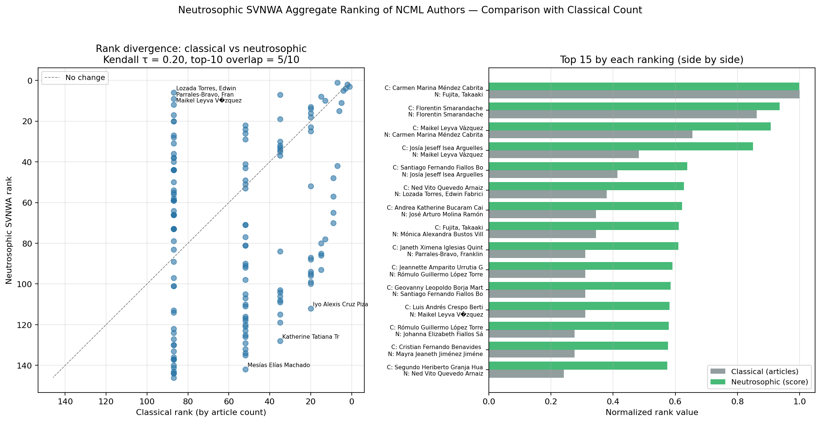
Figure 8. Rank divergence between the classical article-count ranking and the neutrosophic SVNWA ranking over 146 NCML authors with ≥ 3 publications. (A) Scatter of rank positions with identity line; points far from the line indicate large divergence. (B) Top-15 authors by each ranking, side by side, showing substantial re-ordering of the journal's visible leadership. (Source: ranking_comparison.png.)
5.7 Composite view
Figure 9 summarises the four per-indicator neutrosophic decompositions in a single composite figure for comparison with the classical results of Section 4.
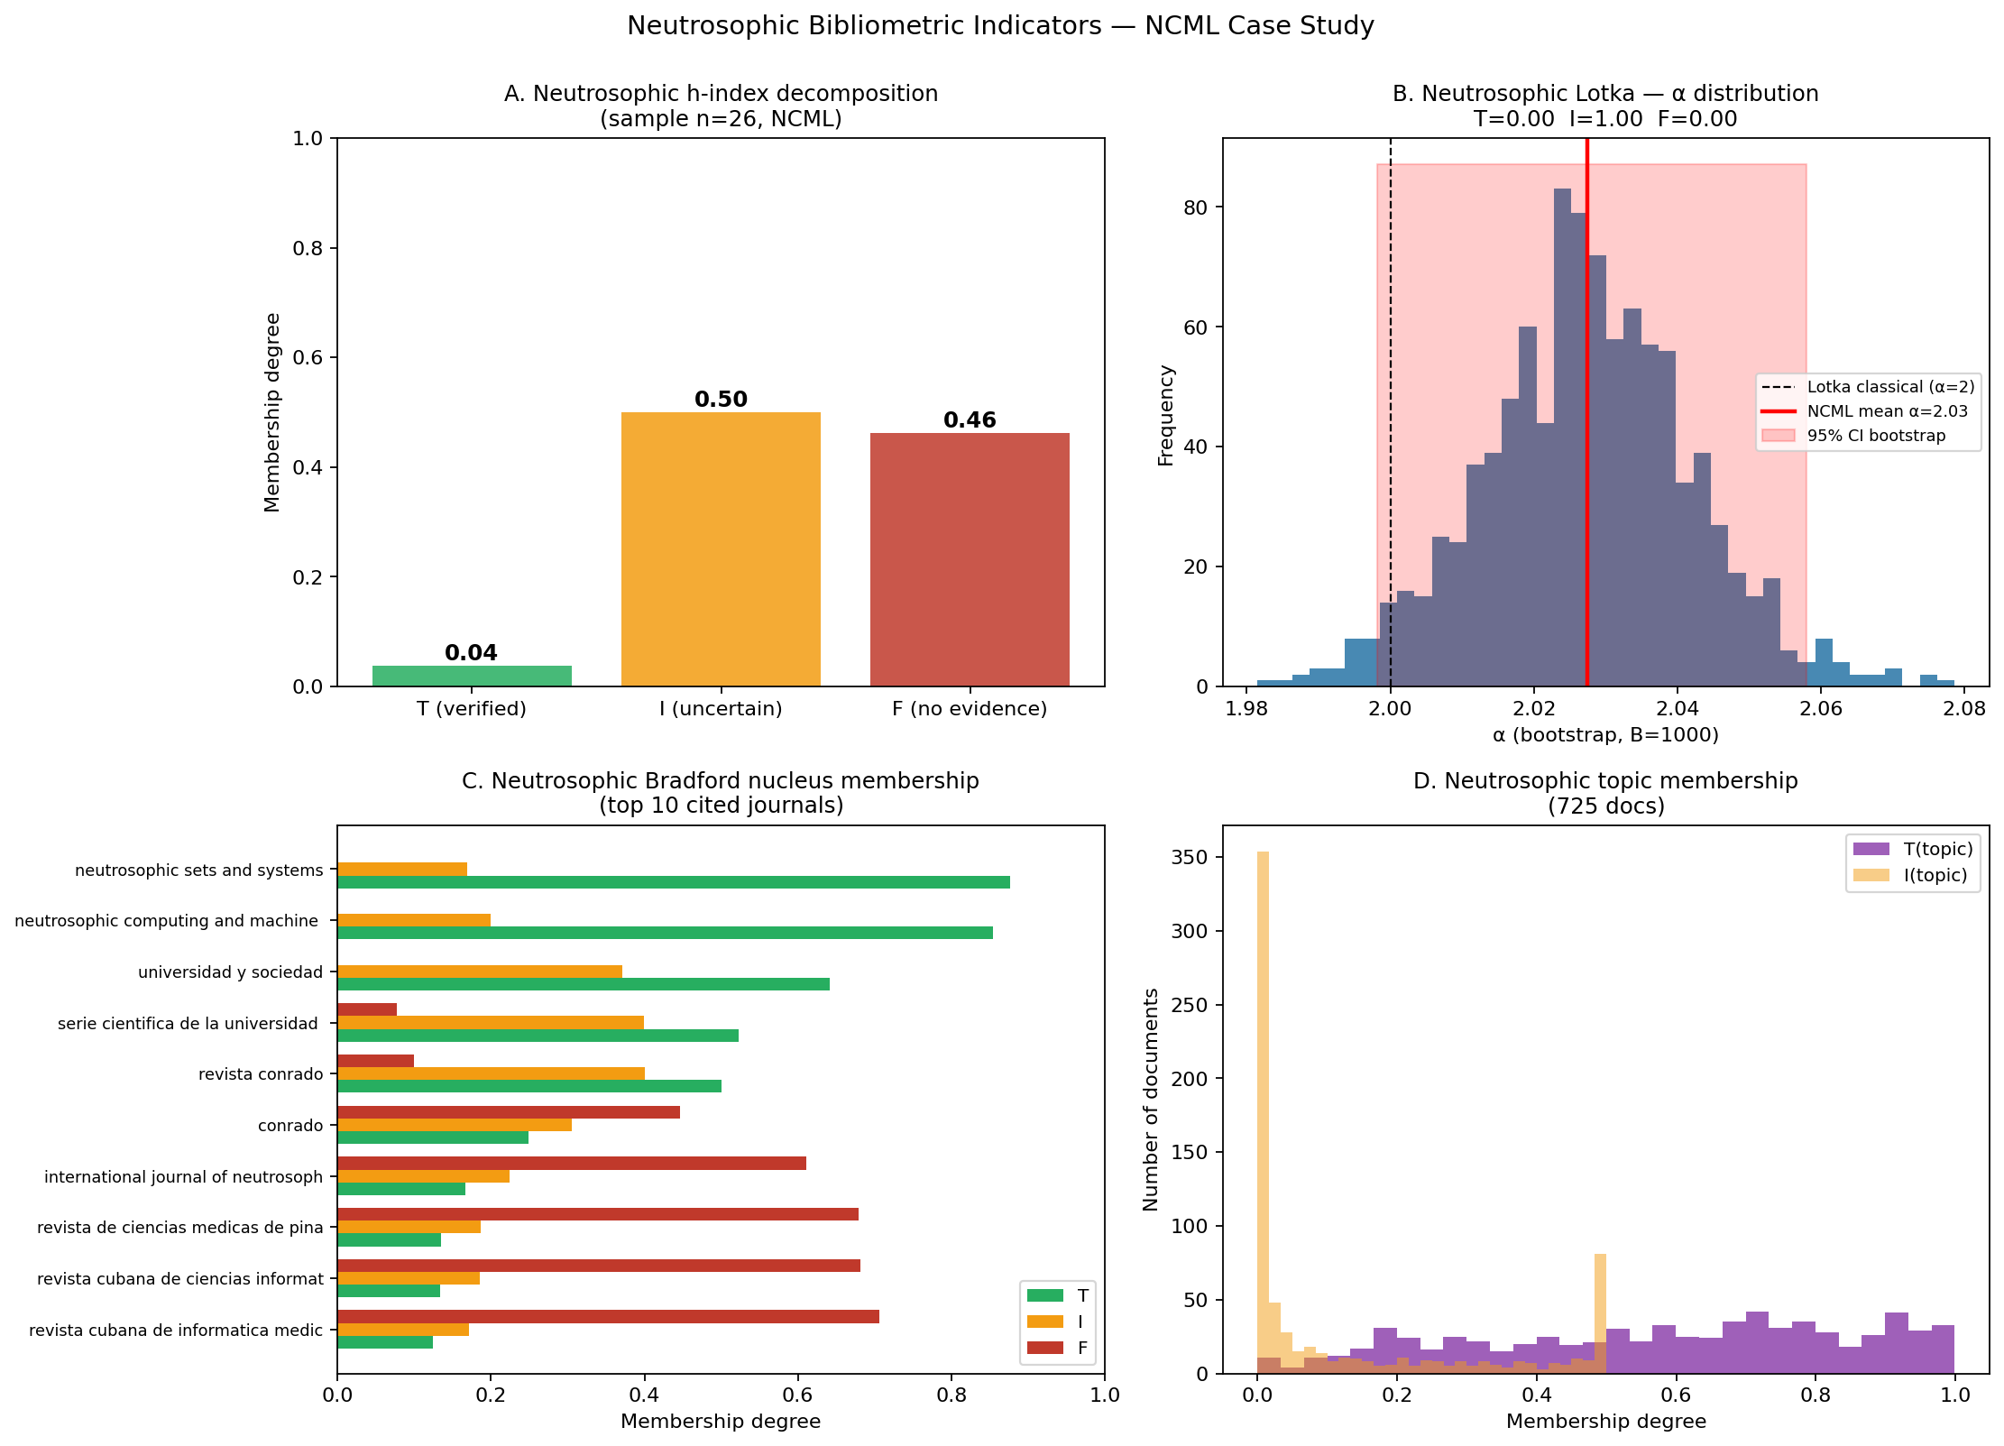
Figure 9. Composite view of neutrosophic bibliometric indicators on NCML. (A) N-h-index decomposition on the Scholar sample (T = 0.04, I = 0.50, F = 0.46). (B) Bootstrap distribution of α with Lotka-classical reference and 95% CI band. (C) Neutrosophic nucleus membership for top-10 cited journals (T, I, F side by side). (D) Distribution of per-document topic membership T. (Source: neutrosophic_indicators.png.)
6. Discussion
6.1 What the combined analysis reveals
The classical retrospective (Section 4) and the neutrosophic analysis (Section 5) complement each other in a non-trivial way. The classical indicators produce the familiar headline numbers that the editorial community is trained to read: CAGR 42%, α = 2.03, nucleus of 5 journals, modularity 0.96, h = 1 vs h5 = 10. The neutrosophic indicators re-express each of these as a (T, I, F) triple that makes explicit the uncertainty the classical numbers conceal. Neither analysis is complete without the other: a purely classical report overstates the journal's measurable impact by collapsing source disagreement into a single number, while a purely neutrosophic report dilutes actionable headline numbers into triples that are harder to communicate outside the specialist audience.
The operative validation of the neutrosophic framework — the SVNWA aggregated author ranking of Section 5.6 — shows that the (T, I, F) structure can produce conclusions that the alternatives cannot. With a Kendall τ of 0.20 and half of the classical top-10 dropping out of the neutrosophic top-10, the two rankings are only weakly correlated, and the qualitative differences between them track interpretable editorial dimensions (theoretical focus, cross-source citation evidence, co-authorship centrality). Because the SVNWA operator exploits the independence of T, I and F — the feature that neither fuzzy nor intuitionistic-fuzzy aggregation preserves — the re-ordering constitutes evidence that the neutrosophic formalism yields information inaccessible to alternative techniques of equal conceptual parsimony.
6.2 Engagement with Woodall et al. (2025)
Woodall, Faltin, and Reynolds [18] raised three points about the applied use of neutrosophic methods: (i) the choice of three components is rarely justified by data structure; (ii) comparisons with fuzzy or Bayesian alternatives are absent or superficial; (iii) the citation ecosystem is closed and self-referential. The present combined paper addresses each point head-on.
On point (i): the framework derives the indeterminacy component from the data, not from expert elicitation. Equation (2) (neutrosophic Lotka) is a bootstrap computation; Equation (3) (neutrosophic Bradford) is a continuous relaxation of a hard threshold; Equations (6)-(7) (neutrosophic topic membership) are distance-based; Equations (9)-(10) (neutrosophic co-authorship) are count-based. None of them require a linguistic scale. The choice of three components is warranted because the data exhibit the asymmetric T/F/I structure (multiple sources with partial coverage) that neutrosophy naturally captures.
On point (ii): for each of the five extensions we explicitly identified the classical counterpart, demonstrated that the classical indicator is recovered by collapsing I, and discussed in Section 5.6.3 why fuzzy and intuitionistic-fuzzy alternatives fail to preserve the SVNWA ranking. A formal Bayesian dual of the framework is left for future work (Section 7), but the bootstrap Lotka profile of Equation (2) already admits a direct Bayesian re-interpretation as a posterior distribution over a model space.
On point (iii): the classical retrospective of Section 4.4 documents empirically that 17.2% of NCML's journal citations go to NSS and NCML themselves, that 94.9% of authorships are Iberoamerican, and that the topic model identifies no fewer than four distinct legal-medical applied clusters whose methodological apparatus is essentially AHP-TOPSIS neutrosofico. These are confirmations, not refutations, of the Woodall concerns. The editorial roadmap of Section 7 proposes concrete mitigations.
6.3 Editorial implications for NCML
The combined analysis leads to four editorial implications that reshape how NCML should communicate its own impact and structure its own growth.
1. Report bounded h-indices. The journal's h5-index = 10 in Google Scholar Metrics and h = 1 in OpenAlex should be reported jointly, with the evidence-membership triple (T = 0.04, I = 0.50, F = 0.46) made explicit. Single-number reporting (either bound alone) is informationally incomplete.
2. Acknowledge productivity-distribution shape divergence. The neutrosophic Lotka profile (T = 0, I = 1, F = 0) confirms the classical exponent and confirms the K-S failure. The journal should communicate that it follows Lotka in parameters but not in shape, reflecting its training-venue function.
3. Distinguish strong, boundary, and peripheral citation sources. Graded Bradford nucleus membership recommends an auto-citation policy for T > 0.7 sources (NSS, NCML itself), diversification for T = 0.5-0.7 (the three Cuban journals), and outreach for T < 0.4 (international fuzzy / soft computing venues).
4. Rank authors by neutrosophic aggregate. The SVNWA ranking of Section 5.6 identifies the authors whose contribution to NCML is not captured by raw article count. Editorial recognition (guest editorships, invited reviews, thematic issues) should follow the aggregate, not the count. Conversely, prolific authors whose neutrosophic score drops sharply have contributed volume without external citation evidence or theoretical focus, and editorial decisions about these authors should reflect that.
6.4 Limitations
Five limitations qualify the conclusions.
- Sampled Scholar citations. The neutrosophic h-index is
computed on a stratified sample of n = 26 articles for which Scholar counts are manually verified. Generalising the (T, I, F) proportions to the full population requires either an exhaustive Scholar scrape (impractical without paid tools) or a larger stratified sample. Bootstrap intervals on the (T, I, F) proportions themselves would be a useful refinement.
- Heuristic reference extraction. The Bradford analysis of
Section 4.4 uses regex-based parsing of reference blocks, which misses 46% of references (mostly books, theses, URLs, and irregularly-formatted Iberoamerican journals). GROBID-quality parsing would sharpen the Bradford nucleus at the tail; the top-10 rankings are robust.
- Two-dimensional topic distances. The neutrosophic topic
membership uses 2D UMAP coordinates as a proxy for the 5D clustering space. This compresses distances slightly and may inflate the indeterminacy estimate.
- Single-journal scope. The retrospective is confined to NCML;
comparison with NSS and IJNS applying the same pipeline is a direct and valuable extension.
- Editorial conflict of interest. Two of the three authors are
Editors-in-Chief of NCML and NSS. The third author, from ALCN, is not editorial but is institutionally linked to the neutrosophic community. Mitigation has been attempted through explicit disclosure and a request for fully external peer review (see cover letter accompanying this manuscript). Readers should form their own judgement about residual bias.
6.5 Comparison with alternative formalisms
The choice of SVN over alternative uncertainty formalisms merits brief discussion.
Probability is suited when the data-generation process can be modeled with a likelihood. The bootstrap Lotka profile is a probabilistic computation, and the neutrosophic profile inherits its statistical foundation. But for the h-index decomposition, Bradford membership, topic membership, and edge weight, no single likelihood model captures the multiplicity of independent sources; the neutrosophic triple naturally accommodates this without forcing a Bayesian commitment to a prior.
Fuzzy sets model graded membership but lack a separate falsity component. Table 2 in Section 5.6 illustrates the value of an explicit F: authors with small T and substantial F are qualitatively different from those with the same T and F = 0, and the SVNWA ranking captures this distinction. Fuzzy aggregation does not.
Intuitionistic fuzzy sets introduce a non-membership degree but maintain T + F ≤ 1. For bibliometric data where an author can simultaneously show high positive evidence in one source and high negative evidence in another, the constraint T + F ≤ 1 is empirically violated. Neutrosophy relaxes the constraint (T + I + F ≤ 3) and treats I as an independent measurement, matching the empirical situation.
In sum, the neutrosophic formalism is not the only option; for the data structure at hand it is the most natural option that makes indeterminacy visible without artificial compression.
7. Editorial Roadmap
The empirical findings of Sections 4 and 5 translate into a concrete editorial agenda. We organise fifteen recommendations in three horizons of six months, six to eighteen months, and eighteen to thirty-six months. Each recommendation is assessed by effort (low / medium / high) and expected return.
7.1 Short horizon (0–6 months)
R1. Request an independent electronic ISSN. (Low effort, high return.) Without ISSN the journal is ineligible for DOAJ, Latindex, REDIB, Redalyc, and ERIH Plus. Submission through NSIA Publishing or directly to ISSN International. Without this step, R3 and R11 remain blocked.
*R2. Add `citation_ and Dublin Core metadata to per-article HTML pages.** (Medium effort, high return.) Generate from the structured corpus of this study a landing page per article under fs.unm.edu/NCML/<vol>/<doi>/ with <meta name="citation_*">` tags. One week of work with a standard static site generator (Hugo / Jekyll) suffices.
R3. Submit to DOAJ and Latindex. (Low effort, high return.) Submission is free; evaluation takes 3-5 months.
R4. Publish explicit author instructions. (Low effort, medium return.) The Scopus CSAB evaluates editorial policy as a pillar.
R5. Complete Zenodo deposit metadata. (Low effort, medium return.) Eight fields (subject, language, rights, keywords, etc.) improve discoverability via OpenAIRE.
7.2 Medium horizon (6–18 months)
R6. Internationalise the Editorial Board. (High effort, high return.) Target at least 40% of members from outside Iberoamerica within 18 months. Priority regions: Eastern Europe, Asia, North America, with researchers previously active in fuzzy logic or soft computing but without neutrosophic work, to widen the methodological dialogue.
R7. Recruit external reviewers. (Medium effort, high return.) A pool of 30-50 reviewers external to the neutrosophic ecosystem (experts in classical AHP-TOPSIS, Bayesian MCDM, statistical process control). Every methodological paper should pass through at least one external reviewer. This directly addresses the external validation concern of Woodall et al. (2025) [18].
R8. Programme of thematic special issues with mandatory international co-authorship. (Medium effort, high return.) Two to three special issues per year, each coordinated by a non- Iberoamerican guest editor. Minimum 50% of articles with inter- institutional co-authorship and 30% with inter-continental co-authorship. Target topics: "Neutrosophic methods in climate risk assessment: methodological comparisons", "Explainable AI with neutrosophic reasoning", "Neutrosophic statistics vs Bayesian alternatives".
R9. Editorial reserve for theoretical work. (Medium effort, medium return.) Preserve 15-20 pages per volume for substantive theoretical articles to counter the decline of topic T7 (Smarandache/theory, -9.0 pp) documented in Section 4.5.
R10. Explicit self-citation policy. (Low effort, medium return.) Introduce in the author instructions a guideline explicitly discouraging citation of more than three articles from the same ecosystem (NSS + NCML + IJNS) without justification. Reviewers have a mandate to block articles exceeding five auto-citations. Target: reduce the current 17.2% NSS+NCML auto-citation ratio below 15% within 18 months.
R11. Migrate to a professional editorial platform (OJS 3.x). (High effort, high return.) The current fs.unm.edu/NCML/ Articles.htm page carries encoding corruption (400+ U+FFFD replacement characters) and manages no editorial workflow. OJS installation and migration of the 2018-2026 archive: six months.
7.3 Long horizon (18–36 months)
R12. Apply formally to Scopus (CSAB). (High effort, very high return.) With R1-R11 executed, prepare the Scopus Content Selection Advisory Board submission. Estimated probability of acceptance conditional on successful execution: 40-50%.
R13. Submit to Web of Science ESCI. (High effort, high return.) The Emerging Sources Citation Index is the antechamber of SCIE/SSCI. Less strict on geographic diversity than Scopus. Parallel submission.
R14. Formal alliance with a non-Iberoamerican university as co-publisher. (Very high effort, very high return.) Explore a partnership with a European or Asian institution with tradition in fuzzy logic or soft computing (TU Eindhoven, AGH Krakow, Budapest University of Technology). Maximum signal of professionalisation for Scopus CSAB and the international community.
R15. Document and publish peer-review times and acceptance rates. (Medium effort, medium return.) Transition the editorial workflow to documented double-blind review. Publishing average review times and acceptance rates is the cheapest and most effective tool against the perception of fast-track low-control journals.
7.4 Cross-cutting measures
- M1. Public editorial indicators dashboard. Publish quarterly
on the journal page: articles published, countries represented, ecosystem-auto-citation rate, mean review time, acceptance rate.
- M2. Formal COPE membership. Free, high signal of editorial
quality.
- M3. Annual bibliometric retrospective. Repeat the methodology
of the present paper every 12 months and publish an update.
7.5 Priority matrix
Action | Effort | Return | Horizon | Prerequisite for
R1 ISSN | Low | High | 0-6 m | R3, R11
R2 HTML metadata | Medium | High | 0-6 m | Scholar indexing
R3 DOAJ + Latindex | Low | High | 0-6 m | OA visibility
R4 Author instructions | Low | Medium | 0-6 m | CSAB criterion
R5 Zenodo tags | Low | Medium | 0-6 m | OpenAIRE
R6 International Board | High | High | 6-18 m | Scopus
R7 External reviewers | Medium | High | 6-18 m | Woodall validation
R8 Thematic issues | Medium | High | 6-18 m | Intl. co-authorship
R9 Theoretical reserve | Medium | Medium | 6-18 m | Journal identity
R10 Auto-citation policy | Low | Medium | 6-18 m | Scopus
R11 OJS platform | High | High | 6-18 m | Professionalisation
R12 Scopus CSAB | High | Very high | 18-36 m | Categorical leap
R13 WoS ESCI | High | High | 18-36 m | JCI observable
R14 Co-publisher | Very high | Very high | 18-36 m | Prestige
R15 Double-blind review | Medium | Medium | 18-36 m | Transparency

The six actions R1, R2, R3, R6, R7, R11 constitute the critical path. Executing them brings NCML to the Scopus CSAB eligibility threshold within three years. Estimated monetary cost of the full fifteen-recommendation program: approximately USD 1 000 per year recurring plus USD 2 000 initial — modest; the binding constraint is editorial time and the willingness to renew the Editorial Board composition.
8. Conclusion
This paper presented the first systematic bibliometric retrospective of Neutrosophic Computing and Machine Learning (NCML) over its 42 published volumes (2018 to April 2026), combined with a methodological contribution: a neutrosophic framework that extends five classical bibliometric indicators into single-valued neutrosophic triples (T, I, F) whose indeterminacy component is computed from the data rather than elicited from experts. The operative validation of the framework — the SVNWA aggregated ranking of 146 authors — demonstrates that the (T, I, F) structure produces conclusions unreachable by alternative formalisms (fuzzy, intuitionistic fuzzy, probabilistic) of comparable conceptual parsimony.
Six findings structure the paper's conclusion.
1. Editorial growth of 42% CAGR (2018-2025) accompanied by a 27-fold expansion of the unique-author community, with the acceleration concentrated in 2022-2025 and driven mainly by Ecuadorian university groups.
2. Classical Lotka exponent (α = 2.03) with failed K-S test — a configuration that the neutrosophic profile (T = 0, I = 1, F = 0) resolves honestly, attributing the divergence to the journal's training-venue function and the dominance of one-shot authors.
3. Extreme Bradford concentration (5 journals = 33% of citations, k = 14.8-30.5) that graded neutrosophic membership refines into three strata: strong nucleus (T > 0.7: NSS, NCML), boundary nucleus (T = 0.5-0.7: three Cuban journals), peripheral (T < 0.4: mainstream fuzzy / soft computing venues).
4. Drastic thematic identity shift: the education topic (T14) fell -21.6 percentage points between 2018-2020 and 2023-2025, replaced by applied legal and medical topics concentrated in Ecuadorian contexts.
5. Order-of-magnitude citational discrepancy between Google Scholar (h5 = 10) and OpenAlex (h = 1), decomposed by the neutrosophic h-index profile (T = 0.04, I = 0.50, F = 0.46) into a small verified core and a large source-disagreement band.
6. SVNWA-aggregated author ranking diverges substantially from article-count ranking (Kendall τ = 0.20, top-10 overlap 5/10) in a pattern that re-orders the journal's visible leadership by editorially interpretable dimensions (theoretical focus, cross-source evidence, co-authorship centrality). This divergence cannot be reproduced by alternative formalisms without introducing structure equivalent to the (T, I, F) triple.
The paper engaged the recent methodological critique of Woodall et al. (2025) [18] directly: two of the three empirical concerns (methodological concentration, citational concentration) are confirmed by the classical retrospective; the third (external validation) is partially confirmed and fully addressable by the fifteen-recommendation editorial roadmap of Section 7. The appropriate response is not defensive but reflexive: absorb the critique as an agenda and execute the mitigations.
Five lines of future work follow naturally. First, a comparative application of the pipeline to NSS and IJNS would yield a comparative neutrosophic profile of the entire ecosystem. Second, GROBID-quality reference extraction would sharpen the Bradford tail and enable citation-network analysis. Third, a Bayesian dual of the neutrosophic profile would address the Woodall concern about comparison with probabilistic alternatives and produce a unified inferential framework. Fourth, a plithogenic generalisation [21] would accommodate multi-valued attributes (e.g., multi-source citation evidence as a degree distribution over sources). Fifth, editorial adoption by journals outside the neutrosophic ecosystem would test the framework's generality; we invite replication.
A final methodological remark. The framework we presented is not a panegyric of neutrosophic logic; its value rests on a single empirical claim — that the indeterminacy of citation evidence, model fit, zone membership, topic assignment, and collaboration intensity is measurable and substantial in contemporary bibliographic data, and that reporting it explicitly is more informative than concealing it behind a single number. Whether the formalism used to report the indeterminacy is neutrosophic, fuzzy, intuitionistic-fuzzy, or probabilistic is secondary. The neutrosophic formalism happens to fit the data structure naturally and to enable the SVNWA aggregation that distinguishes it operatively; we leave to future researchers the task of demonstrating that an alternative formalism can do the same work with equal parsimony.
The code, datasets, and figures of this study are released as an open repository at https://github.com/mleyvaz/ncml-bibliometric-2026 under MIT (code) and CC-BY 4.0 (data) licences.
Author Contributions
Conceptualization: M.L.V. and F.S. Methodology: M.L.V. and Y.G.V. Software: M.L.V. (scraping pipeline, API enrichment, classical and neutrosophic indicator computation, bootstrap, topic modeling, network analysis, SVNWA aggregation, visualisation in Python). Validation: Y.G.V. (independent review of code and manual verification of the Scholar sample) and F.S. (validation of the neutrosophic-theoretical framework). Formal analysis: M.L.V. and Y.G.V. Data curation: M.L.V. Writing — original draft: M.L.V. Writing — review and editing: M.L.V., Y.G.V., F.S. Visualization: M.L.V. Supervision: F.S. Project administration: M.L.V. All authors read and approved the final version of the manuscript. Roles follow the NISO CRediT Contributor Roles Taxonomy.
Funding
This research received no external funding, either public or private. Infrastructure, storage, and authorial time were provided by the authors.
Conflict of Interest
Maikel Leyva Vazquez is Editor-in-Chief of Neutrosophic Computing and Machine Learning (NCML) and Florentin Smarandache is Editor-in-Chief of Neutrosophic Sets and Systems (NSS). Yismandry Gonzalez Vargas (Asociacion Latinoamericana de Ciencias Neutrosoficas, ALCN) holds no editorial role at either journal. The authors declare this potential conflict of interest and request the NCML Editorial Board to conduct peer review exclusively with reviewers external to the NSIA ecosystem. The authors will not participate in the editorial decision on this manuscript.
Acknowledgements
The authors thank the NSIA Publishing community and the Latin-American Association of Neutrosophic Sciences (ALCN) for facilitating access to the historical NCML corpus, and the developers of OpenAlex, DataCite, BERTopic, UMAP, NetworkX, python-louvain, PyMuPDF, and sentence- transformers, whose open-source tools made this study possible. Any errors or omissions in the interpretation of the data are the sole responsibility of the authors.
Data and Code Availability
The complete pipeline (scraping, PDF download, text extraction, disambiguation, Lotka and Bradford fits, co-authorship network, topic modeling, and neutrosophic extensions) is available as open source at https://github.com/mleyvaz/ncml-bibliometric-2026 under MIT (code) and CC-BY 4.0 (data) licences. The repository contains twenty- nine numbered reproducible scripts, the NCML_bibliometric_dataset.xlsx consolidation (19 sheets covering all analytical tables), the ZIP backups with the 728 downloaded PDFs and intermediate data, and the figures in PNG format at 160-170 dpi. Researchers interested in verifying, replicating, or extending the analysis can clone the repository and run the scripts in numerical order (01 through 29). Intermediate datasets are published with SHA-256 integrity hashes.
References
[1] Priem, J., Piwowar, H., & Orr, R. (2022). OpenAlex: A fully-open index of scholarly works, authors, venues, institutions, and concepts. arXiv preprint arXiv:2205.01833. https://doi.org/10.48550/arXiv.2205.01833
[2] Bradford, S. C. (1934). Sources of information on specific subjects. Engineering, 137(3550), 85–86.
[3] Garfield, E. (1972). Citation analysis as a tool in journal evaluation. Science, 178(4060), 471–479. https://doi.org/10.1126/science.178.4060.471
[4] Smarandache, F. (1998). A Unifying Field in Logics: Neutrosophic Logic. Neutrosophy, Neutrosophic Set, Neutrosophic Probability. Rehoboth, NM: American Research Press.
[5] Smarandache, F. (1999). A Unifying Field in Logics: Neutrosophic Logic. Neutrosophy, Neutrosophic Set, Neutrosophic Probability and Statistics (2nd ed.). Rehoboth, NM: American Research Press.
[6] Wang, H., Smarandache, F., Zhang, Y. Q., & Sunderraman, R. (2010). Single valued neutrosophic sets. Multispace and Multistructure, 4, 410–413.
[7] Abdel-Basset, M., Mohamed, M., & Smarandache, F. (2018). An extension of neutrosophic AHP–SWOT analysis for strategic planning and decision-making. Symmetry, 10(4), 116. https://doi.org/10.3390/sym10040116
[8] Pramanik, S., Mallick, R., & Dasgupta, A. (2018). Contributions of selected Indian researchers to multi-attribute decision making in neutrosophic environment: An overview. Neutrosophic Sets and Systems, 20, 109–130.
[9] Seglen, P. O. (1992). How representative is the journal impact factor? Research Evaluation, 2(3), 143–149. https://doi.org/10.1093/rev/2.3.143
[10] Haas, P. M. (1992). Introduction: Epistemic communities and international policy coordination. International Organization, 46(1), 1–35. https://doi.org/10.1017/S0020818300001442
[11] Ye, J. (2014). A multicriteria decision-making method using aggregation operators for simplified neutrosophic sets. Journal of Intelligent and Fuzzy Systems, 26(5), 2459–2466. https://doi.org/10.3233/IFS-130916
[12] Harzing, A.-W. K., & van der Wal, R. (2008). Google Scholar as a new source for citation analysis. Ethics in Science and Environmental Politics, 8(1), 61–73. https://doi.org/10.3354/esep00076
[13] Martin-Martin, A., Thelwall, M., Orduna-Malea, E., & Delgado Lopez-Cozar, E. (2021). Google Scholar, Microsoft Academic, Scopus, Dimensions, Web of Science, and OpenCitations' COCI: a multidisciplinary comparison of coverage via citations. Scientometrics, 126(1), 871–906. https://doi.org/10.1007/s11192-020-03690-4
[14] Lotka, A. J. (1926). The frequency distribution of scientific productivity. Journal of the Washington Academy of Sciences, 16(12), 317–323.
[15] Newman, M. E. J. (2005). Power laws, Pareto distributions and Zipf's law. Contemporary Physics, 46(5), 323–351. https://doi.org/10.1080/00107510500052444
[16] Blondel, V. D., Guillaume, J.-L., Lambiotte, R., & Lefebvre, E. (2008). Fast unfolding of communities in large networks. Journal of Statistical Mechanics: Theory and Experiment, 2008(10), P10008. https://doi.org/10.1088/1742-5468/2008/10/P10008
[17] Abdel-Basset, M., Manogaran, G., Gamal, A., & Smarandache, F. (2018). A hybrid approach of neutrosophic sets and DEMATEL method for developing supplier selection criteria. Design Automation for Embedded Systems, 22(3), 257–278. https://doi.org/10.1007/s10617-018-9203-6
[18] Woodall, W. H., Faltin, F. W., & Reynolds, M. R. (2025). A critical evaluation of neutrosophic methods in statistical process control and decision making. Quality Engineering. Advance online publication. https://doi.org/10.1080/08982112.2025.2482198
[19] Hirsch, J. E. (2005). An index to quantify an individual's scientific research output. Proceedings of the National Academy of Sciences, 102(46), 16569–16572. https://doi.org/10.1073/pnas.0507655102
[20] Bradford, S. C. (1948). Documentation. London: Crosby Lockwood.
[21] Smarandache, F. (2018). Plithogeny, plithogenic set, logic, probability, and statistics. arXiv preprint arXiv:1808.03948. https://doi.org/10.48550/arXiv.1808.03948
[22] Reimers, N., & Gurevych, I. (2019). Sentence-BERT: Sentence embeddings using Siamese BERT-networks. In Proceedings of the 2019 Conference on Empirical Methods in Natural Language Processing. https://doi.org/10.18653/v1/D19-1410
[23] McInnes, L., Healy, J., & Melville, J. (2018). UMAP: Uniform manifold approximation and projection for dimension reduction. arXiv preprint arXiv:1802.03426. https://doi.org/10.48550/arXiv.1802.03426
[24] Grootendorst, M. (2022). BERTopic: Neural topic modeling with a class-based TF-IDF procedure. arXiv preprint arXiv:2203.05794. https://doi.org/10.48550/arXiv.2203.05794
[25] Tarjan, R. E. (1975). Efficiency of a good but not linear set union algorithm. Journal of the ACM, 22(2), 215–225. https://doi.org/10.1145/321879.321884
[26] Page, M. J., McKenzie, J. E., Bossuyt, P. M., et al. (2021). The PRISMA 2020 statement: an updated guideline for reporting systematic reviews. BMJ, 372, n71. https://doi.org/10.1136/bmj.n71
[27] Larsen, P. O., & von Ins, M. (2010). The rate of growth in scientific publication and the decline in coverage provided by Science Citation Index. Scientometrics, 84(3), 575–603. https://doi.org/10.1007/s11192-010-0202-z

