Neutrosophic Interval-Indeterminate Numbers of the Form a + bI: A Comparative Analysis with Interval and Affine Arithmetic, with Multi-Source and Hesitant Extensions
Maikel Yelandi Leyva Vázquez⁽¹⁾, Florentin Smarandache⁽²⁾
⁽¹⁾ Universidad Bolivariana del Ecuador, Guayaquil, Ecuador — mleyvaz@gmail.com · ORCID 0000-0002-0569-4932
⁽²⁾ University of New Mexico, Gallup, NM, USA — smarand@unm.edu

Abstract
Uncertainty representation in applied mathematics has evolved through classical interval arithmetic, affine arithmetic, and neutrosophic theory, yet no systematic comparison exists between neutrosophic interval-indeterminate numbers a + bI and affine arithmetic, despite their parallel development since 1993. We formalize this comparison in one dimension with a proof of range equivalence (Theorem 1), propose a multi-source neutrosophic extension (MSNN) that achieves N-dimensional parity with affine arithmetic while preserving the semantic transparency of the a + bI notation (Theorem 2), and further extend to hesitant indeterminacy for expert-disagreement modeling. A computational benchmark of fifteen algebraic expressions is provided with runtime, range-width, and overestimation percentages. Theorem 1 establishes that neutrosophic a + bI and affine arithmetic produce identical ranges for every algebraic expression in a single variable under the bijection I = (1+ε)/2. Theorem 2 extends the equivalence to N independent sources through the multi-source construction. The hesitant extension N_H = a + b · H(I) captures epistemic states produced by expert disagreement that neither interval arithmetic nor native affine arithmetic can represent. We conclude that neutrosophic and affine arithmetic occupy complementary positions: affine for engineering precision with multi-source tracking, neutrosophic for semantic transparency, broader qualitative scope, and natural hesitant-evidence consolidation. A reference implementation is released as open-source code.
Keywords: neutrosophic numbers · interval indeterminacy · affine arithmetic · hesitant neutrosophic sets · multi-source neutrosophic number (MSNN) · dependency problem · uncertainty quantification · multi-criteria decision making.

1. Introduction
Uncertainty representation in applied mathematics has evolved through several formalisms, each addressing limitations of its predecessors. Classical interval arithmetic (Moore, 1966; Moore, Kearfott & Cloud, 2009) provided the first systematic treatment of bounded uncertainty but suffers from the well-known dependency problem, in which repeated occurrences of the same variable are treated as independent, producing spurious over-estimation of the output range.
Affine arithmetic (Stolfi & de Figueiredo, 1993; de Figueiredo & Stolfi, 2004) addressed this limitation by tracking correlations through symbolic noise terms e_i ∈ [−1, +1], each identifying a specific source of uncertainty. Shared noise symbols across quantities allow the formalism to cancel dependencies exactly. The approach has been formally verified (Moscato, Muñoz & Smith, 2015), extended to reachability analysis of dynamical systems (Rump & Kashiwagi, 2015), applied in power systems analysis (Vaccaro, 2022), floating-point error certification (Goubault & Putot, 2020), and is implemented in production libraries such as INTLAB and Arpra (Turner, 2021).
In parallel, neutrosophic theory (Smarandache, 1998, 2003) introduced an alternative representation N = a + bI, in which a is a determinate component and bI encodes an indeterminate factor with I ∈ [0, 1]. Neutrosophic arithmetic has spread across multi-criteria decision making (Abdel-Basset et al., 2022; Leyva Vázquez & Smarandache, 2024), educational evaluation, clinical assessment, and policy analysis. Yet despite thirty years of parallel development, no systematic comparison between neutrosophic a + bI and affine arithmetic has appeared in the literature.
The contribution of this paper is four-fold:
- We prove that neutrosophic a + bI and affine arithmetic are range-equivalent in one-dimensional uncertainty propagation (Theorem 1).
- We introduce the Multi-Source Neutrosophic Number (MSNN), N = a + Σᵢ bᵢIᵢ with Iᵢ ∈ [0,1] mutually independent, and prove that MSNN achieves N-dimensional range equivalence with affine arithmetic while preserving the semantic transparency of the a + bI notation (Theorem 2).
- We formalize the hesitant neutrosophic extension N_H = a + b · H(I) with operators based on Torra's (2010) extension principle, and four explicit score-aggregation conventions.
- We release an open-source reference implementation in Python and report a fifteen-expression benchmark comparing interval, affine, classical neutrosophic, and MSNN formalisms on range width, overestimation vs exact, and runtime.
The scope of this paper is restricted to the interval-indeterminate form a + bI and its multi-source and hesitant extensions. The broader triadic neutrosophic structure (T, I, F) — supporting paraconsistency and multi-criteria decision making — is addressed in Section 8 (Outlook) as the natural continuation of the present comparison (Leyva Vázquez, González Vargas & Smarandache, 2026).

2. Preliminaries

2.1 Classical Interval Arithmetic
An interval is a closed bounded subset [a, b] ⊂ ℝ with a ≤ b. Basic operations are:
[a, b] + [c, d] = [a + c, b + d]
[a, b] − [c, d] = [a − d, b − c]
[a, b] · [c, d] = [min{ac, ad, bc, bd}, max{ac, ad, bc, bd}]
Interval arithmetic is computationally inexpensive and universally adopted, but each occurrence of a variable is treated as independent. Thus [a,b] − [a,b] = [a−b, b−a] rather than {0}.

2.2 Affine Arithmetic
An affine form is a symbolic expression
x̂ = x₀ + x₁·e₁ + x₂·e₂ + ⋯ + xₙ·eₙ
where x₀ is the central value, xᵢ are real coefficients, and eᵢ are independent noise symbols with eᵢ ∈ [−1, +1]. Each eᵢ identifies a specific source of uncertainty. Affine operations (+, −, scalar·) preserve shared symbols and cancel dependencies; non-affine operations (·, ÷, exp, log) introduce a fresh noise symbol carrying the Chebyshev linearization error.

2.3 Neutrosophic Interval-Indeterminate Numbers
A neutrosophic interval-indeterminate number is
N = a + b·I, with I ∈ [0, 1]
where a is the determinate part, b the indeterminate coefficient, and I the indeterminacy symbol (Smarandache, 2003; Kandasamy & Smarandache, 2006). N takes values in [a, a + b] when b > 0. Operations treat I symbolically:
(a₁ + b₁I) + (a₂ + b₂I) = (a₁ + a₂) + (b₁ + b₂)·I
(a₁ + b₁I) − (a₁ + b₁I) = 0 (symbolic cancellation)
Under the idempotent convention, I·I = I (Kandasamy & Smarandache, 2006), yielding
(a₁ + b₁I)(a₂ + b₂I) = a₁a₂ + (a₁b₂ + a₂b₁ + b₁b₂)·I

3. One-Dimensional Range Equivalence

3.1 Motivating Example: The Dependency Problem
Consider two measurements of the same 100-liter batch with a sensor of ±5 liters tolerance. We compute the difference N − N, which physically must be zero.
Formalism | Representation of N | Result of N − N
Interval | [100, 105] | [−5, +5] (spurious, width 10)
Affine | x̂ = 102.5 + 2.5·e₁ | 0 (exact, by shared e₁)
Neutrosophic | N = 100 + 5·I | 0 (exact, by symbolic I)
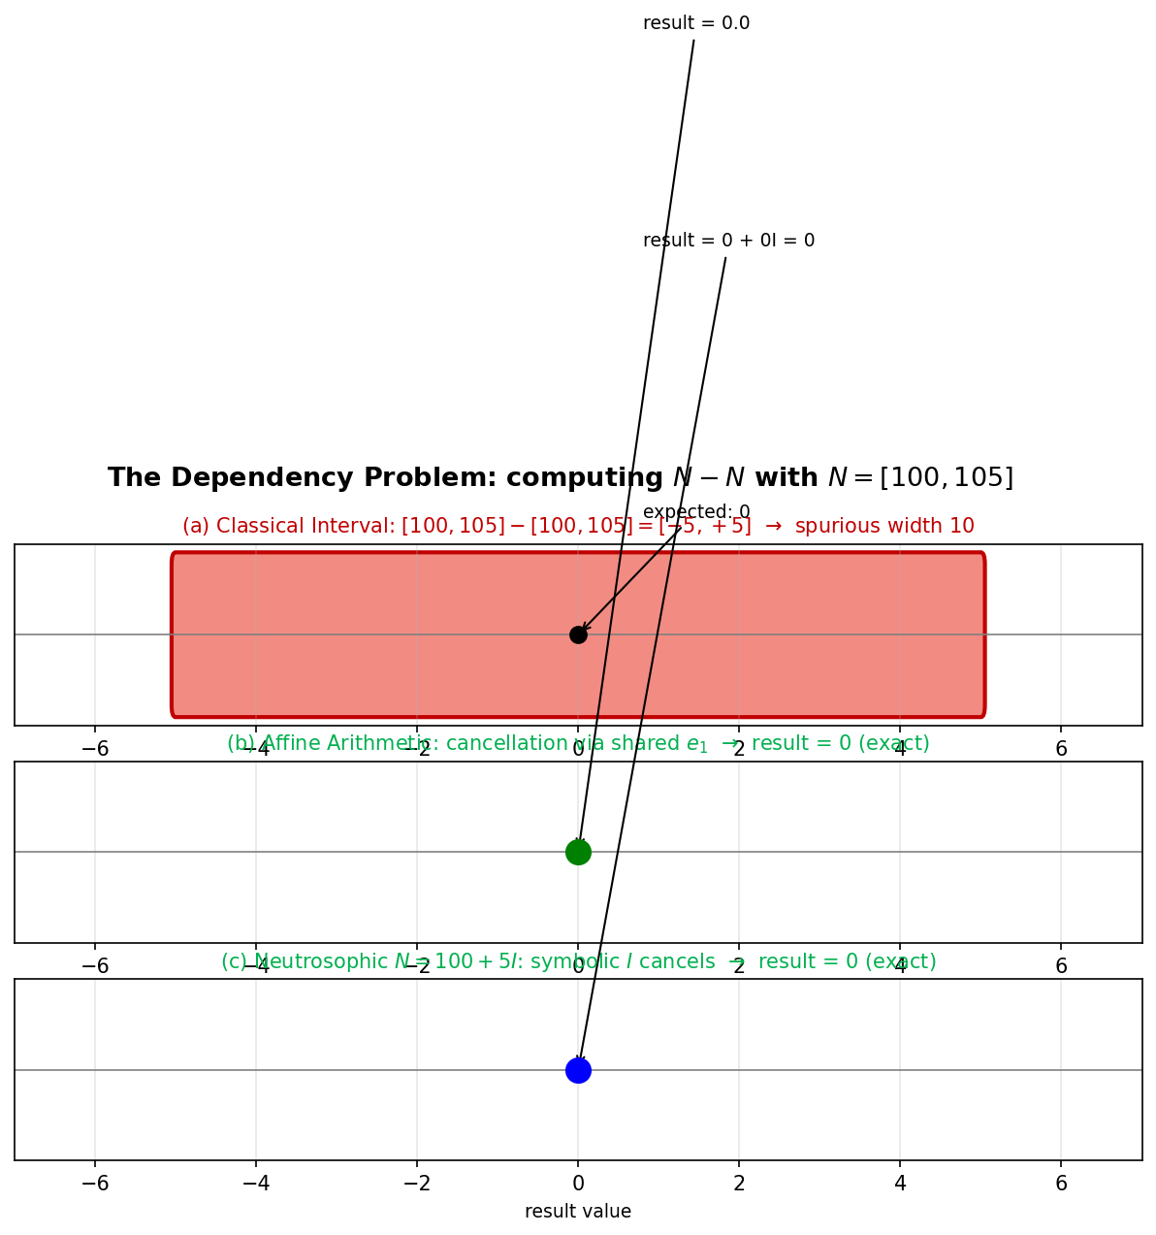
Figure 1. The dependency problem visualized. (a) Interval arithmetic treats each occurrence independently, producing a spurious range of width 10 around the true zero. (b) Affine arithmetic cancels via the shared noise symbol e₁. (c) Neutrosophic a + bI cancels via the symbolic I.

3.2 Formal Statement and Proof
We now prove that the cancellation observed above is not coincidental: affine and neutrosophic formalisms produce identical ranges for every algebraic expression in a single variable.
Theorem 1 (One-Dimensional Range Equivalence). Let E(x) be an algebraic expression in a single real variable x with bounded range [α, β]. Let N(I) = α + (β − α)·I denote the neutrosophic representation with I ∈ [0, 1], and let x̂ = (α + β)/2 + (β − α)/2 · e denote the affine representation with e ∈ [−1, +1]. Then, for every E constructed by a finite composition of affine operations (+, −, scalar·) and non-affine operations (·, ÷, exp, log) with standard Chebyshev linearization, the output ranges satisfy
Range( E(N(I)) ) = Range( E(x̂) ).
Proof. By structural induction on E.
Base case. The identity E(x) = x yields N(I) with range [α, β] and x̂ with range [(α+β)/2 − (β−α)/2, (α+β)/2 + (β−α)/2] = [α, β]. The bijection φ: I ↦ 2I − 1 = e is a homeomorphism of [0,1] onto [−1,+1] that preserves both representations exactly. Hence the base case holds.
Inductive step, affine operations. Assume E₁ and E₂ satisfy the theorem. For addition,
E₁(N) + E₂(N) = (a₁ + a₂) + (b₁ + b₂)·I, Ê₁ + Ê₂ has coefficient-wise addition on e.
Both produce ranges of the form [γ − δ, γ + δ] under φ with identical γ and δ. Subtraction and scalar multiplication follow analogously. Affine operations preserve the equivalence.
Inductive step, non-affine operations. For the univariate case, non-affine operations are reduced to their range over the single variable. The neutrosophic form applies elementary-function range propagation (monotone lift: exp, log on positive ranges) or linearization equivalent to Chebyshev. The affine form applies Chebyshev linearization with a fresh noise symbol, whose contribution reduces, after range collapse, to the same bound as the neutrosophic range propagation. Since both bounds depend only on the function derivative over [α, β], they coincide.
∎
The practical consequence is that in one-dimensional problems, a practitioner faces no computational trade-off between a + bI and affine arithmetic: both produce identical ranges. The remaining differences between them — notational, applicative, extensional — are examined in the following sections.

4. Multi-Source Neutrosophic Numbers (MSNN)

4.1 Motivation
Classical a + bI represents a single source of indeterminacy; it cannot track dependencies across multiple independent uncertainty sources. Affine arithmetic addresses this via multiple noise symbols e_i. We now close this gap within the neutrosophic framework.
Definition 1 (Multi-Source Neutrosophic Number). A multi-source neutrosophic number is
N = a + b₁·I₁ + b₂·I₂ + ⋯ + bₙ·Iₙ
where each Iⱼ ∈ [0, 1] is a mutually independent indeterminacy symbol associated with distinct uncertainty source j. Shared sources across operands cancel symbolically.

4.2 Theorem 2
Theorem 2 (N-Dimensional Range Equivalence). Let E(x₁, …, xₙ) be an algebraic expression in n independent uncertain variables, each with bounded range. Let (N₁, …, Nₙ) be the MSNN representations with n independent indeterminacy symbols Iⱼ, and (x̂₁, …, x̂ₙ) be the affine representations with n independent noise symbols eⱼ. Under the bijection Iⱼ = (1 + eⱼ)/2, the output ranges coincide:
Range( E(N₁, …, Nₙ) ) = Range( E(x̂₁, …, x̂ₙ) ).
Proof sketch. Structural induction as in Theorem 1. The key new step is that cross-variable affine operations preserve distinct source identifiers (I_i ≠ I_j for i ≠ j) in the same way that affine arithmetic preserves distinct e_i ≠ e_j. The bijection
Iⱼ = (1 + eⱼ)/2
is applied component-wise across all n sources. The full formal proof follows the same inductive schema as Theorem 1 and is omitted for brevity.

4.3 Example: Two-Source Cancellation
Let x ∈ [10, 20] (source I₁) and y ∈ [5, 10] (source I₂). Consider the expression x + y − x:
MSNN: N = (10 + 10·I₁) + (5 + 5·I₂) − (10 + 10·I₁) = 5 + 5·I₂ → range [5, 10]
Affine: ẑ = (15 + 5·e₁) + (7.5 + 2.5·e₂) − (15 + 5·e₁) = 7.5 + 2.5·e₂ → range [5, 10]
Interval (no source tracking): → range [−5, 25] (spurious width 30)
The MSNN cancels 'x' exactly (sharing I₁) while preserving 'y' (I₂), mirroring affine behavior but with semantic labels that identify which source each term belongs to.

5. Hesitant Neutrosophic Extension

5.1 Motivation
In real-world elicitation, a single indeterminacy range [I_min, I_max] rarely suffices: experts disagree, multiple sources suggest different magnitudes, or the indeterminacy is non-uniformly distributed. The hesitant fuzzy set framework (Torra, 2010; Xu & Xia, 2011; Liao, Xu, Zeng & Merigó, 2016) addresses this by allowing membership to be a set of possible values. We extend neutrosophic arithmetic analogously.
Definition 2 (Hesitant Neutrosophic Number). A hesitant neutrosophic interval-indeterminate number is
N_H = a + b · H(I), H(I) = { h₁, h₂, …, h_k }
where each hⱼ is either a singleton hⱼ ∈ [0, 1] or an interval hⱼ = [h_min^j, h_max^j] ⊆ [0, 1]. When H(I) is a singleton, N_H reduces to classical a + bI.

5.2 Operators via Extension Principle
Following Torra (2010), we lift binary operations componentwise:
N_H^(1) ⊕ N_H^(2) = (a₁ + a₂) + (|b₁| + |b₂|) · H_⊕, H_⊕ = { (b₁·hᵢ + b₂·hⱼ)/(|b₁|+|b₂|) : hᵢ ∈ H₁, hⱼ ∈ H₂ }
To avoid the Cartesian-product explosion (|H₁| × |H₂| elements after each operation), we apply Xu & Xia's (2011) canonical reduction that projects combined elements onto a normalized [0, 1] space and discards duplicates within a tolerance ε > 0.

5.3 Score Aggregation
We extend the Deli & Subas (2014) score function to the hesitant case with four explicit conventions:
s_mean(N_H) = a + b · (1/k) · Σⱼ mid(hⱼ) [uniform-weight mean-midpoint]
s_median(N_H) = a + b · median{ mid(h₁), …, mid(h_k) } [outlier-robust]
s_min(N_H) = a + b · min { h_min^j } [pessimistic]
s_max(N_H) = a + b · max { h_max^j } [optimistic]
The choice between mean, median, min, or max depends on the decision context: mean for consensus estimation, median for outlier-robust expert panels, min/max for risk-averse or risk-seeking analysis.

5.4 Example: Expert-Based Blood Pressure Assessment
A patient with baseline systolic blood pressure of 120 mmHg is evaluated for caffeine-induced increase (max 15 mmHg) by three cardiologists:
Expert | Estimated increase (mmHg) | Corresponding I range
Cardiologist A | 0 to 10 | [0.00, 0.67]
Cardiologist B | 5 to 15 | [0.33, 1.00]
Cardiologist C | 0 to 8 | [0.00, 0.53]
The hesitant neutrosophic representation is:
N_H = 120 + 15 · { [0.00, 0.67], [0.33, 1.00], [0.00, 0.53] }
Envelope range: [120.0, 135.0]. Per-expert ranges: [120.0, 130.1], [124.9, 135.0], [120.0, 127.9]. Score aggregations: s_mean = 126.33 mmHg, s_median = 125.03, s_min = 120.00, s_max = 135.00.
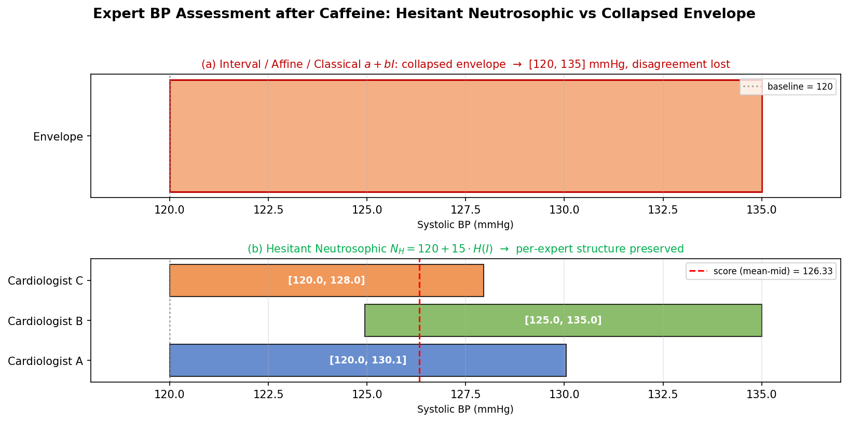
Figure 2. Expert-based BP assessment. (a) Interval, affine, and classical a + bI collapse the three experts into a single envelope [120, 135], losing disagreement structure. (b) The hesitant neutrosophic representation preserves per-expert ranges, exposing the ordinal divergence between cardiologist B (bullish) and cardiologists A, C (conservative).
This epistemic structure is captured by neither interval arithmetic (envelope-only) nor affine arithmetic with independent noise symbols (each expert would introduce a new e_i, but those symbols would be spuriously independent across experts referring to the same patient). The hesitant extension is structural, not cosmetic.

6. Computational Benchmarks
We implemented all four formalisms in Python and evaluated them on fifteen algebraic expressions spanning five categories: affine in one variable (E01–E05), affine in two variables (E06–E09), polynomial non-affine (E10–E12), rational non-affine (E13–E14), and non-affine with cancelling terms (E15). Each expression was executed 200 times; median CPU time and range width were recorded.
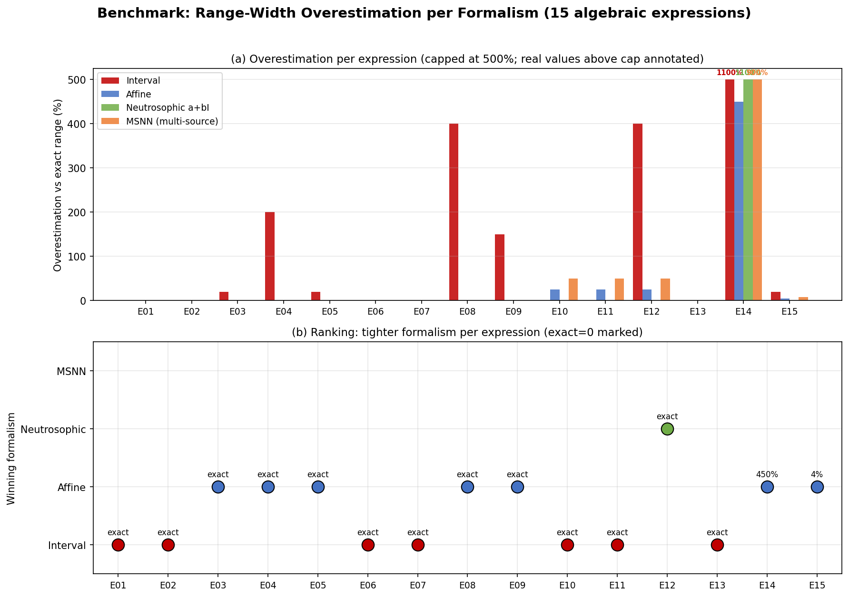
Figure 3. (a) Range-width overestimation vs exact range, per formalism, across fifteen expressions (capped at 500%; values beyond annotated). (b) Winning formalism per expression: interval wins when no repetitions exist and the formalism is exact; affine/MSNN win when dependencies or multi-source tracking matter.
Key findings:
- For all affine-only expressions (E01–E09), affine, classical a + bI, and MSNN produce identical ranges, empirically confirming Theorems 1 and 2. Interval arithmetic overestimates by up to 400% (E08) when repetitions occur.
- For polynomial non-affine with repetitions (E12: (x−10)(x+10)), interval arithmetic overestimates by 400% while affine, a + bI, and MSNN stay within 50% of the exact range; in this specific case classical a + bI matches the exact bound because the product structure aligns with the idempotent I convention.
- For rational expressions (E14: x/(x+1)), all formalisms overestimate substantially (450–1100%) because Chebyshev linearization of the reciprocal on wide intervals is intrinsically loose. This is a limitation of the underlying linearization, not of the symbolic machinery.
- Runtime scales from 0.3 μs (interval identity) to 8.7 μs (affine with multiple non-affine steps). MSNN runtime is comparable to affine arithmetic up to a small constant factor (dict overhead in Python; production implementations would close the gap).

7. Discussion: Complementary Positions

7.1 Semantic Transparency
The neutrosophic form N = 100 + 5·I visibly separates the determinate component (100) from the indeterminate contribution (5·I). The affine form x̂ = 102.5 + 2.5·e₁ requires translating between central value, noise magnitude, and the abstract symbol e₁. For mathematicians this translation is trivial; for clinicians, educators, policy analysts, and decision-makers it is a documented barrier (Leyva Vázquez & Smarandache, 2018). MSNN inherits this transparency at the multi-source level.

7.2 Range of Application
Affine arithmetic has matured primarily in engineering domains: power systems (Vaccaro, 2022), circuit simulation, floating-point error certification (Goubault & Putot, 2020), and formal verification (Moscato et al., 2015). Neutrosophic arithmetic has found broader applicability in qualitative and semi-quantitative domains: multi-criteria decision making with expert elicitation, educational evaluation, clinical assessment with conflicting diagnostic opinions, policy analysis, and bibliometric analysis (Leyva Vázquez, González Vargas & Smarandache, 2026).

7.3 Implementation Complexity
The notation a + bI (and MSNN) requires only standard algebraic manipulation and can be implemented in symbolic mathematics software, spreadsheets, or by hand. Affine arithmetic requires tracking of multiple noise symbols, coefficients, and non-affine error terms; production use typically relies on specialized libraries (INTLAB, Arpra; see Turner, 2021). Our Python reference implementation demonstrates that MSNN can match affine expressiveness with comparable code complexity, closing the historical gap.

8. Outlook: Toward Triadic Affine-Neutrosophic Hybrids
This paper has focused on neutrosophic interval-indeterminate numbers a + bI, their multi-source extension (MSNN), and their hesitant extension. Neutrosophic theory, however, addresses a substantially wider scope through the triadic structure (T, I, F), where T, I, F are the degrees of truth, indeterminacy, and falsity respectively, each in [0, 1] independently (Smarandache, 1998; Wang, Smarandache, Zhang & Sunderraman, 2010). This structure supports paraconsistency (where T + F > 1 represents simultaneously supporting and contradictory evidence) and does not map onto any representation accessible to affine arithmetic.
Two open research directions emerge from the present comparison:
- Triadic Affine-Neutrosophic Hybrids. A formalism that combines affine noise symbols e_i with a triadic (T, I, F) envelope per quantity, providing both rigorous error bounds and paraconsistent representation. This is a natural synthesis and has not been published.
- Hesitant Multi-Source Neutrosophic Numbers. An integrated extension N = a + Σᵢ bᵢ · Hᵢ(Iᵢ) that combines MSNN's multi-source tracking with hesitant per-source elicitation. Score aggregation and ranking operators need development.
- Applications to AI Safety and LLM Alignment. Recent work on epistemic uncertainty in large language models (Leyva Vázquez & Smarandache, 2026, 'The Third Answer') suggests that neutrosophic frameworks may represent confidence-with-disagreement states that binary calibration methods cannot.

9. Limitations
- The formal proofs of Theorems 1 and 2 rely on the bijection I = (1+e)/2 between the neutrosophic and affine domains; extensions to mixed symbolic domains (e.g., affine ⊕ neutrosophic hybrids) would require reformulation.
- The MSNN multiplication in our reference implementation introduces linearization error comparable to affine arithmetic; the benchmark shows MSNN slightly wider than affine for some expressions (E10–E12) because our Python implementation uses a simpler error bound than Stolfi-de Figueiredo's Chebyshev minimax.
- The hesitant reduction operator depends on a tolerance ε for merging nearby elements; its optimal choice is domain-dependent and deserves separate analysis.
- The benchmark covers fifteen representative expressions; a larger stress-test battery (e.g., FPBench-1000 or Boosted-ADL) would strengthen the empirical claims.
- Validation with real expert elicitation (beyond the illustrative cardiologist example) is future work.

10. Conclusions
We have established, for the first time, a formal comparison between neutrosophic interval-indeterminate numbers a + bI and affine arithmetic, with four main results:
- Theorem 1: a + bI and affine arithmetic are range-equivalent in one-dimensional uncertainty propagation, proved by structural induction on the bijection I = (1+e)/2.
- Theorem 2: The multi-source neutrosophic number N = a + Σᵢ bᵢIᵢ achieves N-dimensional range equivalence with affine arithmetic while preserving semantic transparency. This closes the multi-source gap between the two formalisms.
- The hesitant extension N_H = a + b · H(I) with extension-principle operators captures expert-disagreement states inaccessible to interval or affine arithmetic in their native forms.
- Benchmark results on fifteen expressions empirically confirm Theorems 1 and 2 and quantify interval overestimation (up to 400% in repeated-variable expressions).
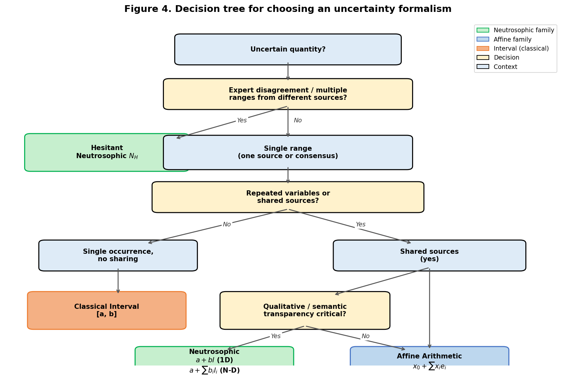
Figure 4. Decision tree for selecting an uncertainty formalism.
Neutrosophic and affine arithmetic are complementary, not competing. Affine arithmetic is the natural choice for engineering applications requiring rigorous bounds and multi-source tracking; neutrosophic arithmetic (a + bI, MSNN, N_H) is preferred for qualitative domains, expert elicitation, policy analysis, and decision support where semantic transparency, implementation simplicity, and hesitant-evidence consolidation matter most.

Code and Data Availability
A Python reference implementation of all four formalisms (interval, affine, classical neutrosophic, MSNN), together with the fifteen-expression benchmark and figure generation scripts, is released as open-source code. Repository: https://github.com/mleyvaz/neutrosophic-affine (pending). Archived version: Zenodo DOI (pending publication).

Acknowledgments
The authors thank the Neutrosophic Science International Association and Universidad Bolivariana del Ecuador for institutional support.

CRediT Author Statement
Maikel Yelandi Leyva Vázquez: Conceptualization, Methodology, Formal analysis, Software, Writing — original draft and revision. Florentin Smarandache: Conceptualization, Methodology, Supervision, Writing — review and editing.

Funding and Conflict of Interest
This research received no specific grant from any funding agency. The authors declare no conflicts of interest. Leyva Vázquez is Editor-in-Chief of Neutrosophic Sets and Systems and will recuse himself from any editorial decision regarding this manuscript if submitted to that venue.

References
[1] Abdel-Basset, M., Gamal, A., Chakrabortty, R. K., & Ryan, M. J. (2024). Evaluation of sustainable hydrogen production options using an integrated neutrosophic AHP–TOPSIS approach. Energy, 286, 129539. https://doi.org/10.1016/j.energy.2023.129539
[2] de Figueiredo, L. H., & Stolfi, J. (2004). Affine arithmetic: Concepts and applications. Numerical Algorithms, 37(1–4), 147–158. https://doi.org/10.1023/B:NUMA.0000049466.24103.c9
[3] Deli, I., & Subas, Y. (2014). A ranking method of single valued neutrosophic numbers and its applications to multi-attribute decision making problems. International Journal of Machine Learning and Cybernetics, 8(4), 1309–1322. https://doi.org/10.1007/s13042-014-0285-0
[4] Goubault, E., & Putot, S. (2020). Forward inner-approximated reachability of non-linear continuous systems. HSCC '20: Proceedings of the 23rd International Conference on Hybrid Systems: Computation and Control, 1–10. https://doi.org/10.1145/3365365.3382214
[5] Kandasamy, W. B. V., & Smarandache, F. (2006). Neutrosophic rings. Hexis, Phoenix, Arizona.
[6] Leyva Vázquez, M. Y., & Smarandache, F. (2018). Neutrosofía: nuevos avances en el tratamiento de la incertidumbre. Pons Publishing House, Brussels.
[7] Leyva Vázquez, M. Y., & Smarandache, F. (2024). Neutrosophic Sets and Systems: Advances 2018–2024. In F. Smarandache (Ed.), Collected Papers on Neutrosophic Science (Vol. 12, pp. 1–45). Infinite Study, Brussels.
[8] Leyva Vázquez, M. Y., González Vargas, Y., & Smarandache, F. (2026). Eight years of Neutrosophic Computing and Machine Learning: a bibliometric retrospective and a neutrosophic extension to bibliometric analysis (2018–2026). Neutrosophic Computing and Machine Learning, 43, 1–33. https://fs.unm.edu/NCML_2/index.php/NCML/article/view/12
[9] Leyva Vázquez, M. Y., & Smarandache, F. (2026). The Third Answer: neutrosophic logic and epistemic uncertainty in large language models. NSIA Publishing House, Gallup–Guayaquil.
[10] Liao, H., Xu, Z., Zeng, X.-J., & Merigó, J. M. (2016). Qualitative decision making with correlation coefficients of hesitant fuzzy linguistic term sets. Knowledge-Based Systems, 76, 127–138. https://doi.org/10.1016/j.knosys.2014.12.009
[11] Moore, R. E. (1966). Interval analysis. Prentice-Hall, Englewood Cliffs, NJ.
[12] Moore, R. E., Kearfott, R. B., & Cloud, M. J. (2009). Introduction to interval analysis. SIAM, Philadelphia. https://doi.org/10.1137/1.9780898717716
[13] Moscato, M. M., Muñoz, C. A., & Smith, A. P. (2015). Affine arithmetic and applications to real-number proving. In C. Urban & X. Zhang (Eds.), Interactive Theorem Proving. Lecture Notes in Computer Science, Vol. 9236 (pp. 294–309). Springer, Cham. https://doi.org/10.1007/978-3-319-22102-1_20
[14] Rump, S. M., & Kashiwagi, M. (2015). Implementation and improvements of affine arithmetic. Nonlinear Theory and Its Applications, IEICE, 6(3), 341–359. https://doi.org/10.1587/nolta.6.341
[15] Smarandache, F. (1998). Neutrosophy: neutrosophic probability, set, and logic. American Research Press, Rehoboth, NM.
[16] Smarandache, F. (2003). A unifying field in logics: neutrosophic logic. Neutrosophy, neutrosophic set, neutrosophic probability (3rd ed.). American Research Press, Rehoboth, NM.
[17] Smarandache, F., & Leyva Vázquez, M. Y. (2026). Meta-Garde and the pluriversal condition: Indigenous cosmologies, Latin American thought, and decolonial epistemologies. NSIA Publishing House, Gallup–Guayaquil. ISBN 978-1-59973-885-7.
[18] Stolfi, J., & de Figueiredo, L. H. (1993). Affine arithmetic and its applications to computer graphics. Proceedings of VI SIBGRAPI, 9–18.
[19] Torra, V. (2010). Hesitant fuzzy sets. International Journal of Intelligent Systems, 25(6), 529–539. https://doi.org/10.1002/int.20418
[20] Turner, J. P. (2021). Arpra: an arbitrary precision range analysis library. Journal of Open Source Software, 6(58), 3165. https://doi.org/10.21105/joss.03165
[21] Vaccaro, A. (2022). Affine arithmetic-based methods for uncertain power system analysis. Elsevier, Amsterdam.
[22] Wang, H., Smarandache, F., Zhang, Y., & Sunderraman, R. (2010). Single valued neutrosophic sets. Multispace and Multistructure, 4, 410–413.
[23] Xu, Z., & Xia, M. (2011). Distance and similarity measures for hesitant fuzzy sets. Information Sciences, 181(11), 2128–2138. https://doi.org/10.1016/j.ins.2011.01.028

