OSCM – Helper App based on Django
Internal Project – HuCE-microLab

Andreas Habegger <andreas.habegger@bfh.ch>
Florian Marilly <florian.marilly@gmail.com>
V 1.0 , Draft, 09/24/14
Bern University of Applied Sciences
Engineering and Information Technology
HuCE - microLab

Contents

1 Project Description 3
2 Requirements 3
3 Project Analysis 3
4 Project Concept and SW Modules 3

Project Description
The target of this project is to develop an helper application to optimize the ordering process in an engineering laboratory. The term OSCM is an abbreviation for Ordering and Supplier Chain Manager. Our engineering environment undergoes a lot of chances during an academic year. This means we have frequent chances of collaborators such as master and bachelor students working on short-term projects, as well as PHd candidates or part-time collaborators working on CTI projects. Because we realize prototypes - meaning development of electronics or electro-mechanical devices, we need 3rdParty Suppliers that deliver the needed components for realizing. This ends in supplier management as well as component ordering tracking, organization and payment supervising. The helper application OSCM should be based on the framework Django – a Python based framework. We want reduce management over-head, increase tracking capabilities in the warehouse process and therefor reduce the overall costs.

Requirements
- The applications should be role based – see the three roles below for more detail:
  - not logged-in user (no access)
  - logged-in user (basic user access)
  - logged-in admin (full back-end control)
- An user authenticate over the std. Django auth. Interface (LDAP, DB etc.)
- Only logged-in users can fill-in the form
- The form has the following fields controlled by the back-end
  - Supplier (as list) (one or more suppliers – added in back-end only, selected in front-end)
  - Product number (number – regex validation)
  - Project field ( string )
  - user, derived from users login
  - description ( string )
  - quantity ( number only )
  - due date
- The form walks trough the following process steps
  - order booking
  - order settled
  - order received
  - order checked
  - invoice transferred
- There are some information requirements in the different steps described as “projects steps”
  - order booking : first supplier, quantity, product number, due date, user – derived from login
  - order settled : order number, check-box and apply button for confirmation. An order is settled, when components are ordered. Hence it needs an export as CVS first – CVS depends on the CVS input of supplier. When order is settled we get an order number from the supplier this number is required to confirm this step. Again, user is derived from login.
  - Order received : material check and internal distribution. Again, user derived from login. This step can be done in sub-steps and sub-steps can be confirmed – due to time differences in delivery process etc.
  - Order fully checked, ready for payment.
  - Invoice transferred to BFH internal process. A PDF can be attached to the order. The process is finished and will be archived for further information lookup for example.
- The front-end is simple and does basic input-validation as well as logging the users filing-in stuff. Secondly the system notifies special users over the e-email interface (e.g. sendmail) a special group of users when an order is pending for settling and close to the due date.
- The back-end allows to organize the user rolls, add suppliers and manage topics such as supplier groups. There is also a capability to manage different research groups. These groups can add their own supplier etc. and group specific sub-organization meaning a different mail notification chain etc.

Project Analysis
In this part the different screenshots are just used to explain the context (simple view) and there aren't the final screenshoots of the application.

At the beginning the users must be registered in the system. This operation can be done by an user who has the admin level of the system, but a specific feature can be created to register an user and an user who has the admin level can set the rights.

- Authentication – Login

level authentication :
Admin :
can set the different groups (group X, group Y,...) and set their rights too (“admin”, “manager”, “standard user”)
can add, remove and edit components (suppliers, description,...)
can configure the group and specially set if necessary to send an email to all members or not and how to do it (via SMTP or SENDMAIL)
can have an option to set or not the right to create a template (supplier template) for a specific group and for a specific “manager” Manager :
can validate the list of orders
can add, remove and edit components (suppliers, description,...)
Standard user
can create a list of components which are necessary to him

Views :

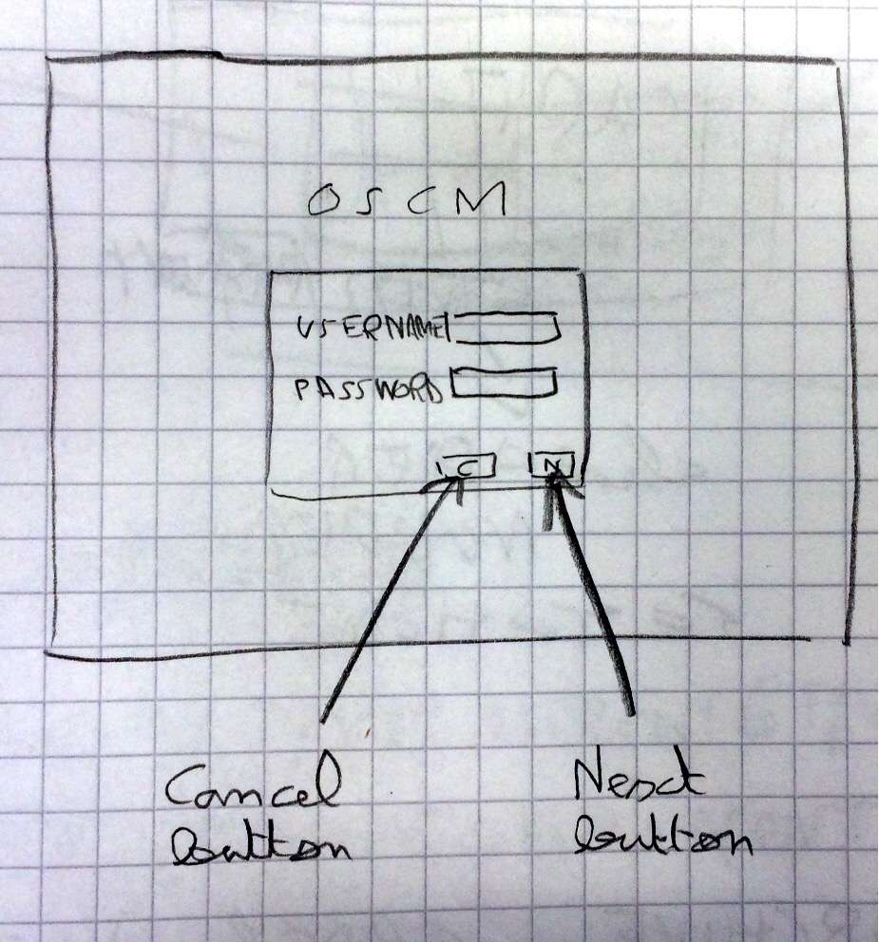
When you click on the “Cancel” button all fields are cleared (“username” and “password”).

If the login doesn't manage, we have a specific box with the message under the authentication content (see the next picture below).

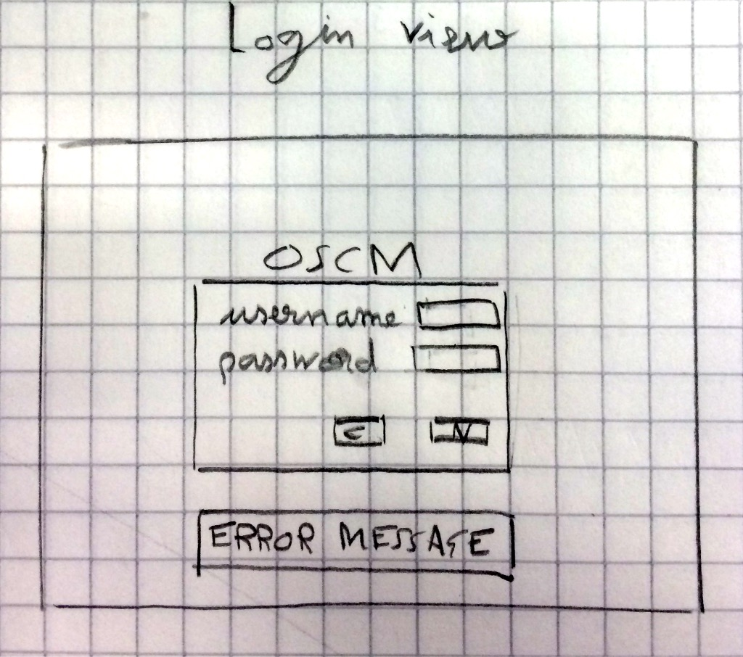
In the next picture you can see the different views with the different access levels.

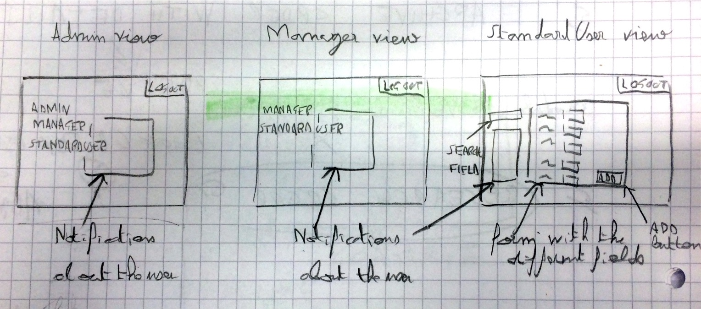

Remarks :
- all users must have a valid email.
- the “thumbnail” field could be optional with the other fields (to find easily the specific composant)
- the fields if it possible must be validated by a REGEX (front-end side)

- Order booking

- Admin :
The admin doesn't interact with the order booking process.

- Manager :
The manager donesn't interact with the order booking process.

- Standard user :
He can
- add the different components in the cart
- delete and edit them as soon as the first component is added to the cart
- cancel the whole cart by using a specific popup about it to confirm the operation
book the cart and thus receive the order number

- Order settled

- Admin :
No action

- Manager :
The manager can see the workflow of the process for the different orders which have been done by a standard user.
He can :
- interact with the orders as soon as the last are in “booked” state : edit an order by deleting a component or modifying its quantity
- export to CSV format a file for a specific supplier
- add the specific order from a supplier for one or more components (a popup to confirm the order will be added just before sending the order)
- add a personalized message to the user when the order is sent

- Standard user :
As soon as the manager has the specific orders from the suppliers about the original order (= master order) he receives an email with all info about his order (done by the “manager”) .

- Order received :

- Admin :
No action

- Manager :
He checks the delivery note with the order number and the content of the box

- Standard user :
He receives an email to confirm that all (from the order booking process) components are here

- Order fully checked, ready for payment :

Admin
No action

Manager :
He fills the specific formular and scans it to save in the application (optional feature)

Standard user :
No action

- “Archive” process :

- Admin
No action

- Manager
In fact it's like a monitoring process. He can print the document (real bill from the supplier) to the PDF format or send it by email to the external responsible by adding this document (PDF format). Moreover he can archive it in the application or not (optional feature).

Standard user :
- No action

Project Concept and SW Modules
- Project concept

The goal is to define the concept of the project and the best solution is to create a schema which explains it.

TO DO : insert schema about the concept

- SW Modules

In this part we will start to describe (views and explanations) the modules which is used in the project.
We can enumerate the list of modules :
- Translation
- Authentication (group, rights, …)
- Login
- Add a component in a cart
- Remove a component in a cart
- Edit component in a cart
- Message (text, email, general templates,...)
- Import/Export document in X format
- Search a component by criterias

  - Translation

The main languages which is used are :
- Deutsch
- English
- Français

As soon as we change the language, we must reload the page (all data will be cleared → it's a safe process → no corrupted data)

  - Authentication

This module is configured by the admin, but it's used in whole application.

