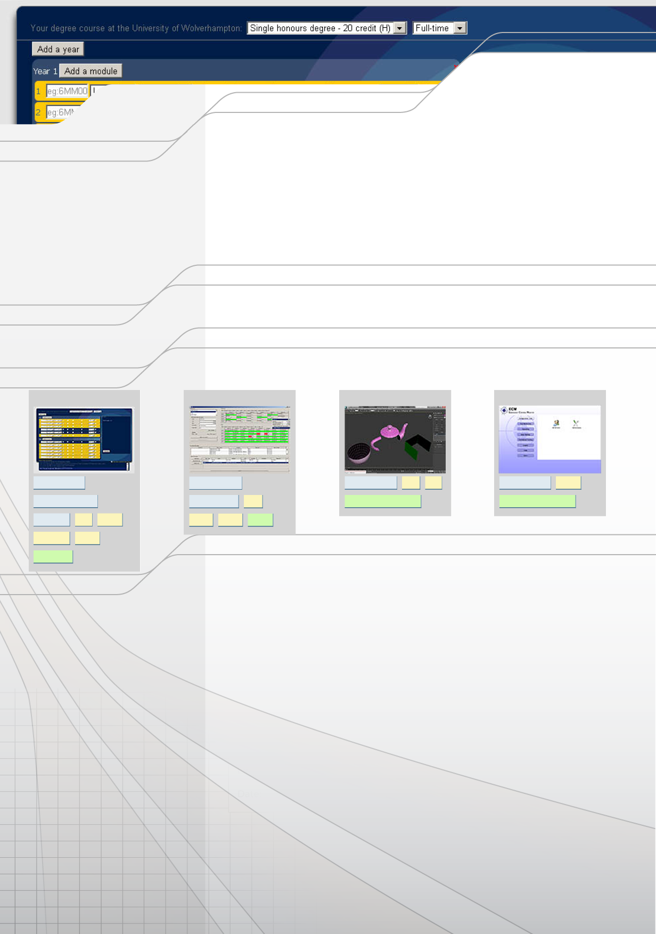
OTHER ACHIEVEMENTS: 2004 Paris Marathon - Ring of Kerry Cyclist 2004 - Nvidia Unreal Contest entrant 2004 - Student Course Rep 2004-06 - Four peaks (Ben Nevis,
Snowdon, Carrauntoohil, Scafell) 2005 - Feltham Faith Mentor Certificate 2007 - Building Design Image of the Week 2009 - Student Course Rep 2009-11 -
Junior java/php/c++/web developer
Tel: 01902 422 831 M:07816 426 797
Address: 44 Leicester Street, Wolverhampton
Email: matthew@mlfvs.info
Personal statement
A highly-motivated recent graduate with an honours degree in computer science and a portfolio of several A-grade applications. Prior to my degree I have a strong, ten-year, record of acheivement in the luxury architectural illustration sector, providing exemplary levels of service to leading organisations such as RMJM, St Paul's Cathedral and Cambridge University. This experience has enabled me to develop not only specific media industry experience, but also a valuable and transferable skill set in this fast-paced sector.
Since obtaining my degree, I have worked on several successful projects such as unitool.info. Utilising excellent communication skills, I have developed and maintained successful working relationships with internal and external colleagues.
Presently looking to secure a position in a software/web development organisation, where I can bring immediate and strategic value and develop my skill set further.
Education
2009 - 2011 Computer Science (BSc)
2:2 University of Wolverhampton (UK)
Merit+ University of the Arts, London (UK)
C&G Cert. Foras Aiseanna Saothair Tralee (IRL)
2004 - 2006
2000 - 2001
Portfolio
Unitool.info
Computer games production (FdA)
2D/3D cad
Downloads available at www.mlfvs.info/resume
S4S
Halver 3ds max
EC Monitor
php developer
java developer
c++ developer c++
uml
.net developer vb.net
web designer
scrum master
java
extreme programming
RAD methodologies
sysadmin php
drupal
swing mysql
scrum
javascript jquery
test-driven
Employment History
2010 - 2012
Independent developer
unitool.info
Wolverhampton
-Sole developer on a web application that converts University of Wolverhampton's 200+ degree regulations into a simple ui for students to figure out their progression-trajectory.
-5000 monthly users.
-Concept, design, development, hosting and security all managed in-house.
2010 - 2012
Architectural visualization artist
mlf visual studio (mlfvs)
Wolverhampton
-Owner/manager of a small cg studio making cg images and animations for architectural projects.
-Highlights include working on St Paul's Cathedral and scripting a geometry conversion utility for issuing sketchup models to clients.
2007 - 2009
Lead architectural visualization artist
rmjm
Cambridge
-lead visualizer making award-winning images and animations for rmjm's uk projects including Universities of Hertforshire, Buckinghamshire, Bedfordshire, Coventry and Leicester DeMontfort.
-Awards include rmjm "best visualization ever", and bdonline "Image of the week".
-Coordinated teams of up to four specialists.
-Developed an automated render farm of 200+ PCs using sysinternals tools, batch files and wakeonlan.
2004 - 2007
Architectural visualization artist
freelance
London
-Responsible for making images of residential and leisure architectural projects across London, including
Hemel Hempstead reconstruction following the explosion in 2005.
2005 - 2006
Software tester
razorback
Croydon
-Responsible for examining new builds of World of Warcraft on Nokia Ngage to verify fixed bug status.
-Credited with fixing bugs and appeared in the credits roll - next to William Shatner

