## Abstract:

## Introduction:

* Introduce field at broad level
  + Cells interaction on a spatial diffusion level
  + Coupled reaction diffusion equations
* introduce problem
  + Ref thesis of Julie
  + Insert image of excursions beyond the bifurcation point
  + To the pic below add the period line and remove numbers

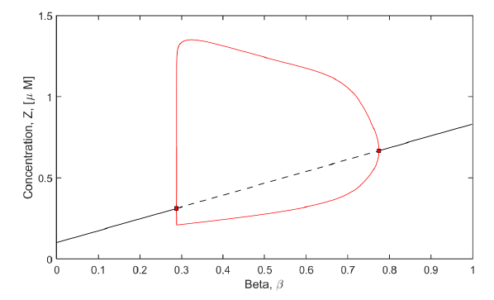 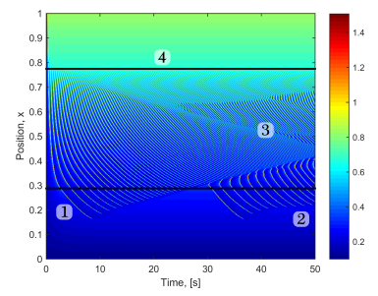

* what everyone really needs is exactly what i said we did in the discussion
  + to be able to predict when these excursions occur

## Method

* Use the wave shape to quantify when the excursions will occur. Define waveshape
* Quantify the FH-score
  + Light Derivation

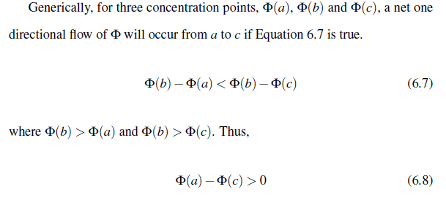

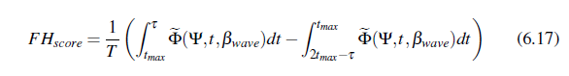

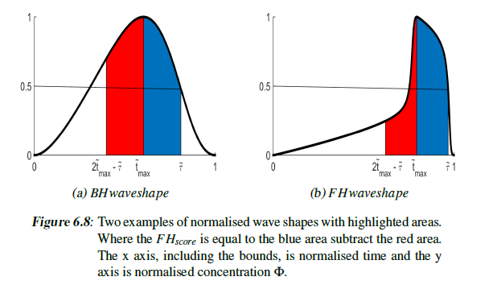

## Models to test hypothesis

* This is tested against 4 physiological models: the one pool model described by dupont, the two pool model described first by goldbeter, the ernmentrout model, the koenigsburger model and fitz hugh nagumo * 2
  + Give a summary of the partial differential equations with diffusion added
  + Reference the papers for the parameters and the sub equations
  + In Appendix the models and their spatial temporal concentration diffusion plots
* 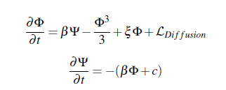In addition to these will introduce two toy models (TM3 and TMP)

$$\frac{∂Φ}{∂t}= -βΨe^{\left(ξ-0.5\right)Ψ}$$

$$\frac{∂Ψ}{∂t}= βΦ+0.2$$

TMP doesn’t work

## Results

* TM3 shows transition
  + Remove undetermined

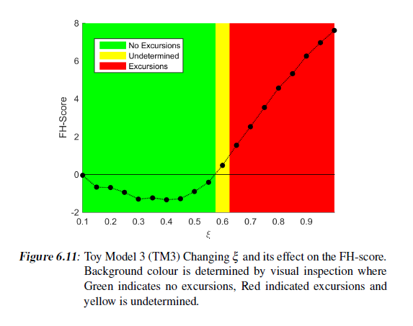

* Same results for TMP
* Table showing win:

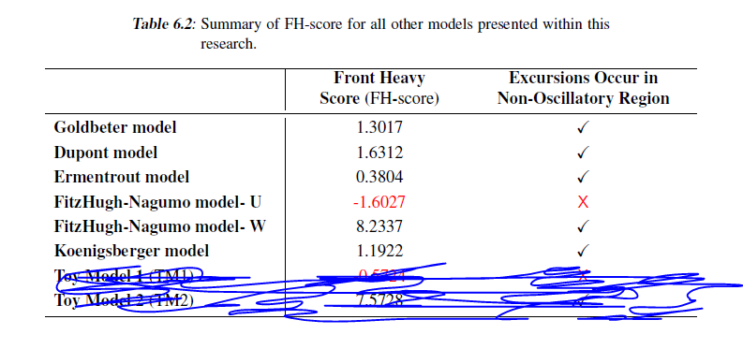

* + Double this with decreasing period and no excursions

## Discussion

* statement of principal findings
  + the waveshape corolates to excursions
* strengths and weaknesses of the study
  + Strength – worked for all examples
  + Weaknesses – haven’t applied it to all models
* strengths and weaknesses in relation to other studies, discussing important differences in results
  + Other research view has only ever noted this wave shape using limit cycles but of that seen have not applied it to excursions in the 2d diffusion case
* meaning of the study: possible explanations and implications for clinicians and policymakers
  + Gives an aim to alter the dynamics of the single cell in order to control the presence of excursions
* unanswered questions and future research.
  + Why do the waves stop
  + Is this the only criteria: Briefly mention beta

## Ap**p**endix

Goldbeter:

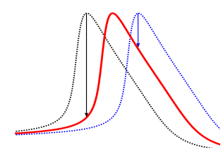

Do the same for each model

the ernmentrout model:

the koenigsburger model:

fitz hugh nagumo variable U:

fitz hugh nagumo variable V:

TM3:

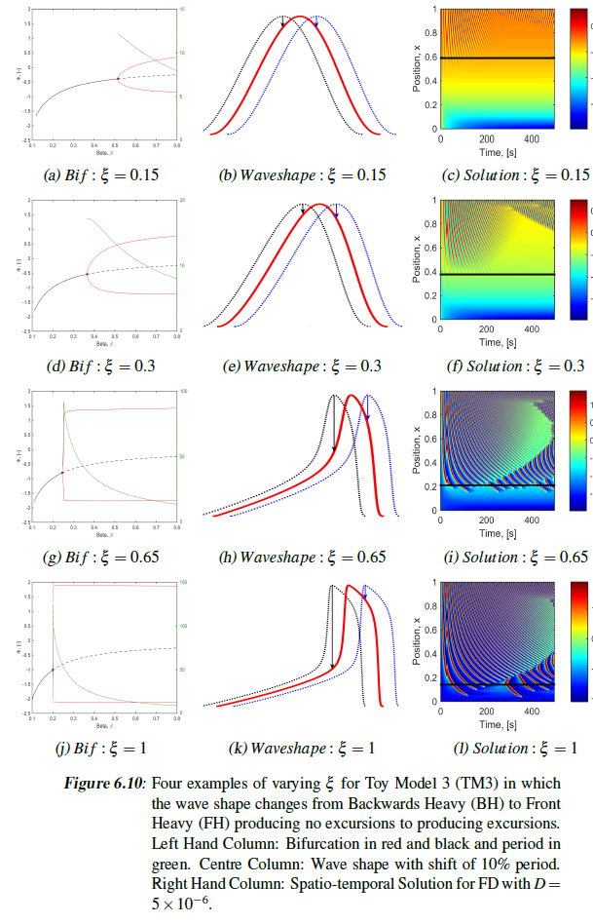

TMP: