On-Call Assistant
Architecture/Design Document

Table of Contents
1 Introduction 3
2 Design Goals 4
3 System Behavior 5
4 Logical View 5
4.1 High-Level Design (Architecture) 6
4.2 Mid-Level Design 7
4.3 Detailed Class Design 8
5 Physical View 8
6 Use Case View 8

Change History
Version: <x.y>
Modifier: <Name>
Date: mm/dd/yyyy
Description of Change: <What was modified/added?>
______________________________________________________
Version: <x.y>
Modifier: <Name>
Date: mm/dd/yyyy
Description of Change: <What was modified/added?>

Introduction

Architecture and Design
The purpose of the architecture/design document is to explain the organization of the code. A well-written architecture document will make it easier for new programmers to become familiar with the code.

The architecture/design document should identify major system components and describe their static attributes and dynamic patterns of interaction.

Software architecture and designs are typically expressed with a mix of UML models (class and sequence diagrams being the two most common) and prose. Dataflow diagrams are also helpful for understanding the interaction between components and overall flow of data through the system.
About this Template
This template suggests one way of documenting a software system’s architecture/design. You aren’t required to include every section in this template nor all the content in the sections you do include. However, the document you do submit should pass the following checklist:
- Are design objectives clearly stated? For example, if performance is more important than reusability, this should be made clear at the start of the design specification.
- Does the architecture partition the implementation into clearly defined subsystems or modules with well-defined interfaces?
- Does the architecture express in a clear way the main patterns of communication between subsystems and modules?
- Does the architecture satisfy the requirements?
- Is the architecture traceable to requirements?
- Any models created should either be expressed with a well-known modeling language, or if a well-known modeling language isn't used, the syntax and semantics of the symbols that are used should be defined.

This document describes the architecture and design for the On-Call Assistant application being developed for Commerce Bank. The application quickly creates on-call schedules for the customer.

The purpose of this document is to describe the architecture and design of the On-Call Assistant application in a way that addresses the interests and concerns of all major stakeholders. For this application the major stakeholders are:

- Users and the customer – they want assurances that the architecture will provide for system functionality and exhibit desirable non-functional quality requirements such as usability, reliability, etc.
- Developers – they want an architecture that will minimize complexity and development effort.
- Project Manager – the project manager is responsible for assigning tasks and coordinating development work. He or she wants an architecture that divides the system into components of roughly equal size and complexity that can be developed simultaneously with minimal dependencies. For this to happen, the modules need well-defined interfaces. Also, because most individuals specialize in a particular skill or technology, modules should be designed around specific expertise. For example, all UI logic might be encapsulated in one module. Another might have all business logic.
- Professor Burris – The instructor wishes to have UMKC well represented to businesses that are likely to be hiring future graduates.

The architecture and design for a software system is complex and individual stakeholders often have specialized interests. There is no one diagram or model that can easily express a system’s architecture and design. For this reason, software architecture and design is often presented in terms of multiple views or perspectives [IEEE Std. 1471]. Here the architecture of the On-Call Assistant application is described from 3 of the 4 different perspectives [1995 Krutchen]:

- Logical View – major components, their attributes and operations. This view also includes relationships between components and their interactions. When doing OO design, class diagrams and sequence diagrams are often used to express the logical view.
- Development View – how system modules map to development organization.
- Use Case View – the use case view is used to both motivate and validate design activity. At the start of design the requirements define the functional objectives for the design. Use cases are also used to validate suggested designs. It should be possible to walk through a use case scenario and follow the interaction between high-level components. The components should have all the necessary behavior to conceptually execute a use case.

Design Goals
There is no absolute measure for distinguishing between good and bad design. The value of a design depends on stakeholder priorities. For example, depending on the circumstances, an efficient design might be better than a maintainable one, or vise versa. Therefore, before presenting a design it is good practice to state the design priorities. The design that is offered will be judged according to how well it satisfies the stated priorities.

The design priorities for the <product name> application are:
- The design should minimize complexity and development effort.
- The design should <another design goal>.

System Behavior
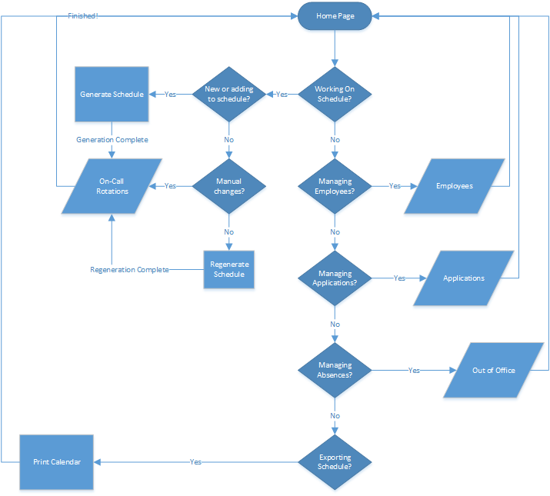

Logical View
The logical view describes the main functional components of the system. This includes modules, the static relationships between modules, and their dynamic patterns of interaction.

In this section the modules of the system are first expressed in terms of high level components (architecture) and progressively refined into more detailed components and eventually classes with specific attributes and operations.

High-Level Design (Architecture)
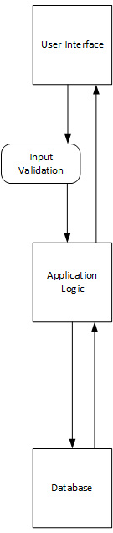
This application uses an MVC style architecture
- The user interface is provided as a web application. This provides useful views for the user to glean information about the on-call schedule that has been created. This interface also allows the user to make changes to necessary entries in the database through useful, friendly abstractions. Input from the user is validated to help prevent failures or unpredictable behavior when creating a schedule.
- The application logic layer passes data between the database and the user interface. This layer also consists of the behavioral logic needed to create schedules.
- The database stores information necessary to allow the application to function.

Mid-Level Design
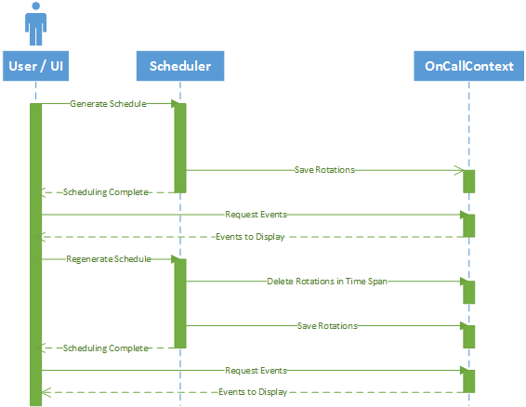

Detailed Class Design
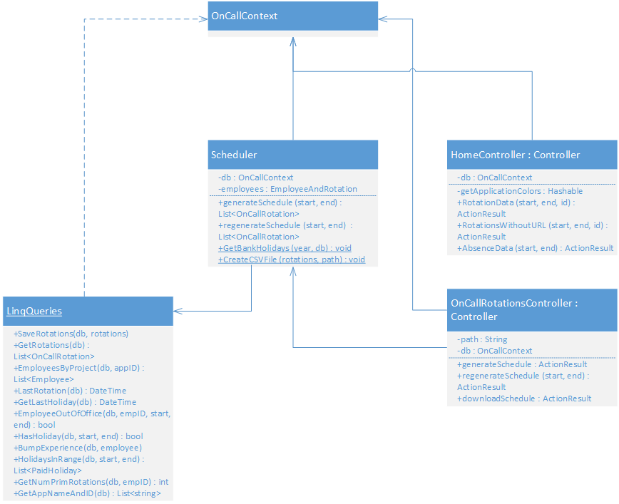

Physical View
On-Call Assistant is to be deployed solely on the customer’s computer using Microsoft IIS.

Use Case View
Specific use cases can be found in our requirements document. Generalized view shown below.
