Forecasting Stock Prices Using Machine Learning Technique

Abstract:
the stock market is an emerging sector in any country of the world . Many people directly related to this sector . Along with the development with the stock market ,forecasting become an important topic .Since finance market has become more and more competitive, stock price prediction has been a hot research topic in the past few decades .predicting stock price is regarded a challenging task because stock market is essentially non linear ,non-parametric,noisy,and a chaotic system .Trend of a market depends on many things like liquid ,money human behavior, news related to stock market etc. All this together controls the behavior of trends in a stock market with the advancement of the computing technology we use machine learning technique,like Support Vector Regression,K-nearest-neighbor,liner Regression for analyzing time series data to predict stock price. In this paper I try to develop a forecasting model with multiple method to find the best forecast of the stock price.

‘Keywords— Google stock, , Time Series data, SVR, KNN-Regressor, liner regression’

Introduction:

BACKGROUND OF THE STUDY :

Trend forecasting becomes an essential topic for stockholders, investors and the authority that are related to the stock market business here have been numerous attempt to predict stock price with Machine Learning . no method has been discovered to accurately predict stock price movement. The difficulty of prediction lies in the complexities of modeling market dynamics. Even with a lack of consistent prediction methods, there have been some mild successes .Most researches in this domain have only found models with around 50 to 60 percent accuracy. And they often work only for classification. After close investigation, we noticed that some papers that claim to have better result used problematic metrics to evaluate the model Although the graphs or numbers might look fancy, the actual model provides limited meaningful guidance for trading. we applied complicated models to pre-process the time series data before running ML models. We didn’t find any works that combined these financial technical indicators with machine learning algorithms like we did. And we got better results than other papers we found in this particular problem domain

OBJECTIVE:

The goal is to take time series data, find the equation that best fits the data, and be able forecast out a specific value. Time series data is a continuous data statistical observations recorded over a specific period of time. This model will try to understand the pattern of the continuous data with different method and produce a best fit line that fits the data. The target is to determine the future stock price and improve their strategy for future

Related work:

Many machine learning techniques have been used in recent time to predict the stock price. Neural network and support vector machine are the most usable among those [1][2]. SVM and NNs are both standard machine learning approaches to predict time series data [3][4].[5]A researchers in india find a pattern of stock price using the sentiment analysis.in [6] another authors used nural networks approach to find the pattern of stock price.

Methodology:

ARCHITECTURE OVERVIEW:

The multiple data source prediction system has a two tier architecture. The top tier is dedicated to preparing the data sets from multiple information sources to make them ready for the predication tasks in the next tier. It is composed of two major parts. The first part is data prepossessing . In this process we process the data by adding more feature and removing unnecessary feature and removing the bad data and also the absence of the data . The second part is the data alignment. The second tier is dedicated to the market volatility analysis and prediction through the model integration and training, which uses multiple kernel learning methodology to train the classifier. It consists of three tasks: First, we build one regression model per source. Second, we train the model with the same data sets ,and find the accuracy by cross validation of the result and finally we perform the comparison between the those result of different model to find the best prediction model
In this paper, we use the multi-kernel learning method .

A. Data Prepossessing:
In the real world, many data sets are very messy. Most stock price/volume data is pretty clean, rarely with missing data, but many datasets will have a lot of missing data. filter out other unimportant feature from the feature because not all the feature will be included into the final feature list .The reason behind it is the unnecessary feature and those value which has no relation with the stock market prediction will reduce the accuracy of the prediction

B. Feature Extraction:
We only work with the valuable feature , created some new valuable feature through manipulation.
Right feature can help to get more accurate results.

C .Training The ML Model:

Now comes the training and testing. The way this works is we take, 75% of our data, and use this to train the machine learning classifier. Then we take the remaining 25% of our data, and test the classifier. Since this is our sample data, we should have the features and known labels. Thus, if we test on the last 25% of our data, we can get a sort of accuracy and reliability,
C . Finding The Best Method
we estimate the best method by evaluating the accuracy of the Ml method using cross validation
and comparing them to find the best method for this specfic kind of datasets.

C . Predict The Feuture Value
we use the best selected method to predict the future closing price of the stock market

Methods:

This paper provides a hybrid methodology that combines both support vector machine ,liner regression and knn regression technique for dealing with high dimensional feature ,finding relation among the data and create a best fit line which will give us a significant accuracy and representational advantages

linear regression is a linear approach to modeling the relationship between a scalar response dependent variable and one or more explanatory variables (or independent variables). The case of one explanatory variable is called simple linear regression. For more than one explanatory variable, the process is called multiple linear regression

support vector machines are supervised learning models with associated learning algorithms that analyze data used for classification and regression analysis. Given a set of training examples, each marked as belonging to one or the other of two categories, an SVM training algorithm builds a model by creating a hyper plane that assigns new examples to one category or the other . in support vector regression (SVR). The model produced by support vector classification (as described above) depends only on a subset of the training data, because the cost function for building the model does not care about training points that lie beyond the margin.

In pattern recognition, the k-nearest neighbors algorithm (k-NN) is a non-parametric method used for classification and regression. In both cases, the input consists of the k closest training examples in the feature space. The output depends on whether k-NN is used for classification or regression:

in case of the knn regression the output is the property value for the object. This value is the average of the values of its k nearest neighbors .A useful technique can be used to assign weight to the contributions of the neighbors, so that the nearer neighbors contribute more to the average than the more distant ones

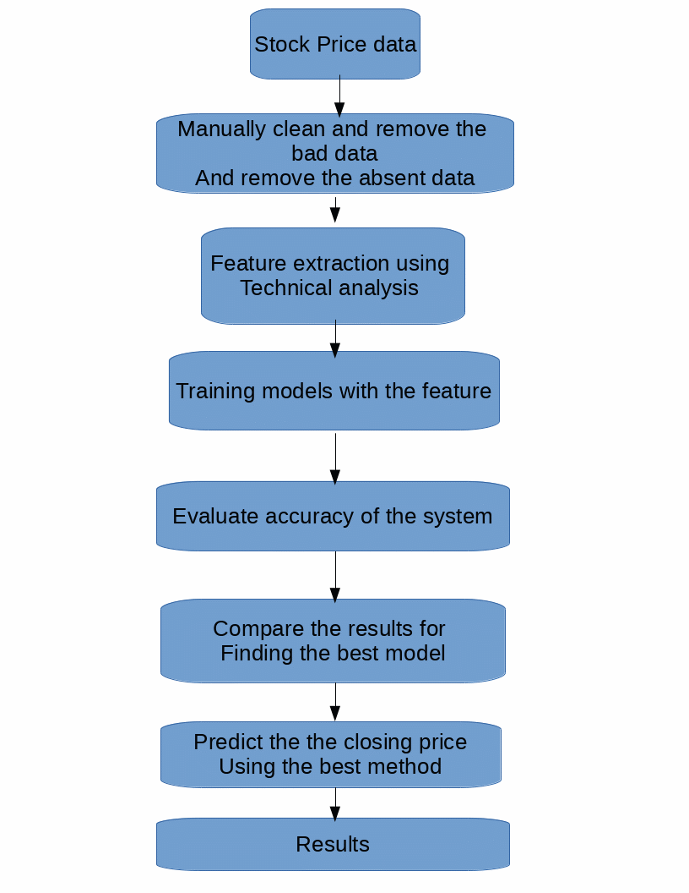

Evaluaton:

Experiment Setup:

In this experimant we use the following softwere

1.python
2.Numpy
3.Scikit-learn
4.Pandas
5.Matplotlib

Python is an interpreted high-level programming language for general-purpose programming. Created by Guido van Rossum and first released in 1991,

NumPy is a library for the Python programming language, adding support for large, multi-dimensional arrays and matrices, along with a large collection of high-level mathematical functions to operate on these arrays.

Scikit-learn (formerly scikits.learn) is a free software machine learning library for the Python programming language. It features various classification, regression and clustering algorithms including support vector machines, random forests, gradient boosting, and is designed to interoperate with the Python numerical and scientific libraries NumPy and SciPy.

Pandas is a software library written for the Python programming language for data manipulation and analysis. In particular, it offers data structures and operations for manipulating numerical tables and time series. It is free software released under the three-clause BSD license

Matplotlib is a plotting library for the Python programming language and its numerical mathematics extension NumPy. It provides an object-oriented API for embedding plots into applications using general-purpose GUI toolkits

Datasets:

We'll use the data of the stock price for Alphabet (previously Google).We collect the data from the Quandl. (Quandl is a platform for financial, economic, and alternative data that serves investment professionals).Quandl's sources include open data from providers such as the UN, Worldbank.Google.Yahoo and central banks core financial data.

Result Analysis:

 | Method Name | Accuracy
1 | Linear Regression | 87.9%
2 | Support Vector Machine with linear kernel | 87.34%
3 | Support Vector Machine with rbf kernel | 72.44%
4 | K-nearest-neighbor | 91.15%

