01.03.2018 г.
Ручки пластиковые, с учетом стоимости нанесения в 1 цвет с одной стороны,
при тираже 5 тыс. шт.

1) 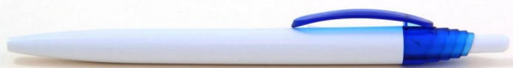
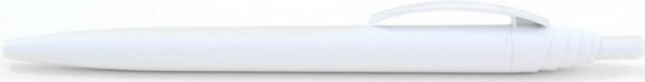
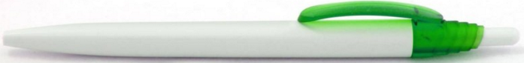
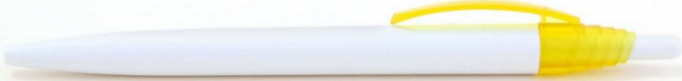
-----------------------------------------------------------------------------------------------------------------------------------
2) 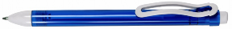
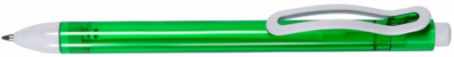
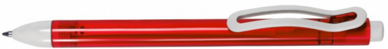
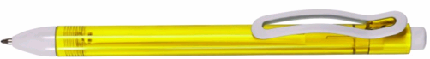
-----------------------------------------------------------------------------------------------------------------------------------
3) 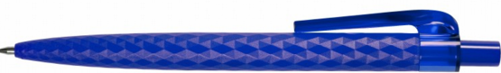
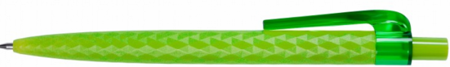
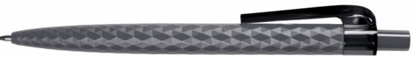
-----------------------------------------------------------------------------------------------------------------------------------
4) 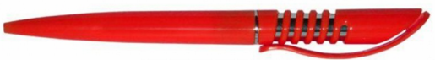
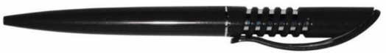
-----------------------------------------------------------------------------------------------------------------------------------
5) 

-----------------------------------------------------------------------------------------------------------------------------------
6) 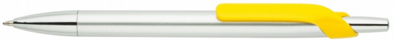
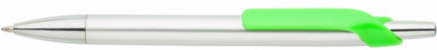
-----------------------------------------------------------------------------------------------------------------------------------

7) 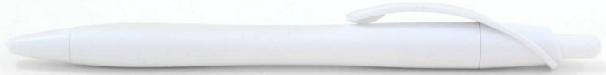
-----------------------------------------------------------------------------------------------------------------------------------
8) 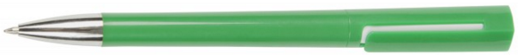  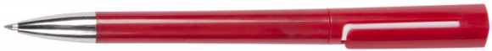 | 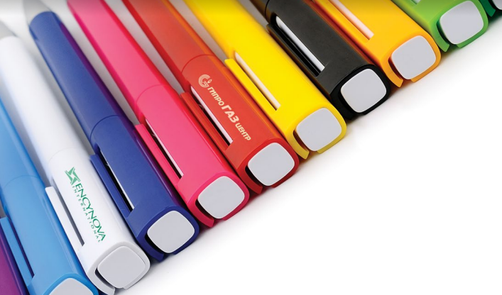
-----------------------------------------------------------------------------------------------------------------------------------
9) 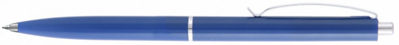
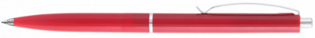
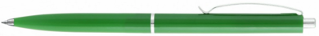
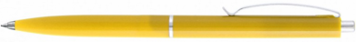
-----------------------------------------------------------------------------------------------------------------------------------
10) 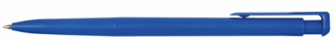
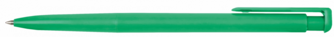
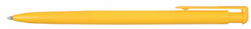
 (фиолет.)
-----------------------------------------------------------------------------------------------------------------------------------
11) 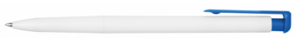

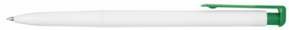
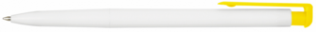
-----------------------------------------------------------------------------------------------------------------------------------
12) 


