# **IBM Cognos Analytics Workshop**

IBM Cognos Analytics provides Users with data discovery capabilities to visually explore and interact with their data to identify the key insights for improving data driven decisions. Users can perform data discovery and then quickly assemble that information which is most relevant to them into interactive, visually appealing dashboards.

In this tutorial, you will experience the following capabilities in Cognos Analytics:

* Uploading External Data Sources
* Working with the Dashboard
* Using the Assistant

The snapshot of the Dashboard you will build in this workshop:

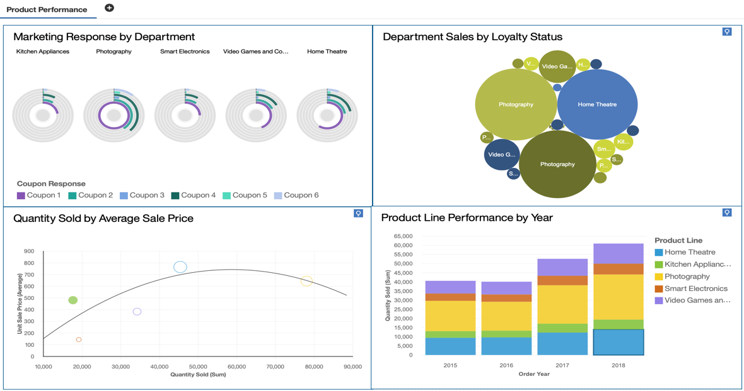

### Get Started with the Tutorial

### Free trial sign up: <https://www.ibm.com/account/reg/ca-en/signup?formid=urx-34710>

### Download data file to your local machine by right click the file below and select Save Link as…”

### [CustomerLoyaltyProgram_Full.csv](https://raw.githubusercontent.com/mlhubca/lab/master/cognos/CustomerLoyaltyProgram_Full.csv)

### This file is located at Github: <https://github.com/mlhubca/lab/blob/master/cognos/CustomerLoyaltyProgram_Full.csv>

### Business Use Case for this workshop

For the purposes of this Workshop, you will be playing the role of a retail marketer.  You have just received the following email from one of the Product Managers asking for assistance.

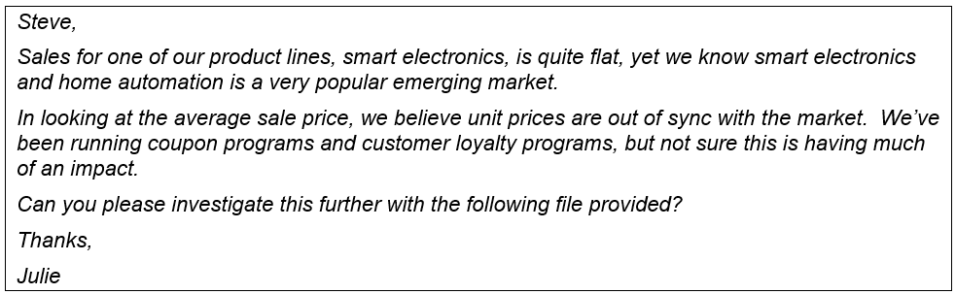

Using the dashboarding capabilities in Cognos Analytics will help you understand what’s happening in your business.  You’ll begin by uploading this file and building a Cognos Analytics dashboard to analyze department sales.  Using a dashboard template, you’ll quickly assemble content for your analysis.  Once your content is assembled, you will move on to formatting each of your widgets to polish it up and really make it shine, so you can share your findings with others in your organization.

### Uploading External Data Sources

* 1. To upload a file, you may either **drag and drop** this file into the **drop zone**, or you may **click** **browse** in the drop zone to navigate to where the file is saved.  For this workshop, we will use the**Drag and Drop**option.  **Drag** the file over to the **Drop zone button** on the canvas until the blue **Quick Launch** menu appears at the bottom of the screen.

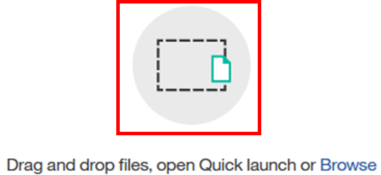

* 1. The Quick Launch button will allow you to select your intent on how you wish to interact with the data you are uploading.  **Drop** the file over the **Dashboard** option on the far right.

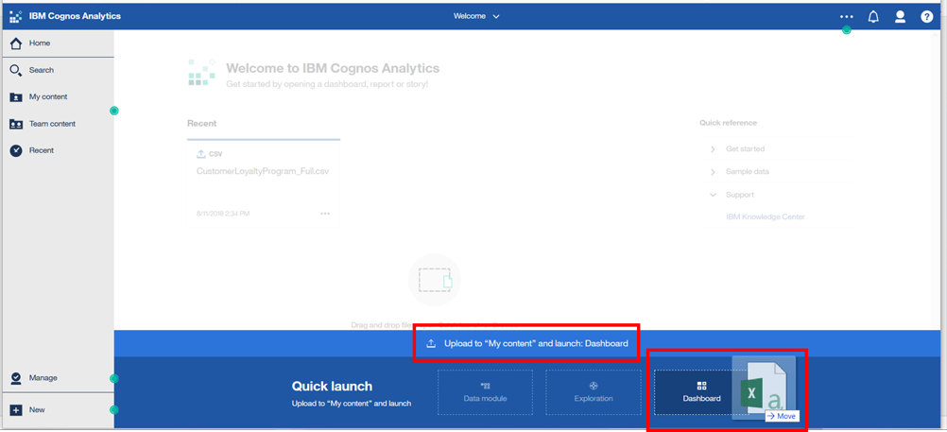

*Using this method, Cognos Analytics will automatically upload the file to your****My Content****folder and launch the Dashboard capabilities to begin working with your data.*

* 1. As the file uploads, notice that under the Switcher Menu, a series of **status bars** will be visible as the upload process reads and analyzes the data being brought in.





* 1. Once it completes, the status bar will update to show the successful completion before closing.



*Since you selected to upload the data and launch a Dashboard, the Dashboard User Interface will immediately open after the upload is complete.  You’re now ready to start to build out your first dashboard from this data.*

### Working with the Dashboard

Dashboards provide a line of sight into your business allowing you to easily monitor KPIs and metrics at a glance.  As a starting point, you would like to use the uploaded data file to analyze product performance.  You’ll use a dashboard template to assist in the layout of the data.

* 1. The Template window appears allowing you to select the type of dashboard and the template style. **Select the tabbed dashboard style**. This will allow you to have multiple pages for your dashboards.  **Select**the **four-panel template with 2x2 configuration.  Click OK**.

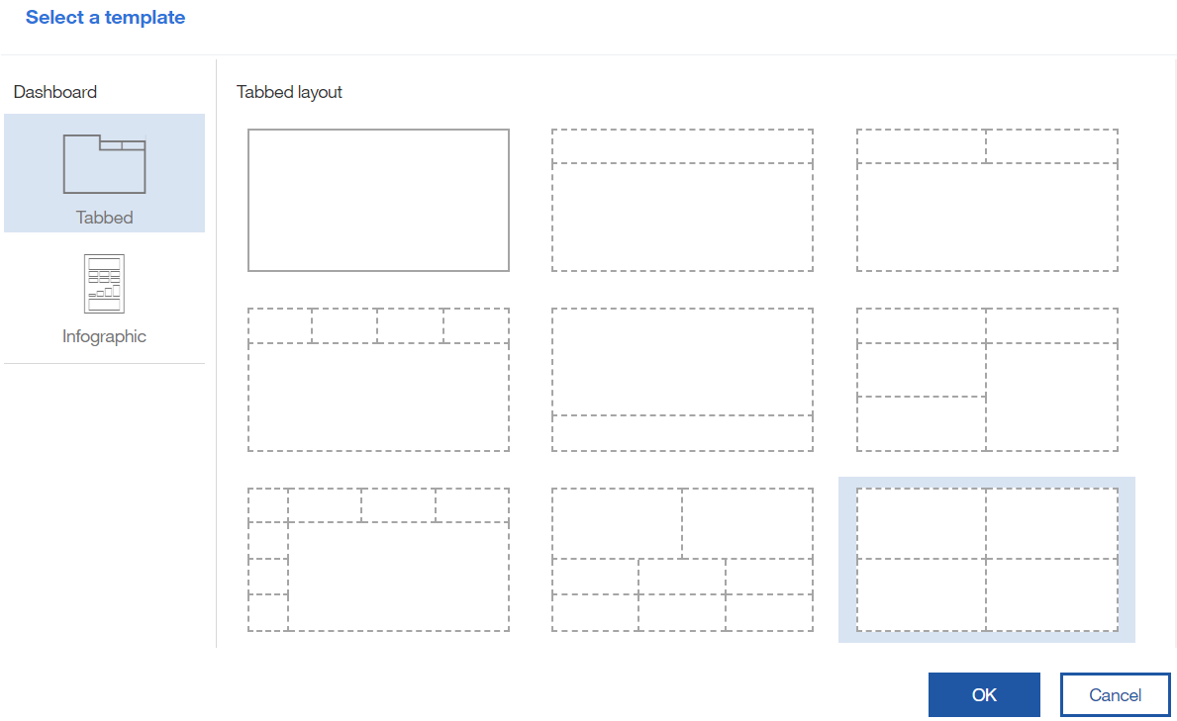

* 1. The **dashboard template** will open in the **Canvas** along with the data source opening in the **Data Source Panel**. Notice that the **Navigation Panel** buttons on the upper left have now updated to show the dashboard toolbox capabilities available for assembling a dashboard. The main toolbar has also updated exposing the dashboard editing functions available.

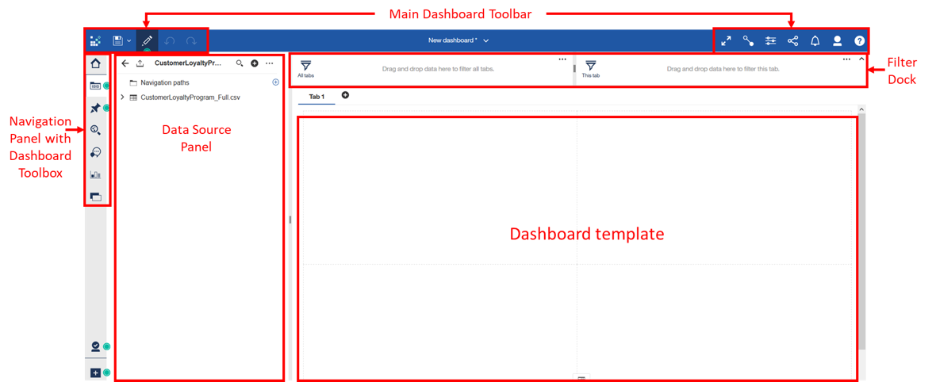

* 1. From the **Navigation panel**, **select** **Sources** image-20181216130426-1 to open the data source panel, if it is not already open.  The **Data Source panel** displays the “**CustomerLoyaltyProgram_Full**”, the uploaded file, as the **Selected Source**.
  2. **Click** the **Expand arrow** “**>**” to view the data items in the file. Scrolling through the data items, you will see all the columns from the uploaded file.

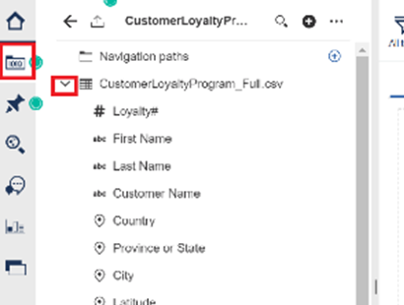

To begin, you would like to understand the performance of Coupon programs in place from Marketing for each of the Product Lines.  You can begin by simply multi-selecting the data items and dropping them into a panel on the template.  The smarts in Cognos Analytics identifies the data items and presents a recommended starting visualization to represent the data.

* 1. From the **Data Source panel,** **Control select** the **Product Line**, **Coupon Response**, and **Quantity sold**and drag it to the center of **Panel 1, releasing**them once you see the**drop zone turn blue.**

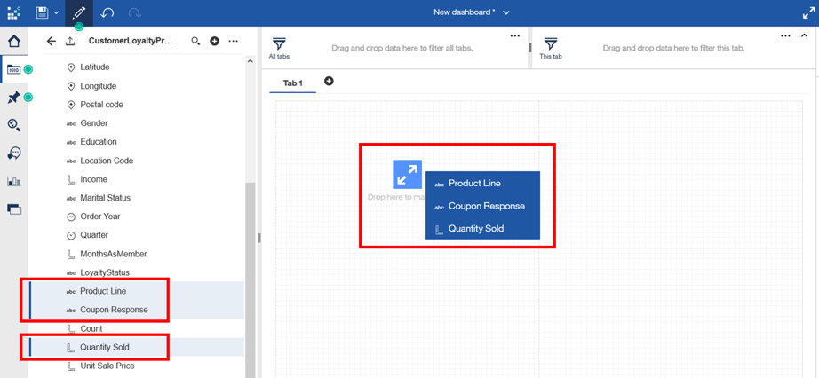

***TECH TIP:***  By dropping the data items on to the drop zone, the widget will automatically size to fill the entire panel.  Users can modify the sizing, placement and layout at any time.

* 1. A visualization will render.

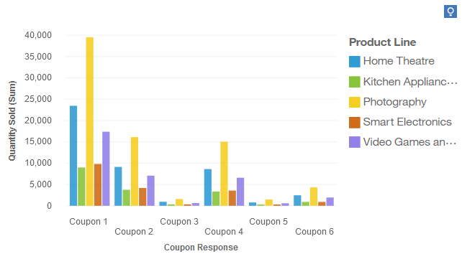

*From this visualization, you can immediately see that the highest level of quantity sold is under Coupon 1, and that Photography has the highest quantities sold across all Product Lines.*

* 1. Users can easily select other visualization options from the Visualization library.  **Click** the **visualization in panel 1** to bring up the on-demand toolbar for the widget.
  2. **Click** the **Change Visualization** button on the on-demand toolbar to bring up the Visualization library.

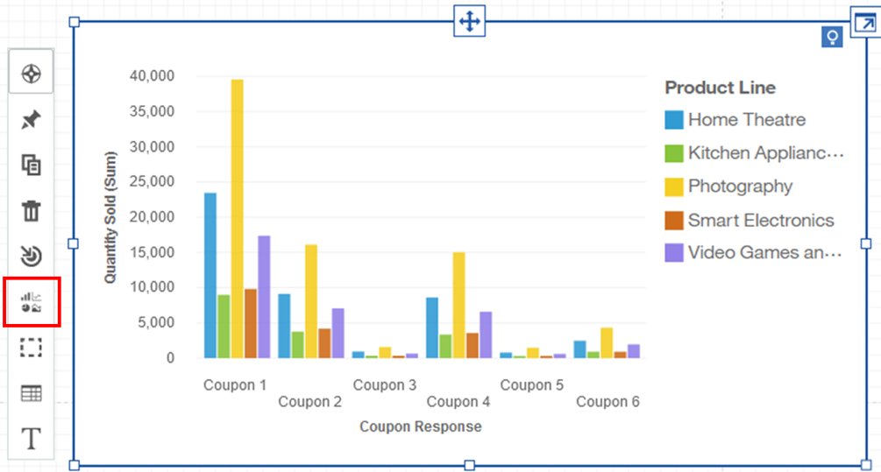

* 1. Use the **arrow** “**>**” to **Expand** **All Visualizations**.  Scroll down and **Select Radial**.

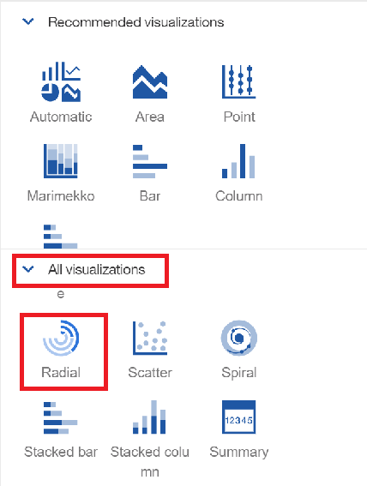

* 1. The visualization updates to a Radial chart.

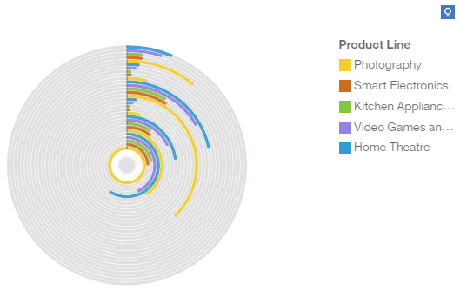

*The new radial chart shows all data rendered in a single radial.  For your analysis, you would like to have each product line have its own radial visualization, so you will customize the visualization to suit your analysis.*

* 1. **Click** the **expand** button in the upper right-hand corner of the visualization widget to open in **Design Mode**.

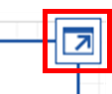

*Once the Design Mode window opens, you will see the data slots in the left panel.  The Data slots are used to set the definitions for how you wish the data items to be defined for visualization rendering.  You would like to see the Coupon Promotions on individual radial charts repeated for each of the Product Lines.  To do so, you’ll move the data items around into the data slots to define and render your desired visualization.*

* 1. **Drag and drop Product Line** to the **Repeat (column)**area.

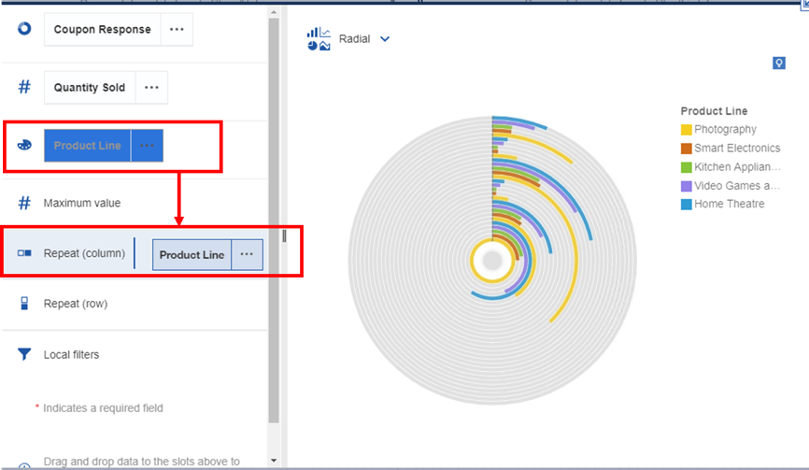

* 1. Next, **move** the **Coupon Response** to the **Color** field.

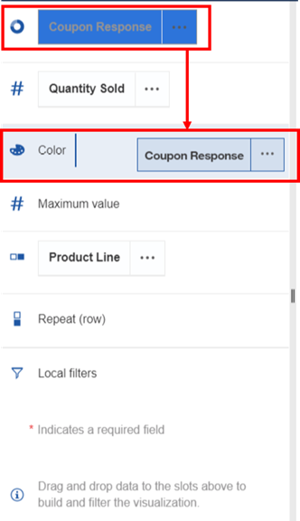

* 1. The visualization updates to show radial charts for each Product Line.  Verify that your data slot definitions are populated with the same data items as shown in the image below.

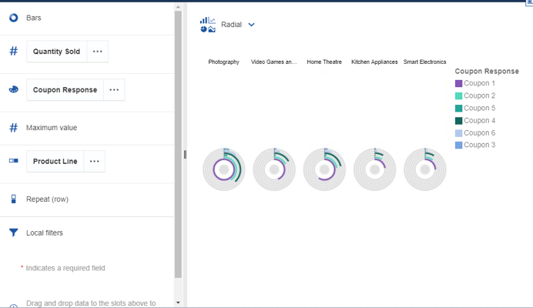

* 1. Next, you’ll set the visualization to sort the data, so it renders in your desired order.**Click** the **ellipses...**next to **Coupon Response** to open options**.** **Select Sort**, then **select** **Sort Ascending**.

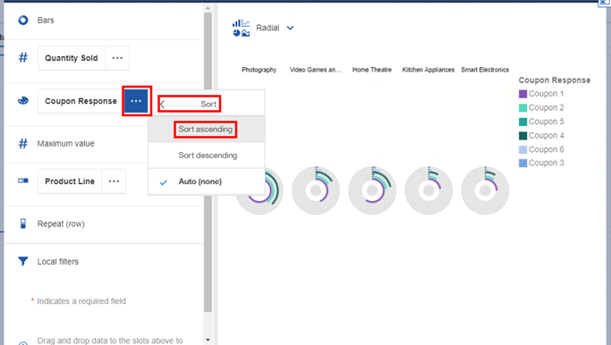

*The individual radial charts make it easy to see the coupon response by Product Line Departments.  Of the five product lines, Kitchen Appliances and Smart Electronics appear to have the lowest coupon redemption overall.  And, both have a significantly lower number of redemptions for Coupon programs 1 and 4.*

* 1. **Collapse** the visualization using the **Collapse** button image-20181216130426-15 in the upper right-hand corner of the widget.  This will close design mode and return the widget to the canvas.
  2. **Click** the arrow next to the **Save** icon on the dashboard toolbar.  **Click “Save As”**.  Navigate to **My Content**.  **Save** **as** **“[Lastname] Retail Dashboard.**

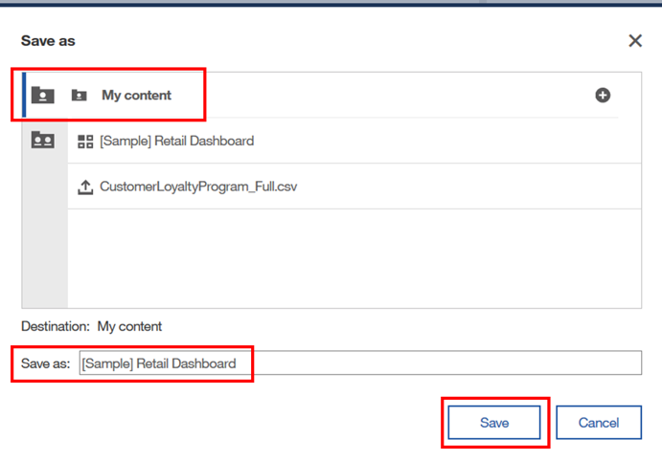

### Assembling a Dashboard

You’re off to a great start with your first visualization.  Next, you’ll continue to assemble content into the other three panels.  You’ll continue to assemble the dashboard by building visualizations that answer more of your questions regarding product line performance.

Continuing your analysis, you would like to measure the performance of Product Line Pricing, Revenues and Quantities Sold.

* 1. From the **Navigation Panel**, **Select Visualizations** image-20181216131535-1 to open the Visualizations library.
  2. **Select** the **Bubble** chartimage-20181216131535-2 and **drag** it to **panel 3** (lower left panel) of the dashboard template, **dropping** it in the **drop zone**so it will auto-fill to the size of the panel.
  3. Since you started by selecting a visualization this time, rather than by selecting data, the bubble chart visualization will open in **Design Mode** for you to setup the data definitions for your visualization.  **Open** the **Data Source** panel and **drag and drop** data items **into the data slots** as follows:
  + image-20181216131535-3X-axis:  **Quantity Sold**
  + image-20181216131535-4Y-axis:  **Unit Sales Price**
  + image-20181216131535-5Size:  **Revenue**
  + image-20181216131535-6Color:  **Product Line**

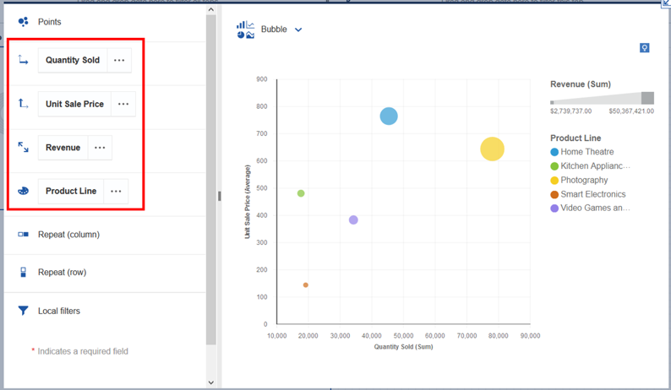

* 1. **Collapse**the visualization.
  2. The widget is returned to panel 3 on the dashboard template where you can easily see how the product lines are performing in comparison to one another.  To get additional detail for each product line, **hover** your mouse over the respective **bubble**.  Details of the underlying data measures for Quantity Sold, Average Unit Sales Price and Revenue will render.  **Hover over** the **largest bubble** and **smallest** **bubble** to render the additional information.

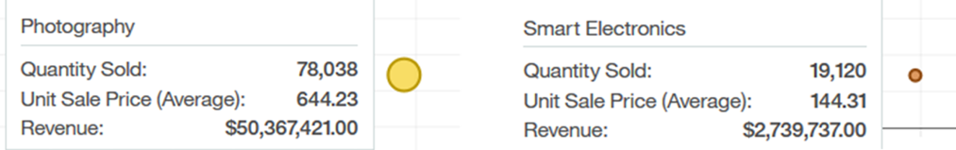

This visualization clearly indicates that Smart Electronics is the lowest performer of all product lines.  And, even though Smart Electronics and Kitchen Appliances have a similar amount of Quantity sold, Smart Electronics average sales price is significantly lower, generating less revenue contribution to the company.

* 1. **To close the details window, click outside of the widget.**

Next, you would also like to monitor Product Line sales by Loyalty Status.

* 1. From the **Navigation Panel**, **Select Visualizations** image-20181216131535-9 to open the Visualizations library.
  2. **Select** the **Packed** **Bubble** chart image-20181216131535-10 and **drag** it to **panel 2** (upper right panel) of the dashboard template, **dropping** it in the **drop zone** so it will auto-fill to the size of the panel.
  3. The Packed bubble chart visualization will open in **Design Mode** for you to setup the data definitions for your visualization.  **Open** the **Data Source** panel and **drag and drop** data items into the**data slots** as follows:
  + image-20181216131535-11**Bubbles:  Product Line**
  + image-20181216131535-12**Size:  Quantity Sold**
  + image-20181216131535-13**Color:  Loyalty Status**

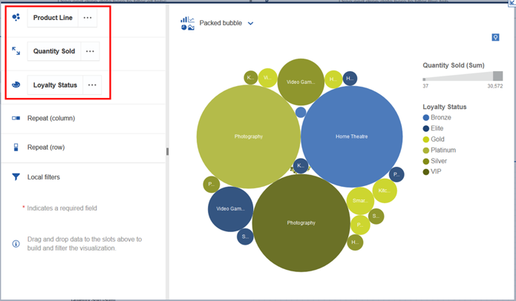

* 1. You can easily see how the product lines are performing within each of the Customer Loyalty tiers as the size of the bubble indicates the quantity sold, whereas color represents the Loyalty tier.
  2. From the **Navigation Panel**, **Select Visualizations** image-20181216131535-16 to open the Visualizations library.
  3. **Select** the **Stacked Column** chart image-20181216131535-17 and **drag** it to **panel 4** (lower right panel) of the dashboard template, **dropping**it in the **drop zone** so it will auto-fill to the size of the panel.
  4. The Stacked column chart visualization will open in **Design Mode** for you to setup the data definitions for your visualization.  **Open** the **Data Source** panel and **drag and drop** data items **into the data slots** as follows.
  + image-20181216131535-18**Bars:  Order Year**
  + image-20181216131535-19 **Length:  Quantity Sold**
  + image-20181216131535-20 **Color:  Product Line**

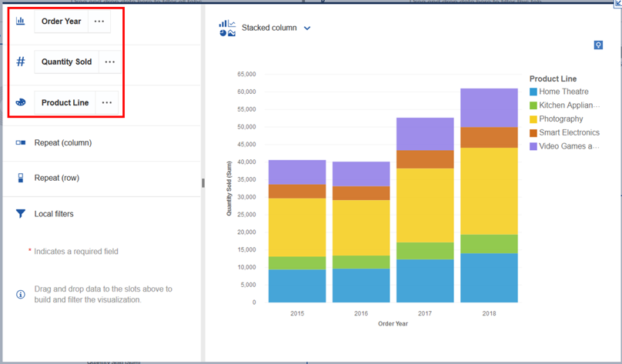

* 1. **Save** the Dashboard.

### Using the Assistant

**Assistant provides recommendations to help answer questions and quick insights. A user can have a specific question they are looking to answer but may not be as familiar with the dataset or exact data items they need to form the insight or visual they are seeking.**

**From within a dashboard or exploration, the User can type in English text to discover patterns and relationships in the data, as well as generate visualizations that can be added to an existing or new dashboard, exploration or story.  Enter text related to the Users analytical intentions and an AI conversational agent will respond with visualizations and other information to satisfy the request.**

* 1. From the Left **Navigation panel**, **click** **New** image-20181217125935-1 , then**Dashboard**.
  2. **Select** the “blank” template (has no panels) and **click OK**.

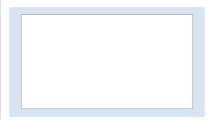

* 1. **Click**the**Assistant** image-20181217125935-3button to**Launch** the **Assistant**.­­

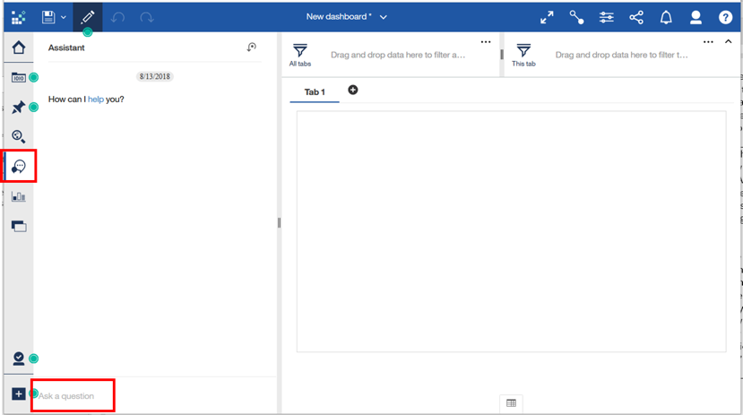

***TECH TIP:***  Your workshop instance may have more or fewer data sources setup, so you may see different suggestions, and some may be from other data sources in your instance.

* 1. For purposes of this workshop, you will direct the Assistant to focus on the data source you’ve been using.  In the **Ask a question** field at the bottom of the panel, type “**load source customer loyalty**” and click **Enter**.
  2. A list of data source matches render. **Select CustomerLoyaltyProgram_Full.csv** from **My Content**.

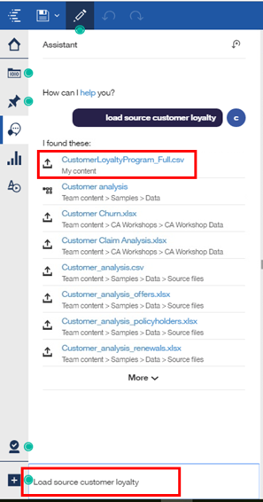

* 1. The Assistant will render a list of fields from the data source where it has identified relevant concepts that you may be interested in for your analysis.  For instance, it shows fields that have outliers in the data and recognizes fields which are identifiers, expenses, revenues and so on.

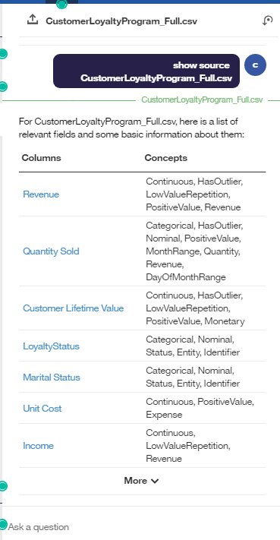

* 1. In the **Ask a question** field, **type** the question “**What is my revenue by product line?**”.  **Click Enter**.
  2. The Assistant will analyze the question and provide an Insight to answer the question with **best match**. Matching is done based on a full match of column names, partial column names and concept matching (e.g. Revenue vs Sales as these conceptually can be related and someone interested in revenue may also be interested in sales).  You can**use** the **left and right arrows** to view the collection of recommended visualizations to represent the results.

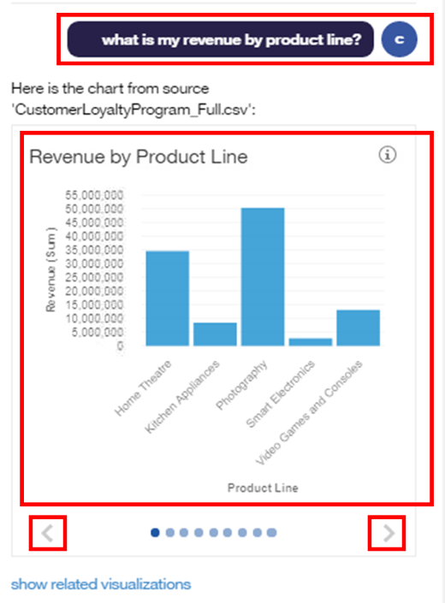

* 1. In the **Ask a question** field, **type** the question “**What is the quantity sold by product line and year?**”.  **Click Enter**.
  2. The Assistant will analyze the question and provide an Insight to answer the question with **best match**. Use the **left and right arrows** to view the collection of recommended visualizations to represent the results and select the one shown in section 5.11.

