Report Module Documentation
Melann Lending System V2 Modernization | Report Types, Advantages, Problems, and Limitations
Prepared: July 14, 2026 | Scope: current React/Node/SQLite modernization repo


1. Executive Summary
Ang Report Module ang pangunahing lugar para makita ng operations, accounting, at management ang collections, releases, loan maturity, reversals, fully paid accounts, disclosure statements, monitoring activity, at daily cash position. Sa modern system, ang report data ay nanggagaling sa SQLite tables sa backend routes, habang ang React UI ang nagpapakita ng summary, drilldown, print view, at export behavior.
- Current UI-supported report types: Collection, Releases, Loans Maturity Checker, Payments Reversed, Full Paid Loans, Collection Sheet, Disclosure Statement, Monitoring Summary.
- Separate Finance report: Daily Cash Report (DCR), dahil may sariling page, formulas, close workflow, and compliance handoff.
- Backend/README-supported but not visible in current Reports sidebar: Loan Type Summary and Payments Encoded.
- Main limitation: some report names and availability differ between README, backend routes, and current UI, so report inventory should be normalized before final production rollout.
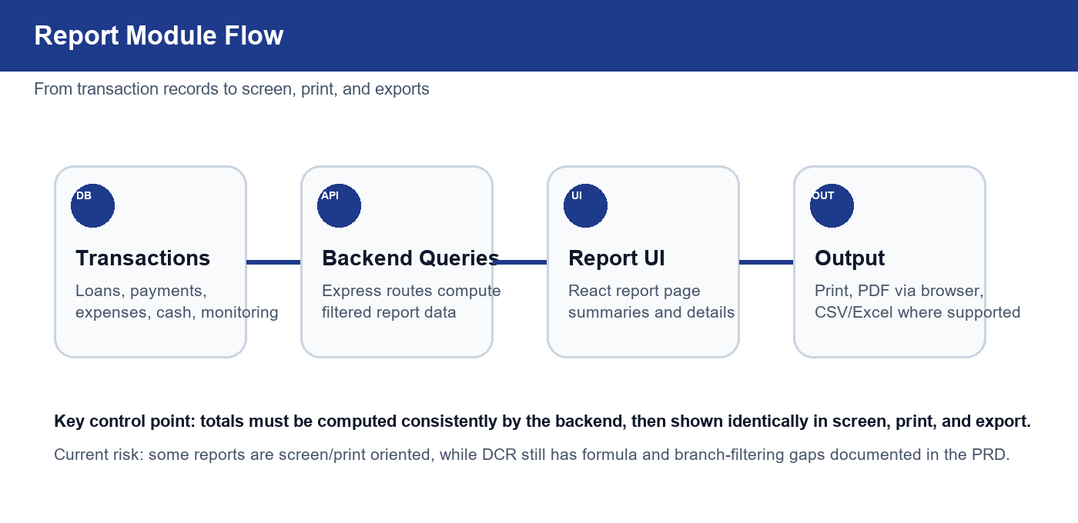

2. Report Module Purpose
Purpose ng module na gawing mabilis, auditable, at print-ready ang operational reporting. Hindi lang ito listahan ng records: ginagamit ito para mag-reconcile ng collections, i-monitor ang loan releases, makita ang risky or overdue accounts, at suportahan ang daily closing.
Area | Description
Operations | Collector performance, collection sheets, maturity monitoring, and release production.
Accounting | Collection totals, reversed payments, DCR cash on hand/bank reconciliation, and expense visibility.
Management | Exception review, monitoring summary, full paid accounts, and audit trail support.
Compliance / Client-facing | Disclosure statement and DCR loan-release checklist handoff to government-compliance workflows.

3. Types of Reports
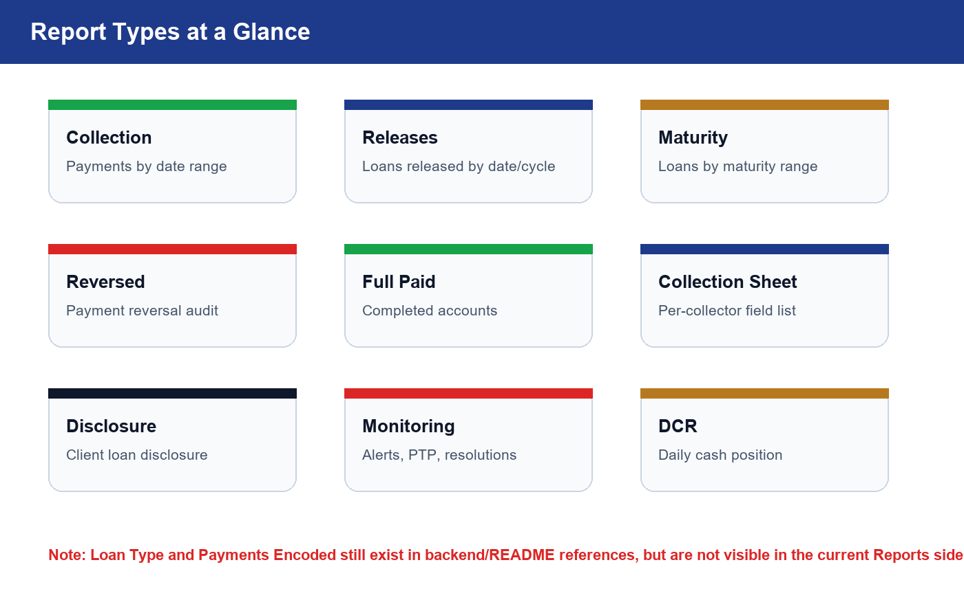
Below are the report types with practical usage notes. The first nine are the current user-facing or finance-facing reports. The last two are documented/backend-supported candidates that need a UI decision.

3.1 Collection Report
Item | Details
Description | Daily and monthly collection view showing active payments by date range, grouped by collector with summary and drilldown detail.
Advantage | Fast cash collection review; supports daily and monthly cycle views; useful for collector accountability.
Problems / Limitations | Relies on active payment status and correct collector assignment; browser print is the main PDF path; branch filtering is not clearly enforced in all current report endpoints.

3.2 Releases Report
Item | Details
Description | Daily and monthly loan-release report showing released loans, principal totals, collectors, and loan type split such as new, re-loan, or recon.
Advantage | Good for release monitoring, cash-out tracking, and collector production review.
Problems / Limitations | Some totals use principal while DCR should prefer net proceeds for cash outflow; current UI name says Releases but README still calls this Monthly Releases.

3.3 Loans Maturity Checker / Past Due
Item | Details
Description | Lists loans by maturity date range and highlights accounts with remaining balance that are active or past due.
Advantage | Helps collectors and managers focus on accounts maturing or already overdue.
Problems / Limitations | Name differs across docs: Past Due Report vs Loans Maturity Checker; days overdue calculation depends on maturity date quality and current date.

3.4 Payments Reversed
Item | Details
Description | Audit report for payments marked reversed, including amount, customer, loan, collector, reversed user, and reason.
Advantage | Supports management review of exceptions and helps detect improper reversals.
Problems / Limitations | Only as reliable as reversal reason and reversed_at encoding; does not replace a formal approval workflow by itself.

3.5 Full Paid Loans
Item | Details
Description | Completed loan-account report based on loans with fullpaid status and optional date range.
Advantage | Useful for re-loan targeting, completion metrics, and customer lifecycle review.
Problems / Limitations | Depends on consistent loan status updates; may miss old legacy statuses if mapping is incomplete.

3.6 Collection Sheet
Item | Details
Description | Printable per-collector active loan list with amortization, balance, maturity, and collected-today fields.
Advantage | Strong field-operations tool; provides a ready list for collectors and signatures.
Problems / Limitations | Requires collector selection; page density can be high; not a management summary by default.

3.7 Disclosure Statement
Item | Details
Description | Client-specific loan disclosure generated by search or selected loan, with borrower details, loan terms, and schedule.
Advantage | Improves transparency and standardizes client-facing loan information.
Problems / Limitations | Requires accurate customer profile, loan terms, and amortization schedule; search must choose the correct loan when several exist.

3.8 Monitoring Summary
Item | Details
Description | Operational monitoring report for alerts, escalated accounts, promises to pay, follow-up logs, and resolutions.
Advantage | Gives management a high-level view of collection-risk activity beyond ordinary payment reports.
Problems / Limitations | Backend comment says 10 reports required, but current endpoint returns summary metrics; full report definitions may still need product decisions.

3.9 Daily Cash Report
Item | Details
Description | Separate Finance report summarizing selected-date releases, expenses, collections, bank movement, cash on hand, and cash position.
Advantage | Best daily closing and accounting reconciliation report; supports print, CSV/Excel export, and compliance handoff checklist.
Problems / Limitations | PRD identifies unresolved gaps: branch filtering, bank formulas, server-side close totals, DCR numbering, and exact legacy parity.

3.10 Loan Type Summary
Item | Details
Description | Backend/README-supported report concept for breaking down releases or portfolio by loan type/status.
Advantage | Useful for product mix and risk segmentation.
Problems / Limitations | Not currently visible in the Reports sidebar; needs UI decision before presenting as a primary report type.

3.11 Payments Encoded
Item | Details
Description | Backend/README-supported report for payments encoded within a date range and encoded-by user.
Advantage | Useful for teller/accounting productivity and audit reconciliation.
Problems / Limitations | Not currently visible in the Reports sidebar; overlaps with Collection Report unless positioned as audit-specific.

4. Daily Cash Report Focus
Ang DCR ay mas accounting-critical kaysa ordinary list report dahil may formulas, cash-on-hand/cash-on-bank logic, day closing, variance, and transaction tagging. Dapat backend ang source of truth para hindi magkaiba ang screen, print, CSV/Excel, at persisted close totals.
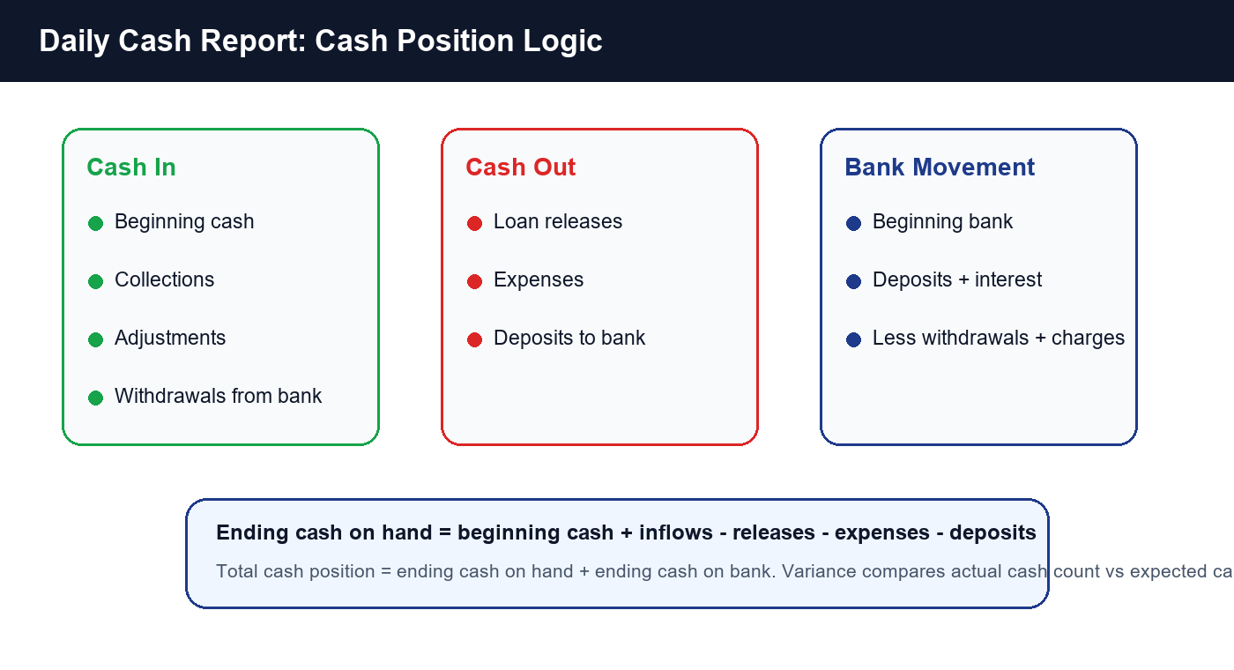
DCR Section | Purpose
Loan Releases | Cash-out review for selected date, including customer, collector, loan type, and amount.
Expenses | Daily operating cash outflows.
Adjustments | Manual cash corrections that should be auditable.
Collections by Collector | Cash inflows from payments, passbooks, penalties, and related collector amounts.
Withdrawal / Deposit | Transfers between bank and cash on hand.
Bank Charges / Interest | Cash-on-bank movements that affect ending bank balance.
Cash Summary | Beginning cash, inflows, outflows, expected ending cash, ending bank, and total cash position.
Signatures | Prepared, checked, and approved accountability area for print output.

5. Cross-Cutting Advantages
- Centralized report access for users with report permission across Admin, Manager, Teller, and Accounting roles.
- Print-friendly browser output hides navigation and controls for cleaner hard copy.
- Collector-level grouping helps accountability and day-to-day branch operations.
- DCR adds accounting reconciliation, not just transaction listing.
- Monitoring Summary connects collection risk activity to follow-up and promise-to-pay data.

6. Cross-Cutting Problems and Limitations
- Report inventory mismatch: README says 9 types, Reports UI shows 8 sidebar types, DCR is separate, while backend exposes additional endpoints.
- Some reports depend on status mapping from legacy data; inconsistent statuses can hide or overcount accounts.
- Browser print/PDF is practical, but not the same as a controlled server-generated PDF renderer.
- Branch filtering is a known risk, especially for DCR and reports that join loans/payments/expenses.
- DCR PRD identifies current gaps around bank formulas, backend recomputation on close, unique branch/date close rules, and exact legacy report parity.
- Very dense reports such as Collection Sheet can become hard to read unless page breaks and print layout are carefully tested.

7. Recommended Next Steps
Priority | Recommendation | Reason
High | Normalize report inventory and labels across README, UI, and backend routes. | Prevents user confusion and missing/duplicate report expectations.
High | Make backend formula services the source of truth for DCR and reusable totals. | Ensures screen, print, export, and close records match.
High | Add branch-aware filters and tests for reports that affect cash or collector accountability. | Avoids cross-branch totals and audit disputes.
Medium | Decide whether Loan Type Summary and Payments Encoded should return to the UI. | They exist in docs/backend but are not current sidebar items.
Medium | Add controlled PDF/export generation for critical reports. | Improves consistency beyond browser print behavior.

8. Source Basis
This document is based on repository inspection of:
- README.md report inventory and role permissions.
- CODEBASE_PRD.md legacy reporting inventory.
- DCR_MODULE_PRD.md DCR behavior, formulas, and known gaps.
- server/src/routes/reports.js and server/src/routes/dcr.js API behavior.
- client/src/pages/Reports.jsx and client/src/pages/DailyCashReport.jsx current UI behavior.

