

**Generative AI Lab**

**Assignment 2 - SWOT Analysis Generator**

Submitted by -

Likhita M

(FT253048)

**Problem Statement:**

Businesses often struggle with conducting comprehensive SWOT analyses due to **time constraints, bias, and lack of structured insights**. Traditional methods rely heavily on manual research, expert opinions, and subjective assessments, which can be inconsistent.

This project aims to automate and streamline the SWOT analysis process using AI-driven natural language generation (NLG) or LLMs, ensuring accuracy, objectivity, and speed. By inputting key organizational details, users can instantly receive data-driven, strategic recommendations, reducing manual effort and enhancing decision-making capabilities.

**Objective:**

To develop an ***LLM-based*** **SWOT Analysis Generator**, enabling businesses to generate detailed and strategic SWOT (Strengths, Weaknesses, Opportunities, and Threats) analyses efficiently.

The tool aims to assist organizations in making informed decisions by providing AI-driven insights based on user-provided business context.



**Technical Specifications**

The project has below technical specifications with respect to the versioning of the libraries.

* Streamlit - 1.43.0
* LangChain - 0.3.20
* Gemini (google-genai) - 1.5.0
* Python - 3.12.6

*Note:* The project uses an API_KEY / API_TOKEN (token) generated from Google AI Studio to access the Google GenAI API. The token needs to be stored in a vault or as a secret while deploying the code, based on the deployment platform.

**Prompt Template used for the Agent**

**System Prompt**: You are a subject matter expert and a strategic business consultant with expertise in corporate strategy and market analysis. Your task is to perform a comprehensive SWOT analysis for {organization_name} based on the following context in a formal tone: {context}.

**User Prompt**: Ensure each point is accurately described with a precise description. Stick closely to the given context without adding generic information. Use bullet points for clarity, with each Strength, Weakness, Opportunity, and Threat accompanied by a precise description (1-2 lines) following the point. Provide 3 real-world examples of companies or cases that have faced similar situations, explaining how their SWOT analysis aligns with this case. Provide a 3 liner conclusion indicating the heading. Please keep a formal tone throughout the response.

**Assistant Prompt**: Example Response -

SWOT Analysis for Tesla

Strengths

* Strong Brand Equity – Tesla is a globally recognized leader in electric vehicles (EVs), with a reputation for innovation and cutting-edge technology, attracting strong customer loyalty.
* Technological Leadership – Tesla’s proprietary battery technology and self-driving software give it a competitive advantage in vehicle range, efficiency, and autonomous driving.
* Vertical Integration and Supply Chain Control – Tesla’s ownership of key components like battery manufacturing (Gigafactories) and charging infrastructure (Superchargers) ensures cost control and faster innovation.
* Financial Strength and Market Leadership – Tesla’s high market valuation and profitability provide capital for R&D, production scaling, and global expansion.

Weaknesses

* Production and Delivery Bottlenecks – Tesla has faced delays due to supply chain disruptions, semiconductor shortages, and production line inefficiencies.
* High Production Costs – The costs of lithium, cobalt, and nickel, along with advanced battery technology, increase manufacturing expenses and reduce profit margins.
* Quality Control Issues – Reports of inconsistent product quality (e.g., panel gaps, paint defects) and software malfunctions have affected customer satisfaction.
* Over-reliance on Elon Musk’s Leadership – Strategic decisions and public statements by Elon Musk have led to stock volatility and reputational risks.

Opportunities

* Growing EV Market in Emerging Economies – Expanding into India and Southeast Asia, where EV adoption is rising due to government incentives, could drive revenue growth.
* Expansion into Renewable Energy – Tesla’s solar panels and energy storage solutions (Powerwall, Megapack) align with the global shift toward sustainable energy.
* Advancement in Autonomous Driving – Enhancing Full Self-Driving (FSD) capabilities and licensing the technology to other manufacturers could create new revenue streams.
* Strategic Partnerships and Collaboration – Partnering with governments and infrastructure providers could improve charging infrastructure and increase adoption rates.

Threats

* Intensifying Competition – Legacy automakers (e.g., Volkswagen, Ford) and Chinese manufacturers (e.g., BYD) are launching competitive EVs with lower costs and advanced features.
* Regulatory and Legal Risks – Changes in emissions regulations, autonomous driving laws, and trade tariffs could increase costs and restrict market access.
* Economic Downturns – Inflation and rising interest rates could reduce consumer demand for premium-priced electric vehicles.
* Cybersecurity and Data Privacy Risks – Increasing reliance on connected vehicles exposes Tesla to data breaches and regulatory scrutiny over customer data handling.

Comparable Real-World Cases

Apple Inc.

* Strength: Apple’s vertical integration and proprietary technology (e.g., A-series chips) give it control over product quality and supply chain efficiency, similar to Tesla's control over battery production and software.
* Weakness: Overdependence on CEO leadership (Steve Jobs, Tim Cook) reflects Tesla’s vulnerability to Elon Musk’s strategic decisions.
* Opportunity: Apple’s expansion into wearable technology mirrors Tesla’s move into renewable energy solutions.
* Threat: Regulatory pressure and competition from Android-based manufacturers align with Tesla’s competitive landscape.

Toyota

* Strength: Toyota’s dominance in hybrid technology mirrors Tesla’s leadership in EVs.
* Weakness: Toyota faced production delays during the semiconductor shortage, similar to Tesla’s supply chain issues.
* Opportunity: Toyota’s shift toward electric and hydrogen vehicles parallels Tesla’s push for sustainable energy solutions.
* Threat: Rising competition from Chinese manufacturers affects both Tesla and Toyota’s global market share.

Netflix

* Strength: Netflix’s first-mover advantage in streaming reflects Tesla’s leadership in EV technology.
* Weakness: Content production costs affect Netflix’s profitability, similar to Tesla’s high production expenses for batteries and EV components.
* Opportunity: Global expansion into untapped markets aligns with Tesla’s strategy to enter developing economies.
* Threat: Competition from Disney+ and Amazon Prime parallels Tesla’s market pressure from legacy automakers and new EV entrants.

Conclusion:

Tesla’s technological and market leadership gives it a competitive advantage, but operational challenges and competitive pressures pose significant risks. Strategic expansion into renewable energy and emerging markets could drive future growth, provided Tesla addresses its quality and production weaknesses.

**Streamlit User Interface**

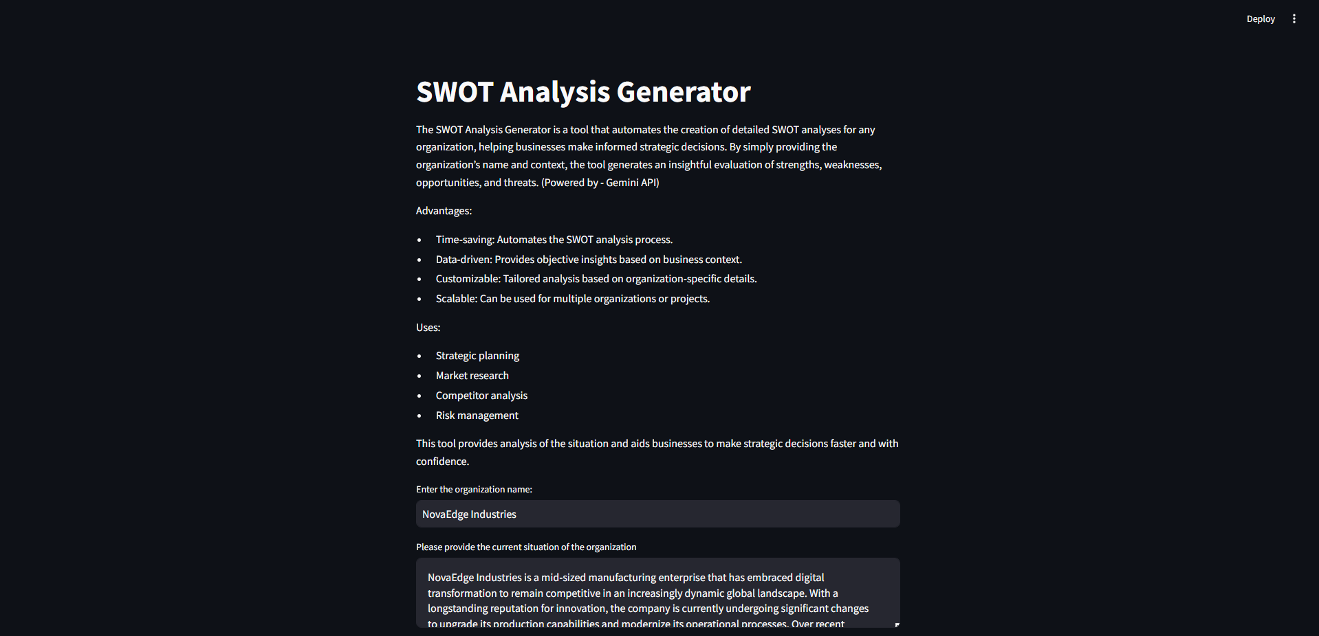

Inputs to be provided

* Organization Name
* Context of the organization describing its current situation; provide detailed explanation

**AI - Agent Response - SWOT Analysis for Organization**



**SWOT Analysis for NovaEdge Industries**

**Strengths**

* **Long-standing Reputation for Innovation:** NovaEdge possesses a recognized history of innovative practices within the manufacturing sector, fostering customer trust and market credibility.
* **Proactive Digital Transformation:** The integration of automation, AI-powered quality control, IoT-based monitoring, and predictive maintenance systems provides a competitive edge and positions the company for operational improvements.
* **Skilled Workforce Blend:** The combination of seasoned engineers and digitally adept new recruits ensures a balance of deep industry knowledge and modern technological capabilities.
* **Adaptable Workforce Policies:** The implementation of remote and hybrid work models, coupled with continuous learning programs, enhances employee satisfaction and talent retention.

**Weaknesses**

* **Reliance on Legacy Systems:** The ongoing integration challenges posed by outdated legacy systems hinder operational efficiency and digital synergy.
* **Communication Challenges:** The rapid expansion and hybrid work model have introduced communication bottlenecks, impacting internal collaboration and information flow.
* **Limited R&D Scale Compared to Competitors:** Despite commendable R&D efforts, NovaEdge’s scale lags behind larger rivals, potentially limiting the scope of digital innovation.
* **Intensified Competition for Top Talent:** Flexible work policies, while beneficial, have heightened competition for talent, especially against competitors offering more advanced digital work environments.

**Opportunities**

* **Tech-Enabled Market Expansion:** Leveraging digitized production capabilities to enter new international markets and establish strategic partnerships.
* **Strategic Collaborations:** Forming partnerships with tech startups and academic institutions to accelerate innovation and the development of advanced manufacturing solutions.
* **Diversified Supplier Network:** Broadening the supplier base to mitigate risks associated with geopolitical instability and regulatory changes, ensuring supply chain resilience.

**Threats**

* **Aggressive Competition from Tech-Forward Rivals:** Competitors aggressively adopting emerging technologies like AI-Agents set new benchmarks for efficiency and innovation, increasing market pressure.
* **Geopolitical Tensions and Regulatory Shifts:** Changes in international trade regulations and political instability introduce cost uncertainties and potential supply chain disruptions.
* **Rapid Technological Advancements:** The dynamic nature of the market requires constant adaptation to keep up with emerging technologies which may cause instability.

**Comparable Real-World Cases**

**Siemens**

* **Strength:** Siemens' strong focus on digitalization and industrial automation positions it as a leader in Industry 4.0, aligning with NovaEdge's digital transformation.
* **Weakness:** Siemens faces challenges integrating acquired companies and their legacy systems, similar to NovaEdge's integration issues with outdated systems.
* **Opportunity:** Siemens expands into new markets through strategic partnerships, mirroring NovaEdge's plans to leverage tech-enabled production for international growth.
* **Threat:** Siemens faces competition from agile startups and tech companies that innovate at a faster pace, mirroring NovaEdge's competitive pressures.

**General Electric (GE)**

* **Strength:** GE's historical reputation for innovation in industrial manufacturing aligns with NovaEdge's long-standing commitment to innovative practices.
* **Weakness:** GE faced significant challenges integrating digital initiatives with legacy operations, reflecting NovaEdge's ongoing integration hurdles.
* **Opportunity:** GE's ventures into renewable energy and digital services parallel NovaEdge's ambition to expand through tech-enabled solutions.
* **Threat:** GE's financial struggles and restructuring due to market competition highlight the risks NovaEdge faces from aggressive market strategies of rivals.

**Schneider Electric**

* **Strength:** Schneider Electric's focus on energy management and automation solutions positions it well in the digital transformation landscape, similar to NovaEdge.
* **Weakness:** Schneider Electric, like many large organizations, deals with communication silos that impede internal collaboration. NovaEdge also faces communication challenges with its hybrid work model.
* **Opportunity:** Schneider Electric focuses on sustainability and energy efficiency, providing a path to leverage existing technical resources for a good cause.
* **Threat:** Like NovaEdge, Schneider Electric is also concerned about cyber security and data privacy risks since technology adoption is necessary.

**Conclusion:**

NovaEdge Industries demonstrates strong foundational strengths in innovation, digital transformation, and workforce adaptability, providing a solid basis for future success. However, strategic priorities must include overcoming integration challenges with legacy systems, addressing internal communication issues, and increasing R&D scale. By capitalizing on market expansion opportunities and mitigating threats from aggressive competition and geopolitical instability, NovaEdge can achieve sustainable growth and maintain its competitive edge.