**2048_Project increment2 (group 10)**

Jagadish Tirumalasetty

Murali Krishna Kalvakuri

Prudhvi Nalluri

Sowmya Kamaraju

* First Increment: June 20 (F)
* Second Increment: June 30 (M)
* Third Increment: July 11 (F)
* Fourth Increment: July 21 (M)
* Project Video: July 25 (F)
* Project Presentation: July 29 (T) & July 31 (Th)

**Introduction**

The primary goal of our project is to extend the existing 2048 game which is a touch based game app and implement the same as a gesture based game app. The game uses the gyroscope sensors on the user’s smartphones to recognize the direction in which the user wants to add up the numbers to achieve the target of 2048.

The game would record all the user moves and the plan with which the user tries to solve the 2048 and would calculate the predictability of the user moves and the risk taking factor of the user.

**Project goal and Objective**

The main objective is drawing a sketch of the user mentality on how does he/she treats a problem. How safe sided is the approach taken or how conventional is the problem solving technique. In order to do this we use the motion sensor and build a 2048 android application using the large amount of data generated by the motion sensor i.e., sensor tag and use the data provided by the motion sensor to decide the mood of the player who is playing i.e., he is upset or calm. The game would give out a report with all these calculations of the predictability of user’s move on the basis of previous move.

For this to achieve we first have to train our system by taking different sample players and ask them to play the game and try to solve it completely. This would be primary data for our machine learning algorithm. We plan on training the system with at least 10-20 players playing the game at least 5-10 times to capture as many possible cases in between the game that different people could take different ways around it.

On top of this data we would define a set of rules and trends to define a person’s mentality depending on the stage at which the player is making the move. We are considering the level as well in which the move is being made cause in the earlier stages of the game it is quite simple to add up the numbers and the plan of any player would show his own mark when compare to others from a particular stage of the game.

**Project Background and related work**

* 2048 (open source android game)
* Sensor tag (Open source Android application)

**Proposed System:**

* Our Project mainly focusses on usage of 2048 android application.
* The data obtained from training will be stored in the Hbase (solr).
* Sensor tag is used as a motion sensor to play the game.
* Sensor tag will generate the data about the moves made by user.
* Mahout will be used to provide the Players mood by analyzing the recommendations from the trained data.
* Web services will be used to display the relevant information obtained from solr.

**Technological and Architectural requirements**

● Cloudera Virtual Machine and Hadoop tools

● Hadoop

● HBase

● Mahout

● Solr

● Solr’s RESTful services

● Android Developers Tools

**Architecture diagram**

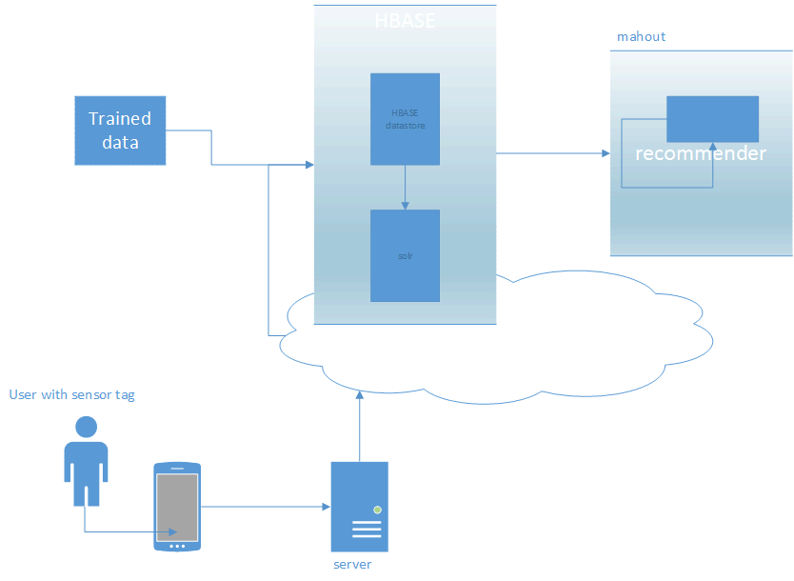

**Github**

<https://github.com/mlikk/BigDATA/tree/master/Project_2048/Project%20increment2>

**Bibliography**

<http://processors.wiki.ti.com/index.php/SensorTag_User_Guide>

<http://en.wikipedia.org/wiki/2048(video_game)>

<https://github.com/uberspot/2048-android>

<https://play.google.com/store/apps/details?id=com.digiplex.game>