**CLOUDERA INSTALLATION AND WORD COUNT EXECUTION**

I have installed VMware and installed cloudera and then I have downloaded the wordcount example and executed the wordcount example I have gone through the code of wordcount and got a good understanding of the mapreduce program.

Setup for cloudera

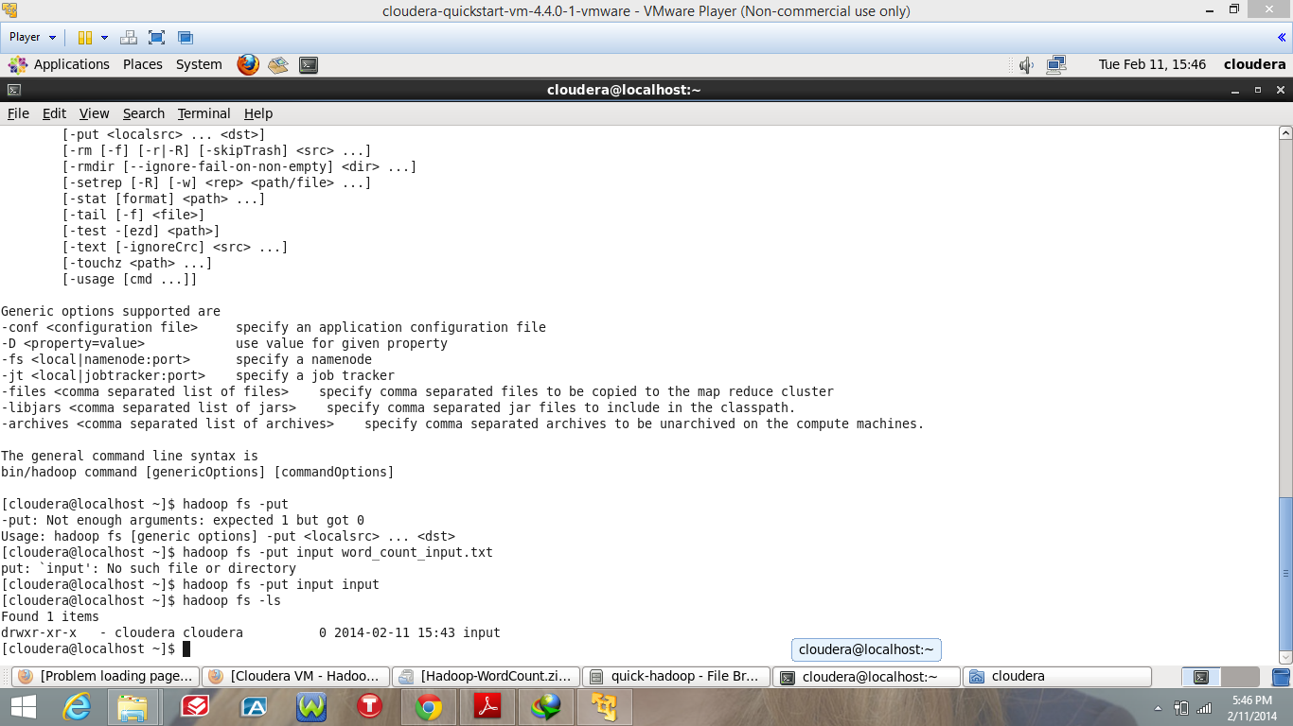

Setup for cloudera

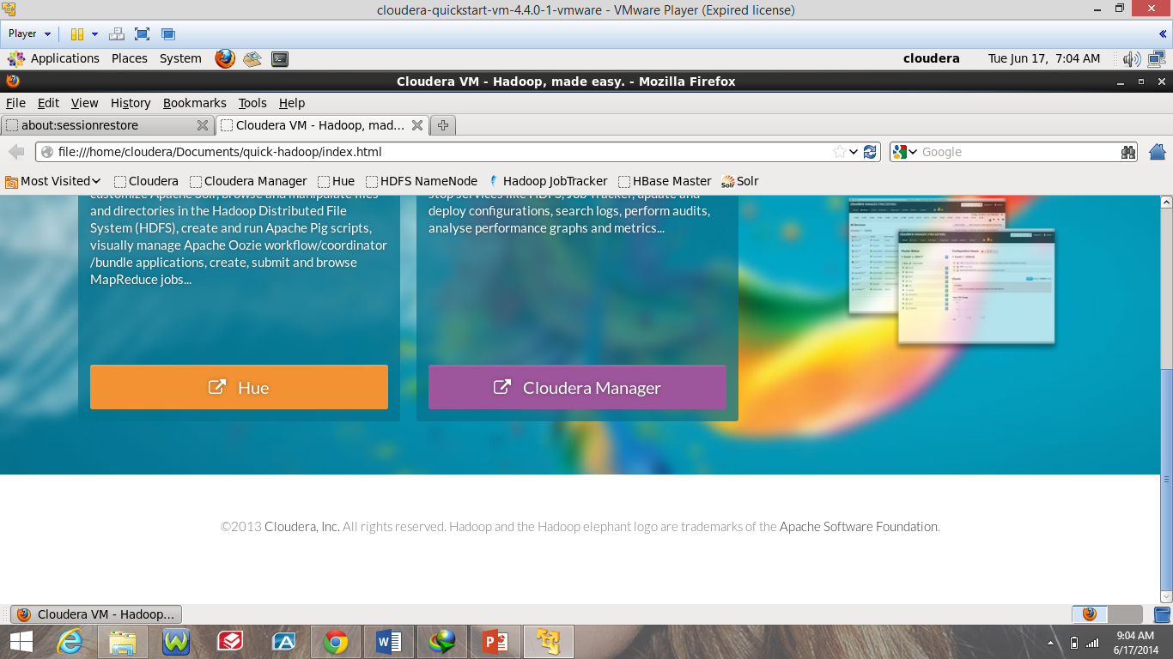

Setup for cloudera

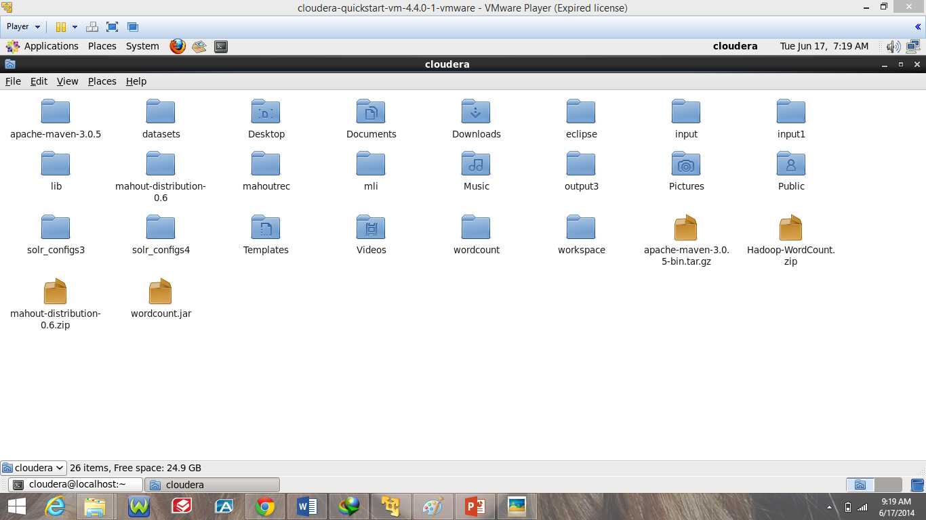

Cloudera WordCount example execution

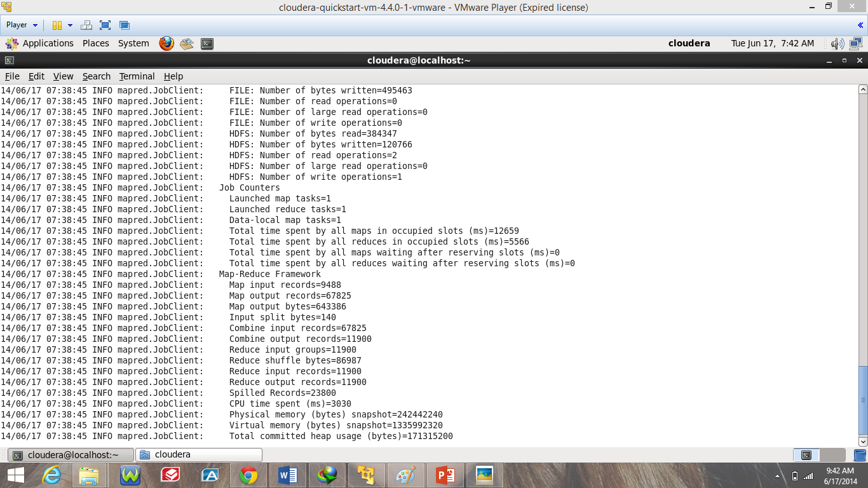

Cloudera WordCount OUTPUT

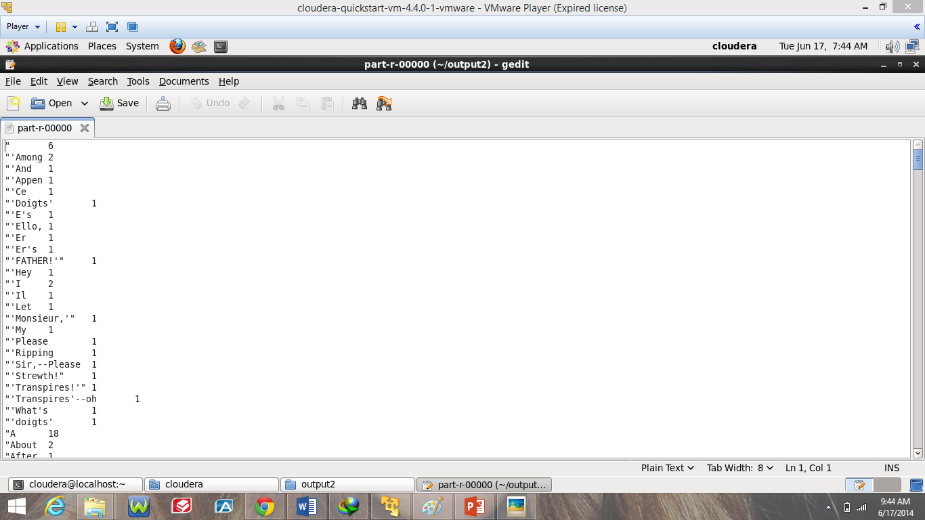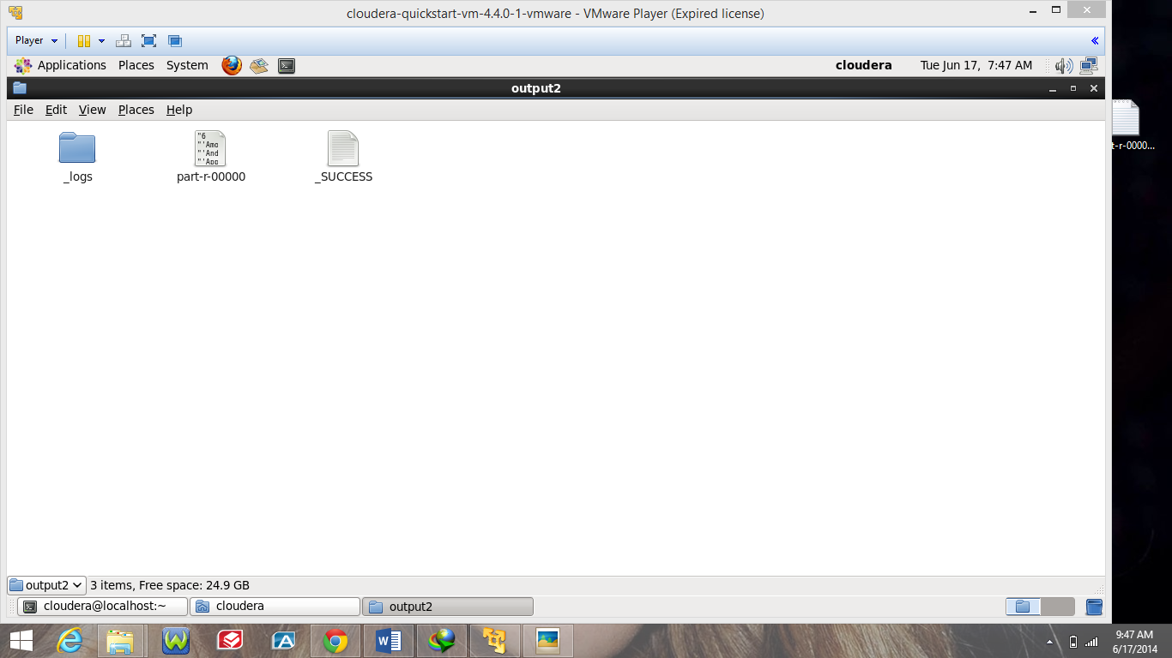

GITHUB <URL:->

<https://github.com/mlikk/BigDATA/tree/master/lab1>

Scrumdo Username:- mkkzr6