**Sensor tag applications**

I was successful in collecting the accelerometer, humidity, time and gyroscope data from sensor tag. I have modified connectionService.java of app1-sensortag project by enabling the humidity, accelerometer and gyroscope sensors. I have modified the oncharacterstic_read, oncharatersticchaged methods by adding the conditions required for enabling the accelerometer, humidity and gyroscope sensors. I was able to retrieve data from sensor tag by using the update accelerometer cals in which I called the data extraction methods of sensortagdata.java. I also modified extractgyroscope_reading of sensortagdata.java.

values = SensorTagData.*extractAccelerometerReading*(characteristic, 0);

Log.*i*("values", "x :"+values[0].toString() "y:"+values[1].toString() +"z:"+values[2].toString());

gyroData = SensorTagData.*extractGyroscopeReading*(characteristic,0);

Log.*i*("gyroData","gyro" + "x :"+gyroData[0].toString() + "y:"+ gyroData[1].toString() +"z:"+gyroData[2].toString());

humidity= SensorTagData.*extractHumidity*(characteristic);

Log.*i*("Humidity","humidity" + String.*valueOf*(humidity));

Date d = **new** Date();

**HbaseStart.java**

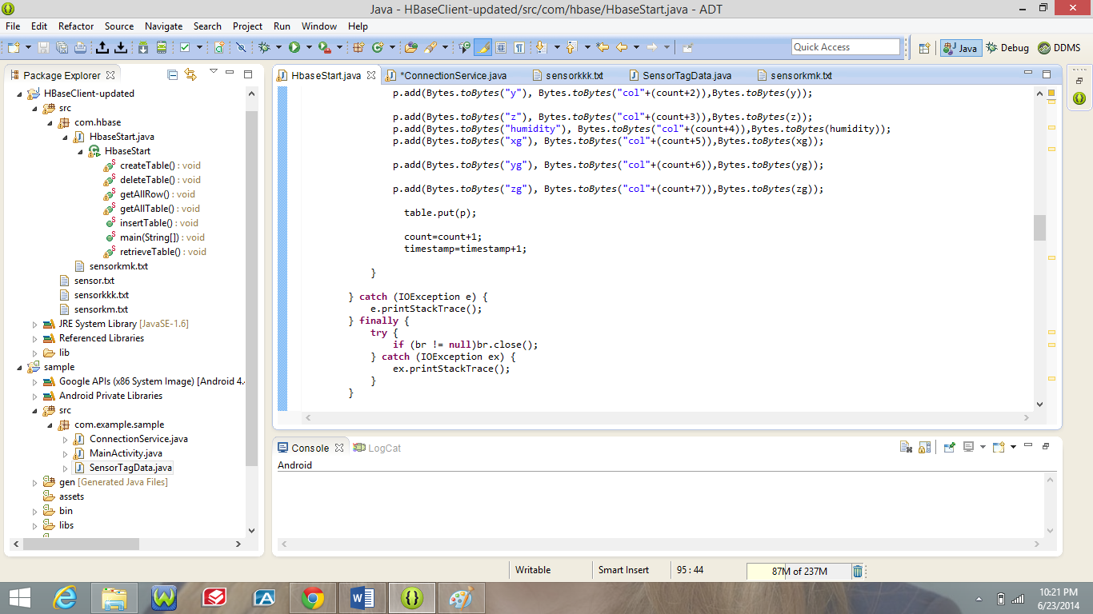

I stored the data to hbase by logging into university VPN. I modified the Hbasestart.java of hbase_client project by adding modifying the createtable, inserttable, retrievetable method to store the data generated from sensor tag.

**Connectionservice.java**

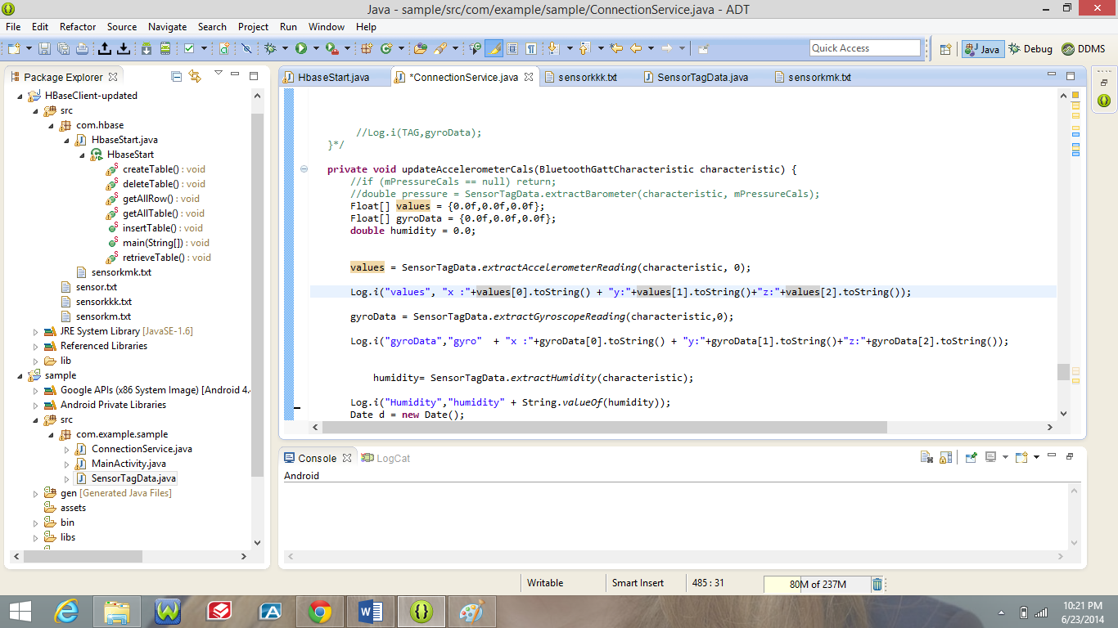

**Data from sensor tag**

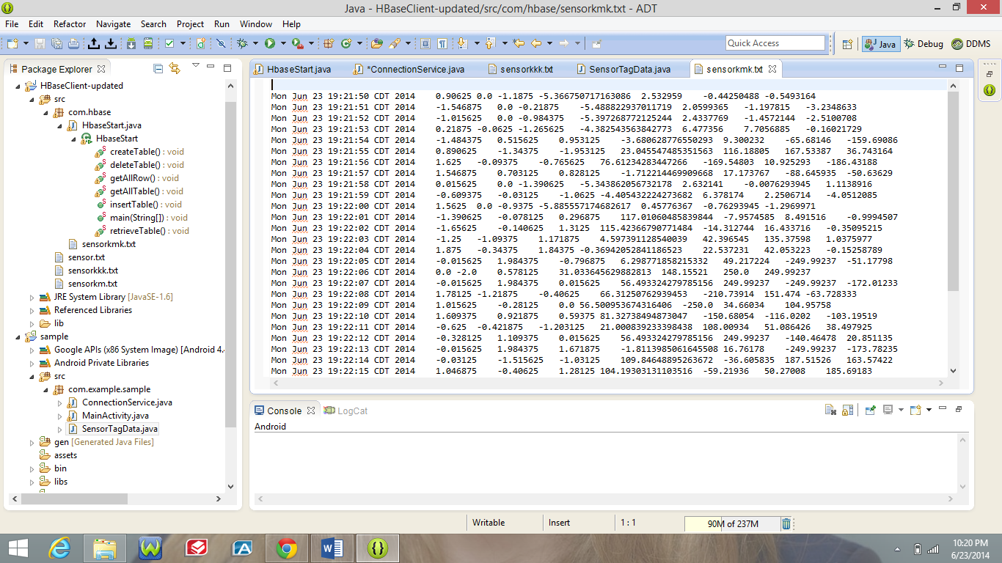

Data stored into Hbase

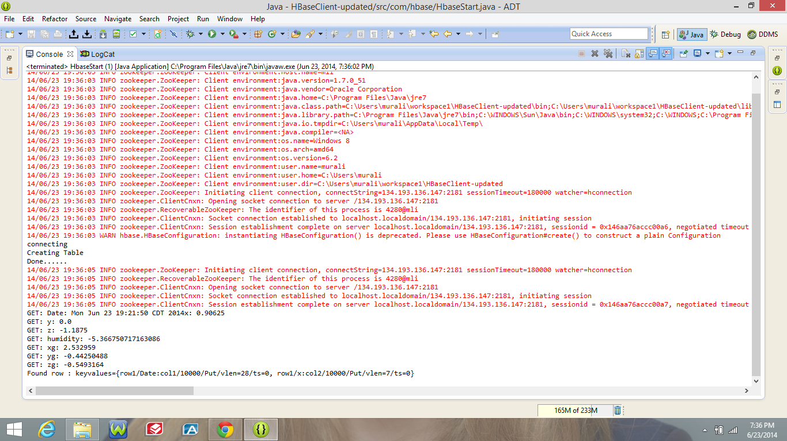

Hbase table

