**Used**: weather api and google maps api

I Created a web page KC radio which contains FM, KC concerts and events ,KC weather, Loaction and also embedded video in FM page.

I have already given city name and country code. Using Weather Underground API ,HTTP request is submitted to server and response is generated in JSON.JSON response is parsed to display current temperature and details.

<http://jsfiddle.net/mlikk/J77Lp/18/> JSfiddle link

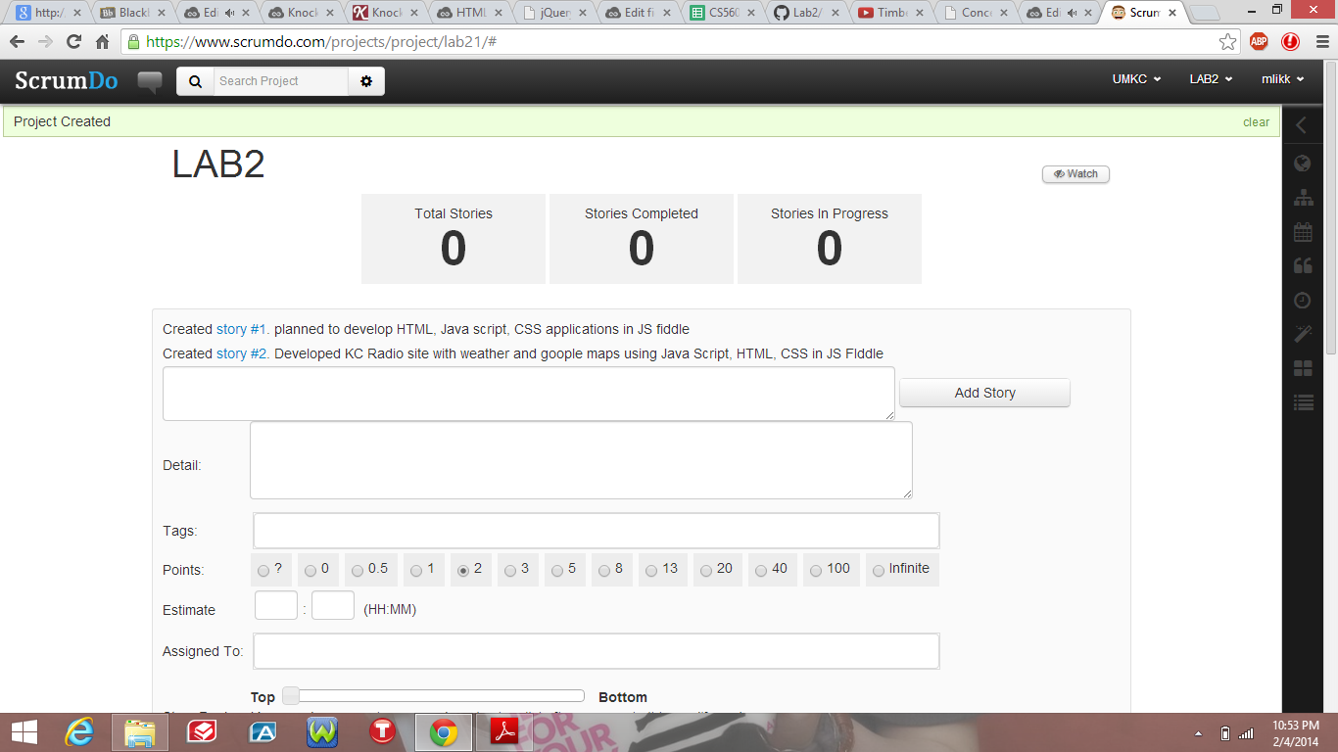

1.Added stories to Scrumdo

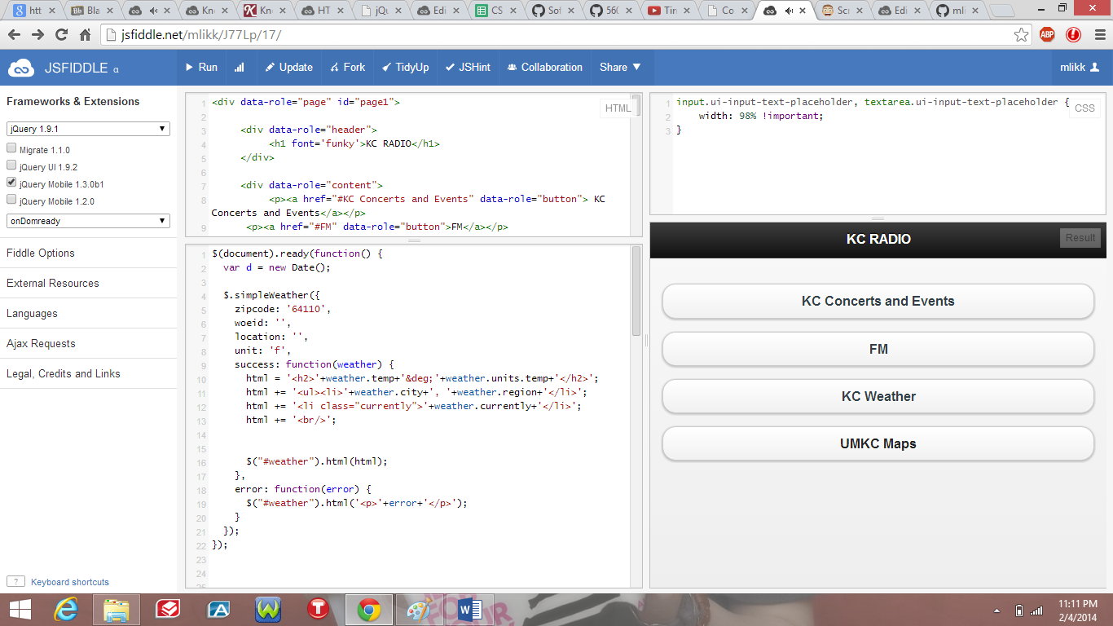

2.KC Radio webpage using html, javascript and css

3.KC concerts and events page

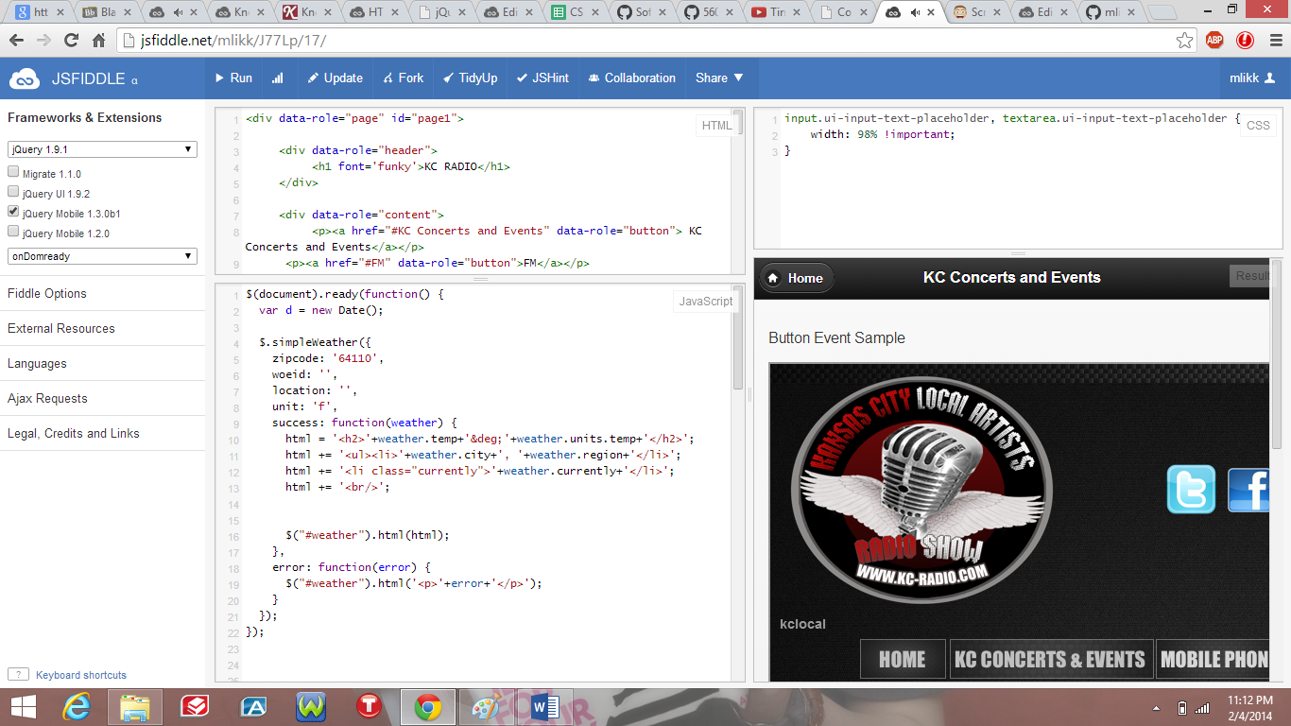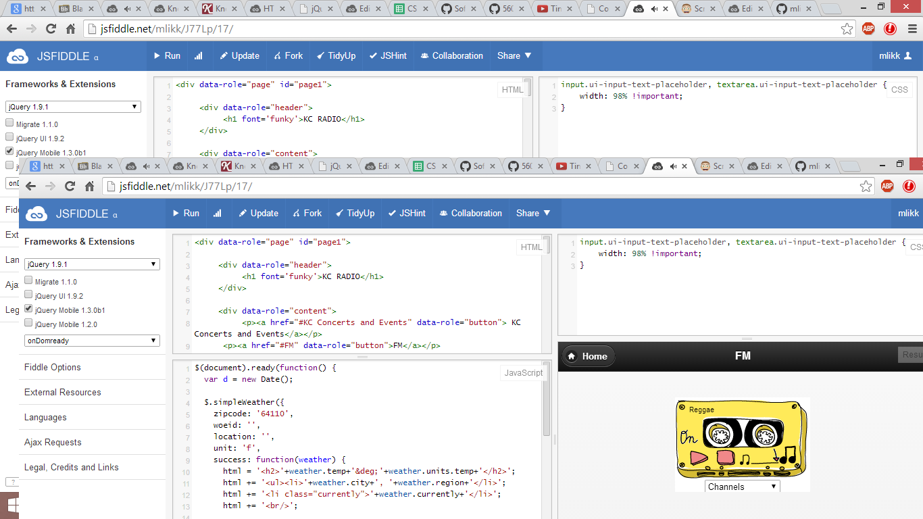

4.FM page

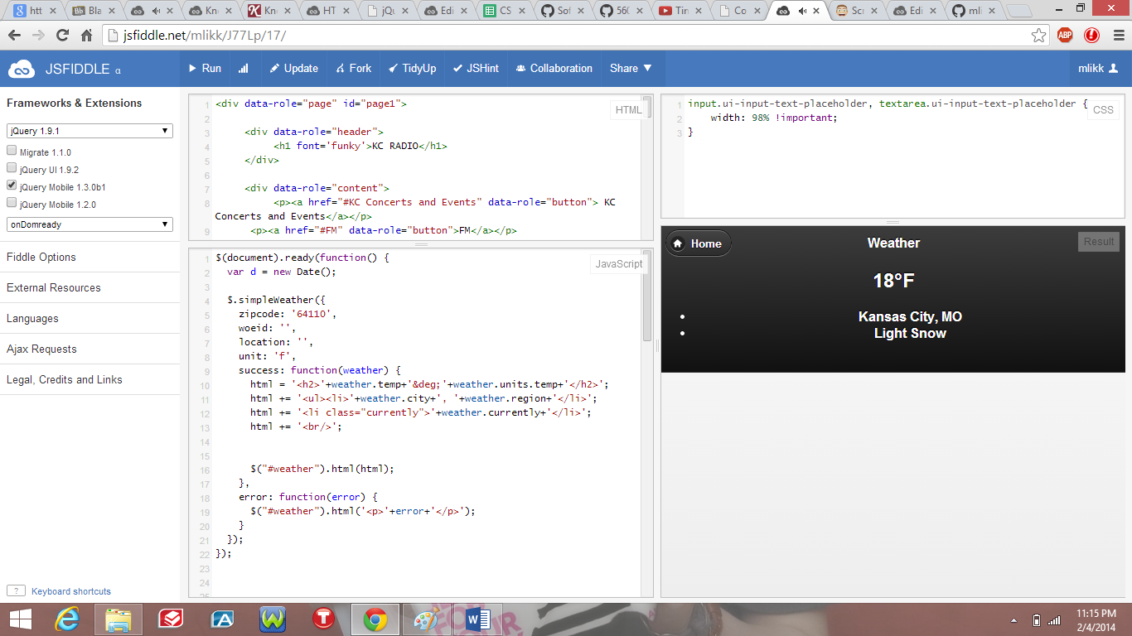

5.KC weather page

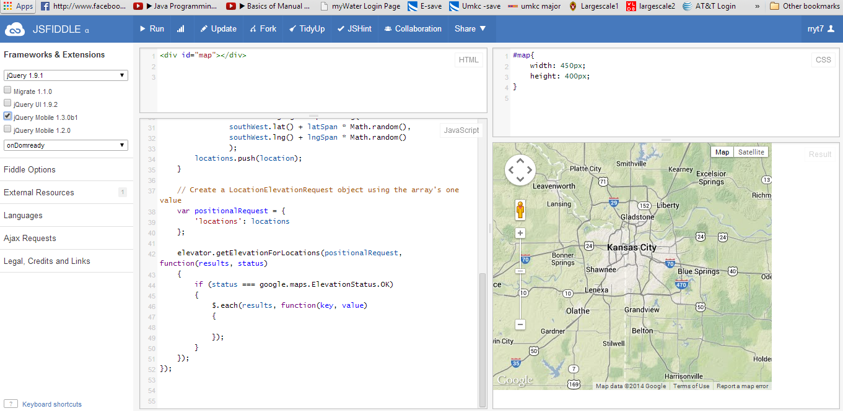

6.Location