**Used**: Mashup of google maps and weather android apps

I have created an android app which gets latitude and longitude from given address using google maps api and then I used latitude and longitude to find temperature in kelvin.

I have installed VMWare and then used cloudera in the Vmware and then I ran word count example of map reduce using hadoop. Then I installed maven and then I followed instructions in tutorial to run classify-20newsgroups.sh file and got the output for sgd and naïvebayes using mahout.

Android app screen shot

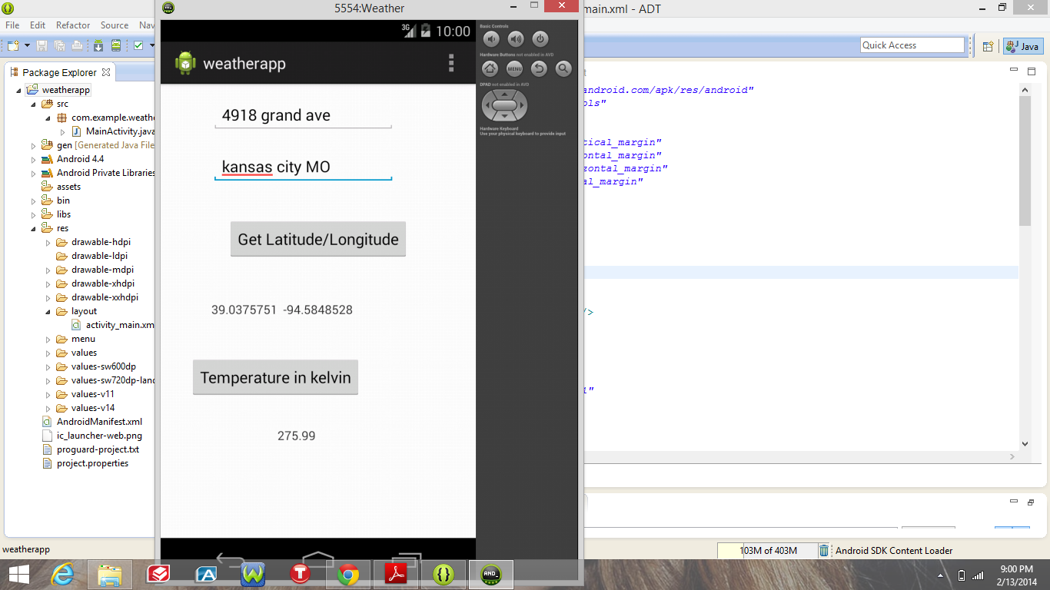

Setup for cloudera

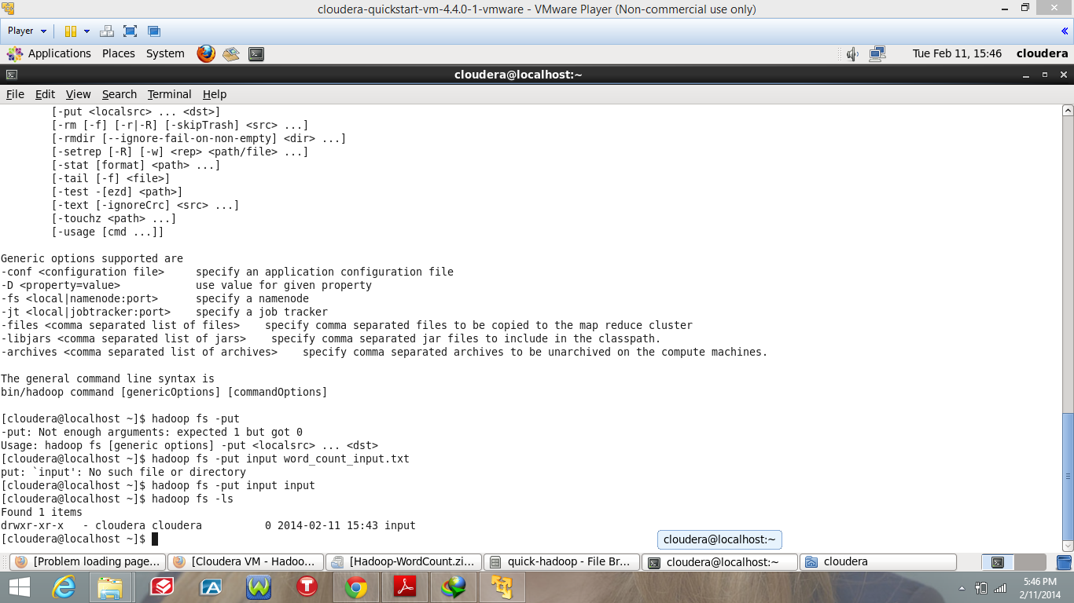

Cloudera WordCount example execution

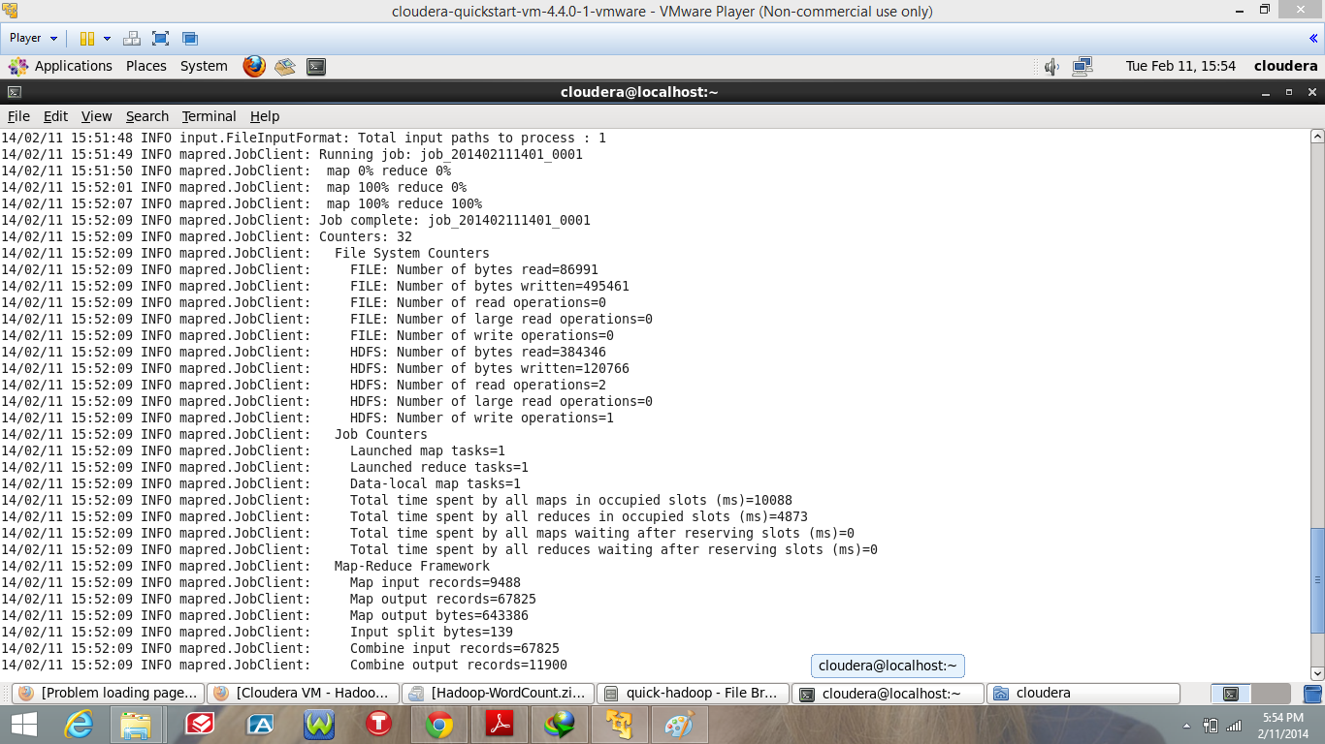

Maven installation

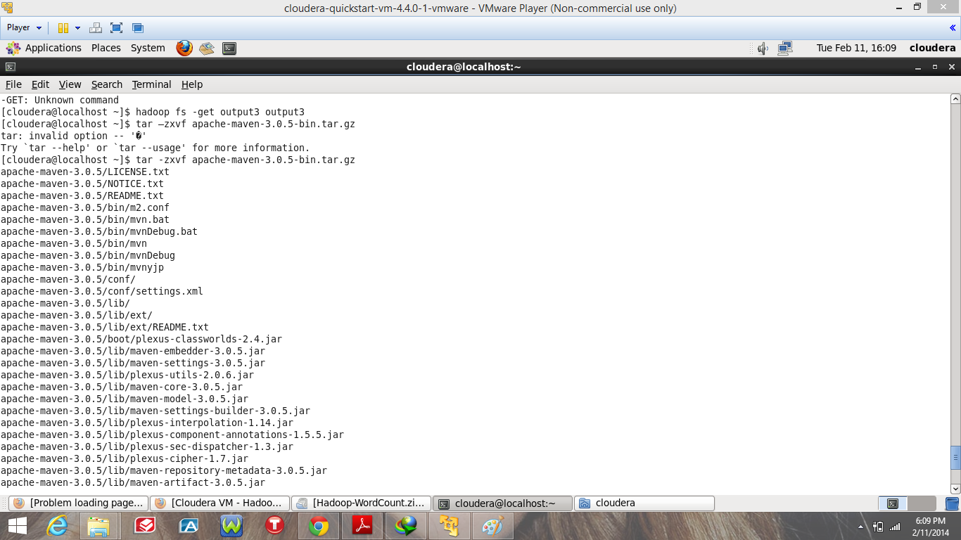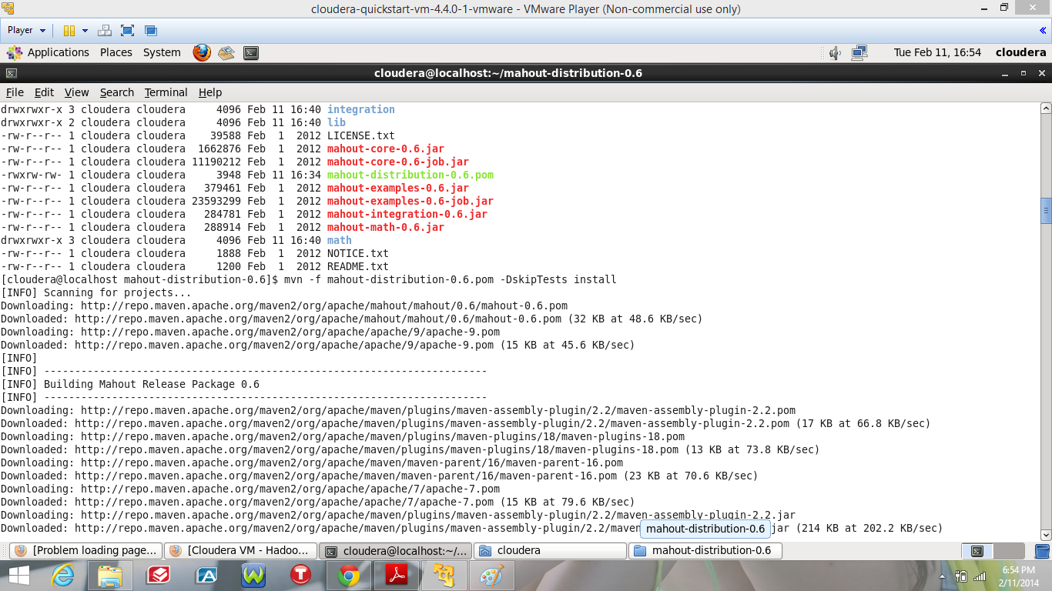

Output after running naïve bayes

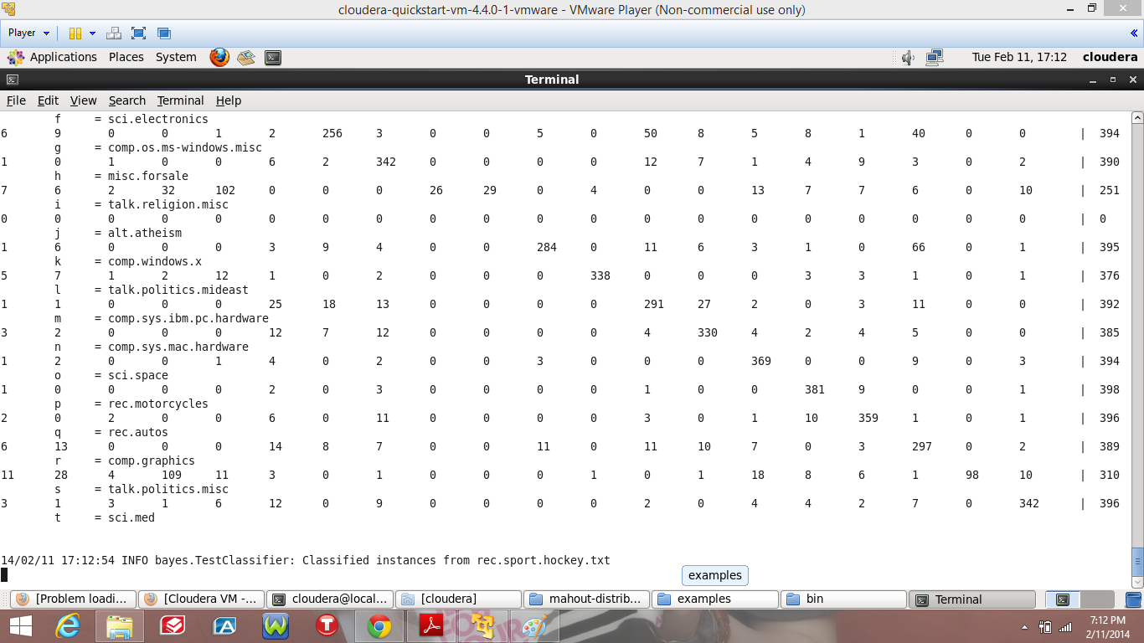

Output after running sgd

