I have implemented a Recommendation system to recommend countries to visit by using Vmware, cloudera, mahout and solr

Implementing recommender system in cloudera

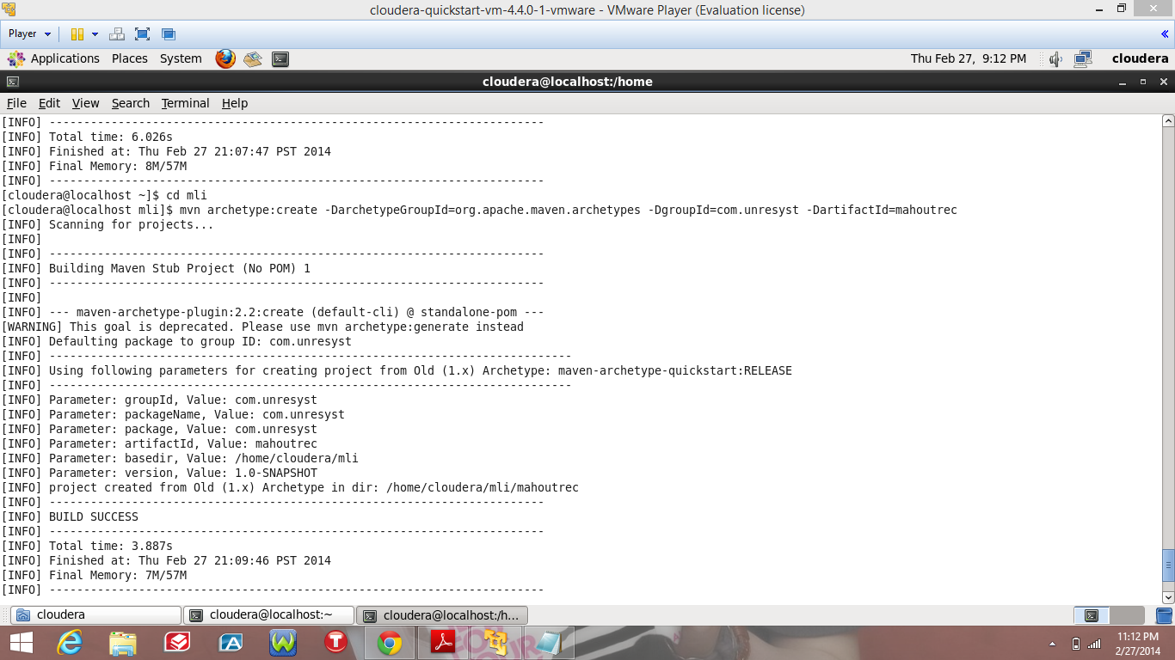

Compiling the recommender project

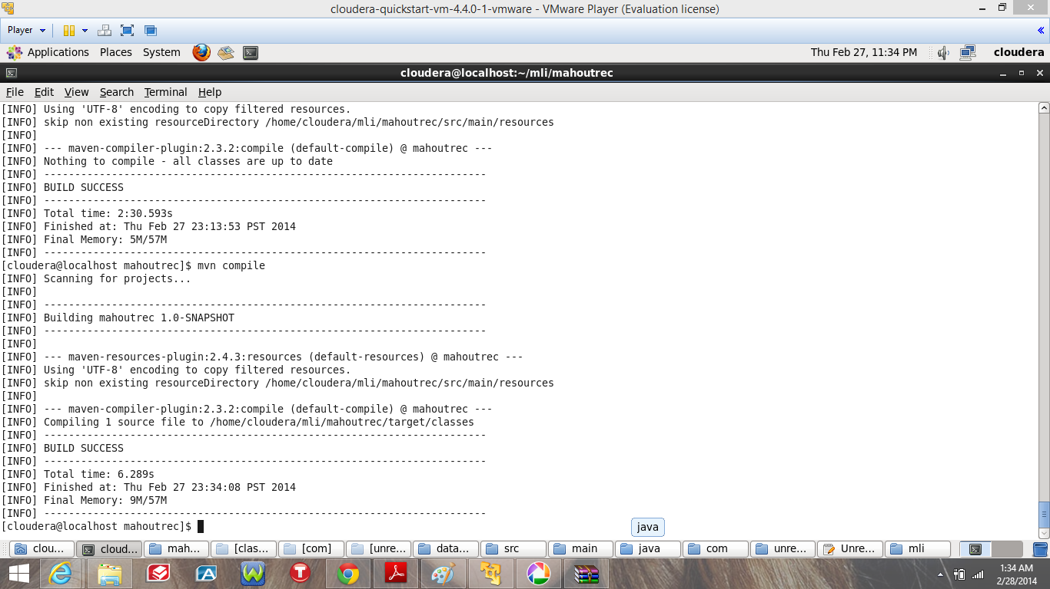

After compiling the recommender system I have taken my own data by using a random number generation java program and by using this data and I implemented the recommender system and stored the output to solr. I have accessed the data from solr and mapped the ids of countries to visit with the country name and using the mobile application if I enter a user Id then we can get the countries he will be recommended to visit.

Output for the recommender system i.e. recommendation for user to visit countries with ids.

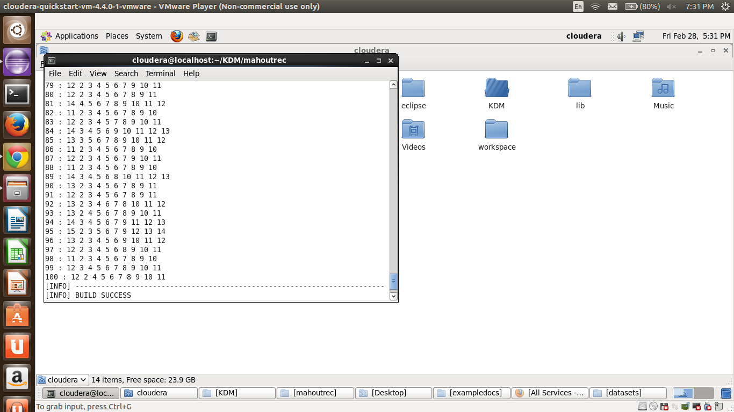

Code for mapping country ids with country name

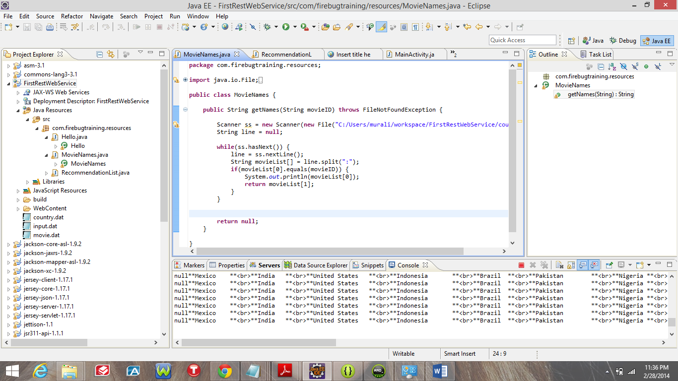

Mobile application: Output for the recommender system for country’s to visit by using the data obtained from solr

