Report

1. **Design**

* Data model

I have considered the data from imdb where one data set is about the movie id, movie name and other details about the movie and one more data set is about the user id, movie id and the movie rating given by user. By using this data I have created a recommender system for movies.

Movie.dat

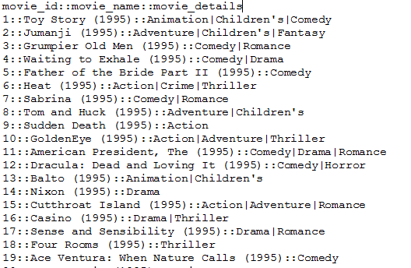

Reco.dat

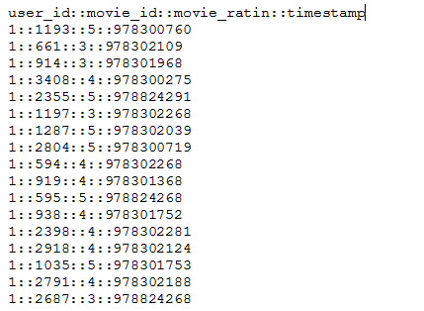

* Recommendation Algorithm

Whenever a user likes a movie it will be considered for providing recommendations from the user. I have used item based recommender system for this recommendation. If we consider recommendations for a specific user we have to consider the movies liked by him and the movies liked by the users which have liked the same movies.

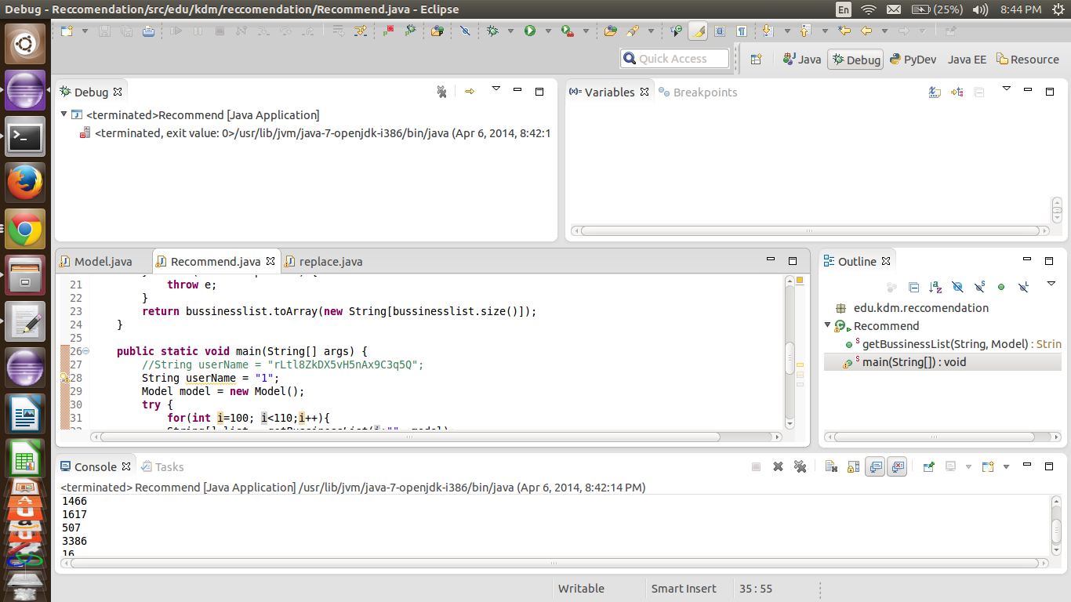

* Selection of datasets

I have selected the recommendation dataset from the imdb using the web crawler. Downloaded datasets were in the form of dat file and then I have written a java code to parse and convert the file to CSV format. Now this data sets are given to recommendation algorithm in mahout to get the recommendations.

* Mobile App

I wrote a java code for mahout by using which we can obtain recommendations and this recommendations are mapped to the movie names and this movie names are displayed by using mobile application.

1. **FEATURES & IMPLEMENTATION**

Movies are recommended based on the movie names and the year in which they were released and what type of movie it is. If the user likes a movie it will be considered for recommendation and the users with same movies liked by him and then the recommendations are obtained by the recommended java code written in mahout and the then I have tried to push the data to solr but it was not successful and then I have created an android app for mobile web service by which user can obtain the recommendations.

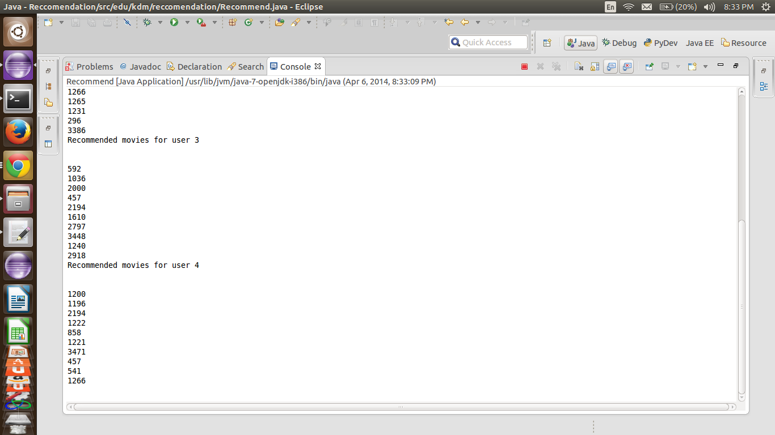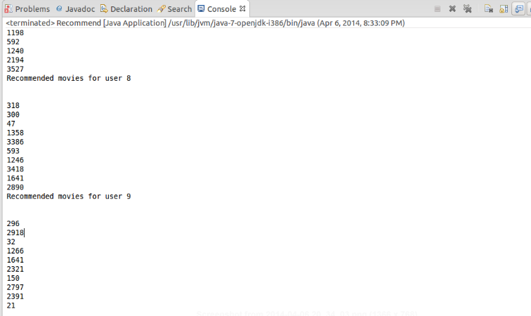

* Software Services:

Solr, android, eclipse, mahout, cloudera, vmplayer.

* Mobile user Interface

The screen shot below is the user interface of my application

Input movies

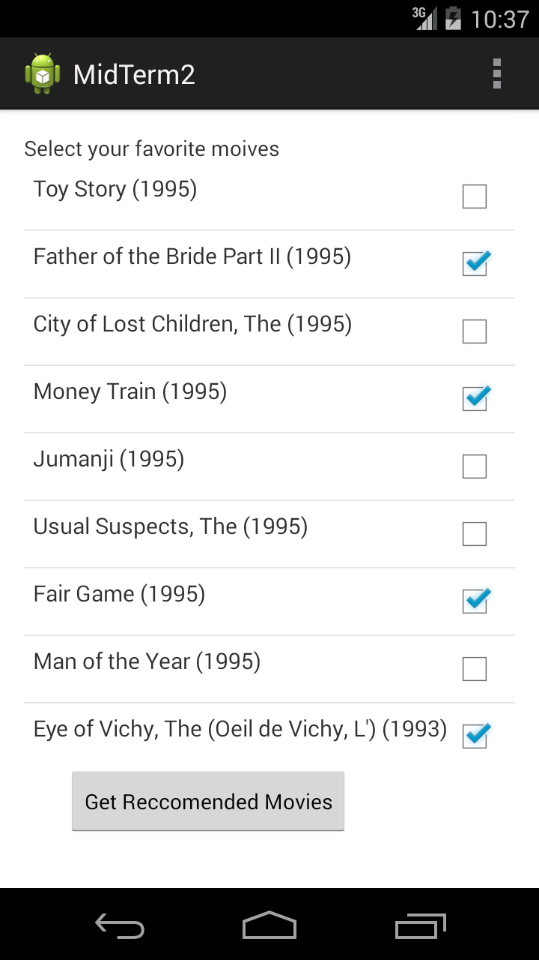

Output recommendations

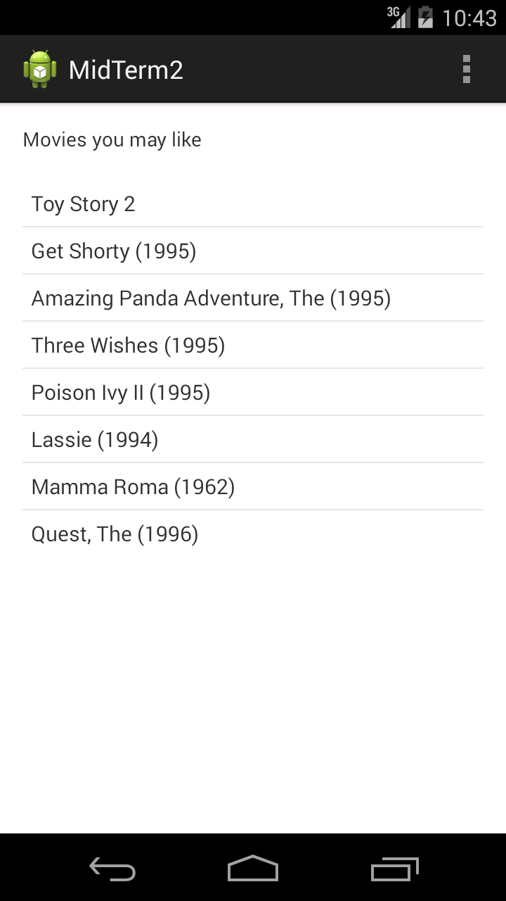

1. Midterm Github URL

<https://github.com/mlikk/midterm>

4.REFERENCES

User Interface:

<http://androidexample.com/>

<http://developer.android.com/samples/index.html>

Mahout algorithm:

<http://www.drdobbs.com/open-source/machine-learning-with-apache-mahout-refi/240163537>

<http://chameerawijebandara.wordpress.com/2014/01/15/simple-recommendation-system-with-mahout-and-netbeans/>