Group 3 – Elevator Simulator

Building
Within out simulator the building class is the main frame that mediates between every other class. For instance, it contains the time and an array of each floor and elevator that will be in the building. As time continues to increase it checks the generated data for anyone that is just arriving at a floor to request the elevator.

Elevator
The elevator class contains an array of people that are within it, and can move up and down according to the instructions by the driver class. Each time it reaches a destination it can unload a list of people within it that have arrived at there destination. Additionally, each floor it moves it increments the run cost.

Drivers
The driver class is an interface that tells the other drivers the basic structure it should follow. This way we were able to create a more generic driver variables that it easily adapt to additional drivers that could be developed in the future.

Base Driver
The base driver implements the driver class and has one simple function. It tells the elevator class to move all the way up then all the way down and repeats this for an entire day.

Smart Driver
The smart driver is the brain behind the elevator. It functions by simulating what would be better going up or down.

People
The people class is the simplest of all of the classes. It contains the person's original position, destination, time they arrived, and their weight. This will be used mainly with the floor and elevator class to ultimately get a total wait time compared to the current time as well by the elevator class to simulate weight being in the elevator.

Basic Layout
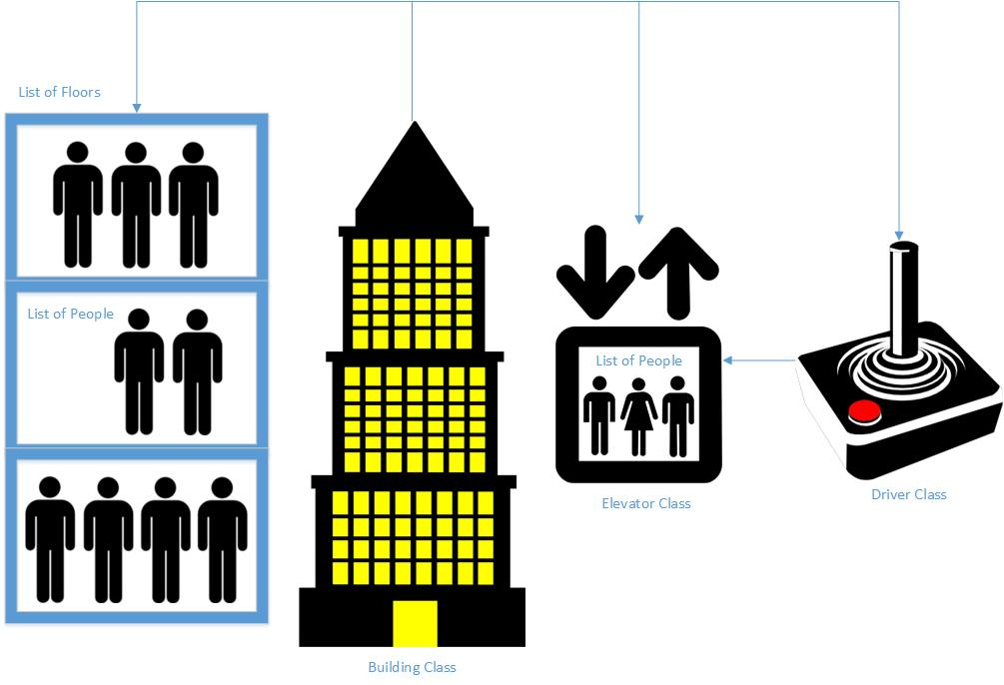

Results

