Score-4 User Manual
Table of Contents
How to run the game | ································· | Page 3
Using the Score Four program | ································· | Page 4
How to run the game

The operation of our Score Four game is extremely simple and intuitive. However, there are a few steps you will need to follow before you can get the game up and running.

Our game uses the Java3D API to render a 3D user interface. Unfortunately, Java3D is not part of the default JRE installation which most Java users have access to on their computers. However, this is but a minor issue, as it is easy to run Java3D applications on your computer even if you do not have the Java3D API installed. There are two options available to you:

If you do not want to (or cannot) install the Java3D API, you can run the Score Four program simply by launching the team3-scorefour.jnlp file included in the distribution of the project. On most systems, this is as easy as double-clicking the file’s icon. (If your system is not configured to run JNLP files by double-clicking, you can run the file from the command line using the command javaws team3-scorefour.jnlp.) Please note that you must have the team3-scorefour-s.jar file in the same folder as the team3-scorefour.jnlp file or the program will not run properly. Once the JAR file has downloaded, a window will pop up asking you if you would like to run the application. Click Run, and the application will start. Complete instructions on how to use the application are provided in the next section.

If you would like to install the Java3D API for easier operation of the Score Four program, you can download the latest Java3D binaries from https://java3d.dev.java.net/binary-builds.html. If you are using Mac OSX, you will need to download the Java3D 1.5 binaries from https://java3d.dev.java.net/binary-builds-old.html, as binaries for the latest revision (1.5.1) have not yet been released. This should not affect the operation of the Score Four program. Once you have installed the Java3D API, you can run the Score Four program simply by double-clicking on the team3-scorefour-s.jar file, or by running it from the command line using the command java –jar team3-scorefour-s.jar.
Using the Score Four program

When you start the Score Four program, you will see the following window.

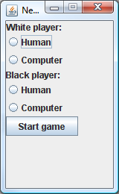

This window allows you to configure your game by choosing which players will participate. You can use the radio buttons to select whether each player will be a human or a computer. Note that the white player always gets the first move. Click the start game button and the game window will appear.

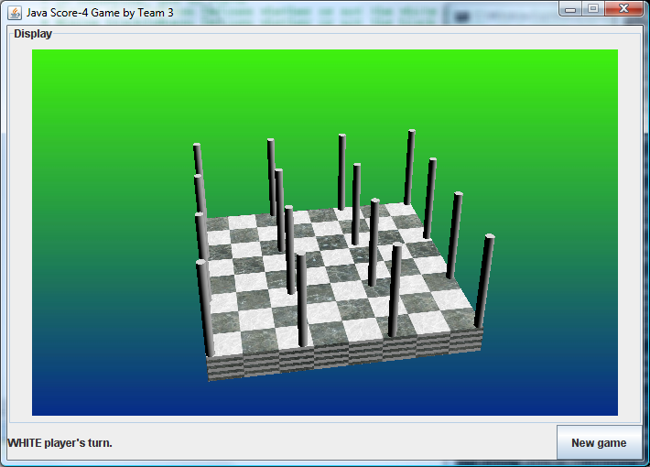

The status message at the bottom of the window lets you know which player’s turn it is. To place a bead when it is your turn, simply click on the peg you would like to place the bead on in the 3D display. You can rotate the board in the 3D display using the left and right arrow keys on your keyboard. If you are playing against the computer, it will instantly respond to your placement by placing a bead of its own and returning control to you. The game continues until one player creates a straight line of four beads of his or her color in any direction (in which case that player wins), or until the board is full (in which case a draw occurs.)

If you would like to start a new game at any time, simply click the “new game” button and the board will be reset.

