MineSweeper

To use the command-line application, navigate to the bin\Debug (or bin\Release) directory and call the binary passing parameters for the number of rows, columns, and boms-per-row.

If any of the paramters is incorrect, a usage message will display and the program will terminate. The following restrictions apply, presently.

* All three parameters must be valid.
* Rows and columns are restricted to the range { 1:100 }
* The value of bombsPerRow paramger is limited to the range { 0 : number_of_rows }

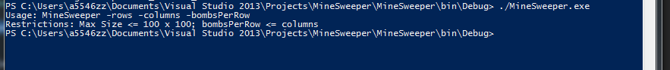

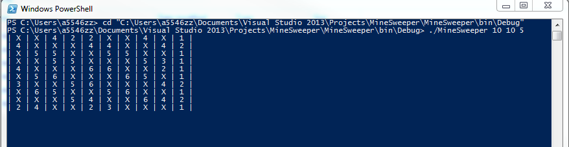

# 

# Architecture

The solution has three classes, Cell (represents a cell in the game field), Field (represents the game field), Program (validates input and consumes the public interface of Field to generate and display a MineSweeper field).

