Sentiment Analysis using Machine Learning
Name: Harsh Raj

Objective
To classify tweets as positive or negative using natural language processing (NLP) techniques.

Methodology
- Data preprocessing using stemming and stopword removal
- Feature extraction using TF-IDF
- Model training using Logistic Regression

Results
The model achieved an accuracy of approximately 79%. The following graphs show the sentiment distribution:
Bar Chart:
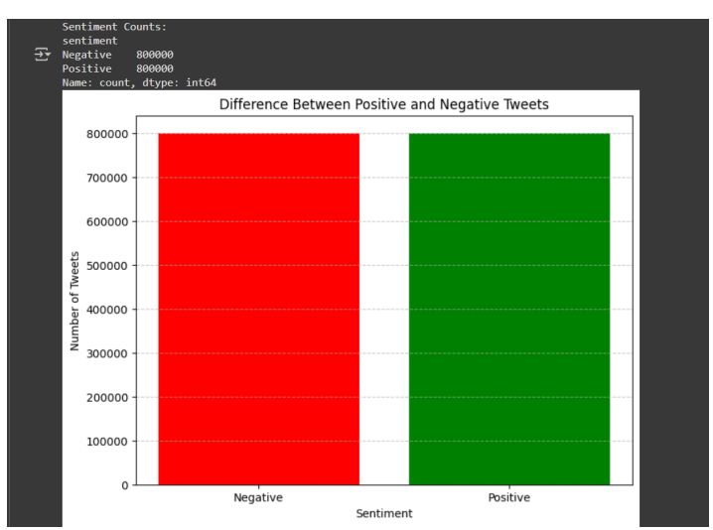
Pie Chart:
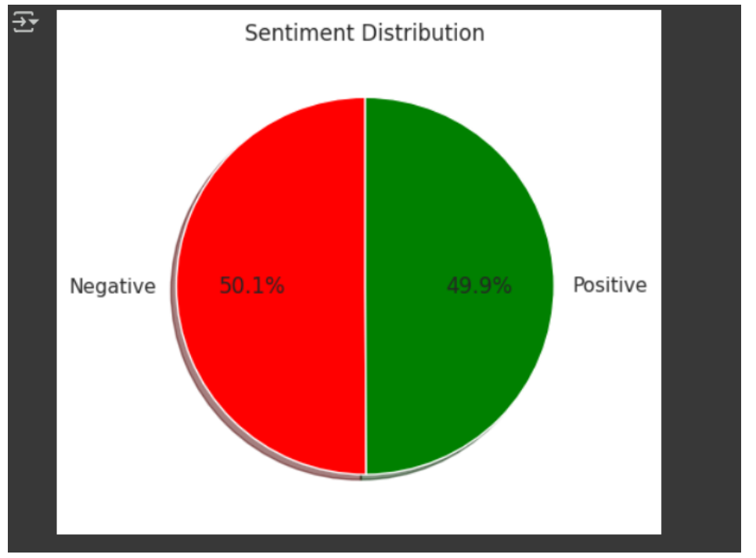

Conclusion
The model successfully classifies tweets with good accuracy and demonstrates the effectiveness of basic NLP techniques.

