Rmarkdown Training

Mercedes Horn

6/17/2020

The sun rose 6 times today.

The sun rose 6 times today. 2*3=6

I woke up in a *very* bad mood today, I am gonna use *italics*.

I want this to be **bold**.

My breakfast:

* Cheerios
* Blueberries
* Staples

I want this sentence to be in code format

All the sentences below end up in the same paragraph

One sentence. Second sentence. Third.

All the sentences below end up in different paragraphs

One sentence.

Second sentence.

Third.

**Inline code gets hard to read quickly**

**What is much more powerful is inserting code chunks**

Below is a code chunk: *code chunks can print more than one output* *echo=FALSE is a code option runs the code hides it from view, only showing the output*

# My summary of cars

The cars dataset has 50 observations. Here is a summary of cars and a plot of some cars data.

print(summary(cars))

## speed dist   
## Min. : 4.0 Min. : 2.00   
## 1st Qu.:12.0 1st Qu.: 26.00   
## Median :15.0 Median : 36.00   
## Mean :15.4 Mean : 42.98   
## 3rd Qu.:19.0 3rd Qu.: 56.00   
## Max. :25.0 Max. :120.00

plot(cars$speed,cars$dist)

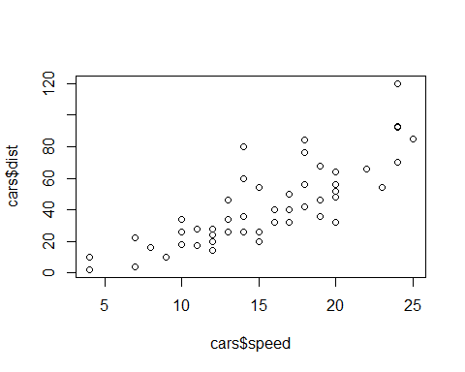

m<-lm(dist ~ speed, data = cars)  
print(m)

##   
## Call:  
## lm(formula = dist ~ speed, data = cars)  
##   
## Coefficients:  
## (Intercept) speed   
## -17.579 3.932

# Take aways

* We have inline code
* Code chunks, code chunks can be as long as we want them to be
* echo=FALSE code is not shown

# Iris

* echo= FALSE code is not shown but results are
* eval= FALSE you can see the code but it doesn’t execute
* message= FALSE any code that is generated is not shown
* include= FALSE doesn’t show you code or results
* cache=FALSE whether to cache your results, for expensive ( expensive ie takes a lot of time to run) things with many lines of code you don’t what to rerun every time so you

# Graphics

* would include after fig.align to format your document
* whole universe of ways to make snazzy tables in Rmarkdown

knitr::kable(head(cars), align = "l", caption="My cars table")

My cars table

|  |  |
| --- | --- |
| speed | dist |
| 4 | 2 |
| 4 | 10 |
| 7 | 4 |
| 7 | 22 |
| 8 | 16 |
| 9 | 10 |

# Pandoc

* pandoc is a soft ware that is running the under the hood here as well
* you can use this to generate a word doc

# Working directories in R markdown

* problem of working directories in R
* don’t use absolute directories because it will then go and break

# How to write comments in Markdown that don’t appear in your final R-markdown document

## R Markdown

This is an R Markdown document. Markdown is a simple formatting syntax for authoring HTML, PDF, and MS Word documents. For more details on using R Markdown see <http://rmarkdown.rstudio.com>.

When you click the **Knit** button a document will be generated that includes both content as well as the output of any embedded R code chunks within the document. You can embed an R code chunk like this:

summary(cars)

## speed dist   
## Min. : 4.0 Min. : 2.00   
## 1st Qu.:12.0 1st Qu.: 26.00   
## Median :15.0 Median : 36.00   
## Mean :15.4 Mean : 42.98   
## 3rd Qu.:19.0 3rd Qu.: 56.00   
## Max. :25.0 Max. :120.00

## Including Plots

You can also embed plots, for example:



Note that the echo = FALSE parameter was added to the code chunk to prevent printing of the R code that generated the plot.